Word Version of Presenter Proposal Form 2025

(Please do not submit this form directly! Instead, use this form to prepare your proposal and to gather the necessary information to fill out the online form at:
https://accessinghigherground.org/speaker-proposal-form/)
Log into site if you are not already logged in:
Please log-in to submit a talk proposal

(or register if you do not have an account – the ‘register’ option is near the bottom of the screenshot shown below)
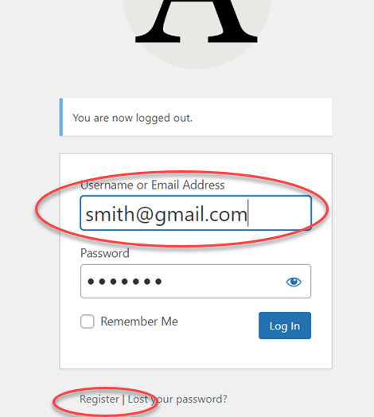
Labels preceded by an asterisk indicate a required field.
Proposal submitter is not speaking (i.e. you are entering this proposal for someone else)

Non-speaking submitter Info (if applicable)

Submitter tel. no.:

Speaker Information

1st Speaker | 2nd Speaker
*First Name:  *Last Name:  Title:  *Company:  Department:  *Address:  *City:  *State/Province:  *Country:  *Zip/Postal Code:  *e-mail: (this will be filled in automatically by the system from your login account)  *Phone Number:  Web Address:  *Bio:  If you have not presented at AHG previously, please list some conferences you have presented at recently and the topics addressed: | *First Name:  *Last Name:  Title:  *Company:  Department:  *Address:  *City:  *State/Province:  *Country:  *Zip/Postal Code:  *e-mail:  *Phone Number:  Web Address:  *Bio:  If you have not presented at AHG previously, please list some conferences you have presented at recently and the topics addressed:

*(Note: the first speaker will receive all conference related correspondence)
(Note: the online form allows the entry of up to 5 speakers. Copy and paste the table above to prepare information for speakers 3, 4 & 5.)

[2nd tab of proposal]

Proposal Information

*Title of Proposal (120 characters maximum - about 18 words)

*Length of Session
General Conference: __1-hr general conference __2-hr general conference
Pre-Conference: __ 3-hr pre-conference __5-6 hr pre-conference
__ 2-day pre-conference

*Type of Presentation
__Lecture __Lab __Panel __Bring your own device workshop __Interactive/discussion

Items Attendees need for Bring-your-own device workshops

*Presentation Summary (500 characters maximum - about 90 words)

*Presentation Abstract (2000 characters maximum - about 360 words)

*Describe the methods you will use to make your presentation engaging and interactive, regardless of your presentation type.

[3rd tab of proposal]

Topics and Key Points

*Expertise Level

__Beginner __ Intermediate __ Advanced __All Levels

*Disability Areas (Check all that apply)
__ All Areas  __ Cognitive/Learning  __ Deaf/HOH  __ Mobility | __ Psychological  __Vision  __Other  If other, specify:

*Topic Areas (Check all that apply)
__ Accessibility and Accommodation in the Current Political/Legal Environment  __ Accessible Course Design  __ Artificial Intelligence (AI)  __ Alternate Format  __ Assistive Technology  __ Campus & System-wide Initiatives  __ Captioning/Transcription | __ Faculty Development & Support  __ Legal  __ Procurement  __ Teaching about Accessibility in Curriculum  __ Web/Media/App Access  __ Other: If other, specify:

*Enter 3 key points attendees will learn at your presentation (110 characters maximum each) (Use strong declarative statements – see examples below)

*Key Point 1: e.g., “Research on cognitive load can inform your decisions when writing alternative text.”
*Key Point 2: e.g., “All online course creators face limitations related to accessibility.”
*Key Point 3: e.g., “Quality of digital publications differ between publishers.”

[4th tab of proposal]

Equipment Needs

A/V & Computer Equipment Needed for Presentation*
__Flip Chart __White Board
*(A screen, lcd projector (HDMI only) and wireless internet are provided in each room).

Proctor Help

I would like a proctor to assist with my session (y/n) ____

For hands-on workshops only: equipment, software and setup required*
__ Fusion __JAWS __NVDA __ Zoomtext
__Other software or equipment. If other, specify:
*(all lab PCs have an Internet connection, Firefox, Office & Chrome)

Maximum class size:

Number of additional proctors needed (from conference staff):

Presentation Mode
__ I plan to present onsite*
__ I plan to present Remotely
*(Note: Remote co-speakers are not allowed for ‘onsite’ sessions).

Are you willing to lead a roundtable discussion on the topic of your presentation or on a related topic?
__ Yes __ No

If yes, do you have a specific idea of how you would like it titled and described? (If you like, it can be on a different topic from your presentation) (120 character limit)
_________________________________________________________________________________
Roundtable Session Description (500 character limit)

[Error Messages]
(Any required fields you have not filled in will be flagged near the top of each page – see example below)
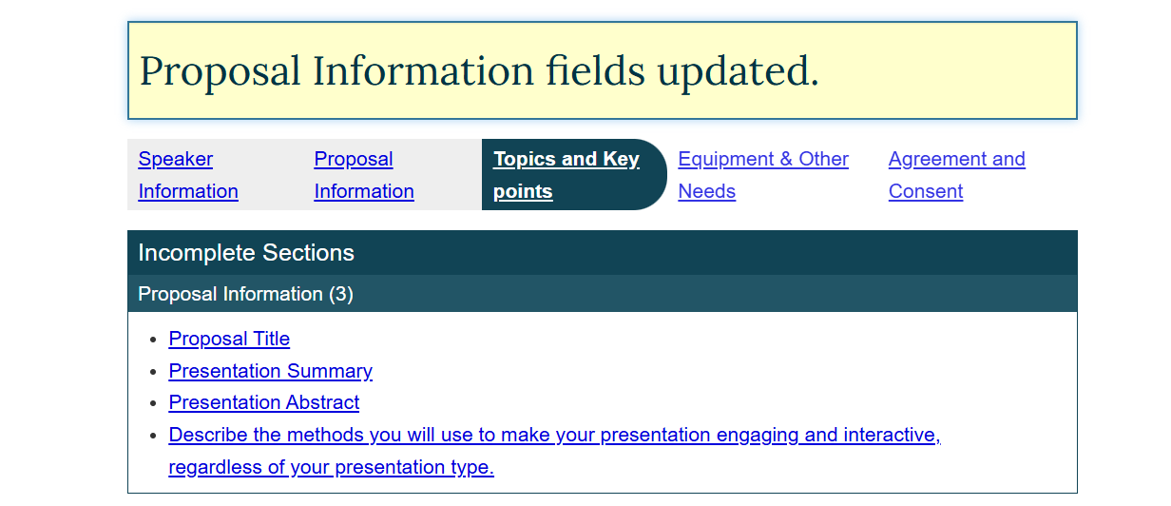

[5th tab of proposal]

Agreement and Consent

Hand-Outs
(can be submitted at a later date)
You must upload an accessible electronic copy of your handouts — including slides, fact sheets, and any other handouts — by October 15 using the instructions to be sent after your proposal is accepted.

First Round of Submissions
Please return this proposal form by April 5 for the first round of submissions. Speakers will be notified by May 31 confirming acceptance or decline of their proposal(s).

Second Round of Submissions
If needed, a second round call for proposals will be announced in late April or May.
Please note that due to a limited amount of time slots, some proposals may not be accepted. Proposals submitted during round one are given preferred consideration for speaker slots.

Speaker Agreement
Please note the following:
- The proposal and any handouts speakers provide may appear on our website and other media as part of marketing for the conference. Conference handouts and links to presenter’s e-mail addresses will also be posted on the post-conference website. Please upload an electronic copy of your slides and handouts by October 15 using the instructions to be sent after your proposal is accepted. You can also e-mail: hkramer@ahead.org for the upload instructions.
- Handouts, including alternate formats (Braille, Large Print, etc.) are the responsibility of the presenter(s). The number of registered attendees requiring alternate formats will be sent to presenters by October 10th. Please let us know if you need assistance in providing your material in alternate format.
- It is understood that permission has been given by program presenters for audio-taping, video-taping and photographs. Audio and video of the sessions may appear on the post-conference website. Videos/audio recordings may also be made of sessions and offered to attendees and non-attendees after the conference for a fee. Pending speaker consent, some conference sessions may be streamed to off-site audiences.
- A 10% discount on registration fees will be provided to presenters who are traveling to the conference from out-of-state. Local presenters who present for one session or more receive a 5% discount off conference fees.
- Pre-conference presenters who present 6 hours or more will receive additional discounts. This discount is available only to the first two speakers or the discount can be divided among all the speakers (i.e. at a lower level). Contact hkramer@ahead.org or 720-351-8668 for specifics.
- Speakers must provide an accessible version of their slides, either in PowerPoint, PDF, EPUB or HTML format (HTML format provided via URL to posted web page) before the start of the conference.

Please indicate your acceptance of the above agreement by typing in your name below in lieu of signature:

Presenter 1: Type your name to indicate agreement with above stipulations

Do you consent to the audio recording of your conference sessions according to the stipulations listed above.
__Yes __No
Optional consents are not required for proposal acceptance

Do you consent to the video recording of your conference sessions according to the stipulations listed above.*
__Yes __No

Do you consent to the video streaming of your conference sessions according to the stipulations listed above.*
__Yes __No
*(Consent for taping and streaming are not required for proposal acceptance)

Required Consent
I will send the final version of my slides in accessible format (as stipulated above) before the first day of the conference * (required)
(check for yes)
The initial version of slides must be submitted by October 15. Updates and corrected versions can be sent after October 15.</li>

