LaTeX Practice Exercises 1

Problem 1
Create the following math expression by entering LaTeX (with delimiters) into the space provided:
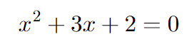

Answer:

Problem 2
Create the following math expression by entering LaTeX (with delimiters) into the space provided:
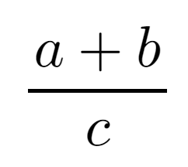

Answer:

Problem 3
Create the following math expression by entering LaTeX (with delimiters) into the space provided:
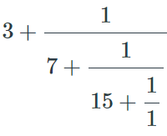

Answer:

Problem 4
Create the following math expression by entering LaTeX (with delimiters) into the space provided:
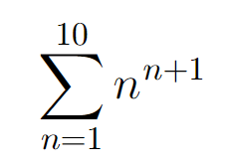

Answer:

Problem 5
Create the following math expression by entering LaTeX (with delimiters) into the space provided:
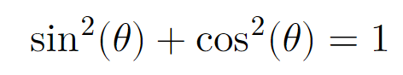

Answer:

