Stanford University Storyline Accessibility Checklist Draft
Table 1 Storyline Accessibility Compliance Checklist
ITEM TO TEST | WHY DO YOU NEED THIS? | EXAMPLE | HOW TO CHECK | HOW TO IMPLEMENT
Does each slide have text and graphics that are easy to read and has a sufficient color contrast ratio? | A learner with reduced contrast sensitivity reads text with a high color contrast ratio against a decorative background. | A learner with reduced contrast sensitivity reads text with a high color contrast ratio against a decorative background. | Use a color contrast checking program. The following apps are recommended. Each checker has an eyedropper feature that allows you to capture the foreground and background color from the slide. The checker will flag content that does not have a sufficient color contrast ratio.  WebAIM Contrast Checker  Colour Contrast Analyser (CCA)  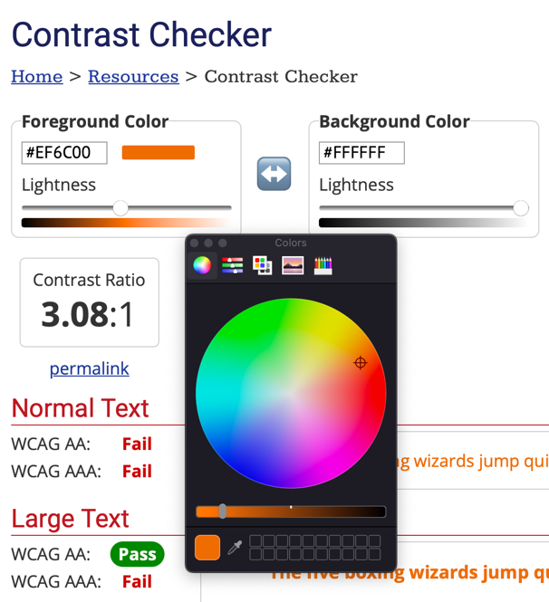 | Before creating course content in Storyline check that all the colors being used meet WCAG 2.0 AA Guidelines. If you’re using Stanford colors it is recommended to use the Stanford color contrast chart.
Has color alone been used to convey meaning? | Color alone should not be used to convey meaning or distinguish between items. This is because people with color blindness or vision loss need an alternative way to access the content. | A learner with color blindness can identify a bar chart because it has labels and does not rely on color alone. | Ensure that color alone is not used to convey meaning. For example, do not convey meaning solely through using different colors. This often occurs when people use different colored fonts or graphics to convey meaning. Ensure that there is a label or alternative way of conveying the meaning.  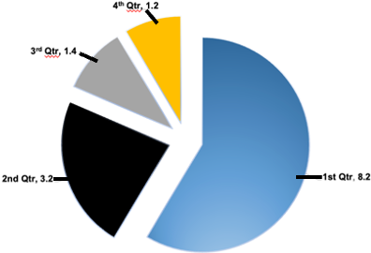 | In Storyline if including a chart or graphic that uses color to convey meaning, ensure that it has labels. Also, avoid using different colored text alone to convey information.
Is any flashing content limited to less than 3 times per second? | Flashing content can trigger seizures in some learners. This is why flashes of more than 3 times per second should be avoided. | A learner with a seizure disorder accesses a video that does not use flashing content. | Check that blinking or flashing content does not included a lot of fast flashing or blinking content. Avoid flashes or blinking that is more than 3 times per second. | Avoid flashes or blinking that is more than 3 times per second.
Does any text or images that pop into the slide include triggered audio narration? | Text that pops onto the screen is not conveyed to people who use assistive technology like screen reading. This is why text needs audio narration so that the new text is conveyed to the user. | A learner using screen reading software selects a button and is alerted to new text on the slide through audio narration. | When new text or images pop into the slide they are read out loud by text to speech software or voice narration. All the narration includes captions and is part of the transcript.  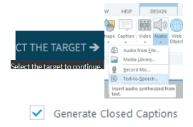 | This requires copying all the text and adding it to the text to speech generator in Storyline. The generator can be found by going to the “Insert” toolbar and selecting “Text to speech” under the “Audio” icon. Make sure generate closed captions is checked. The alt text used to describe different images should be copied too. The audio file needs to be broken up and synced. This way the narration will play when the text or image appears on screen. Alternatively, narration can be created outside of Storyline, imported, and synced to match the timing of the text that is popping in.
Are hover states being used to convey meaning? | The default hover state in Storyline inherently inaccessible to people who use the keyboard or people who use screen reading software. | A learner using screen reading software accesses an accessible slide that conveys the information without the use of hover states. | Identify if a hover state is used to convey meaningful information like text or an image. If a Storyline default hover state is being used to convey meaningful information the content should be made accessible. | Avoid using the default Storyline hover state to convey meaningful information. There are a variety of ways to convey content in Storyline without using a hover state. If a hover state is needed additional JavaScript coding and a combination of Storyline interactive elements may be able to make a custom accessible hover state.
Do all included charts provide accessible supports or alternatives? | It is important to ensure that all charts provided are accessible so that they can be accessed by a wide range of users. | A learner using screen reading software accesses a chart and receives an alt text description of the information. An accessible table with the chart’s data is also included. | Ensure that any chart includes an alt text description. If the data is important and being used throughout the course, it is recommended that an accessible table with the data should be included. | Add alt text for any images of chart data this displayed. If needed a long description may be included in another layer or below the chart. If the data is used throughout the course it is recommend to create an accessible simple table with the data too.
Do all tables have programmatic headings, linear layout, and are not used for layout? | Tables need to be accessible to people who use screen reading software. The software needs programmatic headings and a linear structure to convey the table data to the user. Tables used for layout are incompatible with screen reading software. | A learner using screen reading software can access a table and the header row is read when interacting with table data to provide context and navigational support. | Examine the table and confirm that it is not being used for layout purposes. Ensure the table has a programmatic header row. Storyline tables are designed to avoid merged cell and column headers. The focus order tool should be used to check that the items are presented in a logical order and alt text should be used to ensure the header row is conveyed to people using screen reading software. It may be possible to edit the focus order to support a column header or merged cells.  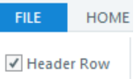 | On Storyline check that the table has a designated header row. This can be done by looking at the style options. Open the focus order tool and set a custom focus order. Ensure the table is presented in a logical order. Use the alt text option to convey the header with the table data to people who use screen reading software.
Do text entry fields include the question in their name? | Text entry fields need alt text descriptions that convey the question. This information is relayed to assistive technology like screen reading software. This makes the content more accessible and easier to access for people who use assistive technology. | A learner using screen reading software navigates to a text entry field and the screen reader conveys the question automatically. | Use the focus order option from the toolbar to check that each text entry field has an alt text description that includes the corresponding question.  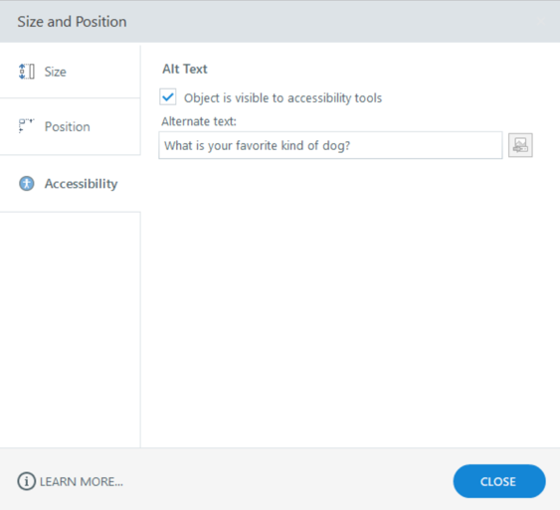 | Right click on the text entry field and choose accessibility. Paste the corresponding question into the alt text box. Make sure object is visible to accessibility tools is also checked. This can also be done by going into the focus order and adding the question into the alternative text box.
Do all buttons and hyperlinks include descriptive text that convey their function and destination? | Buttons and hyperlinks need to accurately describe their function and be presented in a logical order. This information helps a wide range of users understand how to navigate the content. The description needs to be accessible so that people using assistive technology like screen reading software can access it too. | A learner using screen reading software selects a button called “How an MRI works” and the screen reader states “Button, how an MRI works” | Check the focus order of each slide with buttons and hotspots. Ensure that each button has an alt tag with a descriptive name for its action.  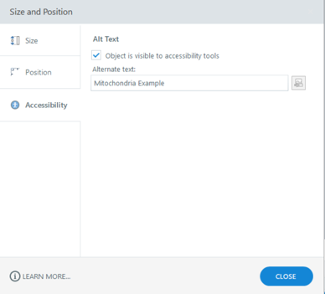 | In the focus order provide each button with a descriptive name in the alt text. Additionally, right clicking on the button in the timeline and selecting the accessibility option provides a pop-up window to provide an accessible name. Do not include words like click or button in the name because that information will be conveyed by the screen reading software.
Does the course contain drag and drop or matching exercises or quiz questions? | Drag and drop and matching exercise or quiz questions developed by using the standard Storyline interactions are inherently inaccessible to people who only use the keyboard or people who use assistive technology. It is recommended to avoid these types of interactions. | A learner who only uses a keyboard can select an accessible multiple choice quiz option. | Identify if there are any drag and drop or matching exercises or quiz questions in the course. | Use Storyline interactions that are inherently accessible like multiple choice or true/false. It may be possible to create an accessible drag and drop or matching exercise or quiz by using JavaScript coding and combining Storyline interactive elements.
Do quizzes have an unlimited amount of time? | Time limits present a barrier for people with learning disabilities, physical disabilities, and cognitive processing delays. Quizzes included in a Storyline course should provide the user with an unlimited amount of time to answer. This ensures a wide range of learners can complete the quiz at the pace they need. | A learner with a learning disability has the time they need to complete the module quiz. | Check that each quiz does not have a quiz timer attached to it. Alternatively, test the published module to ensure that no time limit starts when the quiz begins | Do not add any time limit to quiz content in Storyline.
Do all quiz questions include appropriate alternative text and present the content in a logical order that is keyboard accessible? | Quiz questions need to be accessible to a wide range of users. This includes people who only use the keyboard and people who use assistive technologies. Alternative text and a logical focus order that is keyboard accessible is necessary to provide access. | A learner who uses screen reading software can select the appropriate answer for a multiple-choice quiz question. | It is recommended to use quiz questions like multiple choice and text entry boxes because they are the easiest to make accessible. Quizzes that include images need to include alt text to convey the meaning of each image to people who use screen reading software. Each quiz question must be presented in a logical manner and be focusable using only the keyboard. Use the keyboard to complete each quiz question. Each quiz question should be answerable using only the tab, arrow, and spacebar keys. | Add appropriate alt text to an image in a quiz question by using the focus order option from the toolbar. Adjust the focus order of the quiz items to ensure that they have a logical tab order. Ensure that each quiz type is accessible using only the keyboard. If needed use additional JavaScript coding and Storyline interactions to make the quiz question accessible.
Do all quiz questions provide accessible correct or incorrect feedback? | The feedback provided by quiz questions need to be accessible to people who use assistive technology like screen reading software. The dialog layer is the best option in Storyline because it automatically pulls focus for people who use screen reading software. The feedback also needs to be specific and describe how to fix the mistake. This helps make the content accessible to a wide range of learners. | A learner with vision loss uses screen reading software to complete a quiz. A dialog box pulls focus and provides feedback on whether the question was answered correctly. | Check in the Storyline project that modern dialog layers are being used to convey feedback for quiz questions. Check each feedback layer to ensure that alt text is provided for any images. | Use the modern theme when creating a dialog layer to provide feedback. Ensure the focus order is logical and alt text is applied to any meaningful images. Remove any decorative items from the focus order pane. If the feedback uses triggered text or images narration will be needed to ensure that the feedback is accessible to people who use screen reading software. Avoid displaying answers in a purely visual way, provide a text alternative.
Are there no images of text used throughout the course? | Images of text are not accessible for people who use text to speech or screen reading software. | A learner with vision loss magnifies text to 500% and the text does not pixelate. | Select text on a couple slides throughout the course and confirm that individual characters can be selected.  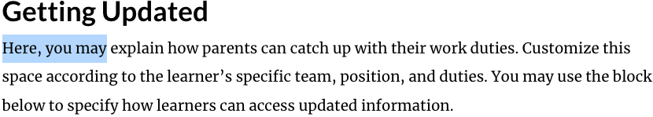 | Insert text to add text throughout the Storyline course.
Are only high-quality meaningful images used that can be magnified to at least 200% without pixelation? | Meaningful images should be high quality and not pixelate when magnified to at least 200%. This supports learners with low vision who may need to magnify meaningful images to read the content. | A learner with low vision magnifies an image of a cell to 200% and it does not pixelate. | Zoom in to 200% when viewing the Storyline project or reviewing the module in a web browser. Examine each image for pixelation. The images should not pixelate and what they represent should remain clear despite the magnification. | Add high quality images to your Storyline page that do not pixelate when magnified to 200%.
Are all lists in the course programmatic lists? | Programmatic lists are compatible with screen reading software. They provide people who use screen reading software information regarding the number of items and make it easier to interact with the content. This information is not conveyed when lists are manually created by using special characters or inputting numbers. | A learner using screen reading software interacts with a list and the screen reader conveys that it is a list and the number of items. | Use the bulleted or numbered options in the home toolbar to create listed content. Avoid manually creating the list by using special characters or manually inputting 1, 2, 3. | Create lists with the bullet or number options from the toolbar. This makes the lists compatible with screen reading software. Avoid manually creating lists by using special symbols or number options.
Are “Heading Labels” used to organize each slide’s content? | Stylized text that breaks up a Storyline slide into different sections visually will not convey that information to people who use screen reading software. This is why programmatic headings are recommended. | A learner with vision loss uses screen reading software to access programmatic headings of a Storyline slide to skip to a desired section. | Check that each Storyline slide is using headings for the different sections instead of normal text. The slide title should be the only heading level 1. | Use headings to structure the content on your Storyline slide. The title of the slide should be a heading level 1. There should only be one heading level 1 per Storyline slide. Heading level 2 should be used for the next section and heading level 3 for a subsection on the slide. The headings should be structured in a logical order on each slide.
Does each Storyline page have a unique name? | Each Storyline page needs a unique name because it can make it difficult for people who screen reading software to navigate and know where they are in the menu. Below is an example from the screen reading software VoiceOver. | A learner with vision loss uses screen reading software to differentiate between the menu options because each one has a unique name. | Check that each Storyline page in the menu has a unique name.  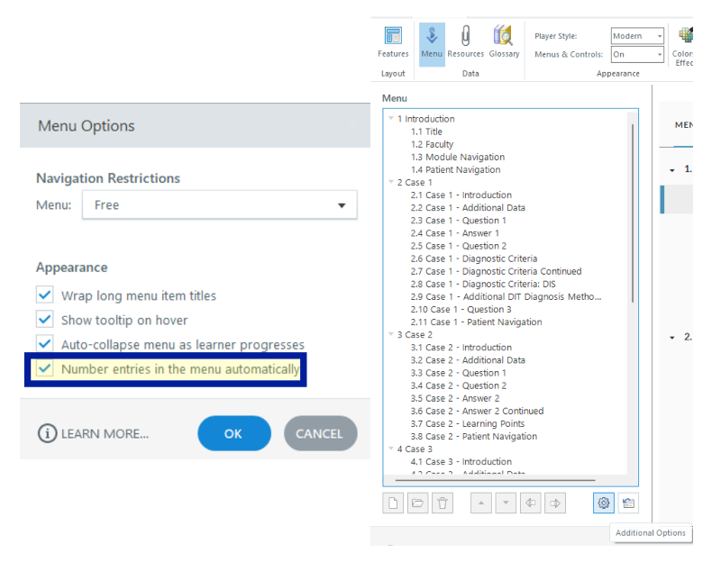 | Create a unique name for each slide listed in the course menu. Alternatively, select the player properties options and choose the menu button. Select the gear icon known as additional options. Check the box for “Number entries in the menu automatically.” Now each slide name will begin with a unique number.
Are accessibility features turned on? | Storyline courses need to have accessibility features to turned on so that the user can magnify slide content and use keyboard shortcuts. This benefits a wide range of users including people with low vision. The content will also not behave as expected without the accessibility features turned on. | A learner with vision loss uses the Zoom to fit and Accessible text features to magnify course content. | On Storyline interface, there should be a “Gear” icon with 3 pop-up Accessibility tools including zoom to fit, accessible text, and keyboard shortcuts.  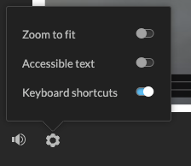 | - If there is no “Gear” icon in the player then accessibility features needs to be turned on. Open “Player” menu from the toolbar. In the pane scroll to “Player Controls”, ensure “Accessibility controls” is checked. Turning on the “Accessibility controls” does not ensure that the features are implemented properly. It is recommended to check each slide with the accessible features on to ensure that the content is compatible and items are displayed properly. “Keyboard shortcuts” is automatically on by default regardless whether “Accessibility controls” is activated.
Are these three accessibility variables flipped to “True”?:  Player.AccessibleText  Player.DisplayCaptions  Player.ZoomToFit | It is possible turn on certain accessibility features by default. This makes the accessibility feature active for all learners who engage with your content. The features can still be turned off if desired, but they are active at the start of the module. | A learner with hearing loss feels included because all the videos in a Storyline course automatically play with captions. | There are two different ways to check. In the Storyline module when you select the CC button or gears option for the accessibility features the desired options should be turned on automatically. Alternatively, you can go into the variable option and choose the built in variables. You can search to ensure the desired variables are set to true.  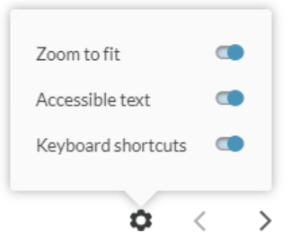 | In Storyline: Click “Variables” icon to the right of the “Group” label. The following variables can be set to true: Player.AccessibleText, Player.DisplayCaptions, and Player.ZoomToFit. Check the accessible text and zoom to fit on each slide. Scroll bars on text and content not appearing on screen is possible if the content is not checked and errors fixed. Also, Zoom To Fit depends on how the course will be launched and its window size, which may impact if content is cut off.
Are modern player “Next” and “Previous” navigation buttons turned on? | The next and previous buttons should be used from the modern player because it is the most accessible player in Storyline. People with learning disabilities, people who only use the keyboard, and people who use screen reading software benefit from consistent design. Keeping the next and previous buttons at the same location supports a wide range of learners by making it easy to find. | A learner with a visual processing disability can easily find the next and previous buttons because they are consistently located in the player on each slide in the course. | In the Storyline module ensure that the next and previous buttons are integrated into the player. Also checking the player properties and ensuring the modern player and menus & controls are on. | In the Storyline player properties make sure that the player is set to “modern” and that the “menus & controls” are on.
Is auto play disabled for any course videos? | People who use screen reading software benefit from auto play being disabled because it gives them more time to pause the screen reading software before accessing the video or auditory content. This might also benefit people with some mental health or learning disabilities too. | A learner using screen reading software can mute the screen reader before playing a video. | Navigate to each page that has a video. The video should not automatically play. The user should need to select the play button for the video to play. This applies to any audio only content too. | Create a trigger that pauses the video when the page loads (“when the timeline starts on this slide”). Using third party video players like Vimeo and YouTube usually do not auto play too.
Have captions been turned on for the Storyline player? | Captions need to be turned on so that learners can access captions in the Storyline player. | A learner with hearing loss selects the captions option from the Storyline player. | In the module there should be a captions option in the Storyline player. It appears as a button that says, “CC.” If there is no CC button then the captions feature is not turned on or a captions file has not been added to the media. | Select the player properties from the toolbar and choose the captions option under player controls.
Do all screens with spoken audio have closed captions? | Captions support people with hearing loss but also can be beneficial for a wide range of learners. This can include people with ADHD, autism, or people with auditory processing disorder. | A learner with auditory processing disorder enables captions for a video to help with comprehension. | For any screen with narration audio and/or a video with narration audio, look for a “CC” icon.  If there is no ”CC” icon, there are no closed captions. Play the screen timeline or the video, look for closed captions when you hear narration. If you don’t hear it, try clicking the “CC” icon. If no closed captions appear, you must add them. | Adding closed captions to a video in a Storyline project varies. The steps depend on if the closed captions are for an audio file, video file, or slide narration. They also vary if the video/audio content is hosted in Storyline or outside of Storyline on platforms like Vimeo or YouTube. Audio only files need to be converted to a video to be able to add captions.
Does Storyline generated narration include closed captions? | Storyline allows creators to use a text to speech engine to create narration. There is an option in the popup window that will generate closed captions that connect with the narration audio file. | A learner forgot his headphones and accesses captions for a Storyline module that contains generated narration. | When accessing a module with Storyline generated narration captions should be available. Storyline captions can be activated by selecting the “CC” button in the Storyline player. | Narration can be added in Storyline by selecting the Insert Toolbar, Audio, and then Text-to-Speech. In the Insert Text-to-Speech window select generate closed captions to create captions that will go with the narration.
Does all video/audio content have audio descriptions? | Audio description makes visual content accessible to people with vision loss. Narration conveys important visual information to the user. | A learner who has vision loss accesses a video that includes audio descriptions of the visual content. | Audio description is included in the video as part of the narration. The description should be conveyed in a different tone by the narrator or a different voice. The audio description is not needed if it is just talking head content. The audio description becomes necessary when important visual information is included. | There are two ways to implement descriptive audio descriptions in Storyline. It is possible to add a single video that includes integrated audio descriptions. Another option is to present two videos on a Storyline slide. One with captions and one with audio description. A separate video with extended audio descriptions, can be easier when there is a lot of visual content. The video can pause to provide additional time for the description to be read. Audio description needs to be synced to the video
Are there transcripts for all spoken language in the course? | Transcripts make audio content accessible for a wide range of learners. They make it possible for people who use screen reading software to reference audio content. They also support people with hearing loss by providing untimed text content. Transcripts can be useful for quickly referencing information as well. | A learner with hearing loss references the transcript of a video. | Check that each slide that includes a video or text narration provides access to a transcript. The transcript should not include any time code information.  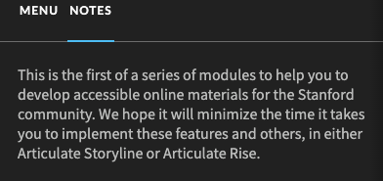 | Turn on the transcript option by going into the player properties option in the toolbar. Check the notes option. The notes section for each slide is where the transcript should be copied. You can copy a clean transcript or captions with a time code. You can then delete the time code. The final transcript in the notes section should be a clean transcript that capture all the audio content on the slide.
Do all graphics with meaningful information have alt text and are decorative images hidden from assistive technologies? | Images are not accessible for people who use screen reading software. It is important to provide a description of meaningful images by using alternative text. Alternative text can also be used to hide decorative images from screen reading software, so it does not distract from the learning content. | A learner with vision loss uses screen reading software to access an alt text description of a meaningful image. | Check that alt text has been included for any images included in a Storyline module. This can be done by selecting the focus order option from the Storyline project toolbar. Meaningful images should have descriptive alt text that includes about 130 characters max. Decorative images should be removed from the focus order. Decorative images should be hidden from assistive technologies.  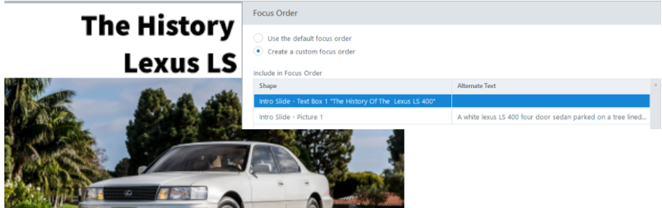 | In Storyline go to the focus order tab in the toolbar. In the focus order pane set it to custom focus order. Remove any decorative items from the focus order pane. In addition, ensure the items are listed in a logical order that matches how they are displayed visually. Include a short description for the key takeaway of meaningful images. The alt text should be about 130 characters max. Image and picture do not need to be written because the screen reading software will convey to the user automatically.
Is the focus order logical and all decorative graphic items removed from the focus order? | Items need to be presented in a logical order so that they are accessible for people who only use the keyboard or people who use screen reading software. This requires the items to be navigated in a logical manner and to be keyboard accessible. | A learner who is a keyboard only user is able to navigate the different buttons in a logical order. | In Storyline go to the focus order tab in the toolbar. Ensure that the focus order matches how the items are displayed visually.  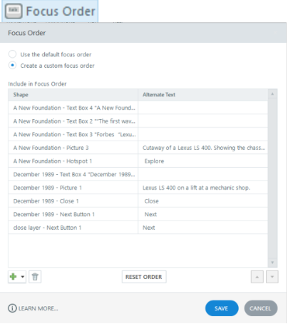 | Open the focus order pane and set a custom focus order. Adjust the items so that they are in the order that they are displayed visually. This should be a logical order.
Does a slide with multiple layers have only the visible layer’s content selectable for people who are using keyboard or screen reading software? | People who use the keyboard and people who use screen reading software benefit from content being navigable in a logical order and only accessing the visible interactive content. When multiple slide layers are used in Storyline it is important to ensure that only the visible layer’s interactive content is focusable for people who use assistive technology or the keyboard to navigate. | A learner who only uses a keyboard is able to navigate a slide with multiple layers and only interacts with the content from each layer when it becomes visible. | In the Storyline project right click on each slide layer and select properties. Confirm that “Prevent the user from clicking on the other slide layers” is checked. “Hide other slide layers” and “Hide objects on the base layer” should also be checked in most circumstances. In the published Storyline module you can also use the keyboard on slides with multiple layers and confirm that only the visible interactive content is selectable. | Right click on each slide layer and select properties. Turn on “Prevent the user from clicking on the other slide layers.” If there are interactive elements on the base layer or other slide layers than “Hide objects on the base layer” and “Hide other slide layers” need to be checked too.
Do all complex graphics have a longer text-based description? | Alternative text is limited to about 130 characters because it cannot be easily navigated when using screen reading software. Sometimes a longer description is needed to covey the meaning of an image. In those cases, a longer description should be included with the image. This makes the content accessible for people who use screen reading software. | A learner using screen reading software selects a “Chart Description” button below an image of a complex chart. The button leads to a new slide layer with a long text-based overview of the key points of the chart. | When there is a complex image that requires alt text longer than 130 characters a text-based description is provided. The text can be added below the image or using a button to trigger a new layer with an additional description.  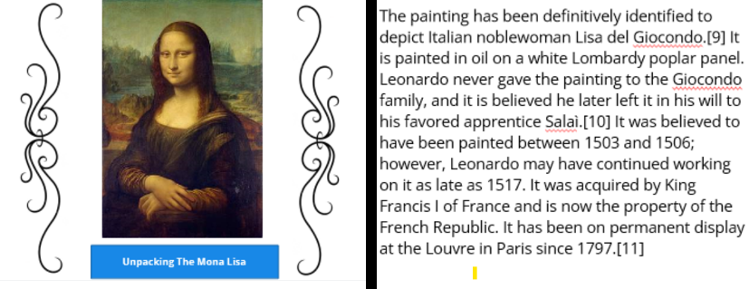 | If the description is longer than 130 characters, a longer text-based description is needed. This can be added below the image. Alternatively, a button can be added below the image that goes to a new layer with text describing the image.
Are documents or websites referenced throughout the course accessible? | Any websites or documents included in the Storyline course needs to be accessible to a wide range of learners too. | A learner using screen reading software opens an accessible Microsoft Word Document accessed from the resources section of the Storyline course. | Use an accessibility checker built into Microsoft Word or Adobe to get a baseline of the accessibility of a document. Automated web accessibility plugins like Site Improve and the Wave Tool provide a baseline for the accessibility of a webpage too. If there is interactive content on the webpage try to access the content using only the keyboard. | It is recommended to create and include Microsoft Word documents because they are more accessible than most PDF files. The Microsoft Accessibility Checker can be used to look for errors. Headings should be created using the styles pane and only use simple tables should be included. Use automated and manual testing to confirm that webpages are accessible.
Is there a designated contact to report an accessibility issue with the course? | It is important that learners with disabilities have someone they can contact when an accessibility barrier is encountered. | A learner with color blindness reports an issue with a chart in a course that uses color alone to display content and receives a quick response and the issue is fixed in a timely manner | Contact information to report an accessibility issue is provided on the course sign up page. It can also be highlighted in one of the first slides of the Storyline course. | Add contact information to report an accessibility issue on the course sign up page. The contact person should understand Storyline accessibility principles. It is also recommended to call out the accessibility contact on an introductory slide in the module.
Is the learner introduced to how to navigate the course and the accessibility features available? | New learners need to understand how to navigate the Storyline course and access accessibility features. This why providing an introductory slide in a Storyline course benefits a wide range of learners. | A learner who is low vision learns from the introductory Storyline slide how to magnify content in the course. | Check that the Storyline course includes an introductory tutorial slide. The tutorial slide should include the accessibility contact’s information. It should also go over navigating, accessing the Storyline content, and accessibility features. | The tutorial should cover going over accessibility features like zoom to fit, accessible text, and keyboard shortcuts. The tutorial should also cover how to access captions and transcripts. This may involve going over different third-party players like Vimeo and YouTube. The menu, glossary and resources sections if included should be covered. Also, the accessibility contact’s information.

