Stanford University Rise Accessibility Checklist Draft
Table 1 Rise Accessibility Compliance Checklist
ITEM TO TEST | WHY DO YOU NEED THIS? | EXAMPLE | HOW TO CHECK | HOW TO IMPLEMENT
Does each slide have text and graphics that are easy to read and has a sufficient color contrast ratio? | A learner with reduced contrast sensitivity reads text with a high color contrast ratio against a decorative background. | A learner with reduced contrast sensitivity reads text with a high color contrast ratio against a decorative background. | Use a color contrast checking program. The following apps are recommended. Each checker has an eyedropper feature that allows you to capture the foreground and background color from the slide. The checker will flag content that does not have a sufficient color contrast ratio.  WebAIM Contrast Checker  Colour Contrast Analyser (CCA)  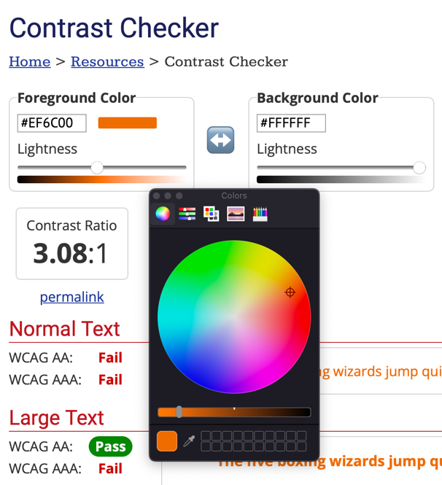 | Before creating course content in Rise check that all the colors being used meet WCAG 2.0 AA Guidelines. Keep in mind that all buttons created in Rise use white text. If you’re using Stanford colors it is recommended to use the. Stanford color contrast chart.
Has color alone been used to convey meaning? | Color alone should not be used to convey meaning or distinguish between items. This is because people with color blindness or vision loss need an alternative way to access the content. | A learner with color blindness can identify a bar chart because it has labels and does not rely on color alone. | Ensure that color alone is not used to convey meaning. For example, do not convey meaning solely through using different colors. This often occurs when people use different colored fonts or graphics to convey meaning. Ensure that there is a label or alternative way of conveying the meaning.  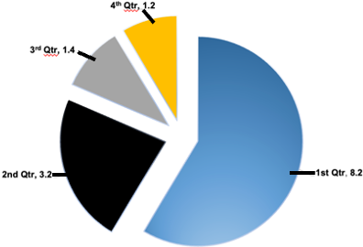 | In Rise avoid using the pie chart block because the labels are only triggered by the mouse. If including a chart or graphic that uses color to convey meaning, ensure that it has labels too. Also, avoid using different colored text alone to convey information.
Is any flashing content limited to less than 3 times per second? | Flashing content can trigger seizures in some learners. This is why flashes of more than 3 times per second should be avoided. | A learner with a seizure disorder accesses a video that does not use flashing content. | Check that blinking or flashing content does not included a lot of fast flashing or blinking content. Avoid flashes or blinking that is more than 3 times per second. | Avoid flashes or blinking that is more than 3 times per second.
Have only accessible interactive elements been used throughout the Rise project? | There are Rise content blocks that are inherently inaccessible to a wide range of users. This includes people who only use the keyboard, people who use screen reading software and people who use other assistive technologies. These Rise blocks should be avoided. | A learner who is using screen reading software encounters a sorting activity and the controls cannot be accessed. | Examine the Rise course and ensure that matching, sorting, and scenario blocks are not used in the course. This also applies to quote and image-based carousels too. These blocks are currently not accessible within the Rise platform. | It is recommended to choose accessible blocks and avoid the matching, sorting and scenarios blocks when creating a Rise course. Use a single quote block and image grid blocks instead of carousels.
Do all included charts provide accessible supports or alternatives? | It is important to ensure that all charts provided are accessible so that they can be accessed by a wide range of users. | A learner using screen reading software accesses a chart and receives an alt text description of the information. An accessible table with the chart’s data is also included. | Ensure that any chart includes an alt text description. If the data is important and being used throughout the course it is recommended that an accessible table with the data should be included.  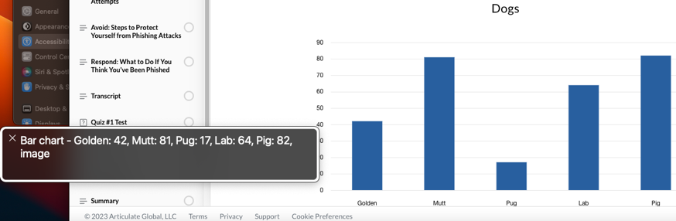 | Use the chart block to create a bar or line chart. Avoid creating a pie chart because it is inaccessible for people with color blindness. The alt text will automatically convey the table type and items the data represents. Do not include item labels because they are not conveyed to the screen reading software. If the data is used throughout the course, it is recommended to create an accessible simple table with the data too. If needed a long description may be included in another layer or below the chart.
Do all tables have programmatic headings, linear layout, and are not used for layout? | Tables need to be accessible to people who use screen reading software. The software needs programmatic headings and a linear structure to convey the table data to the user. Tables used for layout are incompatible with screen reading software. | A learner using screen reading software can access a table and the header row is read when interacting with table data to provide context and navigational support. | Examine the table and confirm that it is not being used for layout purposes. Ensure the table has a programmatic header row. If it is created with Rise, it cannot include merged cells or use a column header.  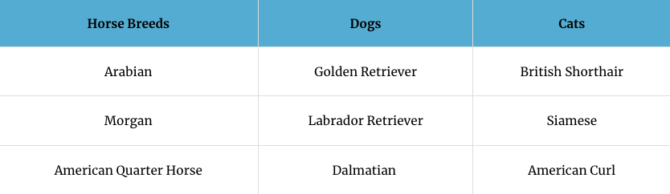 | On Rise the table block is used to create a table. The programmatic heading row should be automatically enabled by default. However, if it is not, you can select a cell and an options pane appears. The H option that appears is for headings. Selecting the H adds a programmatic table row heading. It will appear as the first row for the table. If a complex table is desired it could be created as a webpage and linked to in the Rise course.
Is all embedded content or added content from Storyline accessible in the Rise course? | It is possible to add Storyline content or embedded third party content into a Rise course. The accessibility of this content is variable so it needs to be checked before using it in a Rise course. | A learner with low vision accesses an accessible Storyline presentation that includes accessibility options like zoom to fit to magnify the slides. | First check that the Storyline content has the accessibility functions listed in this document enabled. If the content is accessible as a published Storyline course than import it to Rise. In Rise test that all the functions can be performed used the keyboard. This check should be performed for third-party embedded content too. Also, the Storyline player should have accessibility features available in the Rise page. | It is recommended to avoid adding Storyline or external third-party content to a Rise page because it increases the risk of accessibility issues. Also, the more complex the embedded content or Storyline project the more likely accessibility issues will occur. An accessible Storyline project with slides can be added to Rise and will be accessible. Storyline and third party embedded content depend on the use case.
Do all buttons and hyperlinks include descriptive text that convey their function and destination? | Buttons and hyperlinks need to accurately describe their function and be presented in a logical order. This information helps a wide range of users understand how to navigate the content. The description needs to be accessible so that people using assistive technology like screen reading software can access it too. | A learner using screen reading software selects a button called “How an MRI works” and the screen reader states “Button, how an MRI works” | Buttons created in Rise should include a name that describes their function. Hyperlinks should not use the full URL in their name. The link name should describe the landing page of the website. Avoid using undescriptive names like “Click Here” or “Read More.” Also repeated buttons or links with the same name should be avoided because they can be difficult to navigate for people who use screen reading software.  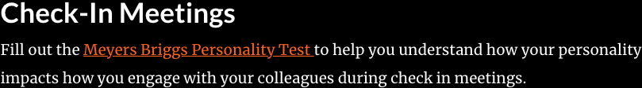 | Buttons and hyperlinks should have a descriptive name. Buttons should have a name that describes their function. Links should have a name that describes the landing page in about 3-5 words. This usually can be done by copying the title of the landing webpage.
Are any labeled graphic blocks accessible? | Labeled graphic blocks need to present each item in a logical order that matches how they are displayed visually. Alt text should be added for any meaningful images. The text and images should fit inside of the smaller item window without the need to scroll. This ensures that the content is accessible to people with low vision who use screen reading software and people who use only the keyboard. | A person with low vision uses screen reading software to access an item in a labeled graphic in a Rise course. The content fits inside the smaller window and is not cutoff. | Use the keyboard to tab through the items in the labeled graphic. The items should be navigated in a logical order matching how they are displayed visually. The smaller item window should fit all the content without the need to scroll. Check that alt text has been added for any meaningful images. Double quotation marks (“”) should be used to hide any decorative images in an item. 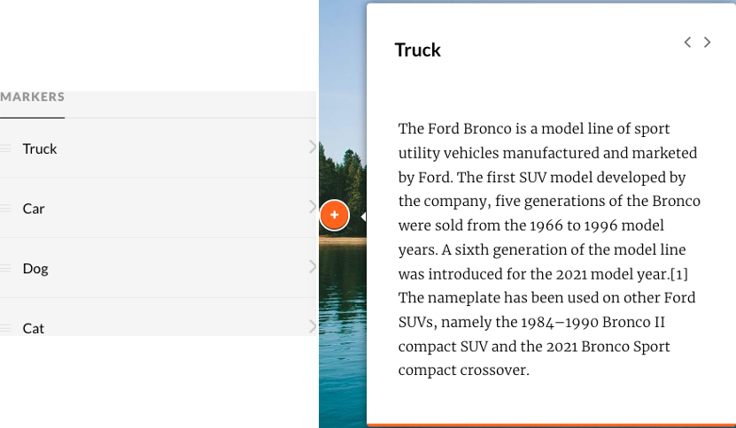 | Rearrange the markers for the labeled graphic to ensure that each item is in the order it is presented visually. Ensure that the content fits within each item’s smaller window. Add alt text for meaningful images and use the double quotation marks (“”) to hide decorative items.
Do all knowledge check blocks, and third-party quiz questions include content that is presented in a logical order and can be completed using only the keyboard or assistive technologies? | Rise knowledge check blocks and third-party quiz questions need to be accessible to a wide range of users. This includes people who only use the keyboard or people who use assistive technologies. | A learner who uses screen reading software can select the appropriate answer for a multiple-choice quiz question. | Rise knowledge check blocks including multiple choice, multiple response, fill in the blank, and draw from a question bank should be inherently accessible. Each interactive item should include a unique name and meaningful images should include alt text description. Check that any additional interactive quiz items can be navigated using the keyboard in a logical manner. Interactive items should also be selectable using only the keyboard and any feedback provided should be compatible with screen reading software.  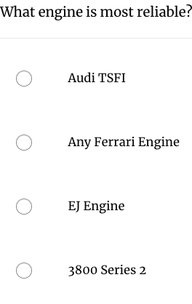 | The Rise matching blocks are inaccessible and should be avoided. Other knowledge check blocks including multiple choice, multiple response, fill in the blank, and draw from a question bank can be accessible. Each interactive item needs to include a unique name and meaningful images must include alt text description. Before adding any third-party quiz content check that the content is accessible and can be accessed using only the keyboard or screen reading software.
Are there no images of text used throughout the course? | Images of text are not accessible for people who use text to speech or screen reading software. | A learner with vision loss magnifies text to 500% and the text does not pixelate. | Select text on a couple slides throughout the course and confirm that individual characters can be selected.  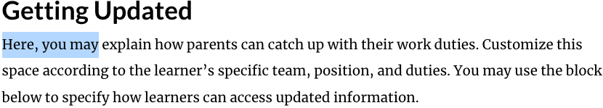 | Use the text block to add text throughout the course.
Are only high-quality meaningful images used that can be magnified to at least 200% without pixelation? | Meaningful images should be high quality and not pixelate when magnified to at least 200%. This supports learners with low vision who may need to magnify meaningful images to read the content. | A learner with low vision magnifies an image of a cell to 200% and it does not pixelate. | Open the Rise page and select the view option from the web browser. There should be an option to Zoom. Zoom to 200% and then examine the images for pixelation. The images should not pixelate and what they represent should remain clear despite the magnification. | Add high quality images to your Rise page that do not pixelate when magnified to 200%.
Are all lists in the course programmatic lists? | Programmatic lists are compatible with screen reading software. They provide people who use screen reading software information regarding the number of items and make it easier to interact with the content. This information is not conveyed when lists are manually created by using special characters or inputting numbers. | A learner using screen reading software interacts with a list and the screen reader conveys that it is a list and the number of items. | Use the bulleted or numbered options in the home toolbar to create listed content. Avoid manually creating the list by using special characters or manually inputting 1, 2, 3.  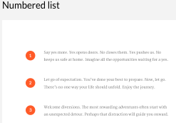 | Use the list block to create lists. Avoid using text blocks and manually creating lists with bullets or numbers. When using text blocks select the ordered or unordered list options.
Are “Heading Labels” set so that content is structured among all pages? | Stylized text that breaks up a Rise page into different sections visually will not convey that information to people who use screen reading software. This is why programmatic headings are needed. They make it easier for people to navigate the different sections of a Rise page. | A learner with vision loss uses screen reading software to access the different programmatic headings of a Ruse page to skip to a desired section. | Check that the Rise page has a unique name, which will be the heading level 1. Check that sections on the page are being created using the heading, heading with paragraph, subheading, accordion, and chart block options. Ensure that non programmatic headings using stylized text blocks are not used.  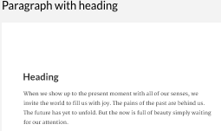 | Use headings to structure the content on your Rise page. The name of the Rise page is automatically designated the heading level 1. There should only be one heading level 1 per Rise page. Heading level 2 blocks are created when using the heading, heading with paragraph, accordion, and chart block options. A heading level 3 can be made by using the subheading block. Create a Rise page with a logical structure that matches the visual sections of the page.
Does each Rise page have a unique name? | Each Rise page needs a unique name because it can make it difficult for people who screen reading software to navigate and know where they are in the menu. Below is an example from the screen reading software VoiceOver. | A learner with vision loss uses screen reading software to differentiate between the menu options because each one has a unique name. | Check that each Rise page on the home screen has a unique name.  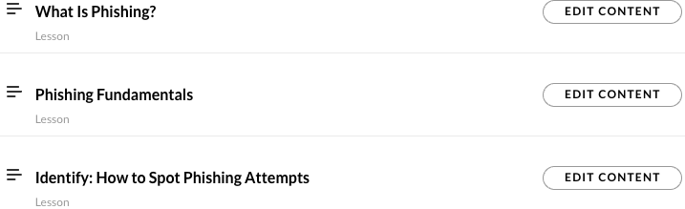 | Each Rise course page should have a unique name. Select the name of the page to change the title.
Do all screens with spoken audio have closed captions? | Captions support people with hearing loss but also can be beneficial for a wide range of learners. This can include people with ADHD, autism, or people with auditory processing disorder. | A learner with auditory processing disorder enables captions for a video to help with comprehension. | Audio only Rise blocks should not be used. All video content should include a CC button icon. Play the video and confirm that the captions are accurate and in sync with the video content.  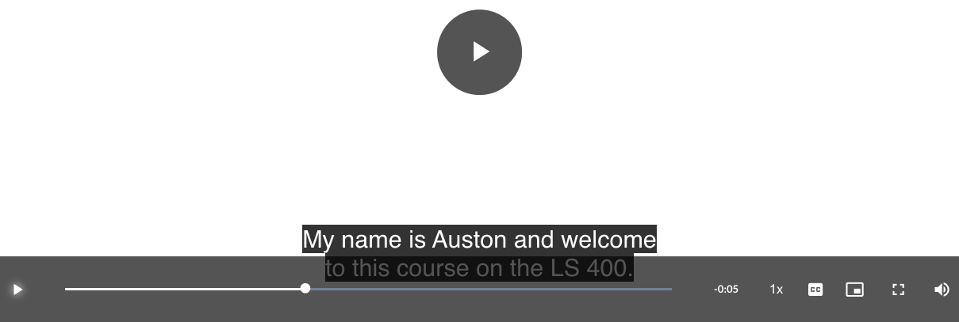 | Adding closed captions to Rise requires a VTT file. Adobe Premiere only provides an SRT file. This can be converted by uploading an SRT captions file to YouTube. YouTube will convert the file to VTT and makes that an option, which you can download. Captioning vendors usually provide a VTT option too. SRT files can be added to embedded videos hosted on Vimeo or YouTube. Audio only files need to be converted to a video to be able to add captions.
Does all video/audio content have audio descriptions? | Audio description makes visual content accessible to people with vision loss. Narration conveys important visual information to the user. | A learner who has vision loss accesses a video that includes audio descriptions of the visual content. | Audio description is included in the video as part of the narration. The description should be conveyed in a different tone by the narrator or a different voice. The audio description is not needed if it is just talking head content. The audio description becomes necessary when important visual information is included. | There are two ways to implement descriptive audio descriptions in Rise. It is possible to add a single video that includes integrated audio descriptions. Another option is to present two videos on a Rise page. One with captions and one with audio description. A separate video with extended audio descriptions, can be easier when there is a lot of visual content. The video can pause to provide additional time for the description to be read. Audio description needs to be synced to the video
Are there transcripts for all spoken language in the course? | Transcripts make audio content accessible for a wide range of learners. They make it possible for people who use screen reading software to reference audio content. They also support people with hearing loss by providing untimed text content. Transcripts can be useful for quickly referencing information as well. | A learner with hearing loss references the transcript of a video. | Check that each video on a Rise page provides access to a transcript. The transcript should not include any time code information.  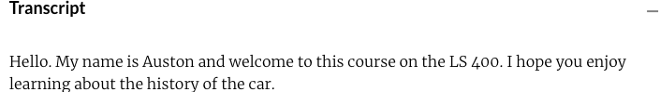 | A transcript can be added to an accordion block or a paragraph with heading block. It is important to remove all the time code information. The transcript should only include text of the audio content.
Do all graphics with meaningful information have alt text and are decorative images hidden from assistive technologies? | Images are not accessible for people who use screen reading software. It is important to provide a description of meaningful images by using alternative text. Alternative text can also be used to hide decorative images from screen reading software so it does not distract from the learning content. | A learner with vision loss uses screen reading software to access an alt text description of a meaningful image. | Check that alt text has been included for any images included in a Rise course. Meaningful images should have descriptive alt text that includes about 130 characters max. Decorative images should have alt text that includes (“”), two quotation marks, to hide decorative images from assistive technologies.  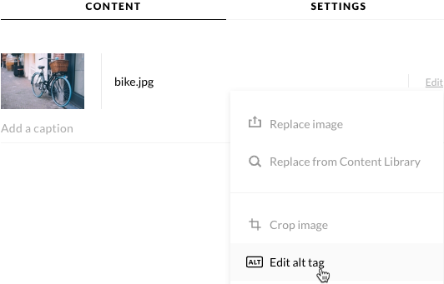 | Ensure that images included in Rise have alternative text. Rise blocks that include an image have an alt text option in the edit options. Include a short description for the key takeaway of meaningful images. The alt text should be about 130 characters max. Image and picture do not need to be written because the screen reading software will convey to the user automatically. If the image is decorative and not meaningful it can be hidden from screen reading software by including (“”) in the alt tag.
Do all complex graphics have a longer text-based description? | Alternative text is limited to about 130 characters because it cannot be easily navigated when using screen reading software. Sometimes a longer description is needed to covey the meaning of an image. In those cases, a longer description should be included with the image. This makes the content accessible for people who use screen reading software. | A learner using screen reading software selects a “Image Description” accordion block in a Rise course. The accordion reveals a longer text-based description highlighting the key points of the graphic. | When there is a complex image that requires alt text longer than 130 characters a text-based description is provided. The text can be added using the accordion or paragraph with heading blocks in Rise. It should highlight the key points that the image is conveying visually.  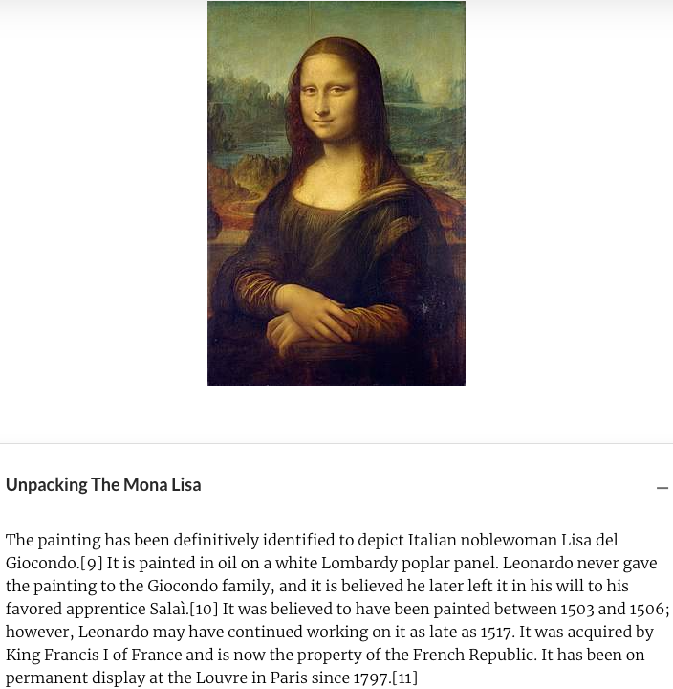 | Use an accordion block or paragraph with heading to add a longer text-based description to a complex image.
Are documents or websites referenced throughout the course accessible? | Any websites or documents included in the Rise course need to be accessible to a wide range of learners too. | A learner using screen reading software opens an accessible Microsoft Word Document downloaded from a Rise course. | Use an accessibility checker built into Microsoft Word or Adobe to get a baseline of the accessibility of a document. Automated web accessibility plugins like Site Improve and the Wave Tool provide a baseline for the accessibility of a webpage too. If there is interactive content on the webpage try to access the content using only the keyboard. | It is recommended to create and include Microsoft Word documents because they are more accessible than most PDF files. The Microsoft Accessibility Checker can be used to look for errors. Headings should be created using the styles pane and only use simple tables should be included. Use automated and manual testing to confirm that webpages are accessible.
Is there a designated contact to report an accessibility issue with the course? | It is important that learners with disabilities have someone they can contact when an accessibility barrier is encountered. | A learner with color blindness reports an issue with a chart in a course that uses color alone to display content and receives a quick response and the issue is fixed in a timely manner | Contact information to report an accessibility issue is provided on the course sign up page. It can also be highlighted in one of the first pages of the Rise course. | Add contact information to report an accessibility issue on the course sign up page. The contact person should understand Rise accessibility principles. It is also recommended to call out the accessibility contact on a page in the module.
Is the learner introduced to how to navigate the course and the accessibility features available? | New learners need to understand how to navigate the Rise course and access accessibility features. This why providing an introductory page in Rise benefits a wide range of learners. | A learner who is low vision learns from the introductory Rise page how to magnify images in the course. | Check that the Rise course includes an introductory tutorial page. The tutorial page should include the accessibility contact’s information. It should also go over navigating the Rise course and how to accessibility features. These accessibility features include magnifying images and using browser zoom to magnify content. Also, an overview of how to access captions and transcripts. | The tutorial should cover how to navigate the Rise course, magnify images, use browser zoom and access captions and transcripts for any included videos. The tutorial page should reference who to contact if there is an accessibility barrier is encountered. The tutorial should also link to Read & Write, which is text to speech software provided for free to members of the Stanford community.

