Admissions Accepted
Audit Report

Contents
Contents 2
Executive Summary 4
Background 4
Summary of the results 4
Overview of the results 6
About the testing 6
How to interpret the errors 7
Technical Content 9
Overview 9
Breakdown of errors 9
Coding Accessibility Errors 10
1. Moving or scrolling content cannot be stopped, hidden or paused 10
2. HTML is invalid 11
3. Asterisks and/or superscripts have been used instead of links 15
4. The site contains empty links 17
5. Deprecated features (elements and/or attributes) have been used 20
6. Foreign language in the page content has not been marked up with the LANG attribute 22
7. Some links are broken 23
Style Sheets Accessibility Errors 24
8. Visual order of columns does not match order of content with style sheets disabled 24
9. Some features do not work with style sheets disabled 25
Calendar Accessibility Errors 27
10. Calendar uses color alone and/or shading alone and/or shape alone to convey information 27
11. Calendar uses non-standard ASCII characters alone to convey information 27
12. Calendar does not have a highly visible keyboard focus indicator 28
Slideshow Accessibility Errors 30
13. Slideshow does not have a highly visible keyboard focus indicator 30
Table Accessibility Errors 32
14. Data tables do not have a SUMMARY attribute 32
15. Data table SUMMARY is not descriptive or sufficient 35
Link Accessibility Errors 38
16. Links are distinguished with color alone and/or shading alone 38
17. Links do not have a highly visible keyboard focus indicator 38
18. Color contrast between the background and the link text is not sufficient 40
Heading Accessibility Errors 42
19. Heading has not been coded with H1, H2 etc 42
20. Heading element is empty 42
General Content 44
Overview 44
Breakdown of errors 44
Images Accessibility Errors 45
21. Some images do not have descriptive ALT attributes 45
22. Some images have incorrect ALT attributes ('image' / 'graphic' / 'photo') 45
Download Alternatives Accessibility Errors 48
23. PDFs are not tagged correctly 48
Link Accessibility Errors 50
24. Link text is not clear 50
Heading Accessibility Errors 52
25. Heading has not been coded with H1, H2 etc 52
26. Headings have not been nested properly 53
Content Accessibility Errors 55
27. References to visual location and/or shape alone have been used to convey information 55
28. Text refers to device-dependent handlers 56
Appendix: Groups 58
Group 1 58
Group 2 58
Group 3 59
Contacts 60
Gian Wild, CEO 60

Executive Summary

Background
AccessibilityOz conducted a general and technical accessibility audit of the Admissions Accepted web site (http://miamioh.edu/admission/accepted/) by AccessibilityOz, in January 2017.
A combination of manual and automated testing was conducted. The site was tested against the W3C Web Content Accessibility Guidelines, Version 2.0, Level AA. The Australian Human Rights Commission requires that Australian web sites comply with this version and level by December 2014. A snapshot of the site was taken on the 20th January 2017, and this version of the site was tested. Changes to the site since that date may mean that some errors are no longer relevant, or that new errors have been introduced into the site.
Testing of the Admissions Accepted site was broken into three sections: template errors, technical content errors and general content errors. For more information see Breakdown of errors into three reports on page 12. This report contains the errors found in the Technical Content and General Content only.

Summary of the results
In total, 28 types of error were identified in the site, consisting of:
- 22 Level A types of error, consisting of:
- 14 errors in Technical Content
- 8 errors in General Content
- 6 Level AA types of error, all occurring in Technical Content.
Of these errors:
- 1 are considered Critical impact, occurring in Technical Content
- 14 are considered High impact, consisting of:
- 11 errors in Technical Content
- 3 errors in General Content
- 4 are considered Medium impact, consisting of:
- 2 errors in Technical Content
- 2 errors in General Content
- 9 are considered Low impact, consisting of:
- 6 errors in Technical Content
- 3 errors in General Content
Critical errors mean that there will be some groups of people with disabilities who are not able to use the site or a section of the site at all.
High impact errors mean that that the issue could significantly interfere with a person’s use of the site.
Errors with an Impact of Medium will increase the amount of time a person with a disability takes to complete a task.
Errors with an Impact of Low require correction to fully conform with WCAG 2.1.

Testing results by Category

Technical Content
Category | Pass | Fail | Critical | High | Medium | Low
Coding | 32 | 7 | 1 | 2 | 1 | 3
Style Sheets | 6 | 2 | 0 | 2 | 0 | 0
Calendar | 12 | 3 | 0 | 2 | 0 | 1
Slideshow | 16 | 1 | 0 | 1 | 0 | 0
Table | 8 | 2 | 0 | 0 | 1 | 1
Links | 13 | 3 | 0 | 3 | 0 | 0
Headings | 12 | 2 | 0 | 1 | 0 | 1

General Content
Category | Pass | Fail | Critical | High | Medium | Low
Images | 11 | 2 | 0 | 1 | 0 | 1
Download Alternatives | 11 | 1 | 0 | 0 | 0 | 1
Links | 15 | 1 | 0 | 0 | 1 | 0
Headings | 12 | 2 | 0 | 1 | 1 | 0
Content | 15 | 2 | 0 | 1 | 0 | 1

Categories that are not applicable to this report
- Navigation
- Forms
- Page titles
- Social Media Alternatives
- Videos
- Audio
- Image Galleries
- Interactive Features
- Interactive Maps
- Magazines
- Slideshows

Overview of the results
In general, the Admissions Accepted site is very accessible, with minor technical and general content errors.

Technical Content
Of most concern is the countdown on the homepage which cannot be paused by the user. This is a violation of one of the Non-Interference Clauses of WCAG2, and must be fixed as soon as possible.
Of secondary concern is that there are three different slideshows on the site:
- Slideshows with white arrows - http://miamioh.edu/admission/accepted/index.html
- Slideshows with green arrows - http://miamioh.edu/admission/accepted/transfer/index.html
- Slideshow with red arrows - http://miamioh.edu/admission/accepted/fall/confirm/index.html
The latter – the slideshow with red arrows – was deemed to be the most accessible and was tested in this document. The calendar feature was mostly accessible, with some changes required regarding the use of color, non-standard ASCII characters and additional keyboard focus indicator. In most cases tables were coded accessibly, however some were missing SUMMARY attributes and in some cases these SUMMARY attributes were not descriptive enough. Links within the site need a more highly visible keyboard focus indicator and should be underlined when in the main body content of the the site. Link color contrast was not sufficient.

General Content
The general content of the Admissions Accepted web site is very accessible, with some minor issues around images, link text and references to visual location or the word “click”. Some headings have not been coded or nested properly but this is easily fixed. PDFs were tagged, however the reading order was often incorrect.

About the testing
AccessibilityOz break up the auditing process into three distinct sections:
- template section of the site;
- general content (for your content authors); and
- technical content (for your developers).
In the following screenshot:
- template content is outlined in green
- content section is highlighted in blue
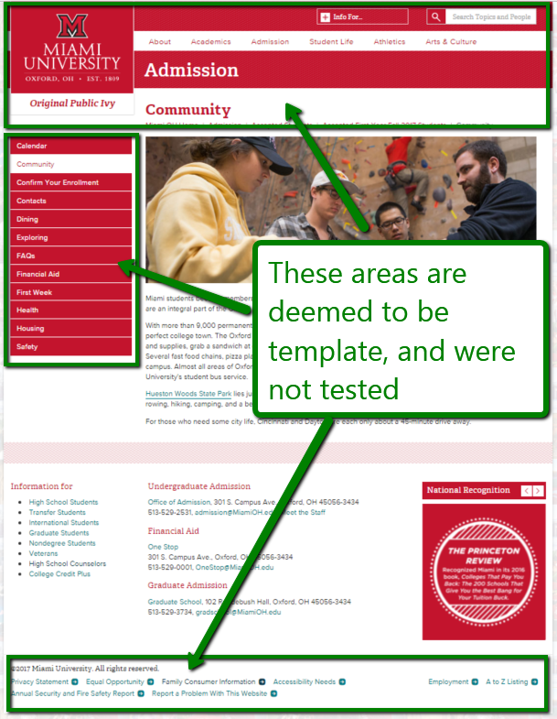 | 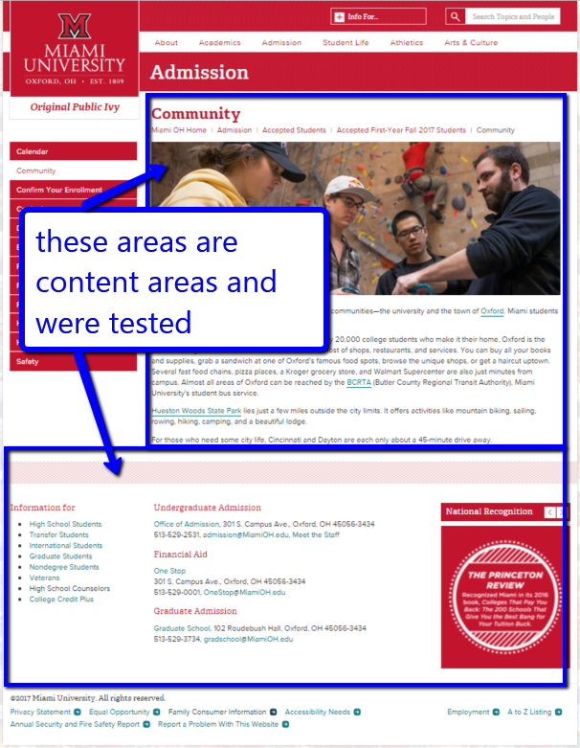
Results of testing the content section is provided in two sections:
- Technical content for CMS and web developers from page 12.
- General content for content authors from page 60.

How to interpret the errors
All the types of errors identified in this document and the associated Fix Lists need to be addressed to comply with the Web Content Accessibility Guidelines, Version 2.0, Level AA.

Error number
This is the number of the particular type of error. Types of errors are numbered sequentially.

WCAG2 SC
The SC indicates the relevant success criterion under WCAG2 that the type of error applies to. The number and the name of the success criterion is included. The success criterion links to relevant definitions in WCAG2.

Occurrence
The relative occurrence of the type of error is noted. For example whether the error occurs on most or all pages. In most cases a fix list is referenced which lists every location of that type of error in the site.

Impact
The Impact of each type of error is included. Critical errors interfere with the ability of some people with disabilities to use the site at all. Errors with a priority of High mean that there will be some groups of people with disabilities who are not able to use the site or a section of the site. Errors with the priority of Medium or Low require correction as they will assist, greatly, people with disabilities to use the site and its associated functionality.

OzWiki
This is a link to the relevant OzWiki error. OzWiki is AccessibilityOz’ database of accessibility errors and solutions.

Error
A brief description of the type of error is included.

Example(s)
An example is provided. In some cases, where multiple errors have occurred and they are sufficiently different to one another, a number of examples have been included.

URL
This is the URL of the example type of error.

Screenshot
This is a screen shot of the example type of error.

Code
This is the actual code of the example type of error. Please note that the Code is not always provided in the examples.

Solution
This is the relevant solution to the type of error.

Technical Content

Overview
Of most concern is the countdown on the homepage which cannot be paused by the user. This is a violation of one of the Non-Interference Clauses of WCAG2, and must be fixed as soon as possible.
Of secondary concern is that there are three different slideshows on the site:
- Slideshows with white arrows - http://miamioh.edu/admission/accepted/index.html
- Slideshows with green arrows - http://miamioh.edu/admission/accepted/transfer/index.html
- Slideshow with red arrows - http://miamioh.edu/admission/accepted/fall/confirm/index.html
The latter – the slideshow with red arrows – was deemed to be the most accessible and was tested in this document. The calendar feature was mostly accessible, with some changes required regarding the use of color, non-standard ASCII characters and additional keyboard focus indicator. In most cases tables were coded accessibly, however some were missing SUMMARY attributes and in some cases these SUMMARY attributes were not descriptive enough. Links within the site need a more highly visible keyboard focus indicator and should be underlined when in the main body content of the the site. Link color contrast was not sufficient.

Breakdown of errors
Technical Content errors are organized by the following categories:
- Coding Accessibility Errors on page 9;
- Style Sheets Accessibility Errors on page 23;
- Calendar Accessibility Errors on page 26;
- Slideshow Accessibility Errors on page 29;
- Table Accessibility Errors on page 31;
- Link Accessibility Errors on page 39; and
- Heading Accessibility Errors on page 43.

Coding Accessibility Errors

Moving or scrolling content cannot be stopped, hidden or paused
WCAG2  SC 2.2.2 | Pause, Stop, Hide  http://www.w3.org/TR/UNDERSTANDING-WCAG20/time-limits-pause.html
WCAG2 Level: | A
Impact: | Critical
OzWiki: | See OzWiki — Moving or scrolling content cannot be stopped, hidden or paused OR does not stop after five seconds
Occurrence: | See example(s)

Error
Moving or scrolling content cannot be paused or stopped by the user.

Example
URL: | http://miamioh.edu/admission/accepted/fall/index.html
Screenshot | 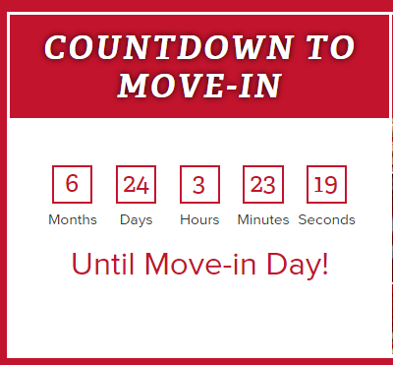

Solution
Ensure there is a mechanism to pause or stop the movement of content. This mechanism should be available to mouse, keyboard and touch users.

HTML is invalid
WCAG2  SC 4.1.1 | Parsing  http://www.w3.org/TR/UNDERSTANDING-WCAG20/ensure-compat-parses.html
WCAG2 Level: | A
Impact: | High
OzWiki: | See OzWiki — HTML is invalid
Occurrence: | See example(s)

Error
HTML does not conform to the declared DOCTYPE.

Example(s)

Example 1
URL: | http://miamioh.edu/admission/accepted/transfer/calendar/index.html
Code: | Line: 506  Character: 960  Error: An element with role=menuitem must be contained in, or owned by, an element with role=menu or role=menubar.

Example 2
URL: | http://miamioh.edu/admission/accepted/fall/make-it-miami/index.html
Code: | Line: 460  Character: 100  Error: Attribute a not allowed on element a at this point.

Example 3
URL: | http://miamioh.edu/admission/accepted/spring/community/index.html
Code: | Line: 388  Character: 91  Error: Attribute value not allowed on element a at this point.

Example 4
URL: | http://miamioh.edu/admission/accepted/fall/confirm/index.html
Code: | Line: 27  Character: 32  Error: Bad value for attribute href on element link: Must be non-empty.

Example 5
URL: | http://miamioh.edu/admission/accepted/index.html
Code: | Line: 215  Character: 188  Error: Bad value 100% for attribute width on element img: Expected a digit but saw % instead.

Example 6
URL: | http://miamioh.edu/admission/accepted/spring/community/index.html
Code: | Line: 347  Character: 6  Error: Bad value http://miamioh.edu/_files/images/homepage/recognition/national recognition-04.jpg for attribute src on element img: Illegal character in path segment: space is not allowed.

Example 7
URL: | http://miamioh.edu/admission/accepted/fall/first-week/
Code: | Line: 139  Character: 84  Error: Discarding unrecognized token col-sm-12 from value of attribute role. Browsers ignore any token that is not a defined ARIA non-abstract role.

Example 8
URL: | http://miamioh.edu/admission/accepted/spring/community/index.html
Code: | Line: 369  Character: 187  Error: Duplicate ID pageContact.

Example 9
URL: | http://miamioh.edu/admission/accepted/transfer/financial-aid/index.html
Code: | Line: 228  Character: 186  Error: Duplicate ID pageLevelNavigation.

Example 10
URL: | http://miamioh.edu/admission/accepted/fall/first-week/
Code: | Line: 95  Character: 5  Error: Element div not allowed as child of element hgroup in this context. (Suppressing further errors from this subtree.)

Example 11
URL: | http://miamioh.edu/admission/accepted/fall/dining/
Code: | Line: 97  Character: 15  Error: Element hgroup is missing a required instance of one or more of the following child elements: h1, h2, h3, h4, h5, h6.

Example 12
URL: | http://miamioh.edu/admission/accepted/fall/dining/
Code: | Line: 102  Character: 87  Error: Element input is missing required attribute alt.

Example 13
URL: | http://miamioh.edu/admission/accepted/spring/community/index.html
Code: | Line: 145  Character: 10349  Error: Self-closing syntax (/&amp;gt;) used on a non-void HTML element. Ignoring the slash and treating as a start tag.

Example 14
URL: | http://miamioh.edu/admission/accepted/transfer/calendar/index.html
Code: | Line: 211  Character: 110  Error: The align attribute on the table element is obsolete. Use CSS instead.

Example 15
URL: | http://miamioh.edu/admission/accepted/transfer/calendar/index.html
Code: | Line: 211  Character: 110  Error: The border attribute on the table element is obsolete. Use CSS instead.

Example 16
URL: | http://miamioh.edu/admission/accepted/transfer/calendar/index.html
Code: | Line: 211  Character: 110  Error: The cellpadding attribute on the table element is obsolete. Use CSS instead.

Example 17
URL: | http://miamioh.edu/admission/accepted/transfer/contacts/index.html
Code: | Line: 220  Character: 71  Error: The cellspacing attribute on the table element is obsolete. Use CSS instead.

Example 18
URL: | http://miamioh.edu/admission/accepted/fall/dining/
Code: | Line: 375  Character: 44  Error: The element header must not appear as a descendant of the footer element.

Example 19
URL: | http://miamioh.edu/admission/accepted/fall/make-it-miami/index.html
Code: | Line: 426  Character: 72  Error: The summary attribute on the table element is obsolete. Consider describing the structure of the table in a caption element or in a figure element containing the table; or, simplify the structure of the table so that no description is needed.

Example 20
URL: | http://miamioh.edu/admission/accepted/fall/calendar/index.html
Code: | Line: 312  Character: 16  Error: The width attribute on the td element is obsolete. Use CSS instead.

Solution
Ensure HTML is valid.

Asterisks and/or superscripts have been used instead of links
WCAG2  SC 1.3.1 | Info and Relationships  http://www.w3.org/TR/UNDERSTANDING-WCAG20/content-structure-separation-programmatic.html
WCAG2 Level: | A
Impact: | Low
OzWiki: | See OzWiki — Asterisks and/or superscripts have been used instead of links
Occurrence: | See example(s)

Error
Asterisks have been used to refer to content further down the page.

Example(s)

Example 1: Asterisks and hashes
URL: | http://miamioh.edu/admission/accepted/transfer/faq/index.html
Screenshot | 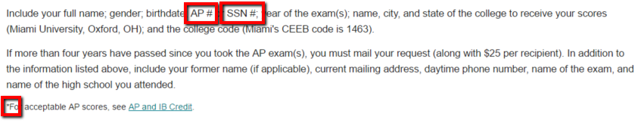

Example 2
URL: | http://miamioh.edu/admission/accepted/fall/confirm/index.html
Screenshot | 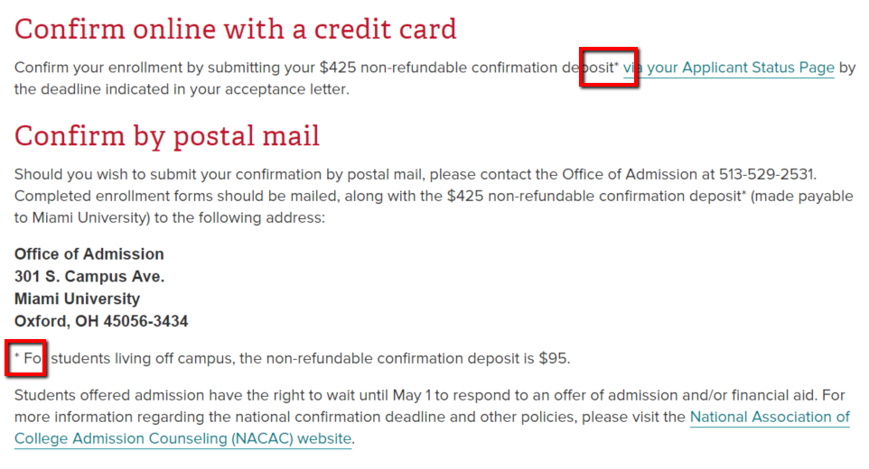

Example 3
URL: | http://miamioh.edu/admission/accepted/spring/confirm/index.html
Screenshot | 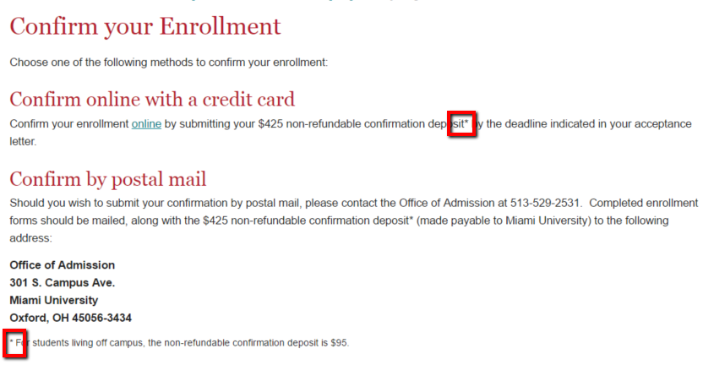

Solution
Ensure these asterisks are replaced with anchor links.

The site contains empty links
WCAG2  SC 1.3.1 | Info and Relationships  http://www.w3.org/TR/UNDERSTANDING-WCAG20/content-structure-separation-programmatic.html
WCAG2 Level: | A
Impact: | Low
OzWiki: | See OzWiki — The site contains empty links
Occurrence: | See example(s)

Error
The site contains empty links.

Example(s)

Example 1
URL: | http://miamioh.edu/admission/accepted/index.html
Code: | <a href=“/index.html”><h3 class=“siteLogo”></h3></a>
Occurrence: | Group 1

Example 2
URL: | http://miamioh.edu/admission/accepted/index.html
Code: | <a href=“#”> </a>
Occurrence: | Group 1

Example 3
URL: | http://miamioh.edu/admission/accepted/index.html
Code: | <a class=“wholeBox” href=“fall/index.html”>&amp;nbsp;</a>

Example 4
URL: | http://miamioh.edu/admission/accepted/index.html
Code: | <a class=“wholeBox” href=“spring/index.html”>&amp;nbsp;</a>

Example 5
URL: | http://miamioh.edu/admission/accepted/transfer/confirm/index.html
Code: | <a href=“https://www.hdg.muohio.edu/housingcontract/”></a>

Example 6
URL: | http://miamioh.edu/admission/accepted/spring/index.html
Code: | <a href=“http://miamioh.edu/emergency#emergencyContacts”></a>
Occurrence: | Group 2

Example 7
URL: | http://miamioh.edu/admission/accepted/spring/index.html
Code: | <a href=“tel:513-217-8862” target=“_blank” value=“+15132178862”><br /></a>
Occurrence: | Group 2

Example 8
URL: | http://miamioh.edu/admission/accepted/spring/index.html
Code: | <a href=“mailto:voalc@MiamiOH.edu”></a>
Occurrence: | Group 2

Example 9
URL: | http://miamioh.edu/admission/accepted/fall/index.html
Code: | <a class=“wholeBox” href=“http://miamioh.edu/student-life/orientation-and-transition/first-year-students/summer-orientation/placement-tests/index.html”>&amp;nbsp;</a>
Occurrence: | http://miamioh.edu/admission/accepted/fall/index.html  http://miamioh.edu/admission/accepted/fall/

Example 10
URL: | http://miamioh.edu/admission/accepted/fall/index.html
Code: | <a class=“wholeBox” href=“http://miamioh.edu/student-life/orientation-and-transition/first-year-students/summer-orientation/index.html”>&amp;nbsp;</a>
Occurrence: | http://miamioh.edu/admission/accepted/fall/index.html  http://miamioh.edu/admission/accepted/fall/

Example 11
URL: | http://miamioh.edu/admission/accepted/fall/index.html
Code: | <a class=“wholeBox” href=“https://shsportal.miamioh.edu/PyramedPortal/Account/Logon?ReturnUrl=/PyramedPortal/”>&amp;nbsp;</a>
Occurrence: | http://miamioh.edu/admission/accepted/fall/index.html  http://miamioh.edu/admission/accepted/fall/

Example 12
URL: | http://miamioh.edu/admission/accepted/fall/index.html
Code: | <a class=“wholeBox” href=“https://www.hdg.muohio.edu/Code/MyCard/IncomingStudentContract/”>&amp;nbsp;</a>
Occurrence: | http://miamioh.edu/admission/accepted/fall/index.html  http://miamioh.edu/admission/accepted/fall/

Example 13
URL: | http://miamioh.edu/admission/accepted/fall/index.html
Code: | <a class=“wholeBox” href=“http://miamioh.edu/admission/accepted/fall/confirm/index.html”>&amp;nbsp;</a>
Occurrence: | http://miamioh.edu/admission/accepted/fall/index.html  http://miamioh.edu/admission/accepted/fall/

Example 14
URL: | http://miamioh.edu/admission/accepted/index.html
Code: | <a href=“mailto:gradschool@miamioh.edu”></a>
Occurrence: | Group 1

Example 15
URL: | http://miamioh.edu/admission/accepted/index.html
Code: | <a href=“http://www.miamioh.edu/onestop”><br /></a>
Occurrence: | Group 1

Example 16
URL: | http://miamioh.edu/admission/accepted/index.html
Code: | <a href=“http://www.miamioh.edu/admission/index.html”></a>
Occurrence: | Group 1

Example 17
URL: | http://miamioh.edu/admission/accepted/index.html
Code: | <a class=“wholeBox” href=“transfer/index.html”>&amp;nbsp;</a>

Solution
Remove these empty links.

Deprecated features (elements and/or attributes) have been used
WCAG2  SC 1.3.1 | Info and Relationships  http://www.w3.org/TR/UNDERSTANDING-WCAG20/content-structure-separation-programmatic.html
WCAG2 Level: | A
Impact: | Low
OzWiki: | See OzWiki — Deprecated features (elements and/or attributes) have been used
Occurrence: | See example(s)

Error
Deprecated features (elements and/or attributes) have been used instead of references to the external style sheet.

Example(s)

Example 1: table (align)
URL: | http://miamioh.edu/admission/accepted/transfer/calendar/index.html
Code: | <table align=“center” border=“0” cellpadding=“0” cellspacing=“0” style=“width: 100%;”>

Example 2: table (border)
URL: | http://miamioh.edu/admission/accepted/spring/contacts/index.html
Code: | <table border=“0” cellpadding=“0” cellspacing=“0” style=“width: 100%;” summary=“Table of contacts for accepted spring students.”>

Example 3: table (cellpadding)
URL: | http://miamioh.edu/admission/accepted/spring/contacts/index.html
Code: | <table border=“0” cellpadding=“0” cellspacing=“0” style=“width: 100%;” summary=“Table of contacts for accepted spring students.”>

Example 4: table (cellspacing)
URL: | http://miamioh.edu/admission/accepted/spring/contacts/index.html
Code: | <table border=“0” cellpadding=“0” cellspacing=“0” style=“width: 100%;” summary=“Table of contacts for accepted spring students.”>

Example 5: td (width)
URL: | http://miamioh.edu/admission/accepted/fall/calendar/index.html
Code: | <td width=“70%”>Confirmation deadline for Early Decision applicants. After you <a href=“../confirm/index.html”>confirm your enrollment</a>, you&amp;#39;ll be able to access your <a href=“http://MiamiOH.edu/myMiami”>Miami student email account</a> and <a href=“https://www.hdg.muohio.edu/Code/MyCard/IncomingStudentContract/”>Residence Hall and Meal Plan Contract</a>.</td>

Example 6: th (width)
URL: | http://miamioh.edu/admission/accepted/fall/calendar/index.html
Code: | <th scope=“row” width=“30%”><strong>Sunday, January 15</strong></th>

Solution
Ensure that all deprecated features are replaced by references to the external style sheet.

Foreign language in the page content has not been marked up with the LANG attribute
WCAG2  SC 3.1.2 | Language of Parts  http://www.w3.org/TR/UNDERSTANDING-WCAG20/meaning-other-lang-id.html
WCAG2 Level: | AA
Impact: | High
OzWiki: | See OzWiki — Foreign language in the page content has not been marked up with the LANG attribute
Occurrence: | See example(s)

Error
Foreign language has been used in the content without markup using the LANG attribute.

Example
URL: | http://miamioh.edu/admission/accepted/spring/index.html
Screenshot | 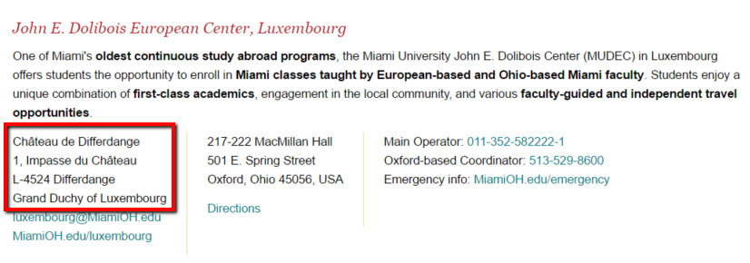
Code: | <p>Château de Differdange<br>  1, Impasse du Château<br>  L-4524 Differdange<br>  Grand Duchy of Luxembourg<br>

Solution
Ensure that all text in languages other than English are marked up with the LANG attribute.

Some links are broken
WCAG2  SC 2.4.5 | Multiple Ways  http://www.w3.org/TR/UNDERSTANDING-WCAG20/navigation-mechanisms-mult-loc.html
WCAG2 Level: | AA
Impact: | Medium
OzWiki: | See OzWiki — Some links are broken
Occurrence: | See example(s)

Error
Some links are broken.

Example(s)

Example 1
URL: | http://miamioh.edu/admission/accepted/fall/faq/index.html
Code: | <a href=“http://miamioh.edu/emss/offices/careers/”>Career Services</a>

Example 2
URL: | http://miamioh.edu/admission/accepted/spring/contacts/index.html
Code: | <a href=“../../../index-archive.html”>Office of Admission</a>

Example 3
URL: | http://miamioh.edu/admission/accepted/transfer/contacts/index.html
Code: | <a href=“../../../index-archive.html”>Office of Admission</a>

Solution
Ensure all links are correct.

Style Sheets Accessibility Errors

Visual order of columns does not match order of content with style sheets disabled
WCAG2  SC 1.3.2 | Meaningful Sequence  http://www.w3.org/TR/UNDERSTANDING-WCAG20/content-structure-separation-sequence.html
WCAG2 Level: | A
Impact: | High
OzWiki: | See OzWiki — Visual order of columns does not match order of content with style sheets disabled
Occurrence: | See example(s)

Error
With style sheets disabled, the right hand related information column occurs prior to the content in the page.

Example
URL: | http://miamioh.edu/admission/accepted/spring/index.html
CSS on | 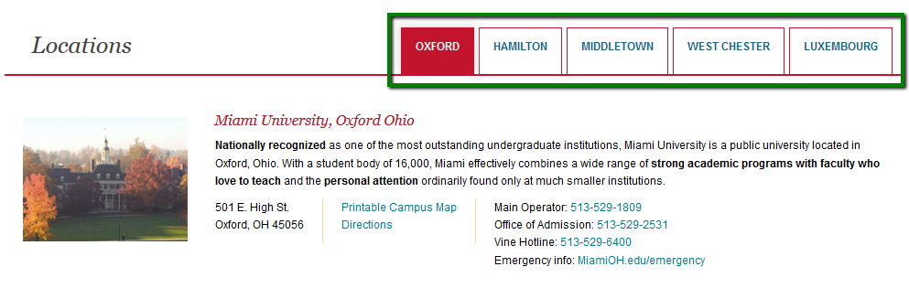
CSS off | 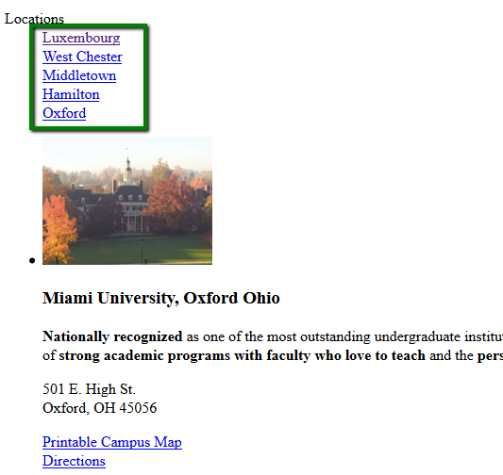

Solution
Ensure that the layout of the page (with style sheets on) matches the source order of the page (with style sheets off).

Some features do not work with style sheets disabled
WCAG2  SC 1.1.1 | Non-text Content  http://www.w3.org/TR/UNDERSTANDING-WCAG20/text-equiv-all.html
WCAG2 Level: | A
Impact: | High
OzWiki: | See OzWiki — Some features do not work with style sheets disabled
Occurrence: | See example(s)

Error
When style sheets are disabled it is not possible use certain features.

Example
URL: | http://miamioh.edu/admission/accepted/fall/faq/index.html
CSS on
CSS off | 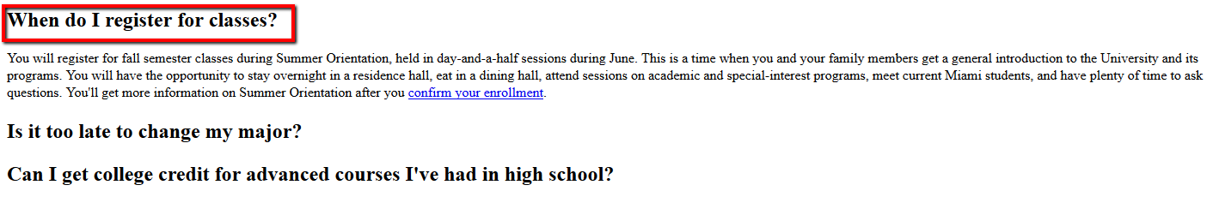
Code: | <h2 class=“accordionHeader ui-accordion-header ui-state-default ui-accordion-icons ui-accordion-header-active ui-state-active ui-corner-top ui-state-focus” role=“tab” id=“ui-id-1” aria-controls=“ui-id-2” aria-selected=“true” aria-expanded=“true” tabindex=“0”><span class=“ui-accordion-header-icon ui-icon square-minus”></span>When do I register for classes?</h2>

Solution
Ensure when style sheets are disabled that the features function as required.

Calendar Accessibility Errors

Calendar uses color alone and/or shading alone and/or shape alone to convey information
WCAG2  SC 1.4.1 | Use of Color  http://www.w3.org/TR/UNDERSTANDING-WCAG20/visual-audio-contrast-without-color.html
WCAG2 Level: | A
Impact: | High
OzWiki: | See OzWiki — Calendar uses color alone and/or shading alone and/or shape alone to convey information
Occurrence: | See example(s)

Error

Example
URL: | http://miamioh.edu/admission/accepted/fall/make-it-miami/index.html
Screenshot

Solution
Ensure the calendar uses some other formatting technique, such as bold or underline to convey this information.

Calendar uses non-standard ASCII characters alone to convey information
WCAG2  SC 3.1.1 | Language of Page  http://www.w3.org/TR/UNDERSTANDING-WCAG20/meaning-doc-lang-id.html
WCAG2 Level: | A
Impact: | Low
OzWiki: | See OzWiki — Calendar uses non-standard ASCII characters alone to convey information
Occurrence: | See example(s)

Error
Calendar uses non-standard ASCII characters (dashes) to convey information.

Example
URL: | http://miamioh.edu/admission/accepted/fall/make-it-miami/index.html
Screenshot | 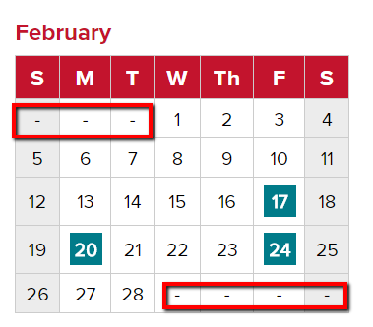

Solution
Ensure this information is conveyed in text.

Calendar does not have a highly visible keyboard focus indicator
WCAG2  SC 2.4.7 | Focus Visible  http://www.w3.org/TR/UNDERSTANDING-WCAG20/navigation-mechanisms-focus-visible.html
WCAG2 Level: | AA
Impact: | High
OzWiki: | See OzWiki — Calendar does not have a highly visible keyboard focus indicator
Occurrence: | See example(s)

Error
Calendar does not have a highly visible keyboard focus indicator

Example
URL: | http://miamioh.edu/admission/accepted/fall/make-it-miami/index.html
No focus
Keyboard focus

Solution
Ensure there is always a visible keyboard indicator.

Slideshow Accessibility Errors

Slideshow does not have a highly visible keyboard focus indicator
WCAG2  SC 2.4.7 | Focus Visible  http://www.w3.org/TR/UNDERSTANDING-WCAG20/navigation-mechanisms-focus-visible.html
WCAG2 Level: | AA
Impact: | High
OzWiki: | See OzWiki — Slideshow does not have a highly visible keyboard focus indicator
Occurrence: | See example(s)

Error
The slideshow does not have a visible keyboard indicator. Note: Although this is a AA issue, its impact on users is very high. We recommend addressing this as if it were a Level A, Impact: High issue

Example
URL: | http://miamioh.edu/admission/accepted/fall/make-it-miami/index.html
Screenshot

Solution
Ensure there is always a visible keyboard indicator.

Table Accessibility Errors

Data tables do not have a SUMMARY attribute
WCAG2  SC 1.3.1 | Info and Relationships  http://www.w3.org/TR/UNDERSTANDING-WCAG20/content-structure-separation-programmatic.html
WCAG2 Level: | A
Impact: | Medium
OzWiki: | See OzWiki — Data tables do not have a SUMMARY attribute
Occurrences: | http://miamioh.edu/admission/accepted/fall/calendar/ http://miamioh.edu/admission/accepted/fall/calendar/index.html http://miamioh.edu/admission/accepted/transfer/tips/index.html http://miamioh.edu/admission/accepted/spring/calendar/index.html http://miamioh.edu/admission/accepted/transfer/calendar/index.html http://miamioh.edu/admission/accepted/transfer/contacts/index.html http://miamioh.edu/admission/accepted/fall/contacts/index.html http://miamioh.edu/admission/accepted/fall/contacts/

Error
Data tables do not have the SUMMARY attribute.

Example(s)

Example 1
URL: | http://miamioh.edu/admission/accepted/spring/calendar/index.html
Screenshot | 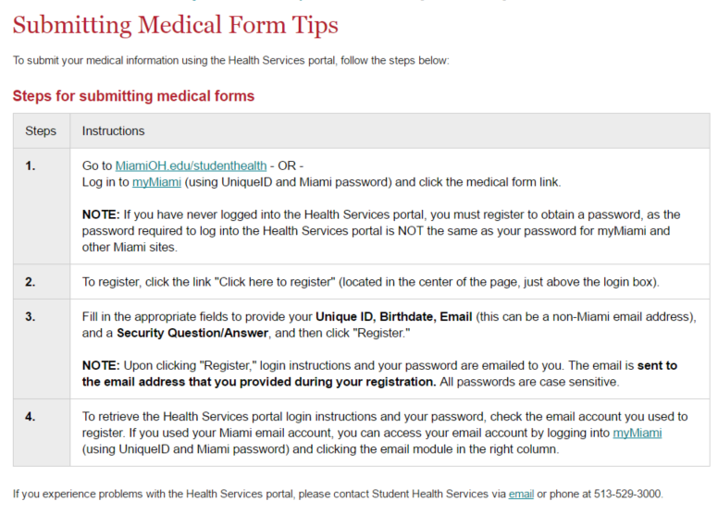
Code: | <table class=“grayWhiteTable” style=“width: 100%;”><caption>Calendar for first-year students enrolling Spring 2017</caption><colgroup><col style=“width: 50%;” /><col style=“width: 50%;” /></colgroup><tbody><tr class=“even”><th class=“rowData” scope=“row”><strong>November 2016&amp;ndash;January 2017</strong></th><td>Confirmation deposit due by the date listed on your acceptance letter. Return your medical form.</td></tr><tr><th class=“rowData” scope=“row”><strong><strong>November 1, 2016</strong></strong></th><td>Register for&amp;nbsp;<a href=“http://miamioh.edu/student-life/new-student-programs/first-year-students/january-orientation/index.html”>January&amp;nbsp;Orientation</a>.</td></tr><tr class=“even”><th class=“rowData” scope=“row”><strong>Late November 2016</strong></th><td>Financial Aid award notifications are mailed on a rolling basis after you are admitted.</td></tr><tr><th class=“rowData” scope=“row”><strong>Late December 2016</strong></th><td>Residential students receive their housing assignment, which includes their local address, arrival information, roommate information, and confirmation of their meal plan selection.</td></tr><tr class=“even”><th class=“rowData” scope=“row”><strong>Thursday, January 19, 2017</strong></th><td>First-year move-in day. (Move-in is also available on Wednesday, Jan. 18 for an additional fee.)</td></tr><tr><th class=“rowData” scope=“row”><strong>Thursday,&amp;nbsp;January 19, 2017&amp;ndash;Friday,&amp;nbsp;January 20, 2017</strong></th><td>January Orientation.</td></tr><tr class=“even”><th class=“rowData” scope=“row”><strong>Monday, January 23, 2017</strong></th><td>First day of classes for spring semester.</td></tr><tr><th class=“rowData” scope=“row”><strong>Monday,&amp;nbsp;March 20, 2017&amp;ndash;Sunday,&amp;nbsp;March 26, 2017</strong></th><td>Spring Break.</td></tr><tr class=“even”><th class=“rowData” scope=“row”><strong>Monday, May 8&amp;ndash;Saturday, May 13</strong></th><td>Final exams.</td></tr></tbody></table>

Example 2
URL: | http://miamioh.edu/admission/accepted/spring/calendar/index.html
Screenshot | 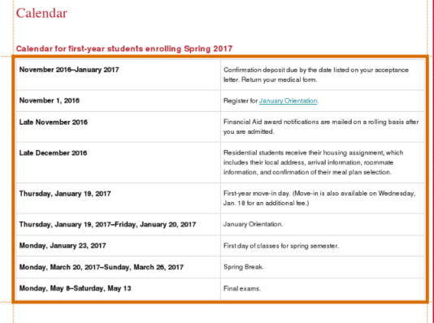
Code: | <table class=“grayWhiteTable” style=“width: 100%;”><caption>Calendar for first-year students enrolling Spring 2017</caption><colgroup><col style=“width: 50%;” /><col style=“width: 50%;” /></colgroup><tbody><tr class=“even”><th class=“rowData” scope=“row”><strong>November 2016&amp;ndash;January 2017</strong></th><td>Confirmation deposit due by the date listed on your acceptance letter. Return your medical form.</td></tr><tr><th class=“rowData” scope=“row”><strong><strong>November 1, 2016</strong></strong></th><td>Register for&amp;nbsp;<a href=“http://miamioh.edu/student-life/new-student-programs/first-year-students/january-orientation/index.html”>January&amp;nbsp;Orientation</a>.</td></tr><tr class=“even”><th class=“rowData” scope=“row”><strong>Late November 2016</strong></th><td>Financial Aid award notifications are mailed on a rolling basis after you are admitted.</td></tr><tr><th class=“rowData” scope=“row”><strong>Late December 2016</strong></th><td>Residential students receive their housing assignment, which includes their local address, arrival information, roommate information, and confirmation of their meal plan selection.</td></tr><tr class=“even”><th class=“rowData” scope=“row”><strong>Thursday, January 19, 2017</strong></th><td>First-year move-in day. (Move-in is also available on Wednesday, Jan. 18 for an additional fee.)</td></tr><tr><th class=“rowData” scope=“row”><strong>Thursday,&amp;nbsp;January 19, 2017&amp;ndash;Friday,&amp;nbsp;January 20, 2017</strong></th><td>January Orientation.</td></tr><tr class=“even”><th class=“rowData” scope=“row”><strong>Monday, January 23, 2017</strong></th><td>First day of classes for spring semester.</td></tr><tr><th class=“rowData” scope=“row”><strong>Monday,&amp;nbsp;March 20, 2017&amp;ndash;Sunday,&amp;nbsp;March 26, 2017</strong></th><td>Spring Break.</td></tr><tr class=“even”><th class=“rowData” scope=“row”><strong>Monday, May 8&amp;ndash;Saturday, May 13</strong></th><td>Final exams.</td></tr></tbody></table>

Solution
Include the SUMMARY attribute to provide a summary of the data table.

Data table SUMMARY is not descriptive or sufficient
WCAG2  SC 1.3.1 | Info and Relationships  http://www.w3.org/TR/UNDERSTANDING-WCAG20/content-structure-separation-programmatic.html
WCAG2 Level: | A
Impact: | Low
OzWiki: | See OzWiki — Data table SUMMARY is not descriptive or sufficient
Occurrence: | See example(s), March calendar, April calendar

Error
Data table SUMMARY is not descriptive or sufficient.

Example(s)

Example 1
URL: | http://miamioh.edu/admission/accepted/fall/make-it-miami/index.html
Screenshot
Code: | <table class=“calendar” summary=“February Calendar of Make It Miami dates”><caption>February</caption><thead><tr class=“weekday”><th scope=“col”>S</th><th scope=“col”>M</th><th scope=“col”>T</th><th scope=“col”>W</th><th scope=“col”>Th</th><th scope=“col”>F</th><th scope=“col”>S</th></tr></thead><tbody><tr><th scope=“row” style=“text-align: center;”>-</th><td>-</td><td>-</td><td>1</td><td>2</td><td>3</td><td class=“grayBg”>4</td></tr><tr><th scope=“row” style=“text-align: center;”>5</th><td>6</td><td>7</td><td>8</td><td>9</td><td>10</td><td class=“grayBg”>11</td></tr><tr><th scope=“row”>12</th><td>13</td><td>14</td><td>15</td><td>16</td><td><a href=“https://admission.miamioh.edu/apply/form?id=b91074ff-9214-4518-ab39-400b21dfd8ed”>17</a></td><td class=“grayBg”>18</td></tr><tr><th scope=“row”>19</th><td><a href=“https://admission.miamioh.edu/apply/form?id=94ba21fc-7b21-434d-a088-b1f7ee1eed6c”>20</a></td><td>21</td><td>22</td><td>23</td><td><a href=“https://admission.miamioh.edu/apply/form?id=d0892320-75fa-4e8e-abb8-136d02db1ad2”>24</a></td><td class=“grayBg”>25</td></tr><tr><th scope=“row”>26</th><td>27</td><td>28</td><td>-</td><td>-</td><td>-</td><td class=“grayBg”>-</td></tr></tbody></table>

Example 2
URL: | http://miamioh.edu/admission/accepted/spring/contacts/index.html
Screenshot | 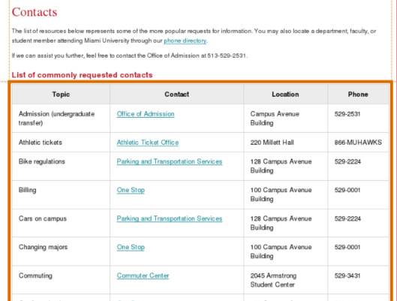
Code: | <table border=“0” cellpadding=“0” cellspacing=“0” style=“width: 100%;” summary=“Table of contacts for accepted spring students.”><caption>List of commonly requested contacts</caption>

Solution
Include a descriptive SUMMARY attribute of the data table.

Link Accessibility Errors

Links are distinguished with color alone and/or shading alone
WCAG2  SC 1.4.1 | Use of Color  http://www.w3.org/TR/UNDERSTANDING-WCAG20/visual-audio-contrast-without-color.html
WCAG2 Level: | A
Impact: | High
OzWiki: | See OzWiki — Links are distinguished with color alone and/or shading alone
Occurrence: | All site

Error
Links differ from text by color only.

Example
URL: | http://miamioh.edu/admission/accepted/spring/calendar/index.html
Screenshot

Solution
Ensure that all inline links are underlined.

Links do not have a highly visible keyboard focus indicator
WCAG2  SC 2.4.7 | Focus Visible  http://www.w3.org/TR/UNDERSTANDING-WCAG20/navigation-mechanisms-focus-visible.html
WCAG2 Level: | AA
Impact: | High
OzWiki: | See OzWiki — Links do not have a highly visible keyboard focus indicator
Occurrence: | See example(s)

Error
There is no keyboard focus indicator on text links. Note: Although this is a AA issue, its impact on users is very high. We recommend addressing this as if it were a Level A, Impact: High issue

Example
URL: | http://miamioh.edu/admission/accepted/spring/calendar/index.html
Screenshot | 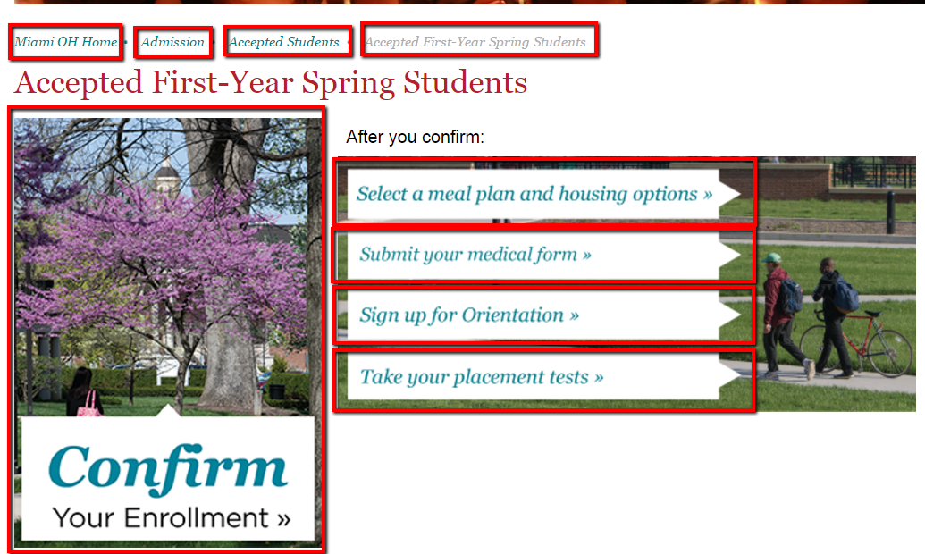
Screenshot | 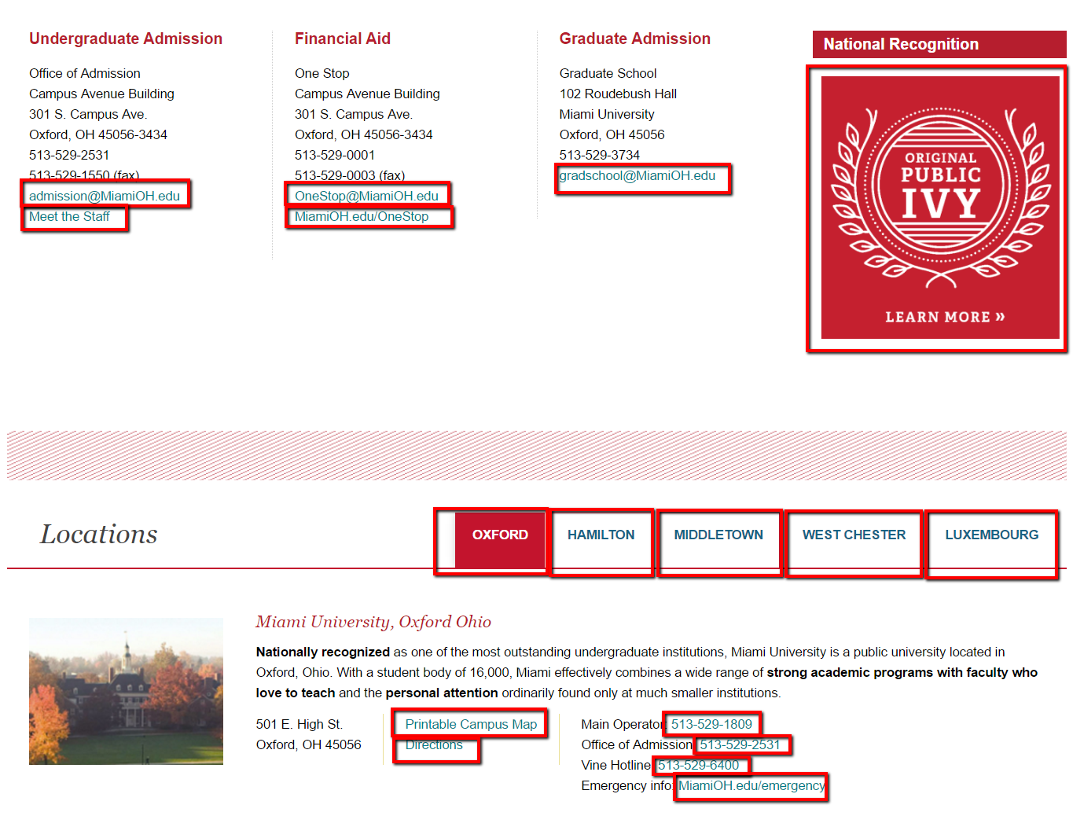

Solution
Ensure there is a keyboard focus indicator on all links.

Color contrast between the background and the link text is not sufficient
WCAG2  SC 1.4.3 | Contrast (Minimum)  http://www.w3.org/TR/UNDERSTANDING-WCAG20/visual-audio-contrast-contrast.html
WCAG2 Level: | AA
Impact: | High
OzWiki: | See OzWiki — Color contrast between the background and the link text is not sufficient
Occurrence: | See example(s)

Error
The contrast between the background and link text color is not sufficient.

Example
URL: | http://miamioh.edu/admission/accepted/spring/calendar/index.html
Screenshot

Solution
Ensure all color contrast is sufficient.

Heading Accessibility Errors

Heading has not been coded with H1, H2 etc
WCAG2  SC 1.3.1 | Info and Relationships  http://www.w3.org/TR/UNDERSTANDING-WCAG20/content-structure-separation-programmatic.html
WCAG2 Level: | A
Impact: | High
OzWiki: | See OzWiki — Heading has not been coded with H1, H2 etc
Occurrence: | See example(s)

Error
Some headings have not been coded using H1, H2 etc.

Example(s)

Example 1
URL: | http://miamioh.edu/admission/accepted/spring/index.html
Screenshot | 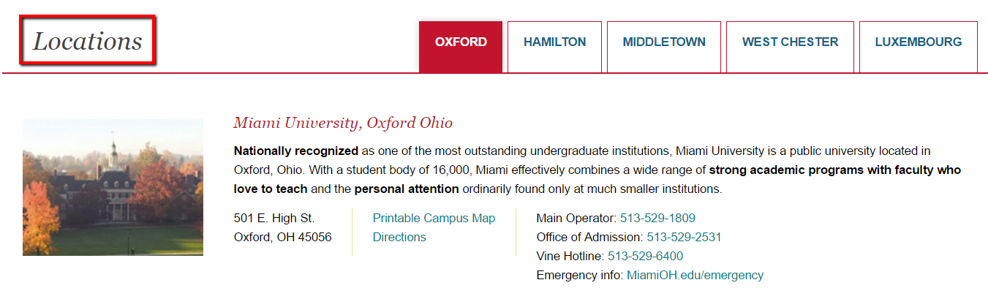
Code: | <dt><span>Locations</span></dt>

Solution
Ensure all headings are coded using H1, H2 etc.

Heading element is empty
WCAG2  SC 1.3.1 | Info and Relationships  http://www.w3.org/TR/UNDERSTANDING-WCAG20/content-structure-separation-programmatic.html
WCAG2 Level: | A
Impact: | Low
OzWiki: | See OzWiki — Heading element is empty
Occurrence: | See example(s)

Error
Some pages contain empty headings.

Example(s)

Example 1
URL: | http://miamioh.edu/admission/accepted/index.html
Code: | &lt;h2 class=&quot;carouselWidgetHeader&quot;&gt;&lt;/h2&gt;
Occurrence: | Group 1

Example 2
URL: | http://miamioh.edu/admission/accepted/index.html
Code: | &lt;h3 class=&quot;siteLogo&quot;&gt;&lt;/h3&gt;
Occurrence: | Group 1

Solution
Ensure there are no empty headings.

General Content

Overview
The general content of the Admissions Accepted web site is very accessible, with some minor issues around images, link text and references to visual location or the word “click”. Some headings have not been coded or nested properly but this is easily fixed. PDFs were tagged, however the reading order was often incorrect.

Breakdown of errors
General Content errors are organized by the following categories:
- Images Accessibility Errors on page 46;
- Download Alternatives Accessibility Errors on page 49;
- Link Accessibility Errors on page 51;
- Heading Accessibility Errors on page 53;
- Content Accessibility Errors on page 56;

Images Accessibility Errors

Some images do not have descriptive ALT attributes
WCAG2  SC 1.1.1 | Non-text Content  http://www.w3.org/TR/UNDERSTANDING-WCAG20/text-equiv-all.html
WCAG2 Level: | A
Impact: | High
OzWiki: | See OzWiki — Some images do not have descriptive ALT attributes
Occurrence: | See example(s), also occurs on "red sun" and "red pencil"

Error
Some images do not have descriptive ALT attributes.

Example
URL: | http://miamioh.edu/admission/accepted/fall/index.html
Screenshot | 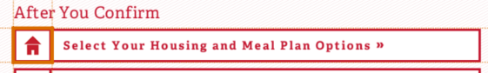
Code: | <img alt=“Red house illustration” class=“spoonFork” height=“49” src=“../../../_files/images/admission/accepted/2016/icon-housing.png” width=“57” />

Solution
Ensure all images have descriptive ALT attributes.

Some images have incorrect ALT attributes ('image' / 'graphic' / 'photo')
WCAG2  SC 1.1.1 | Non-text Content  http://www.w3.org/TR/UNDERSTANDING-WCAG20/text-equiv-all.html
WCAG2 Level: | A
Impact: | Low
OzWiki: | See OzWiki — Some images have incorrect ALT attributes ('image' / 'graphic' / 'photo')
Occurrence: | See example(s)

Error
Some images have incorrect ALT attributes, they use words such as 'image', 'graphic', 'photo' etc.

Example(s)

Example 1
URL: | http://miamioh.edu/admission/accepted/transfer/index.html
Screenshot | 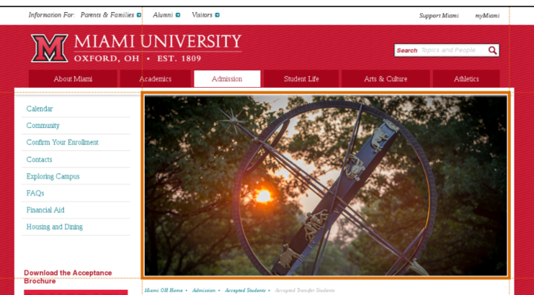
Code: | <img alt=“Universal Banner Image 3” class=“bannerImage” src=“http://miamioh.edu/_files/images/banner/campus.jpg” />

Example 2
URL: | http://miamioh.edu/admission/accepted/transfer/calendar/index.html
Screenshot | 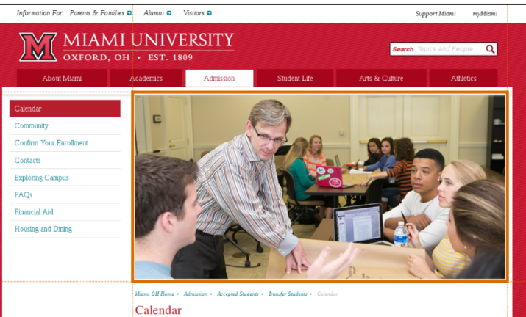
Code: | <img alt=“Universal Banner Image 4” class=“bannerImage” src=“http://miamioh.edu/_files/images/banner/academics.jpg” />

Solution
Ensure all images have descriptive ALT attributes.

Download Alternatives Accessibility Errors

PDFs are not tagged correctly
WCAG2  SC 1.1.1 | Non-text Content  http://www.w3.org/TR/UNDERSTANDING-WCAG20/text-equiv-all.html
WCAG2 Level: | A
Impact: | Low
OzWiki: | See OzWiki — PDFs are not tagged correctly
Occurrence: | See example(s)

Error
PDFs have not been tagged correctly with accessibility features.

Example
: Reading order is incorrect
URL: | http://miamioh.edu/admission/accepted/spring/confirm/index.html
Screenshot | 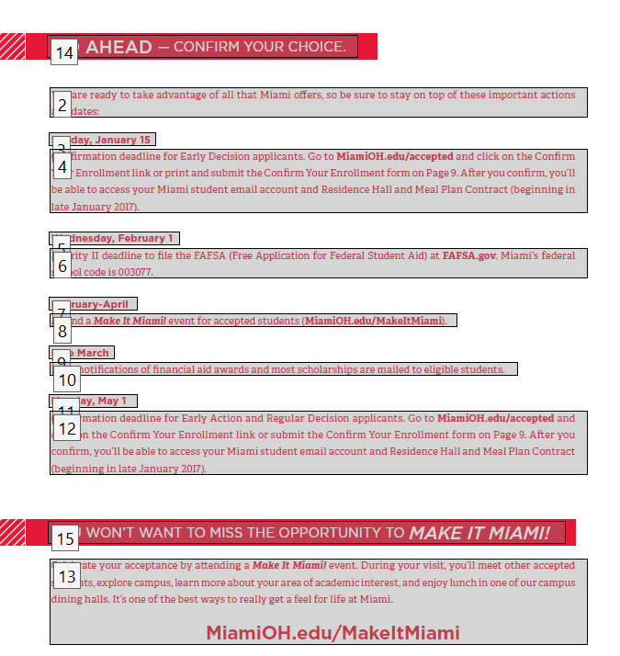

Solution
Ensure PDFs have the correct reading order.

Link Accessibility Errors

Link text is not clear
WCAG2  SC 2.4.4 | Link Purpose (In Context)  http://www.w3.org/TR/UNDERSTANDING-WCAG20/navigation-mechanisms-refs.html
WCAG2 Level: | A
Impact: | Medium
OzWiki: | See OzWiki — Link text is not clear
Occurrence: | See example(s)

Error
The purpose of some links is not evident from the link text.

Example(s)

Example 1
URL: | http://miamioh.edu/admission/accepted/spring/index.html
Code: | <a href=“http://miamioh.edu/emergency#emergencyContacts”>MiamiOH.edu/emergency</a>

Example 2
URL: | http://miamioh.edu/admission/accepted/spring/index.html
Code: | <a href=“http://miamioh.edu/onestop/index.html”>MiamiOH.edu/OneStop</a>

Example 3
URL: | http://miamioh.edu/admission/accepted/spring/index.html
Code: | <a href=“http://miamioh.edu/luxembourg”>MiamiOH.edu/luxembourg</a>

Example 4
URL: | http://miamioh.edu/admission/accepted/fall/calendar/index.html
Code: | <a href=“https://miamioh.edu/onestop/your-money/bill-payment/payment/payment-plans/#/”>MiamiOH.edu/paymentplan</a>

Example 5
URL: | http://miamioh.edu/admission/accepted/spring/index.html
Code: | <a href=“http://miamioh.edu/regionals”>MiamiOH.edu/regionals</a>

Example 6
URL: | http://miamioh.edu/admission/accepted/spring/index.html
Code: | <a href=“http://miamioh.edu/regionals/emergency” target=“_blank”>MiamiOH.edu/regionals/emergency</a>

Example 7
URL: | http://miamioh.edu/admission/accepted/fall/safety/index.html
Code: | <a href=“http://www.miamioh.edu/righttoknow#Health%20and%20Safety”>MiamiOH.edu/righttoknow</a>

Example 8
URL: | http://miamioh.edu/admission/accepted/transfer/tips/index.html
Code: | <a href=“http://miamioh.edu/student-life/student-health-service/”>MiamiOH.edu/studenthealth</a>

Solution
Ensure that links are evident from link text.

Heading Accessibility Errors

Heading has not been coded with H1, H2 etc
WCAG2  SC 1.3.1 | Info and Relationships  http://www.w3.org/TR/UNDERSTANDING-WCAG20/content-structure-separation-programmatic.html
WCAG2 Level: | A
Impact: | High
OzWiki: | See OzWiki — Heading has not been coded with H1, H2 etc
Occurrence: | See example(s)

Error
Some headings have not been coded using H1, H2 etc.

Example(s)

Example 1
URL: | http://miamioh.edu/admission/accepted/transfer/exploring-campus/index.html
Screenshot | 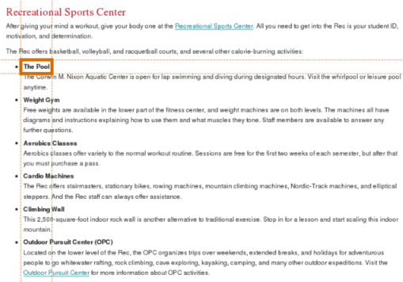
Code: | <strong>The Pool</strong>

Solution
Ensure all headings are coded using H1, H2 etc.

Headings have not been nested properly
WCAG2  SC 1.3.1 | Info and Relationships  http://www.w3.org/TR/UNDERSTANDING-WCAG20/content-structure-separation-programmatic.html
WCAG2 Level: | A
Impact: | Medium
OzWiki: | See OzWiki — Headings have not been nested properly
Occurrence: | Group 3

Error
Headings have been improperly nested.

Example
URL: | http://miamioh.edu/admission/accepted/spring/index.html
Screenshot | 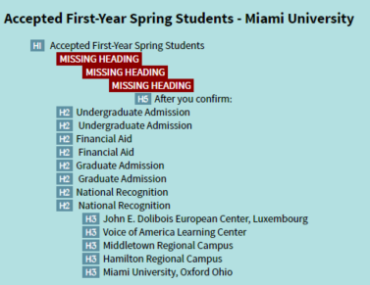

Solution
Ensure that headings are nested properly.

Content Accessibility Errors

References to visual location and/or shape alone have been used to convey information
WCAG2  SC 1.3.3 | Sensory Characteristics  http://www.w3.org/TR/UNDERSTANDING-WCAG20/content-structure-separation-understanding.html
WCAG2 Level: | A
Impact: | High
OzWiki: | See OzWiki — References to visual location and/or shape alone have been used to convey information
Occurrence: | See example(s)

Error
Instructions on understanding content are based solely on visual location ("down" and "right") or appearance ("round" or "square").

Example(s)

Example 1
URL: | http://miamioh.edu/admission/accepted/transfer/confirm/index.html
Code: | Applicant Status Page) to the address below. You'll then need to

Example 2
URL: | http://miamioh.edu/admission/accepted/transfer/tips/index.html
Code: | center of the page, just above the login box).

Example 3
URL: | http://miamioh.edu/admission/accepted/transfer/tips/index.html
Code: | clicking the email module in the right column.

Example 4
URL: | http://miamioh.edu/admission/accepted/transfer/tips/index.html
Code: | follow the steps below:

Example 5
URL: | http://miamioh.edu/admission/accepted/transfer/faq/index.html
Code: | information listed above, include your former name (if applicable),

Example 6
URL: | http://miamioh.edu/admission/accepted/fall/contacts/index.html
Code: | The list of resources below represents some of the more popular requests

Solution
Ensure visual location or appearance is not the only means of conveying information.

Text refers to device-dependent handlers
WCAG2  SC 2.1.1 | Keyboard  http://www.w3.org/TR/UNDERSTANDING-WCAG20/keyboard-operation-keyboard-operable.html
WCAG2 Level: | A
Impact: | Low
OzWiki: | See OzWiki — Text refers to device-dependent handlers
Occurrence: | See example(s)

Error
Device-dependent instructions, for example "click", have been used.

Example(s)

Example 1
URL: | http://miamioh.edu/admission/accepted/transfer/faq/index.html
Code: | “Academic Transcripts,” and click the submit button. The courses for which

Example 2
URL: | http://miamioh.edu/admission/accepted/transfer/tips/index.html
Code: | 2. To register, click the link “Click here to register” (located in the

Example 3
URL: | http://miamioh.edu/admission/accepted/transfer/tips/index.html
Code: | clicking the email module in the right column.

Example 4
URL: | http://miamioh.edu/admission/accepted/transfer/tips/index.html
Code: | Log in to myMiami (using UniqueID and Miami password) and click the

Example 5
URL: | http://miamioh.edu/admission/accepted/transfer/tips/index.html
Code: | NOTE: Upon clicking “Register,” login instructions and your password

Example 6
URL: | http://miamioh.edu/admission/accepted/transfer/tips/index.html
Code: | Question/Answer, and then click “Register.”

Solution
Ensure all instructions are device-independent, for example "select".

Appendix: Groups

Group 1
http://miamioh.edu/admission/accepted/index.html
http://miamioh.edu/admission/accepted/fall/contacts/index.html
http://miamioh.edu/admission/accepted/fall/dining/index.html
http://miamioh.edu/admission/accepted/fall/exploring/index.html
http://miamioh.edu/admission/accepted/fall/faq/index.html
http://miamioh.edu/admission/accepted/fall/finaid/index.html
http://miamioh.edu/admission/accepted/fall/first-week/index.html
http://miamioh.edu/admission/accepted/fall/health/index.html
http://miamioh.edu/admission/accepted/fall/housing/index.html
http://miamioh.edu/admission/accepted/fall/make-it-miami/index.html
http://miamioh.edu/admission/accepted/fall/safety/index.html
http://miamioh.edu/admission/accepted/fall/calendar/
http://miamioh.edu/admission/accepted/fall/community/
http://miamioh.edu/admission/accepted/fall/contacts/
http://miamioh.edu/admission/accepted/fall/dining/
http://miamioh.edu/admission/accepted/fall/first-week/
http://miamioh.edu/admission/accepted/fall/housing/
http://miamioh.edu/admission/accepted/fall/safety/
http://miamioh.edu/admission/accepted/fall/index.html
http://miamioh.edu/admission/accepted/fall/
http://miamioh.edu/admission/accepted/fall/calendar/index.html
http://miamioh.edu/admission/accepted/fall/community/index.html
http://miamioh.edu/admission/accepted/fall/confirm/index.html

Group 2
http://miamioh.edu/admission/accepted/spring/calendar/index.html
http://miamioh.edu/admission/accepted/spring/community/index.html
http://miamioh.edu/admission/accepted/spring/confirm/index.html
http://miamioh.edu/admission/accepted/spring/contacts/index.html
http://miamioh.edu/admission/accepted/spring/dining/index.html
http://miamioh.edu/admission/accepted/spring/exploring/index.html
http://miamioh.edu/admission/accepted/spring/faq/index.html
http://miamioh.edu/admission/accepted/spring/health/index.html
http://miamioh.edu/admission/accepted/spring/housing/index.html
http://miamioh.edu/admission/accepted/spring/safety/index.html
http://miamioh.edu/admission/accepted/transfer/calendar/index.html
http://miamioh.edu/admission/accepted/transfer/community/index.html
http://miamioh.edu/admission/accepted/transfer/confirm/index.html
http://miamioh.edu/admission/accepted/transfer/contacts/index.html
http://miamioh.edu/admission/accepted/transfer/exploring-campus/index.html
http://miamioh.edu/admission/accepted/transfer/faq/index.html
http://miamioh.edu/admission/accepted/transfer/financial-aid/index.html
http://miamioh.edu/admission/accepted/transfer/housing-dining/index.html
http://miamioh.edu/admission/accepted/transfer/tips/index.html
http://miamioh.edu/admission/accepted/spring/index.html
http://miamioh.edu/admission/accepted/transfer/index.html

Group 3
http://miamioh.edu/admission/accepted/fall/housing/index.html
http://miamioh.edu/admission/accepted/fall/housing/
http://miamioh.edu/admission/accepted/fall/exploring/index.html
http://miamioh.edu/admission/accepted/fall/index.html
http://miamioh.edu/admission/accepted/fall/
http://miamioh.edu/admission/accepted/fall/contacts/index.html
http://miamioh.edu/admission/accepted/fall/contacts/
http://miamioh.edu/admission/accepted/fall/community/
http://miamioh.edu/admission/accepted/fall/community/index.html
http://miamioh.edu/admission/accepted/fall/faq/index.html
http://miamioh.edu/admission/accepted/fall/dining/index.html
http://miamioh.edu/admission/accepted/fall/dining/
http://miamioh.edu/admission/accepted/fall/calendar/
http://miamioh.edu/admission/accepted/fall/calendar/index.html
http://miamioh.edu/admission/accepted/fall/safety/index.html
http://miamioh.edu/admission/accepted/fall/safety/
http://miamioh.edu/admission/accepted/index.html
http://miamioh.edu/admission/accepted/fall/health/index.html
http://miamioh.edu/admission/accepted/fall/first-week/index.html
http://miamioh.edu/admission/accepted/fall/first-week/
http://miamioh.edu/admission/accepted/spring/index.html
http://miamioh.edu/admission/accepted/fall/finaid/index.html
http://miamioh.edu/admission/accepted/fall/make-it-miami/index.html
http://miamioh.edu/admission/accepted/fall/confirm/index.html

Contacts

Gian Wild, CEO
Web: www.accessibilityoz.com
Phone: 415 621 9366
Email: gian@accessibilityoz.com

