Determining the reading
level of your text

Determining the reading level of your text
- Copy the relevant text into a blank Word document
- Under the “File” menu select “Options” on the left-hand side.
- Select the “Proofing” section in the left-hand side of the dialog box.
- Scroll down to the “When correcting spelling and grammar in Word” section
- Ensure “Show readability statistics” is selected.
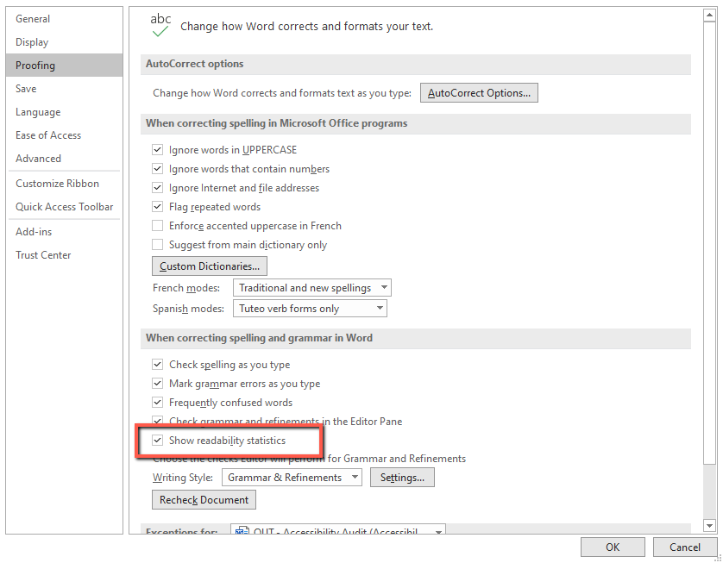
- Select “OK”
- Under the “Review” menu select “Editor”
- The Flesch-Kincaid Grade Level is shown under the “Readability” section. Ensure that it is 8 or below.
