Accessible Math Guide
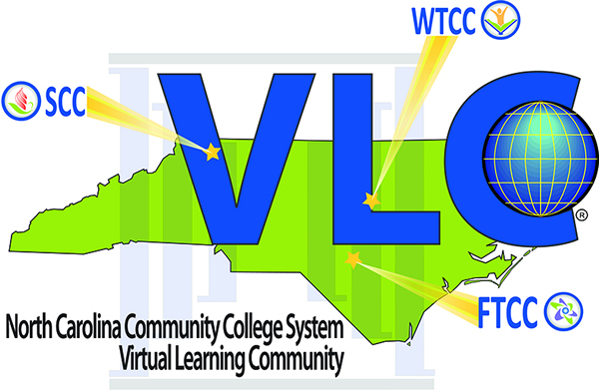

Abstract
We were looking for guides to create accessible digital math, and we found very few resources. We decided to create our own handbook highlighting the latest tools and techniques for creating accessible digital math content. We researched and consulted with accessibility experts from around the country to create this guide. This research and development will continue. This guide represents the most current tools to create screen reader accessible math. We will continue to update this guide as we conduct more research and as the development of software and tools evolves.

Acknowledgements
This guide would not exist without the efforts of the math guide team of Natosha Burgess-Rodriguez, Joseph Polizzotto, and Misty Patinelli of Wake Technical Community College. We simply cannot thank them enough for their hard work and dedication in creating this guide.
We would also like to thank the many math faculty we consulted with who shared their expertise and insight. We thank Vicki Todd of Southwest Community College, Brandon Craft of Wilson Community College, John Hardee of Davidson-Davie Community College, Tammy Sullivan of A-B Tech, Adam Petit of Isothermal Community College, and Deidre Wood of Cape Fear Community College.
Finally, we must express our thanks to Jennifer Marquis of Craven Community College, Jo James of Isothermal Community College, Paulette Evans, Elizabeth Watkin and Barbra Browning of AB-Tech, and Cheryl Fulghum of Haywood Community College. All have allowed us to pilot new training courses that have enriched our offerings.
Any errors or omissions are the sole responsibility of the Virtual Learning Community Professional Development Center Director.

Table of Contents
1
Accessible Math Guide 1
Abstract 2
Acknowledgements 2
Table of Contents 3
Introduction 5
What is Accessible Math 6
Interactive - Examples 7
Understandable - Examples 7
What Your Students Need 8
Text-Based Formats 8
Microsoft Word 9
Web Page 9
EPUB 10
LaTeX 11
Slideshow - Lecture 11
Braille 12
Google Docs 13
PDF 13
Open Source Office Suites 14
Tactile Graphics and 3-D Models 14
Math Conversion Workflows 15
Math Editing 15
Image PDF to Word 15
LaTeX to Word 17
Word to HTML 17
Word to EPUB 18
Word to Learning Management System 20
Creating Math Content 23
Using LaTex to Generate Content 23
Using Office Math 30
Using MathType in Word 34
Creating Accessible Math Content in Your LMS 35
Moodle 36
Creating Accessible Math in Moodle 36
Canvas 40
Blackboard 43
Visual Math Editor 44
Publishing Accessible Math Formats 46
Converting Math Formats 46
The Polizzotto Method 46
Using the Script 47
Full Setup Instructions from the Github Site 48
Converting Images of Math Using OCR 49
Optical Character Recognition 49
Optical Character Recognition Software 50
Adobe Acrobat Pro DC 50
OCR: Software and Mathematical Content 54
MathPix 55
EquatIO 61

Introduction
This guide has been designed to provide you with an overview of accessible design concepts. Its content is based on the most recent version (2.1) of the World Wide Web Consortium’s Web Content Accessibility Guidelines, as they pertain to online course design and digital math content. It is the hope of the VLC that you will find this handbook and the information contained here useful.
This handbook is a guide to authoring accessible math content. This is a living document, and we will update as we research, gather data, and learn new tools and techniques for authoring accessible math content. While we have ideas in mind for future updates, we would love your feedback and suggestions. Please email the center and offer your feedback and suggestions at daevans3@waketech.edu.
Please contact us if you would like training in math or any accessibility or any distance learning topic. We can be reached at daevans3@waketech.edu or by phone at (919) 866-5636
You can also visit the VLC website to see the services offered by all three VLC Centers.

What is Accessible Math
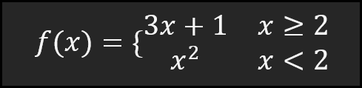
Accessible Math is math that everyone can perceive, interact with and explore. With this definition in mind, it should be clear that accessible math is not simply an electronic format that someone can access on a computer, without needing recourse to a book. Accessible in that sense simply refers to the availability of content on a computer, not a physical medium.
No, accessible math may not be electronic at all; in fact, for higher levels of math, especially disciplines that use lots of graphs, an accessible version would be tactile, not electronic! An accessible version of the physics theorem would include perhaps a 3-D model of what the theorem entails in its application in space. Feeling the theorem’s impact in the physical dimension would be the accessible way to communicate that idea to someone who is visually impaired.
Accessible Math Examples
Here are some examples of accessible versions of math.
Each example will illustrate how the definition of accessible math makes sense in terms of how people access STEM content.
Perceivable – Examples
Inaccessible
The math expression is a picture. You cannot select the math components. It is not readable by assistive technologies. It is not perceivable
Accessible
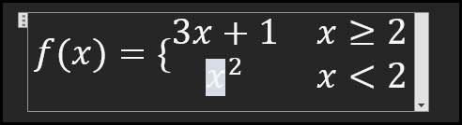
The math expression is authored using Microsoft Word. The variable x is highlighted to indicate that you can select the math components. It is readable by assistive technologies. It is perceivable.

Interactive - Examples
Inaccessible
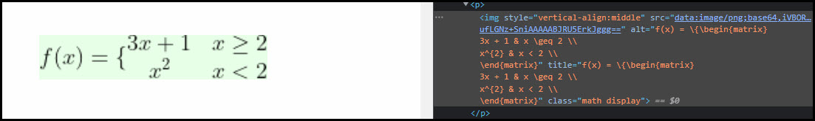
The math is a picture which includes an alternative text description in LaTeX (see text after alt= attribute). The math is perceivable to students who know LaTeX but students cannot use assistive technologies to move up, down, left, or right to explore the equation. It is not an interactive equation.
Accessible
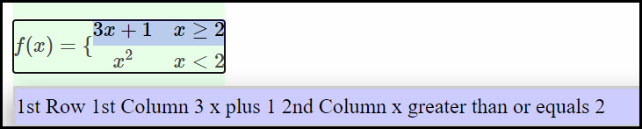
The math is rendered using the JavaScript library MathJax, which allows exploration of the different levels of the math equation by using a shortcut. It is an interactive equation.

Understandable - Examples
In this example, is written on the board and the teacher communicates it in one of the following ways.
Inaccessible
The teacher says, “A plus B over C”. This is confusing because the visually impaired student is not sure whether the teacher is saying or . The math is not understandable.
Accessible
The teacher says, “a fraction whose numerator is a plus b and whose denominator is c”. This way of communicating the math is unambiguous. The teacher is referring to . The math is understandable.
Note: Another instance of an unintelligible math concept is when the math cannot be explored as a tactile graphic or 3D model but only through hearing, e.g., a theorem in a physics course.
The formats you adopt will depend on a variety of factors, including:
- What content your students need,
- What documents you already have,
- What tools you may be familiar with, or
- How much money you can spend?

What Your Students Need
In your efforts to create the most accessible course possible, we recommend creating text-based documents that can be read by your students’ assistive technology.
A text-based document is a document that has real text, not pictures of text. For STEM materials, the math is encoded in a math notation format such as LaTeX, MathML, or ASCII Math, which can be converted by machines.
Speak directly with your students to find out which format of a document they prefer to read.

Text-Based Formats
While there are a variety of text-based document types available, the formats listed below can be made most accessible in the STEM field:
- Microsoft Word (DOCX)
- Web Page (HTML)
- eBook (EPUB)
Note: We do not recommend PDF as an accessible format. At the time of this writing, there is not a clear pathway for producing fully accessible PDF documents with STEM content.

Microsoft Word
Microsoft Word is the most popular text-processing document format used by students, as many campuses provide students with an MS Office license for free.
Microsoft Word is available on the Mac and Windows operating systems or online if users have a Microsoft 365 license.
Microsoft Word has a built-in equation editor in the Microsoft Word ribbon within the Symbols group.
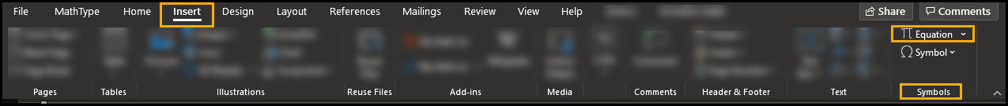
MS Word - Insert Equation
Equations that are created in Microsoft Word using the built-in equation editor are encoded in a math format that students can read with their assistive technologies -both screen readers for visually impaired and text to speech programs for students with reading impairments.
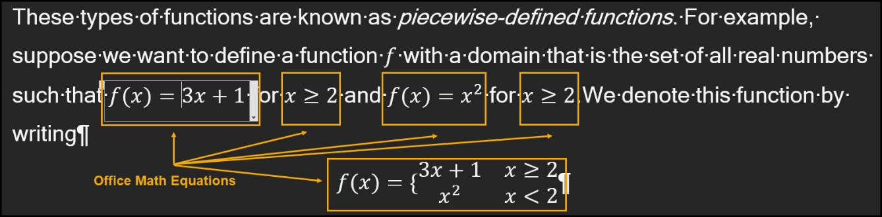
MS Word - Office Math Equations
MS Word documents that have Office Math equations, MS Word’s native format, can also convert easily to other formats that your students may need, such as braille, HTML, or EPUB.

Web Page
A web page is a great way to deliver math content, either as a stand-alone HTML file or by creating a course page within your college’s Learning Management System (LMS).
A web version of your math content will give your students a predictable format that works with their assistive technology.
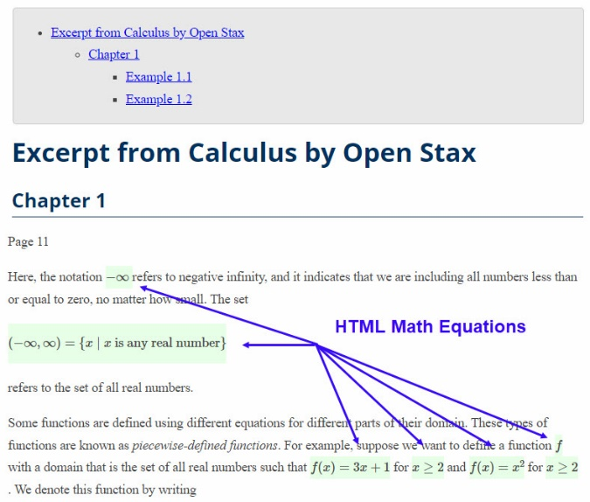
Web Page - Math Equations
There are a variety of tools that can help you create a web page that not only contains standard web markup but meaningful math markup as well. The use of these tools does NOT require that you have a knowledge of HTML.

EPUB
EPUB stands for electronic publication and is the standard format for eBooks.
The EPUB format is built on the same technologies that comprise the modern web. As a result, the same advantages that a web page offers for accessibility applies to an EPUB.
An EPUB can contain math encoding such as LaTeX, ASCII Math, or MathML, and be delivered to assistive technologies. Where a web page is best for shorter documents such as a homework assignment or a test, an EPUB would be well suited for a lengthy document like a department’s handbook or a class textbook.
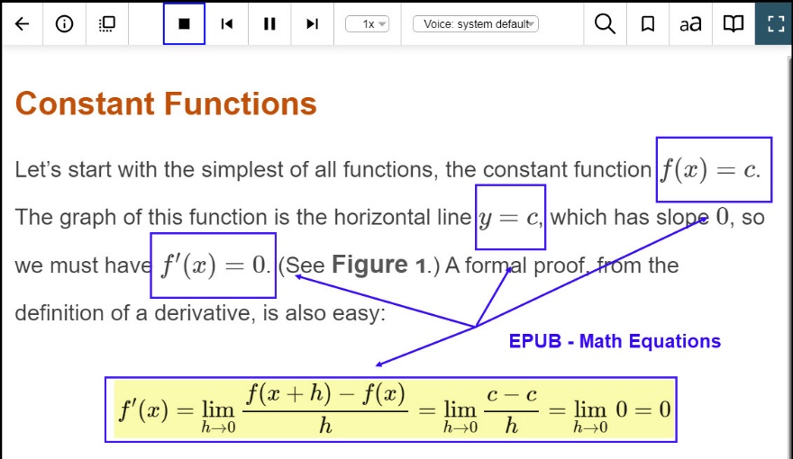
EPUB - Math Equations
Like HTML, an EPUB can be created from other formats, such as LaTeX or Microsoft Word, using freely available tools, which do NOT require an extensive knowledge of the EPUB format itself.

LaTeX
LaTeX is a writing system that many mathematicians use to create lecture notes and produce articles or books. Knowledge of LaTeX can make the authoring of accessible math content a much faster process as there are many tools that can convert LaTeX into other accessible formats.
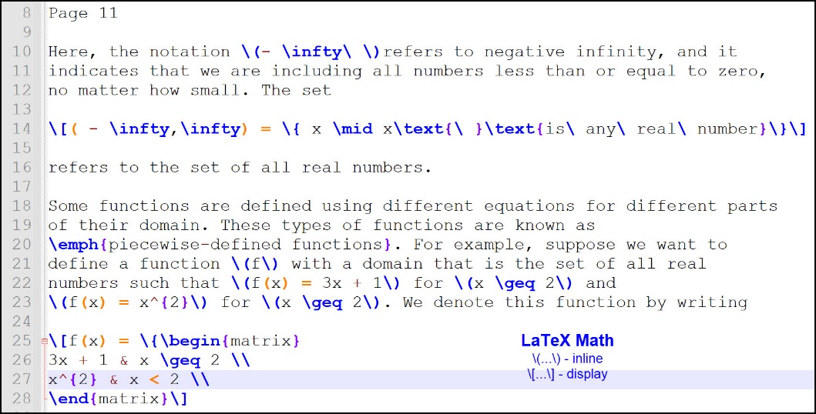
LaTeX - Math Equations
A LaTeX file (.tex) and the ancillary files associated when authoring LaTeX can be helpful in the production of accessible materials. There are many tools freely available that will convert a LaTeX file into one of the accessible formats recommended in this guide (see more information below).
When working with your partners in the Disability Support Services (DSS) department, it is often helpful to share LaTeX files to facilitate accessibility conversions.

Slideshow - Lecture
PowerPoint slides with STEM content can be accessible when using MathType by Wiris.
Note that students who are accessing these PowerPoint files will need to have MathType, MathPlayer, and a 32-bit version of MS Office to access the math successfully.

If you are creating a slideshow that has a lot of math content, it would be better to use a slideshow tool like Slidy.
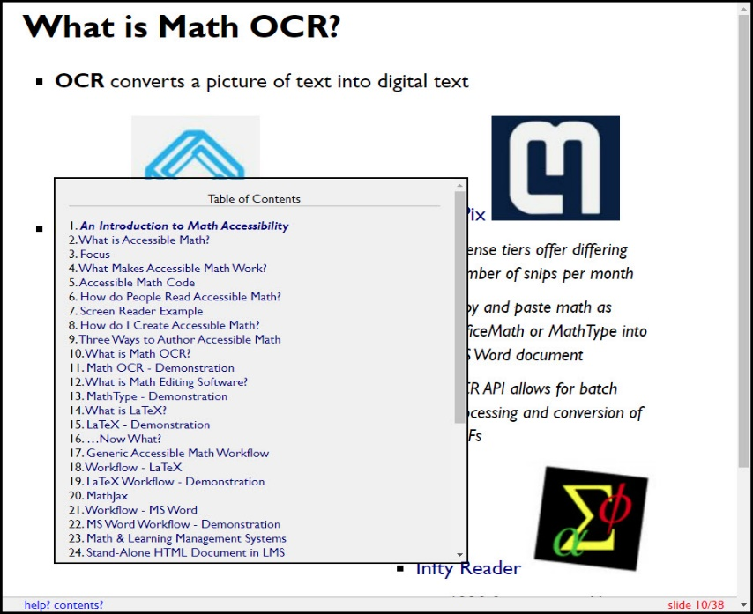
HTML Slideshow - Slidy
There are free tools available, such as Pandoc, a command line program, that can quickly convert a LaTeX or DOCX file into an HTML slideshow.

Braille
Blind students taking mathematics benefit greatly from having their math books, homework, and tests in braille.
STEM content in braille will be encoded in Nemeth braille, which is the standard math braille notation system.
Conversion of math into braille is the work of the DSS office and in particular braille transcribers who possess knowledge of Nemeth.
Nemeth Braille Math Notation
The work of converting math to Nemeth braille is time intensive and can require weeks if not months to produce. For this reason, it is essential that math faculty declare their book adoptions at least a month in advance of the term.
We also strongly recommend adopting a book that has already been transcribed into braille. You can find this information by consulting your publisher representative or contacting the Access Text Network.

Google Docs
Google Docs present challenges for screen reader users, particularly when accessing STEM content.
Students who have a reading disability can access Google Docs with STEM content when the STEM content has been authored using EquatIO by TextHelp. Students can then use TextHelp Read and Write software to hear the math read naturally.

PDF
PDF is a popular format since it is easy to make and easy to open. PDFs also look just like the pages of a physical book and are more difficult to edit, which appeals to faculty concerned about the illicit copying of text.
Despite these advantages, accessible PDFs are not easy to create, especially with STEM content.
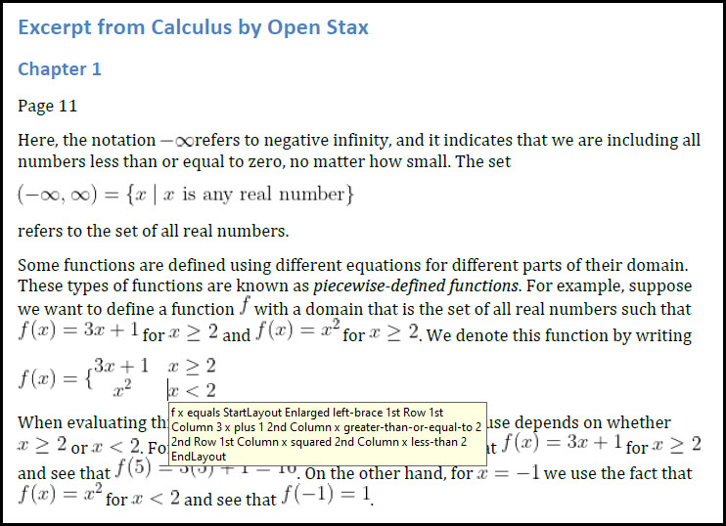
PDF - Math Equations
It is fine to share PDFs with students, but these should be text-based documents and another document such as a DOCX, HTML, or EPUB file should be available as well.

Open Source Office Suites
Both Open Office and Libre Office have math editors, which makes it possible to author STEM files in the ODT format.
While these programs are free and contain some accessibility features, screen reader users will encounter difficulties accessing the math in these files.
Open Office logo
If you have ODT files, you can open them in MS Office and save them as a DOCX, which would be a better format for students to interact with.

Tactile Graphics and 3-D Models
A student who is visually impaired will need to have graphs created in a more accessible format. It is not sufficient to provide text descriptions.
This is the work of the Disability Support Services (DSS) team and requires careful planning. Like the creation of Nemeth braille, the production of tactile graphics or 3D models can be time intensive and is best completed by someone with the knowledge of the technology and principles used to create them.
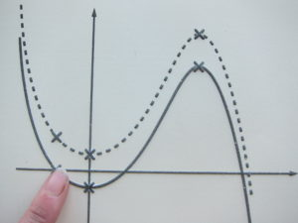
Tactile Graphic
If you will be teaching a student with a visual impairment, we recommend making plans at least a month in advance of the semester to identify which graphs or concepts will need to be created as a tactile graphic or a 3D model.
Work closely with your Disability Support Services (DSS) team to determine the process for how the graphs will be shared with them and what the turn-around times will be for them to be converted.

Math Conversion Workflows
When you are converting to an accessible format, your starting point will be to determine what files you already have.
It is always best to start with the files that were originally used to author the content. With STEM content, this could be a LaTeX file or an MS Word document. Try to get these files before you begin any conversion work.
If you do not have the source document for your STEM content, the time spent on converting to an accessible format will take a longer time and may require the use of particular software.
For example, if the only version of a document you have is a PDF, the process of the conversion could require optical character recognition (OCR) tools. Since this process requires more attention to detail and knowledge of technology, we recommend speaking with your partners in Disability Services who may be able to help you with these conversions.

Math Editing
While there are many aspects that make up a fully accessible document, such as adding alternative text for images, marking up tables, and using a heading structure, we will be focusing here on the steps that specifically relate to converting STEM content.
These steps are not intended to be a detailed workflow that guides users through every step in the process of creating accessible STEM documents. Nor do we intend to teach how to use each software program mentioned in the guide.
Rather, we are discussing the general outline of the process of converting one file format to another.
These are the steps we recommend in the following scenarios:

Image PDF to Word
- Use Optical Character Recognition (OCR) software to convert entire text into text-based format (see image below).
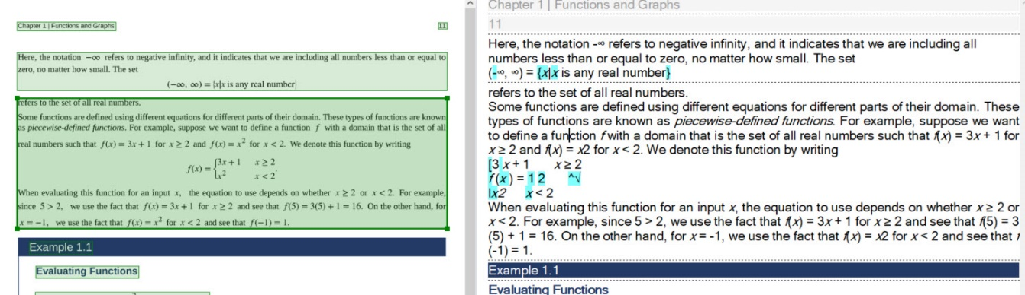
ABBYY Fine Reader OCR
Note: Most OCR programs will not output correct versions of the math equations. It will be necessary to correct the mistakes in the next step.
- Use MathPix or EquatIO OCR tools (see this guide) to recognize the math in the PDF
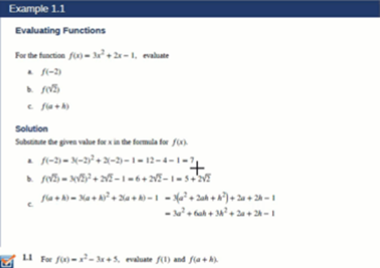
Math OCR - MathPix
- Paste OCRed math into the MS Word document
- Replace the incorrectly formatted math (from Step 1) with the recognized math (steps 2-3).
Note: Due to the time-intensive nature of this conversion, we recommend working with your Disability Services Department who may assist with conversion.

LaTeX to Word
- Use GrindEQ Math LaTeX to Word to open the LaTeX file in MS Word
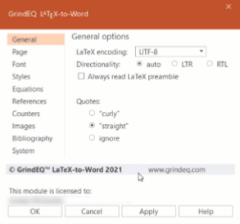
GrindEQ LaTeX to MS Word
- Correct any math that is not properly formatted
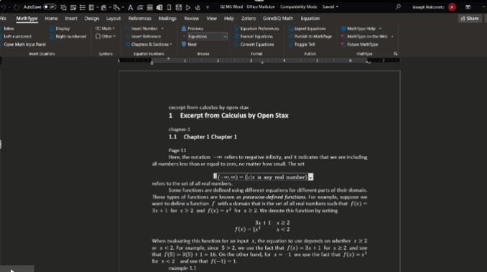

Word to HTML
This workflow requires the use of WordToEPUB.
Plain text link: https://daisy.org/activities/software/wordtoepub/
- Format all math as Office Math (OMML) or MathType
- Select WordToEPUB on the MS Word ribbon
- Select the Advanced Mode.
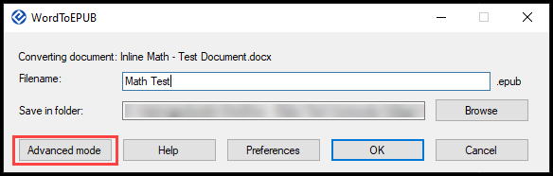
WordToEPUB Menu
- Select the HTML tab and then select Create HTML Version
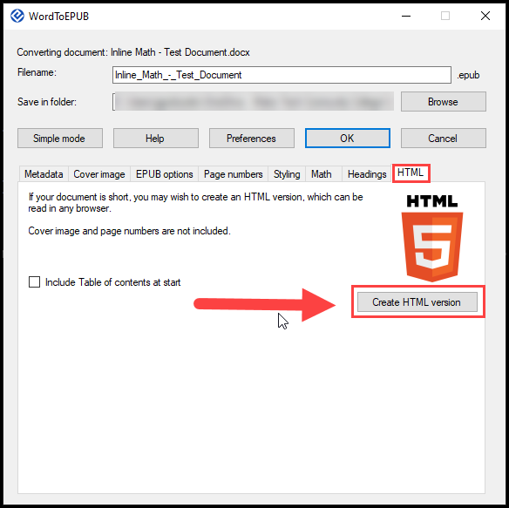
WordToEPUB - Create HTML Vord to EPUB
This workflow requires the use of the WordToEPUB tool developed by the DAISY Consortium. WordToEPUB allows users to convert accessible word documents into EPUB3 format. This tool should only be used to convert source documents that have already been made accessible prior to conversion.
Plain text URL: https://daisy.org/activities/software/wordtoepub/
- Format all math as Office Math (OMML) or MathType
- Installed the WordToEPUB software. A button will appear on your Word ribbon, allowing you to create an EPUB in two clicks.
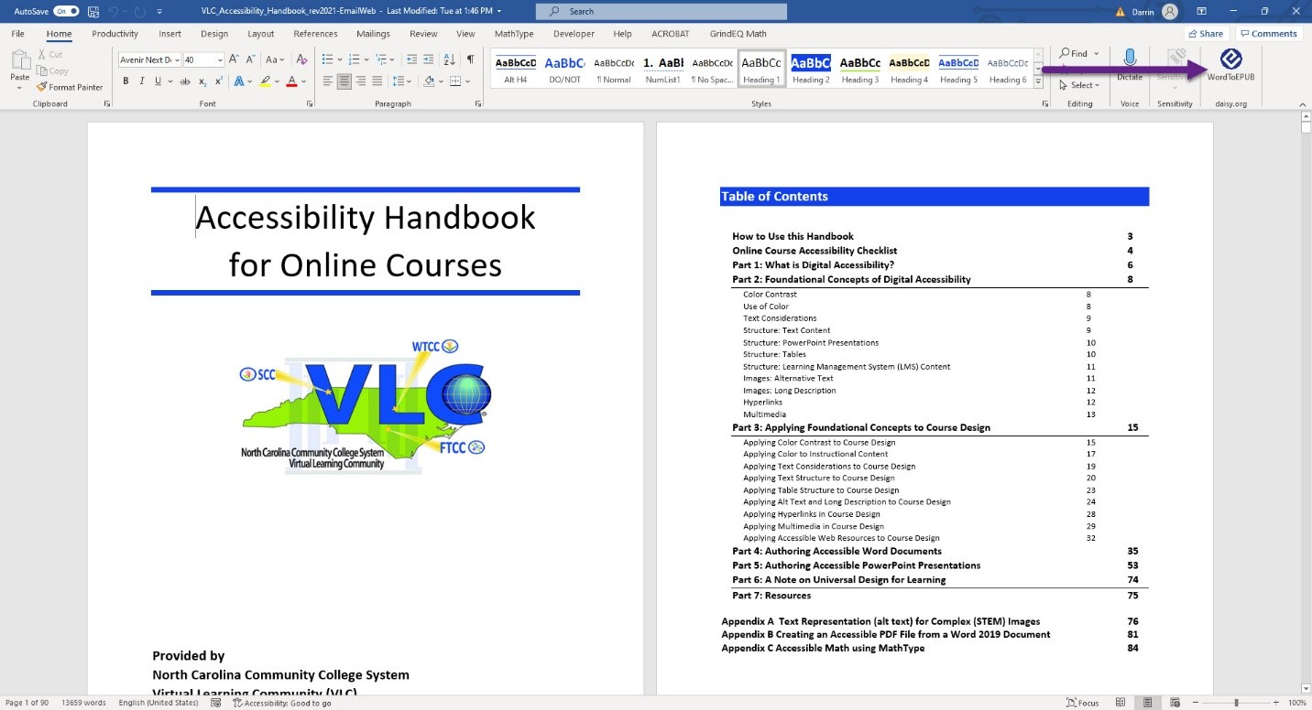
- Select the WordToEPUB button on the MS Word ribbon. A dialogue box appears.
- You can keep the default filename and folder location or change them.
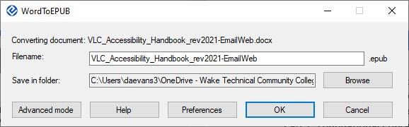
- Select OK. The software will begin converting the Word document to an EPUB file.
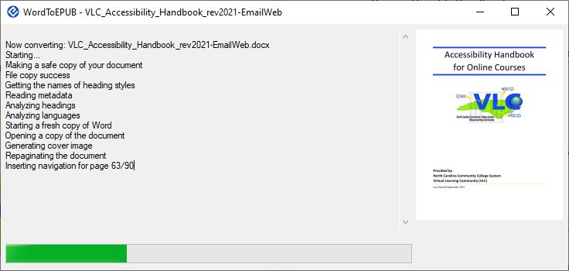
- Once the process is complete, the EPUB file will be saved to the folder selected at the start of the process.
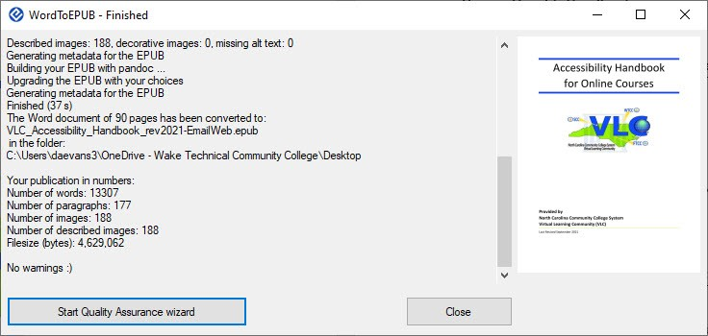
NOTE: There are additional things that you can do when creating an EPUB, such as add metadata etc. A detailed description of other authoring considerations when creating an EPUB is out of scope for this guide.

Word to Learning Management System
- Use WordToEPUB to convert a DOCX file to HTML (see steps above)
- Open the HTML file in a text editor, select all, and press CTRL + C (PC) or CMD + C (macOS) to copy to your clipboard

- In your Learning Management System (LMS), open the HTML source editor and paste the HTML content there.
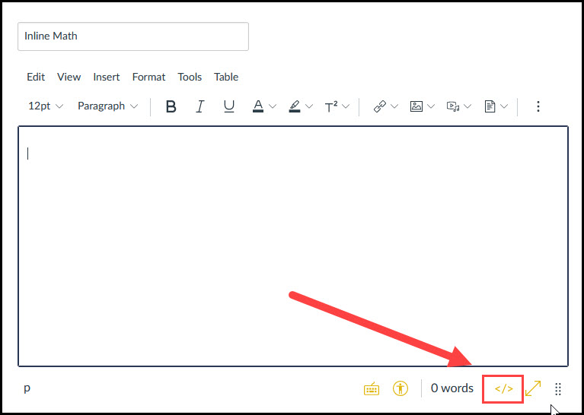
Learning Management System Source Editor (Canvas LMS)
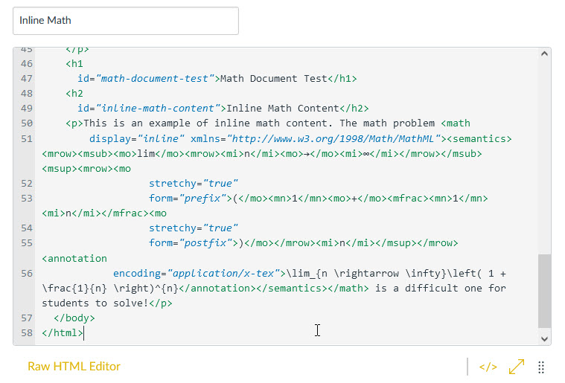
Learning Management System Source Editor with HTML Code (Canvas LMS)
- Edit the page to remove any repeated text.
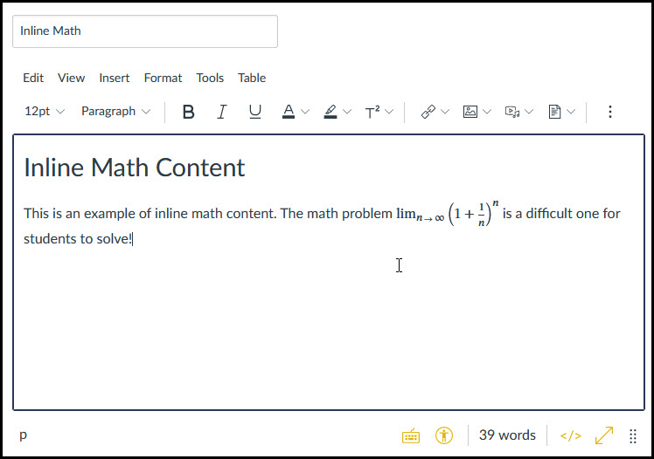
Learning Management System Edit Page Editor (Canvas LMS)

Creating Math Content

Using LaTex to Generate Content
LaTex (pronounced la-tek or lay-tek) is a typesetting markup language used globally by scientists, engineers, and mathematicians to develop discipline-specific documentation that supports reader access using the characters and symbols relative to their discipline.
Using LaTex to Generate Content
There are a few ways to use LaTex to generate Math content, to include using applications like Microsoft Word to insert lines of LaTex code into Word documents. This section of the handbook is dedicated to introducing some of the basic principles of LaTex to support authoring a document using LaTex and writing code snippets used in document authoring applications like Microsoft Word. Later in this guide, you will be introduced to practices related to using LaTex code snippets in platforms and applications.

Creating a Document Using LaTex
To create LaTex documents, you will need two pieces of software, one to gain access to the style and formatting used in the form of packages and the editor used to write the code for your documents. Some options for each of these components will be provided within this introduction to LaTex. The examples in this guide were created using a web-based editor called Overleaf. Plaintext Link: https://www.overleaf.com/ This application can be used to develop, troubleshoot, and view the LaTex document as you are creating it. The image below contains the required LaTex document elements and a few useful package commands. These elements are explained below:
- The creation of a document begins with what is called the preamble, declaring the type of document using the \documentclass command, accessing specific styles used to create your document by adding packages, and adding any document properties. This command lets the editor know you are creating a LaTex document.
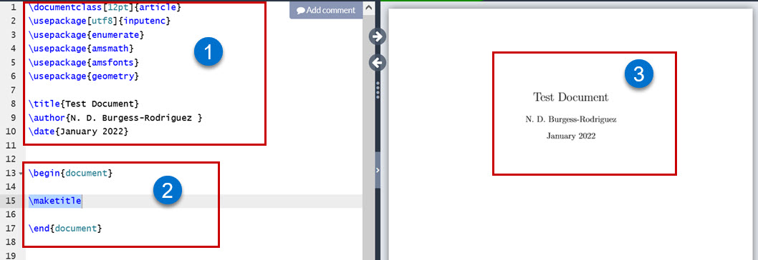
LaTex sample preamble and document content code in the Overleaf editor with preview.
Additional parameters may be used to define document options. You may decide to add parameters to set the overall font size and paper size for the document. The backslash, \ is an important character when creating content using LaTex. All commands, keywords associated with structuring the LaTex document will begin with a backslash. Following the backslash and command, is the argument encased in curly brackets. For commands that pass text arguments, you would enter the text that is to be displayed as the argument. For example, to add the document title, \title{Example Document Title} would be used. In the preamble, we will also include information about the document such as the document s properties and packages which will allow greater functionality.
- After setting up the document properties in the preamble, we will begin creating document content using the \begin{document} command to begin the document and the \end{document} command to mark where the document will end.
- In Overleaf, the preview panel provides the document result after compiling the LaTex code.

Example Preamble and Document Markup
The example preamble and document markup below can be copied, pasted -or typed into Overleaf, and compiled to see the results rendered in the preview pane. After the results have been reviewed, try modifying the arguments within the curly brackets for the title and the document text to begin using LaTex in Overleaf using this template.
\documentclass[12pt, letterpaper]{article}
\usepackage[utf8]{inputenc}

\title{Test Document}
\author{N. D. Burgess-Rodriguez }
\date{January 2022}

\begin{document}
My document content will be created between these two commands.
\end{document}

Common Document Elements and Formatting
There are many elements and formatting practices used in creating documents. The table below provides some of the commonly used elements and specific formatting applied in documents. The example LaTex code listed in the table can be copied and pasted into the Overleaf editor to get a preview of how the LaTex code would render in a published document. Be sure the example code is placed between the \begin{document} and \end{document} commands.
Table 1: Common Document Elements and Formatting
Element | Command | Example LaTex Code
Numbered List | \begin{enumerate}  \item  \end{enumerate} | \begin{enumerate}  \item First Item  \end{enumerate}
Bulleted list | \begin{itemize \item\end{itemize} | \begin{itemize \item Gather\item Analyze,  \item Conclude,  \end{itemize}
Page Break | \pagebreak[] | \pagebreak[1]
Line Break | \\ | add \\ at the end of any line
Table | \begin{tabular}  \end{tabular} | \begin{tabular}{ |c|c|c| }  \hline  cell1 & cell2 & cell3 \\  \hline  cell4 & cell5 & cell6 \\  \hline  cell7 & cell8 & cell9 \\  \hline  \end{tabular}
Italics | \textit{} | \textit{Italicized Text}
Bold | \textbf{} | \textbf{Bold Text}
Section | \section{} | \section{My Next Section}
Section No Number | \section*{} | \section*{My Last Section}

Using the Code Snippets in Overleaf
As you begin typing a command in Overleaf a dropdown menu will also populate, allowing you to select the command from the list and in most cases, insert code templates for the specific command:
- Type the command. We will use the \begin command for this example,
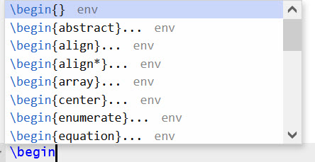
- Select a command from the list. We will select the enumerate command from the dropdown list to create a numbered list.
- The LaTex code snippet for the enumerate command appears in the editor.
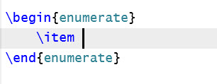

Working with Packages
Packages are code presets that allow LaTex to recognize specific keywords and code structures. There are many uses for packages. The packages command \usepackage{} is used to call a specific package with the package name provided as the argument. The Overleaf editor provides a list of common package commands in a quick dropdown menu as you begin to type the \usepackage command.
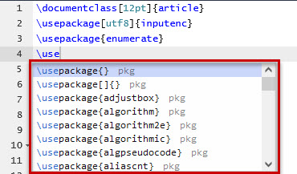

Creating Math Content Using LaTex
There are two ways or modes to add math content to your LaTex document: display mode and inline mode. Display mode will cause the math content to be created separate from the document body text, centered on its own line. Inline mode will cause the math content to be created aligned with the document body text. The LaTex code for each mode will differ, as each syntax form is specific to the placement, style, and display of the math content. The math content will be added between the separators (delimiters) used for each mode type:
Display Mode will use:
- $$ $$ (common shorthand format used)
- \[ \]
- \begin{displaymath}
\end{displaymath}
- \begin{equation} (adds sequential numbering to the equations)
\end{equation}
Inline Mode will use:
- $ $ (common shorthand format used)
- \( \)
- \begin{math}
\end{math}
The AMSmath (American Mathematics Society) package should be added to the preamble to create math content using the most common math commands. The packages most helpful in creating math content are:
- amsfonts provides fonts and alphabet specific to math notation.
- amssymb loads amsfonts, defines all the symbols and associated names.
- amsmath defines and loads math typesetting features and collections.

Using the Math Equation Editor in Word
The math equation editor in Word will accept LaTex code and display the rendered code in your document. Code snippets from your LaTex code editor (Overleaf is used in this guide) can be copied and pasted into the equation editor to streamline the process of building your math content in Word. To access the math equation editor and use LaTex code in the editor:
- Select insert from the Word ribbon menu,
- Select equation from the Symbols group,
- Select insert new equation at the bottom of the drop-down menu after the built-in equation options
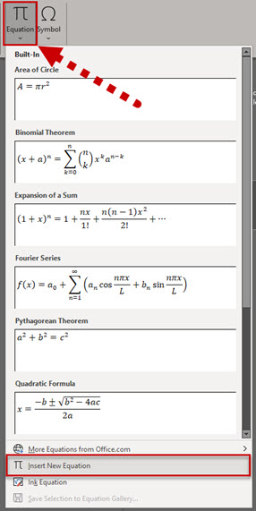
- The equation insertion box appears in the document.
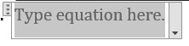
- The Equation menu option and tools appear in the ribbon.
- Confirm the LaTex button is selected (toggled on).
LaTex button in the conversions group on equation tab of the ribbon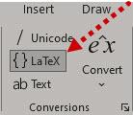
- In the equation insertion box type or paste your LaTex code and press Enter.
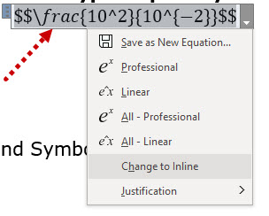
- The equation will appear in your document in display view.
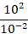

Common Math Commands and Symbols
As there are many symbols used in mathematical notation, we will provide an example of a few commands associated with the use of select characters that are most common in the table below:
Table 2: Common Math Commands and Symbols
Math Element | Command or Character | LaTex Code
Multiple Character Grouping | {} | $78-{34}$
Nesting | {{}} | ${{x^2}+7-{\sqrt{16}}}$
Superscript | ^ (caret) | $10^{-2}$
Subscript | _ (Underscore) | $3_{12}$
Ellipses | \dots | (i.e. Along came \dots)
Uppercase Greek | \Delta | $\Delta$
Lowercase Greek | \delta | $\delta$
Fraction | \frac | $\frac{13}{26}$
Squareroot | \sqrt | $\sqrt4$
Binomial coefficients | \binom | $\binom{7}{4}$

Additional Resource
There are many resources available to support learning LaTex. The YouTube video series created by Michelle Krummel, an educator in the Charlotte-Mecklenburg school district, has proven to be helpful. Plain Text Link: https://www.youtube.com/playlist?list=PL1D4EAB31D3EBC449 Other resources can be found in the references section of this guide.
- MathType
- EquatIO
- Learning Management Systems
Using Office Math
Microsoft Office applications contain a built-in equation editor, allowing users to author math equations in Office without the need to use external math authoring software.
Math equations that are authored using Microsoft’s built-in equation editor are called Office Math equations, which is short for Office Math Markup Language (OMML).
In Microsoft Word, an Office Math equation is accessible to screen reader programs, such as Job Access with Speech (JAWS) and Non-Visual Desktop Access (NVDA). Students using these assistive technologies do not need to purchase another program to access math in a MS Word document that has Office Math equations.
If it is necessary to convert a MS Word document to another format for a student, Office Math equations can be converted easily. Programs like MathType can convert Office Math equations into MathType equations. Pandoc, a command line tool, can also convert a MS Word document with Office Math equations to HTML.
Authoring MS Word documents with the built-in Equation Editor in MS Word can be used to author accessible math content and can be a good starting point in other accessible document workflows.

Creating Office Math Expressions
To access the MS Office Equation Editor in MS Word, simply select the Insert tab and then select Equation.
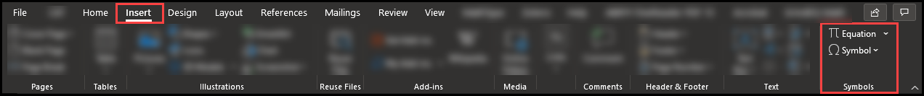
A toolbar will then appear which enables you to insert Office Math. There is a Symbols area and a Structures area, both contain templates for various math concepts.
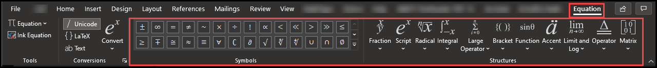
In the body of your MS Word document, you will also see a window with the words, “Type equation here.”
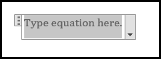

Tips for Authoring Math in MS Word
- Use shortcut keys.
You can press ALT + = to start a new equation.
- Avoid clicking on the symbol palette when it’s unnecessary.
For simple arithmetic, basic algebra, and other simple math statements, just typing the numbers, operators, or variable letters will suffice.
- Do not enter space inside the math equation.
Spaces can interfere with the math being interpreted properly by assistive technologies and math conversions. Press the Right Arrow to exit the equation editor box.
- Apply the text style to words inside a math equation.
Select the items that are text and then select the Text button on the ribbon:
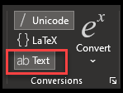
Words should appear in regular, not italicized, script.
Correct:
$$\frac{\text{the number of men}}{\text{the number of women}}$$
Incorrect:
$$\frac{\text{the number of men}}{the number of women}$$
- Learn how to author math in Unicode or LaTeX.
It’s faster to type math in a linear fashion and convert to Office Math, which is possible if you know Unicode syntax or LaTeX.
In MS Word, you can select Unicode or LaTeX from the Conversions group on the ribbon and then enter CTRL + = to convert your math to the Office Math encoding.
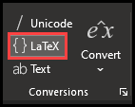
For example, if I enter the following LaTeX in the Office Math equation box and press CTRL + =, my LaTeX will become Office Math:
Before:
\frac{1}{2}
After:
$$\frac{1}{2}$$

- Draw your equation!
- Press the Ink Equation in the Equation toolbar and draw your equation.
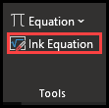
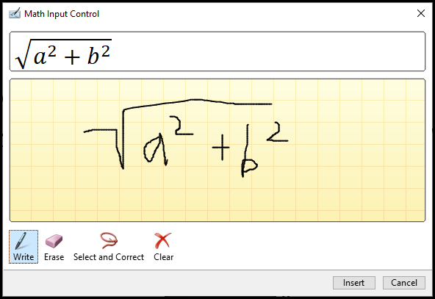
When you press Insert, MS Word will insert your equation as Office Math.
- Add common templates to MS Word’s Quick Access Toolbar.
MS Word’s Quick Access Toolbar can retain a shortcut to one set of math “structures” that you might find yourself using a lot. Selecting the shortcut can save time.
- With one of the math structures open, right-click and select Add Gallery to Quick Access Toolbar:
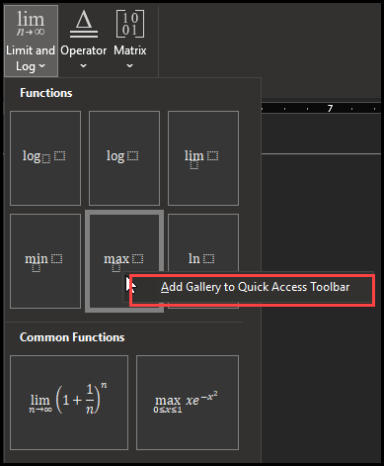
Now the math structure will appear on the Quick Access Toolbar for easier access.
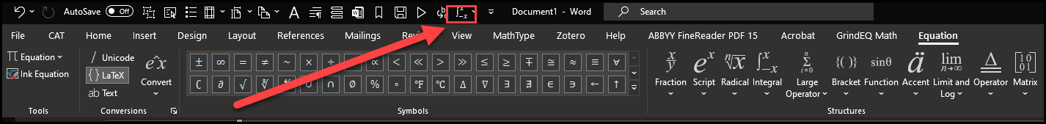
Note: The Quick Access Toolbar can appear above or below the ribbon. See File > Options > Quick Access Toolbar to adjust.
Additional Resource
For more information on accessing math using JAWS visit Freedom Scientific’s website.
Plain Text URL: [https://www.freedomscientific.com/training/teachers/accessing-math-content-with-jaws-and-fusion/]

Using MathType in Word
Before improvements to screen reader technology and Microsoft Office were made to better support math accessibility, many institutions opted to using MathType. As many institutions have established a practice and workflow for content development with MathType as their primary tool for authoring accessible math content, they may still be in the practice of using MathType. Here are a few tips and cautions to support using MathType more effectively:
- When creating a MathType document, always check it afterward.
  - Review the document with a screen reader to make sure that the equations read correctly, if possible.
- Avoid automatic formatting.
  - Type out all numbers and letters when formatting your document
  - Equations will not be read correctly by the screen reader.
- Only create and enter one equation at a time with MathType in a document
  - Avoid multiple or sets of equations.
  - The screen reader can only read one equation at a time.
  - Multiple equations will be grouped together in one object as a “table.”
- Always include headings for directions and sections of the document for easier navigation.
- Always include descriptions/alt text for any graphics and/or images in the document.
- If tables are included, make sure to create column titles.
  - Format as headings for easier navigation.
- When the document is finished
  - Select all, make all text black, and
  - Set the language.
- Never use textboxes.
  - The screen reader cannot navigate inside of them.
- In your instructions for accessing online content, use:
  - Select versus Click in your instructions.
  - “select the link” rather than “click” or “click the link.”
- Do not use ableist language. If you are creating documents for a student who is using a screen reader:
  - you may need to modify the directions depending on the assignment.
  - students using the screen reader can underline their answer choice instead being asked to circle answers.

Creating Accessible Math Content in Your LMS
We all know all Learning Management Systems (LMS) have not been created equal. Our approach to developing accessible math content may differ depending on which LMS our institution is using. There are at least three different environments within the LMS where you may publish your math content:
- Course content area pages,
- Files area, or
- Assessments.
From testing, research, and experience using the most common Learning Management Systems, we have gathered the following guidelines to support developing accessible math content. We discuss practices for Canvas, Moodle, and Blackboard.

Moodle
Like Canvas’ Math Editor, Moodle’s Equation Editor also lets you author equations using LaTeX.
- Select the Equation Editor button
- Enter LaTeX or use the toolbars
- Select Save and Display; the math will be rendered with MathJax.
When you enter LaTeX in the Equation Editor, leave out the math delimiters.
You can also type math directly in Moodle’s Rich Text Editor. When you do this, you must use the \(…\) or \[…\] delimiters not $…$ or $$…$$.
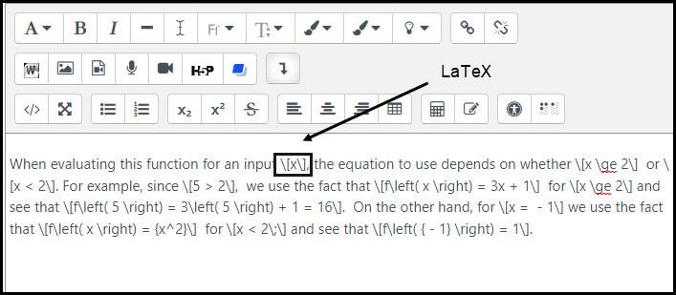
Moodle LMS - LaTeX Math

Creating Accessible Math in Moodle
Some Moodle instances come with the MathJax plugin and this allows for the creation of screen reader accessible math content. In this section we will give you a brief overview of creating accessible math notation in Moodle.
- First, check and see if your Moodle instance has the MathJax plugin installed. You will need to check under site administration > Plugins overview.
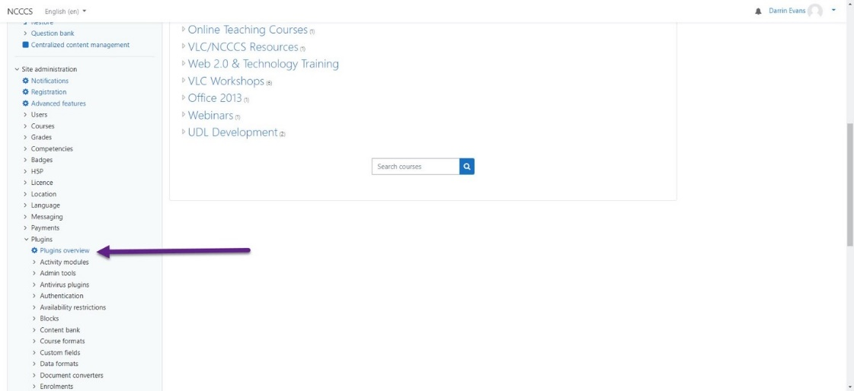
- Confirm that you have the MathJax plugin installed by expanding Filters.
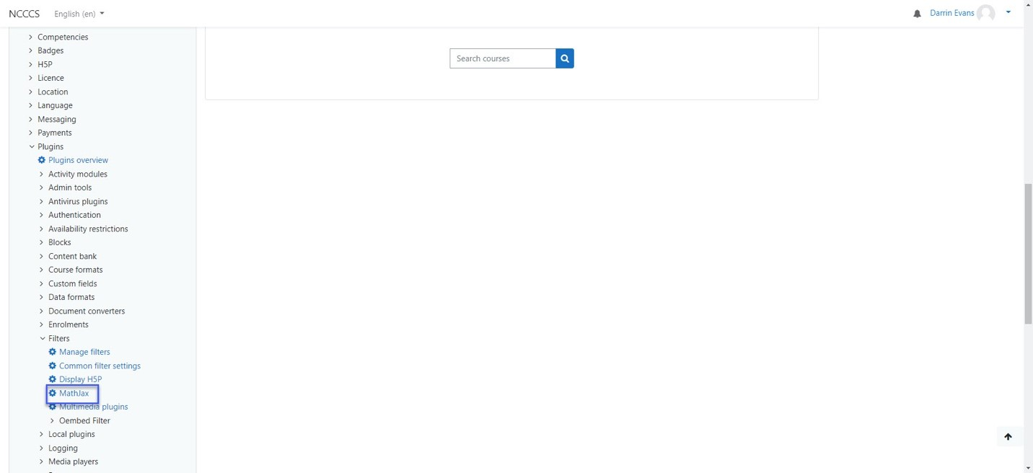
- A local MathJax installation page will open. This MathJax filter will allow you to create screen reader accessible math within Moodle.
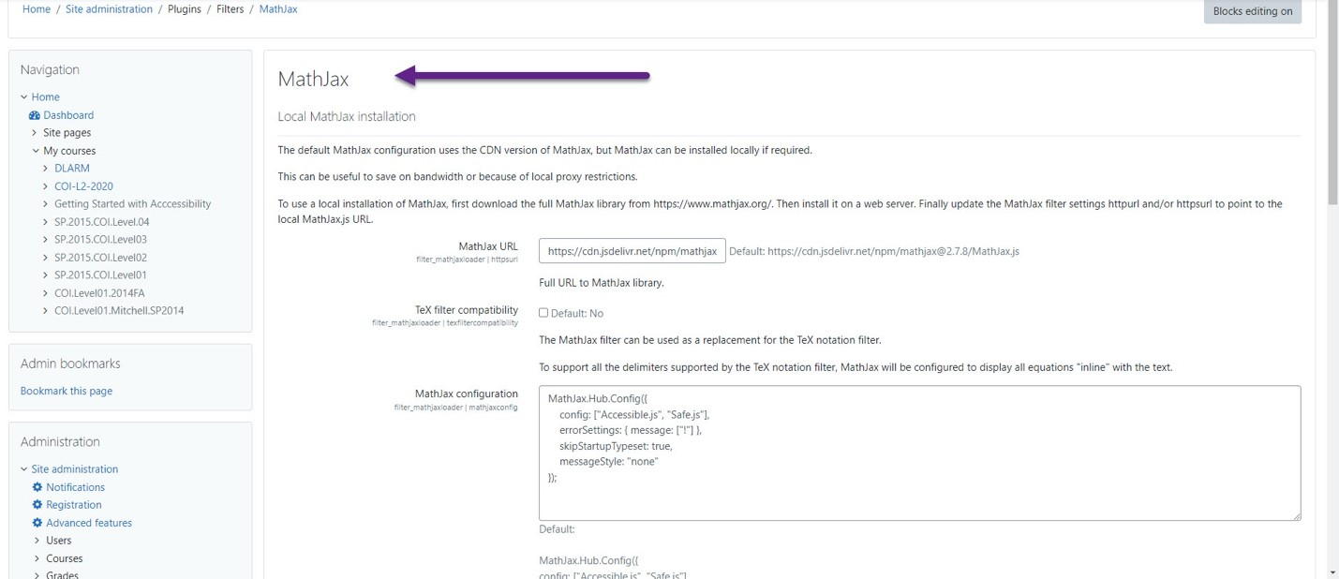
- You are now ready to use the built-in Moodle math equation editor to add content to your course.
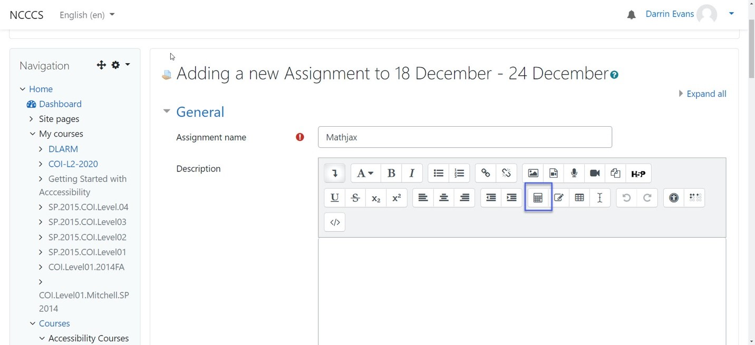

Using the Moodle Math Equation Editor
We will explore the built in Equation editor to see some of its functionality, showing different aspects of the built-in editor, starting with Operators.
- Many mathematical operators are available to construct the math content you need for your course. The screen reader accessible content is created using TeX and the MathJax filter.
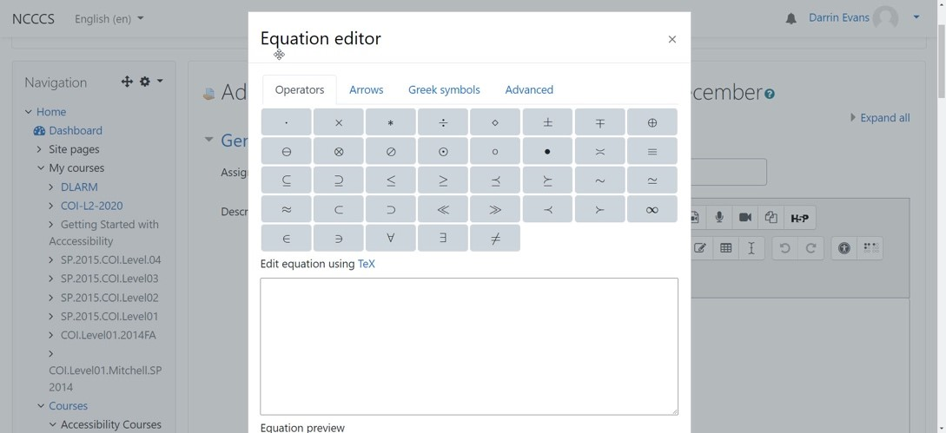
- The Arrows tab contains the many arrows used in math expressions.
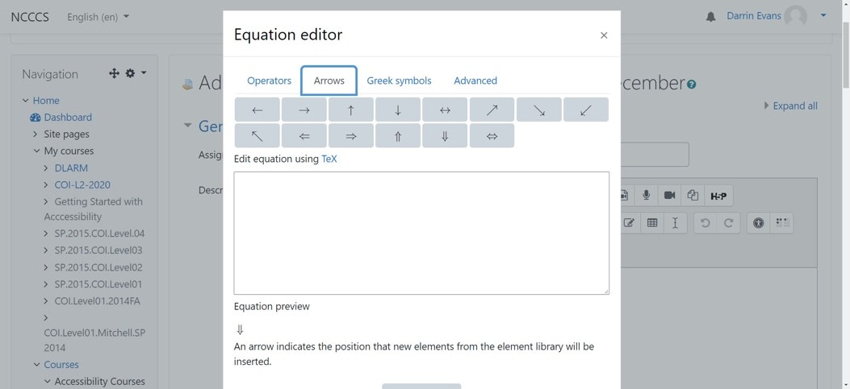
- The Greek symbols tab contains the uppercase and lowercase Greek symbols.

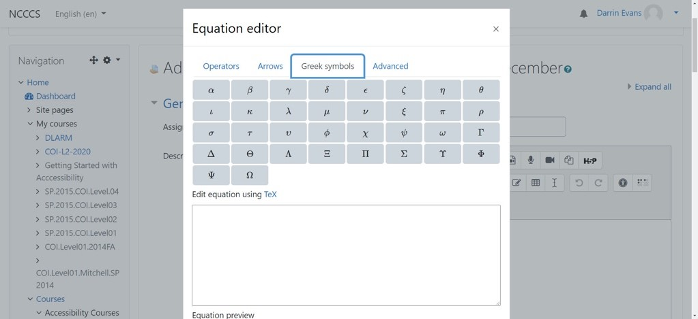
- Lastly, in selecting the Advanced tab we can add advanced math expression elements using the built-in equation editor.
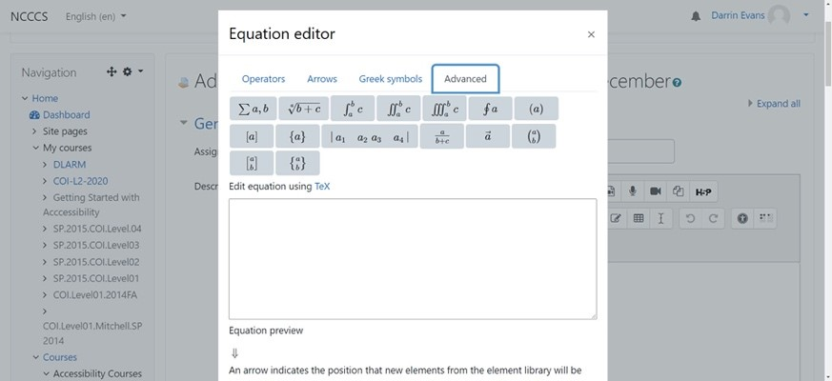

Canvas

Canvas Course Pages and Quizzes
When you are authoring course pages or quizzes in Canvas, use the integrated Math Editor.
The Math Editor allows you to author new equations using LaTeX. You can paste LaTeX math into the editor as well. No math delimiters ($ or \[) are needed.
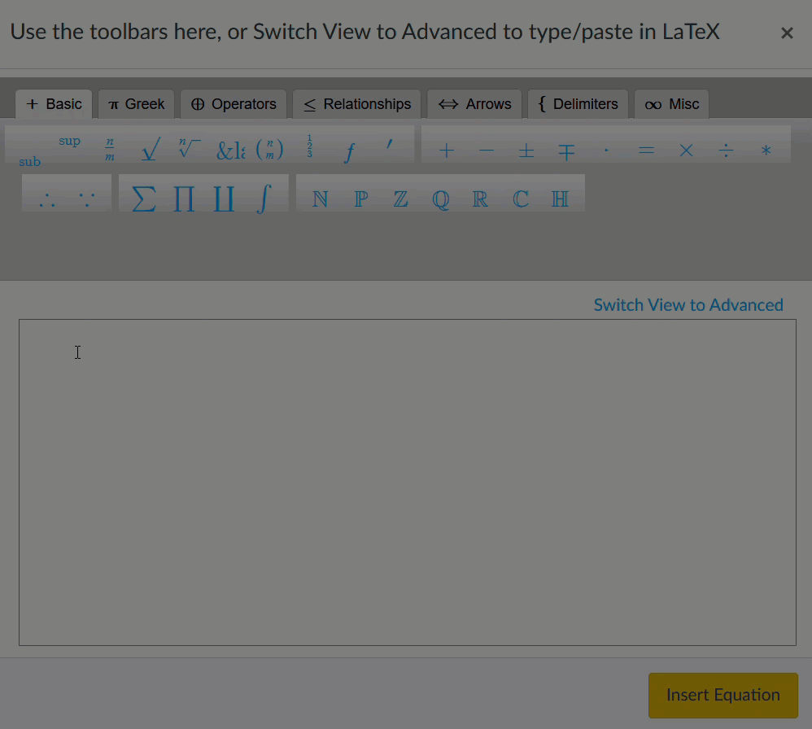
Canvas Math Editor - LaTeX Entry
You may also use the toolbars in the Math Editor. When you insert an equation that has been authored using Canvas’ Math Editor, the math will be rendered using MathJax (currently Instructure supports MathJax 2.7x).
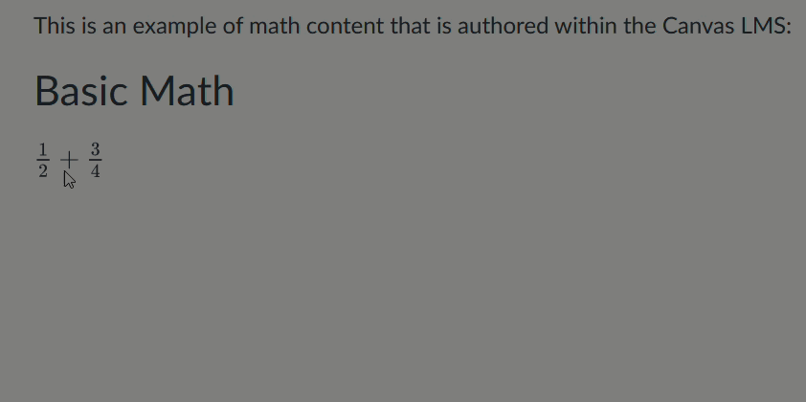
Canvas Math - MathJax Rendering

Canvas Files Area
If an HTML version of your math document is posted to the Files area in Canvas, students can simply select the file name and read the document in Canvas’ Preview screen.
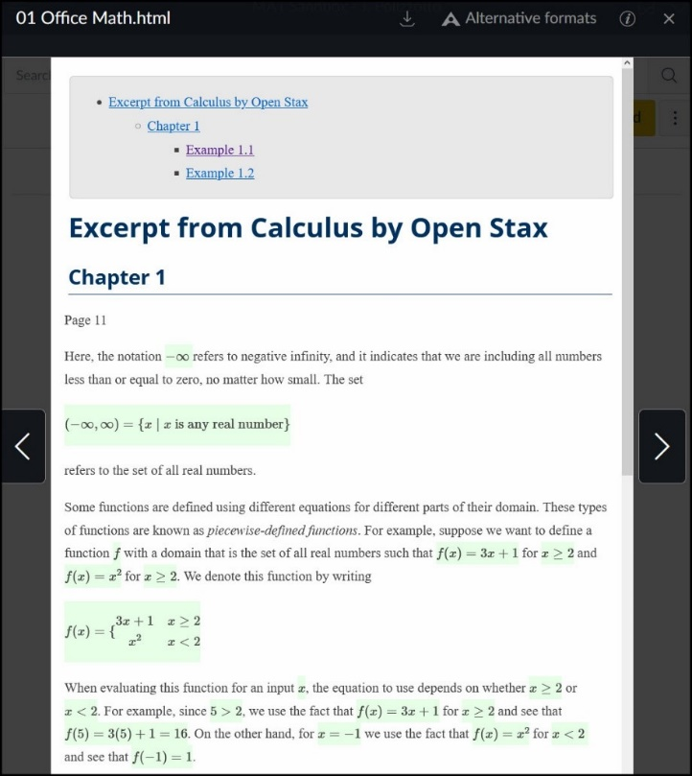
Canvas Files Area - Document Preview

Note: Canvas has a New Quizzes feature that can take the place of Classic Quizzes. At this writing (1/27/2022), New Quizzes is not as accessible as Classic Quizzes, as it uses LaTeX math notation and is not rendered via MathJax. For now, please use Classic Quizzes.

Blackboard
Blackboard’s math editor is MathType by Wiris. The MathType editor allows LaTeX entry like other math editors and has many robust toolbars.
A math equation that has been authored using the MathType Editor in Blackboard will appear, however, as an image in the Blackboard course, which is not an accessible version of the math.
As a workaround for this limitation, we recommend entering math in the Rich Text Editor using LaTeX. Then add the path to the MathJax CDN in the source code:
- Enter LaTeX in the rich text editor area, using \(…\) for inline equations and \[…\] for display equations.
- Select Source Code
- Paste the path to the MathJax CDN:
<script type="text/javascript" async="" src="https://cdnjs.cloudflare.com/ajax/ libs/mathjax/2.7.7/latest.js?config=TeX-MML-AM_CHTML"></script>

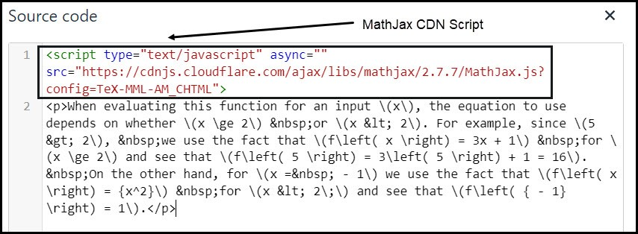
Blackboard LMS Source Code – MathJax Script

Visual Math Editor
If you don’t know LaTeX or the built-in calculator is nor robust enough for you Visual Math Editor is a tool that can help. Visual Math Editor is a free tool that will allow you to write LaTeX using common math symbols. Plain Text Link: http://visualmatheditor.equatheque.net/ Simply navigate to the site and select the get started button.
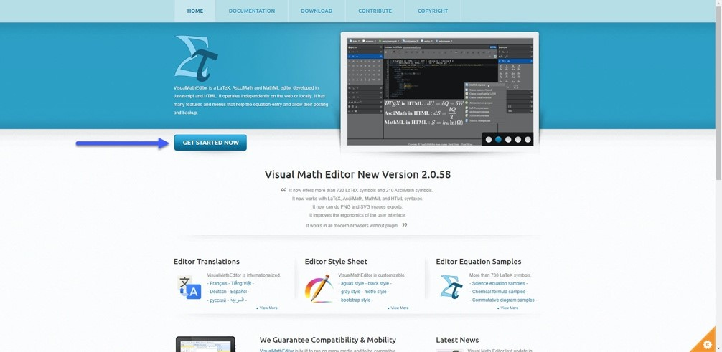

The editor uses JavaScript and HTML to create LaTeX you can copy and paste into your LMS.
- Once you select ‘Get Started Now’ you will be taken to the calculator application and a sample equation.
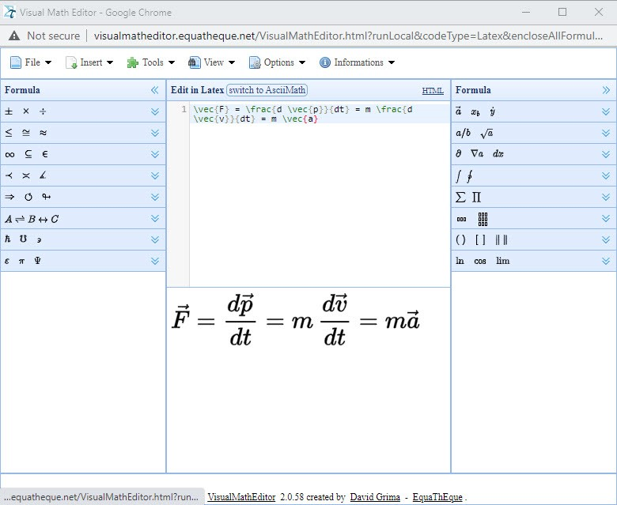

- Copy the equation text.
- Paste it into Moodle.
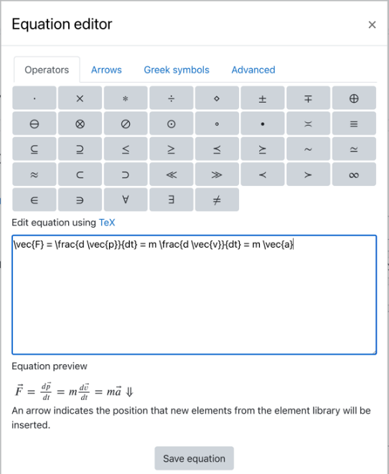

Select and delete the equation to start adding your own content using the built-in calculator. You have the option of creating the math in LaTeX, AsciiMath, or HTML. The application also contains extended math element and symbol menus.
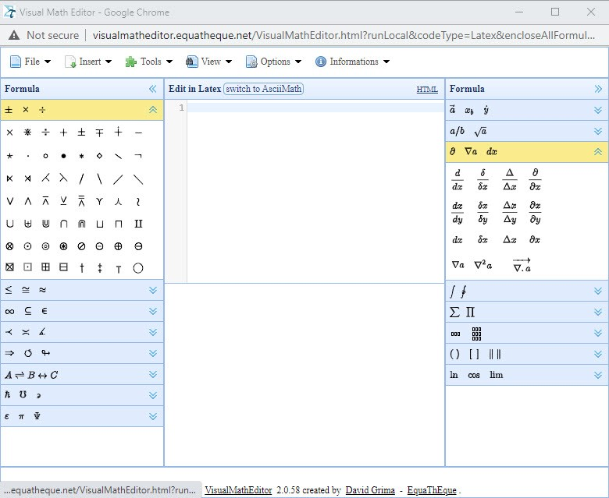
Visual Math Editor website plain text URL: http://visualmatheditor.equatheque.net/
Converting Math Formats

The Polizzotto Method
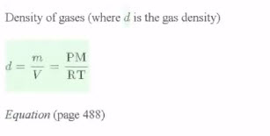
Polizzotto Method rendered math example
The Polizzotto method is a math format conversion tool used to convert equations created using the Microsoft Word equation editor (Office math format) to HTML format. This method uses a BASH script built upon Pandoc, run from the command line on a personal computer (PC) or terminal on a Mac. The examples in this guide have been created running the script from a PC. It is understood that this method may not become a standard practice for novice script users but is included in this accessible math guide as an option. It is our intent to introduce this method and allow accessibility practitioners to decide the methods, techniques, tools, and strategies that best suit their needs.
The workflow followed by the developers of this method begins with math expressions created using the MS Word equation editor or expressions that have been converted to the Office math format, followed by using the script to convert the document to HTML. For math content or documents created in other formats, the math conversion section of this guide addresses how to convert other formats and the conversion tools used. Please refer to the conversion section for support in this area.

Using the Script
Let us look at some of the basic requirements to begin using the DOCX-HTML Bash Script:
- Install Pandoc
- Access Github, download script and setup assets
Git Bash for Windows must be downloaded for PCs to run the script
- Open the Command line window, if using a PC or Terminal, if using a Mac
- Type the command to provide the path for the file that will be converted
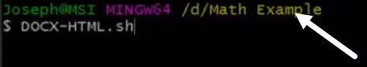
- In file explorer, locate the file and use the right-click menu to run Git Bash from the file location.
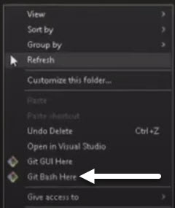
- The command line terminal will open
- The file path (/d/Math Example) appears in the terminal
- Type in the command to run the script: DOCX-HTML.sh
- Press Enter
The script will scan the directory for the file and perform the conversion, creating a folder using the filename, and save the HTML file in this folder. In the terminal, a conversion results message will appear. Successful conversions will be marked as "Done."
The HTML will also be validated with any warnings and errors provided in the results. The results will also advise of the green background formatting applied to all the math equations that were identified and converted in the new HTML document. Finally, the results will advise of a copy of the original .docx file being moved to the Converted-DOCX-HTML folder.

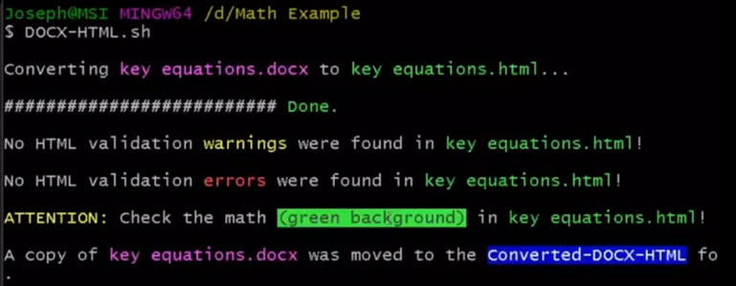
DOCX-HTML Script Result

Setup Instructions in Github
For more information related to the Polizzotto method, visit the DOCX-HTML Github site to gain access to complete setup instructions, links to required software, and additional resources. The installation of the required software and setup can be coordinated with your college s IT department. A snippet of the setup instructions is provided below as a preview of what is required to use the script:
- Install Pandoc
- Download the DOCX-HTML.sh script to your macOS or PC
- Place the script in an easy-to-locate folder (C:\scripts\ for PC or ~/scripts/ for macOS)
- Create a "stylesheets" folder in your C:\stylesheets\ drive (PC) or in your Home directory ~/stylesheets/ (Mac); Name your default stylesheet "standard.css"
- Download and unpack the NuHTML zip folder to your C:\ drive (PC) or to your Home directory ~/ (Mac). On a PC the path to the vnu.bat file should C:\vnu-runtime-image\bin; on a macOS, the path to the vnu.jar file should be ~/.
- Place Tasklist.exe in the C:\scripts\ folder (PC only)
Note: If you want the script to be available systemwide on a PC, place it in the following folder: C:\Program Files\Git\usr\bin; on macOS, place it here: /usr/local/bin. On macOS, you will need to show hidden folders to access this directory in the Finder window. Use CMD + Shift + to reveal hidden folders/files and then use it again to hide them.
Uses: This method is used to convert Microsoft Word documents that contain Office math format

Converting Images of Math Using OCR

Optical Character Recognition
Optical character recognition (OCR) is the process of converting a picture of text into selectable or editable text. From now on, we will be referring to selectable text as real text.
For example, the following image has the words, “Nice to meet you”:
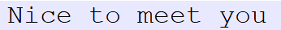
Imagine you wanted to add an exclamation point at the end of this text so that it read, ‘Nice to meet you!’ With just the image of Nice to meet you (above), I could not insert my cursor after ‘Nice to meet you’ nor copy the text to another document to add the exclamation point.
With optical character recognition software, however, I could grab the ‘Nice to meet you’ text from the image, insert it into my document and add the exclamation point.

Optical Character Recognition Software
Optical character recognition (OCR) software is useful when creating accessible digital content. OCR software makes it possible for you to create real text using technology, rather than manual hand-typing the text from a picture.
With large documents, especially, using an OCR software program can save you lots of time! OCR software can convert whole documents in image-only formats (.tiff, .pdf*, .jpg, .png, and .bmp) into text-based formats (.txt, .docx, .odt, .html, or .epub). For example, it can convert an entire .tiff file with an image of text into a .docx with text that is searchable -real text.
Abbyy Fine Reader Pro and OmniPage are two popular OCR programs used by Disability Support Services staff to convert a variety of documents. While these programs have many robust features, including support for multiple languages and zone-editing tools, they are not free and a description of how to use them is out of scope for this guide.
Note: PDF files can be either image-only or text-based, depending on the way that the PDF file was created. To know whether your PDF is image-only, try selecting the text in the document. If you can’t select the text, the PDF is image-only; if you can select the text, the document is text-based.

Adobe Acrobat Pro DC
Adobe Acrobat Pro DC, a tool for editing PDF files, has built-in optical character recognition capabilities that will convert the image-only PDF into real text.
Since many Higher Ed institutions have a license for Adobe Acrobat Pro and since PDF is such a popular file format, it is important that you are aware of this tool as well as its limitations in converting math content.

Adobe Acrobat Pro Optical Character Recognition
Let s say you have an image-only PDF that you want to convert to DOCX. You can tell that it is an image-only PDF because you cannot select the text in Adobe Acrobat Pro DC. The text cursor also does not appear when you hover the mouse pointer over the text, a crosshair icon appears instead.
How would you use Adobe Acrobat Pro DC to convert this image of text into real text? The process is simple:
Select the Edit PDF tool in the toolbar on the right:
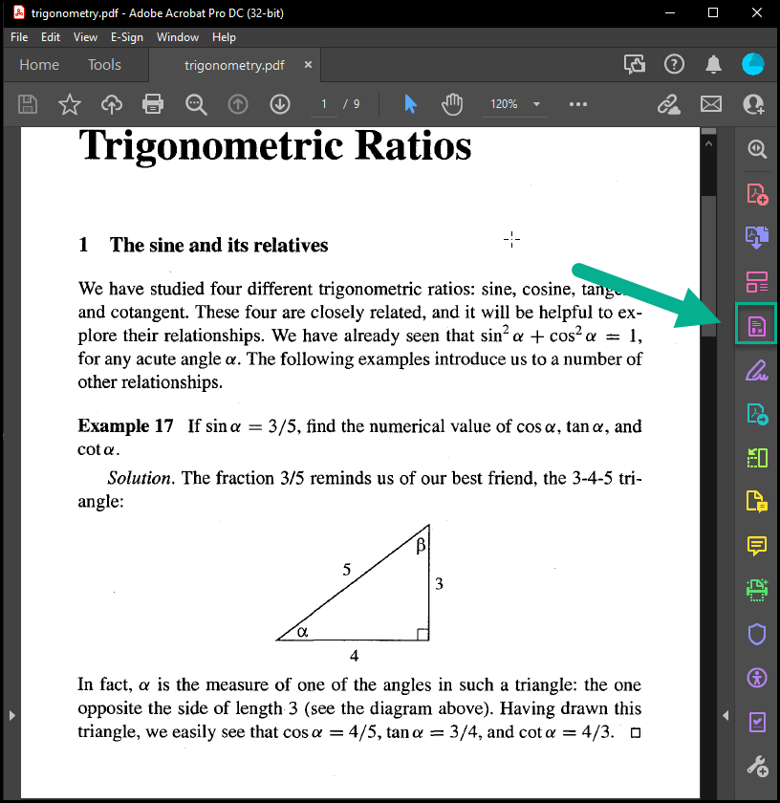
Adobe Acrobat Pro DC - Edit PDF
This conversion should happen quickly.
You may then see a window that states “Text has been recognized”
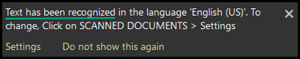
Adobe Acrobat Recognition
You will notice that text areas on the page now have border outlines and you are able to select the text.
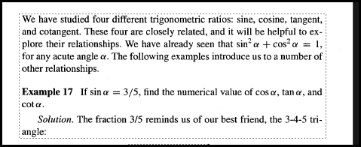
Adobe Acrobat - Recognized Text Area
Now, save the document. That’s it! You have created a text-based PDF with real text from an image-based PDF!

Adobe Acrobat Pro: OCR Settings
If you want to convert a foreign language document, you can open the Scanned Document Editing Settings menu (Edit PDF tool > Settings). Then select the language that is in your document from the Recognize Text in dropdown menu.
Selecting the language should improve the accuracy of the Adobe Acrobat conversion of your document.
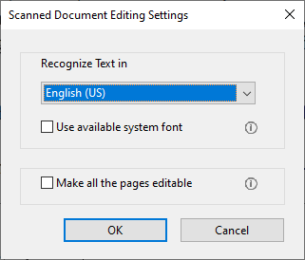
Adobe Acrobat - Scanned Document Settings
You may also want to select the Make All the pages editable checkbox. When you select this checkbox, Adobe Acrobat Pro DC will perform optical character recognition on every page in your document you will not have to go to each page to make the pages editable.

Adobe Acrobat Pro: Export Options
You can save a PDF as a text-based format (e.g., .docx, .txt) by going to the File > Export To menu and selecting the document type you wish.
When selecting a text-based file format (.docx, .txt) from the Export menu option with an image-based PDF, Adobe Acrobat Pro will convert the images of text into real-text automatically. You do not have to convert the Image-PDF to a text-based PDF (using Adobe Acrobat’s built-in recognition tool) beforehand.

Adobe Acrobat Pro: Quality of Optical Character Recognition Process
What do the results look like when you use Adobe Acrobat Pro’s optical recognition tool? See the image below, which shows a before and after view when exporting an image-only PDF to a DOCX file.
On the left is the image-only PDF (original document) and on the right is the text-based DOCX file:
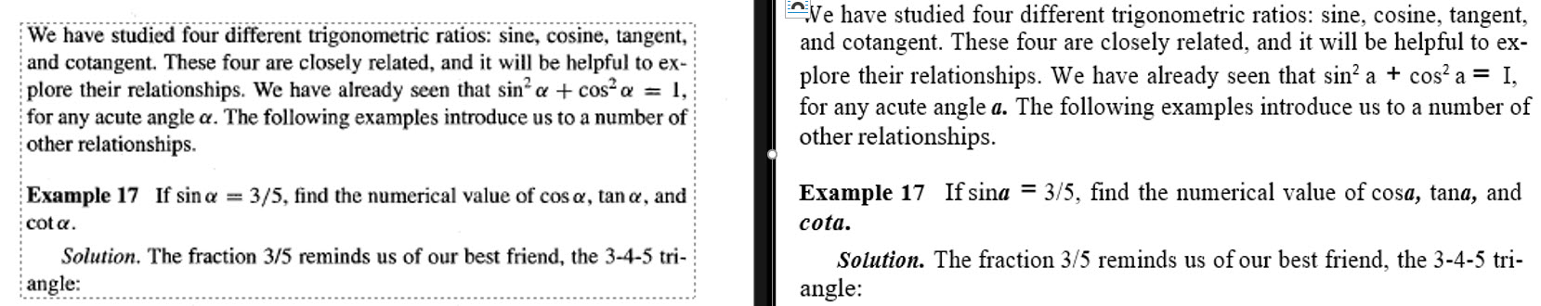
Adobe Acrobat Pro OCR Tool Before and After Examples
If you look carefully at the DOCX file on the right, which shows the results of Adobe Acrobat Pro’s optical character recognition tool, you may notice that some text from the original PDF was not converted quite accurately.
Some of the math elements, specifically, from the original document, seem to have been misrecognized in the conversion process. Notice in the third sentence of the first paragraph: becomes a and 1 becomes I.
These kinds of mistakes would take a lot of time and attention to correct! Imagine correcting an entire document with them!
The correct recognition of math content is not just a limitation of Adobe Acrobat Pro, however. Even OCR programs like ABBYY Fine Reader and OmniPage do not produce consistent and accurate results when you attempt to convert math content.
To avoid the effort of correcting mistakes with math content that was outputted by optical character recognition programs, including Adobe Acrobat Pro s built-in tool, we recommend using software that was specifically designed to recognize math content.

OCR: Software and Mathematical Content
All accessible content has text that is real text, not just pictures of text, and mathematical content is no exception to this rule.
When you create accessible math content, the math must be real text, which is usually math that you have created by using a math editor. But authoring math content from scratch can be a time-consuming process, especially when you are creating lengthy documents.
Since optical character recognition software is the process of converting pictures of text into real text, thus eliminating the need for you to hand type the text, using an optical character recognition program for math content is also an attractive possibility as you strive to create accessible digital content.
In the previous section we saw that optical character recognition software, such as Adobe Acrobat Pro s built-in text recognition tool, can have difficulties with math content, however. So, what optical character recognition programs are there that will do a good job of recognizing math content?
In this section, we will be sharing information about two programs, EquatIO and MathPix, that you might consider using at your institution if you want to use optical character recognition tools to help you with authoring accessible math content.
EquatIO and MathPix are popular tools among Disability Support Services staff and are catching on among math instructors as well. While they do have an associated cost, the time and effort you might save while using them to produce accessible content is worth your consideration!
This guide will provide a brief overview of these tools respective features and how you can implement them in the workflows we have shared with you in this guide.
As EquatIO and MathPix have active development and support, the look and functionality of these programs might appear slightly different than what we have shared in this guide at this writing (Spring 2022).
We are confident that these programs are reliable for you to start using at your institution and we hope that you do!
Infty Reader is another optical character recognition program that can convert mathematical content. It is used by some Disability Service Offices to convert lots of image-only documents with math. Because of the high cost and training involved with Infty Reader, however, a discussion of this program’s features and usage are out of scope for this guide.

MathPix
Math Pix is an optical character recognition program that recognizes mathematical content. It is available on macOS or Windows (PC) and can help you author accessible math equations more quickly.
Using MathPix
If you have a PDF file with math content, MathPix enables you to snip a math equation from the PDF and then paste the accessible math version into your MS Word document or learning management system. All you must do is draw a box around the equation that you want to convert and MathPix will do the work of encoding that picture of math into a more accessible version of math.
Another advantage of using MathPix is your snips will be stored to your MathPix account. You only must snip the math one time and then you can access the converted equation again from your MathPix dashboard. Accessing previously converted equations is especially helpful when you are working with long math formula or when a formula appears multiple times in your document.
Most of all, MathPix’s ability to recognize complex math formula, even handwritten mathematics, is impressive! Try it out on a long equation and see how it does!

MathPix: Getting Started
To get started with MathPix, go to the Downloads page and select the button for your operating system:
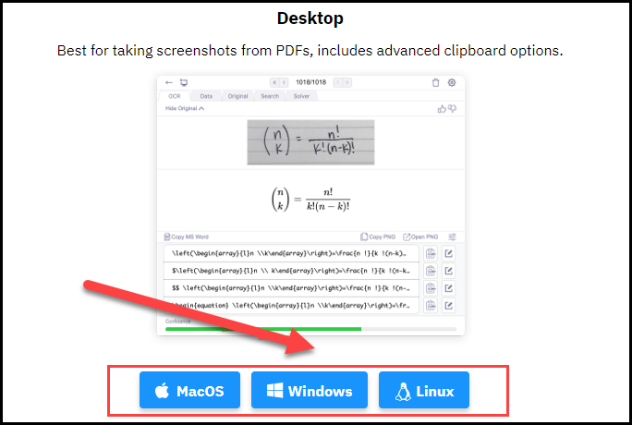
https://mathpix.com/#downloads
Once MathPix is installed, you will need to create a MathPix account before you can start using it:
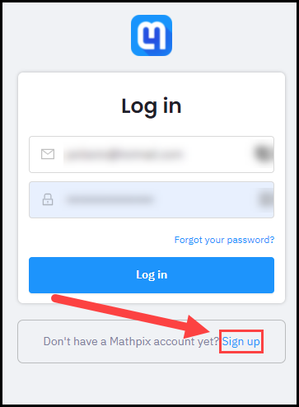
https://accounts.mathpix.com/login
When you sign up with the (free) educational plan, you can use MathPix 100 times per month.
For more information about how to install MathPix or how to sign up for an account, go to the Mathpix website. https://mathpix.com/docs/snip/overview
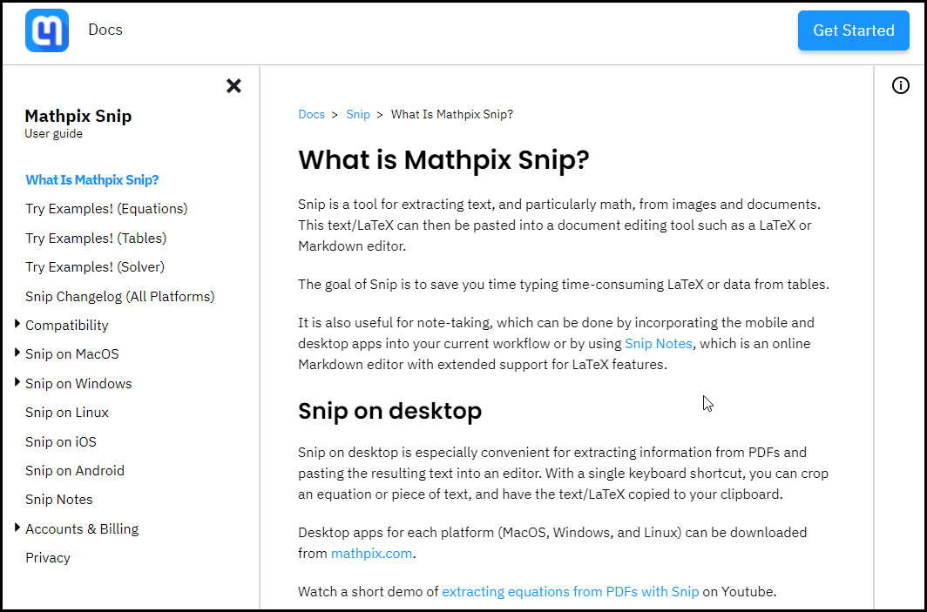

MathPix and MS Word
To add a math equation to your MS Word document using MathPix, follow these steps:
Use the MathPix shortcut for snipping content:
CTRL + ALT + M (PC) or CTRL + CMD + M (macOS)
- Draw a box around the math equation
- Either select the Copy MS Word button under the OCR tab
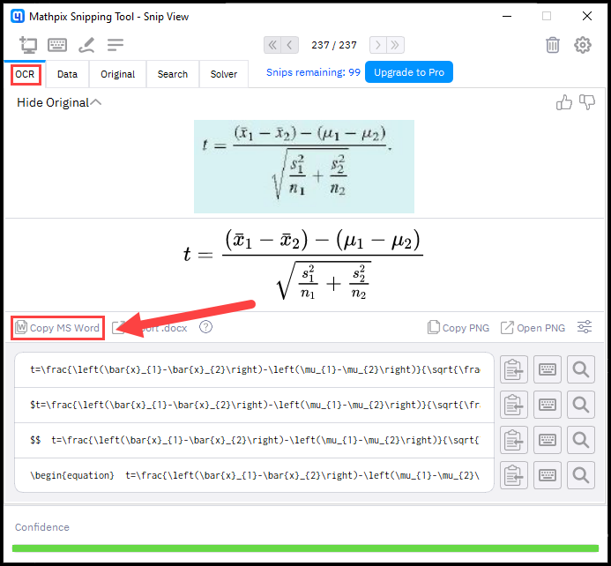
or select the clipboard icon next to MathML (MS Word) under the Data tab.
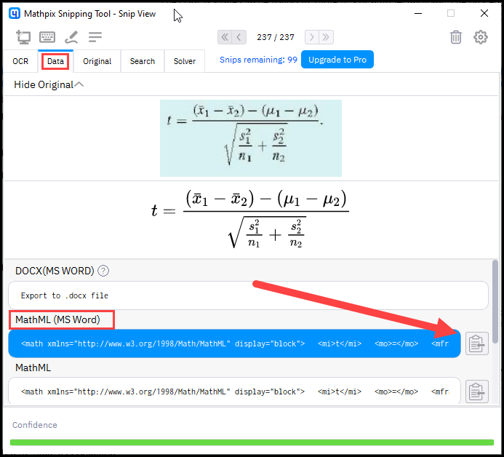
- Then Paste the equation into your document.
This converts mathematical expressions to an HTML document. The script has also been used to produce HTML documents that contain MathJax and SVG content.
The equation should now appear as an editable MS Word equation, not just a picture of math!

MathPix and Learning Management Systems
The steps for using MathPix with a Learning Management System (LMS) may vary slightly depending on the particular LMS that your institution uses.
Most Learning Management Systems allow users to input LaTeX math, but some Learning Management Systems let you enter LaTeX directly in the Rich Text Editor while others allow LaTeX input in the math editor only. Another variation is that some Learning Management Systems allow you to input LaTeX math with $...$ delimiters but not \[\].
It is important that you know which input area of your Learning Management System either the Rich Text Editor or the Math Editor allows you to insert LaTeX. Then determine which math delimiter the Learning Management System recognizes either $...$ or \[ \]. Whichever situation you are in, however, you will use MathPix to copy the LaTeX version of the math equation before you paste the equation into your LMS.
With your particular Learning Management System in mind, follow these steps to use MathPix to create accessible math content:
Use the MathPix shortcut for snipping content:
CTRL + ALT + M (PC) or CTRL + CMD + M (macOS)
- Draw a box around the math equation
- Select the clipboard icon next to your LMS preferred LaTeX formula under the OCR tab.
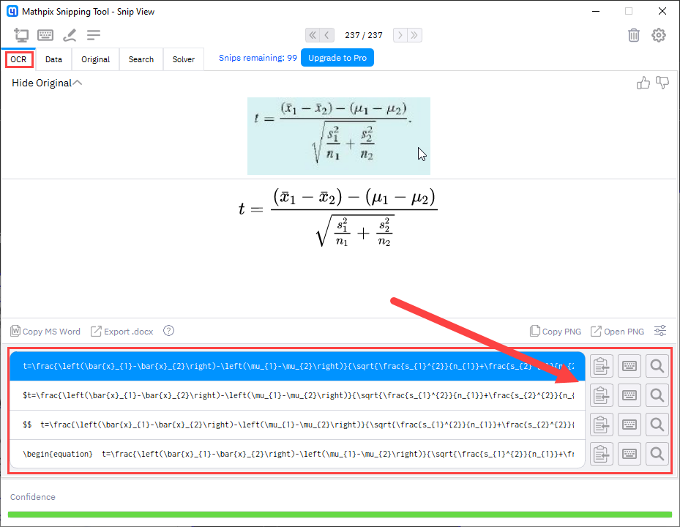

- Now Paste the equation into your Learning Management System either in the Rich Text Editor or in the Math Editor.
Note: In the LaTeX system, a single dollar sign delimiter ($) is used on each side of an inline equation whereas two-dollar signs ($$) are used on each side of a display equation.

MathPix: Additional Information
You can monitor how many snips you have remaining per month from the MathPix window:
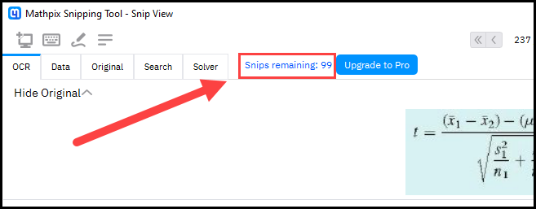
- Select the Snip List icon to see previous equations that MathPix has converted. Then select that equation to access the various copying toolbars.
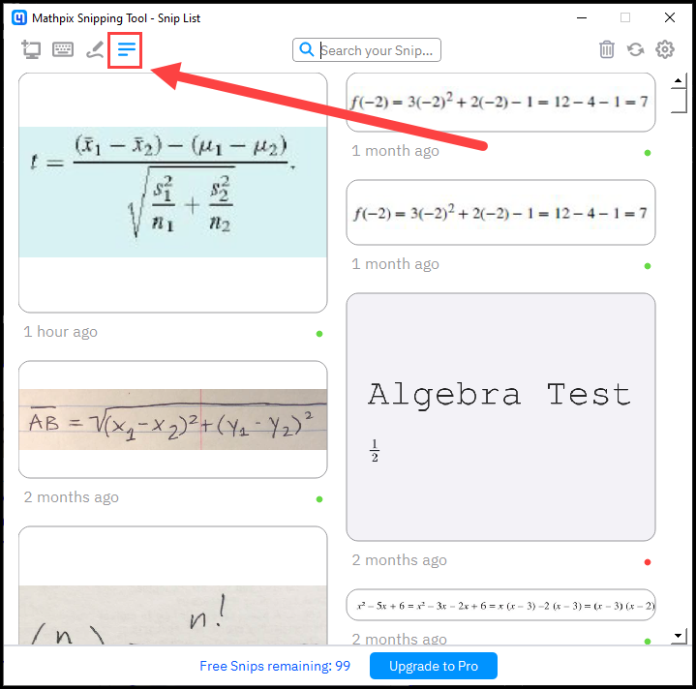
- Filter your previous snips by typing LaTeX in the Search your Snips search field. In this example, previous snips that contain a fraction (/frac) are displayed.
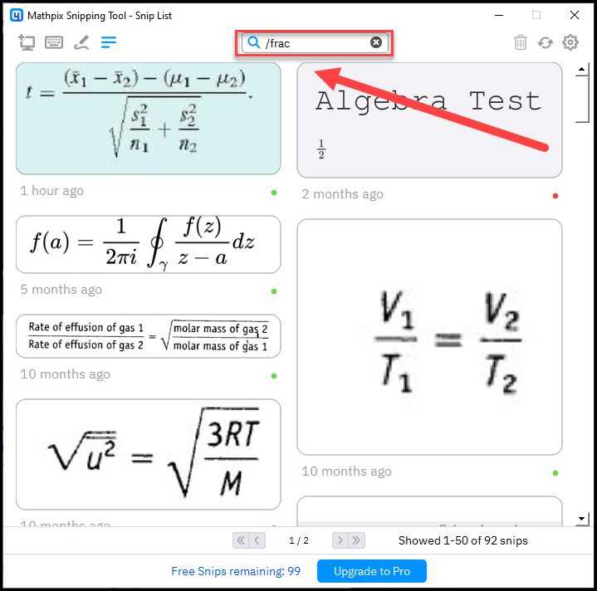

EquatIO
EquatIO is a math literacy tools suite created by the popular assistive technology company TextHelp. Equatio includes a math recognition tool, called Screenshot Reader, that will convert pictures of mathematical content into various math output formats, which can make it easier to author accessible math content.
EquatIO integrates into the Google Docs and Microsoft Office programs and can be installed on macOS and Windows (PC) platforms.

Using EquatIO
EquatIO’s ScreenShot Reader tool will do the work of converting an image of math into real math content. To begin, draw a box around the math that you want to convert. This tool can speed up the process of creating accessible math content.
EquatIO lets you select from a variety of output formats before you copy the math into your document. You can copy these formats: MathML, LaTeX, or a picture of math with alternative text.
EquatIO also allows users to create math by entering LaTeX, speaking math, or drawing math. EquatIO will take each of these various forms of input and create an accessible math from them. This expansive suite of math input methods is useful for students.
Note: A full discussion of each authoring method in EquatIO, including its graphing and math workspace tools, is out of scope for this guide.

EquatIO: Getting Started
To get started with EquatIO, select the Download link at EquatIO’s website:
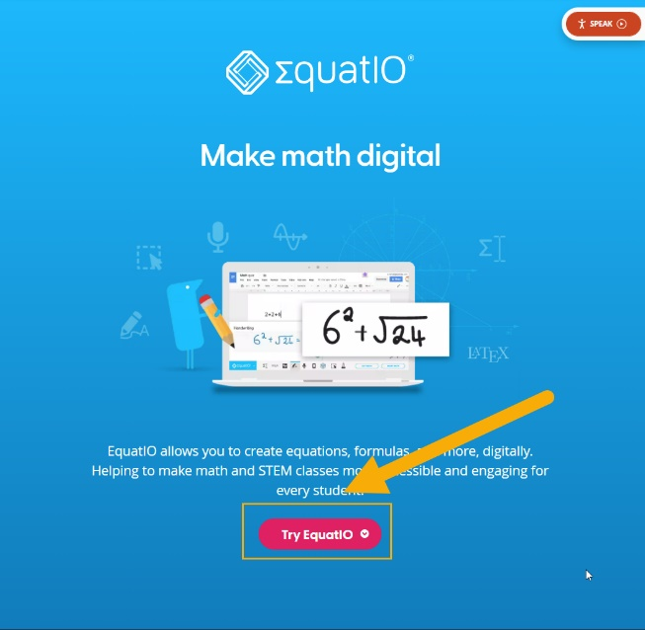
https://www.texthelp.com/products/equatio/
Select the version of the software that you wish to use (Chrome, WebApp, Windows, Mac):
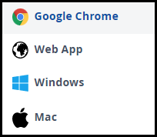
Then sign in with your institutional email account, which you can use to access other EquatIO apps or access EquatIO on other devices:
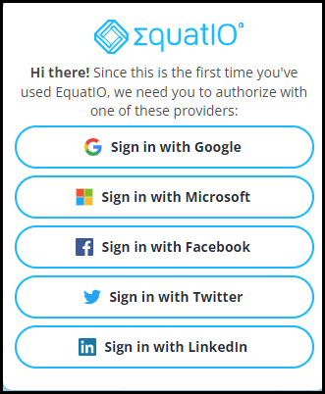
With your new account, you can trial the software for 30 days, which gives you full access to all of EquatIO’s features. Once the trial is over, you will need to purchase the software to access the screenshot reader tool.
EquatIO appears as a toolbar along the bottom of your screen.

EquatIO and MS Word
To add a math equation to your MS Word document using EquatIO, follow these steps:
- Select the Screenshot Reader icon on the toolbar
- Draw a box around the math content
- When the ScreenShot Reader bar appears, select the Options menu.
  - 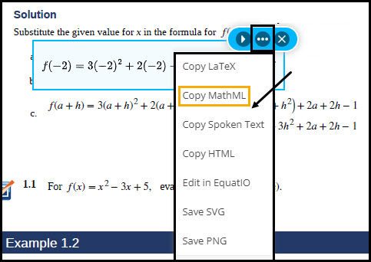

- Select Copy MathML.
- Paste the math into your MS Word document.

EquatIO and Learning Management Systems
As we explained when we described how to use MathPix with a Learning Management System (LMS), it is important that you know which input area of your Learning Management System either the Rich Text Editor or the Math Editor allows you to insert LaTeX.
Like MathPix, EquatIO lets you copy LaTeX from the Screenshot Reader’s options menu, and LaTeX is the format that you will be pasting into your LMS.
- Select the Screenshot Reader icon on the toolbar
- Draw a box around the math content
- When the ScreenShot Reader bar appears, select the Options menu.
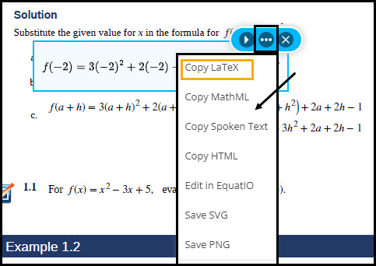
- Select Copy LaTeX.
- Paste the equation into your Learning Management System either in the Rich Text Editor or in the Math Editor.
Note: You may need to add delimiters ($...$ or \[\]) around the LaTeX on each side of the equation for your Learning Management System to recognize the math.

EquatIO: Additional Information
You can use your mobile device (Android or iOS) to insert math into your documents (Google or Microsoft Office).
- Tap on the EquatIO Mobile icon on the toolbar.
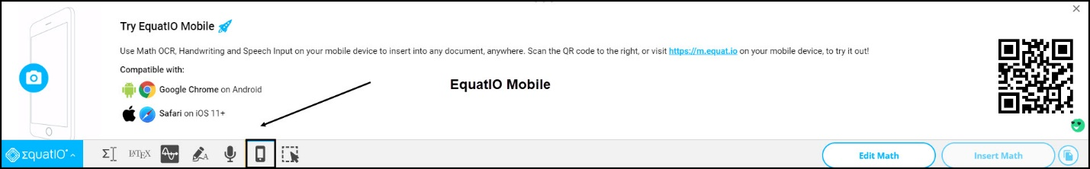
- With your mobile device, scan the QR code or type https://m.equat.io
- Log into your EquatIO account
- Select Active Documents
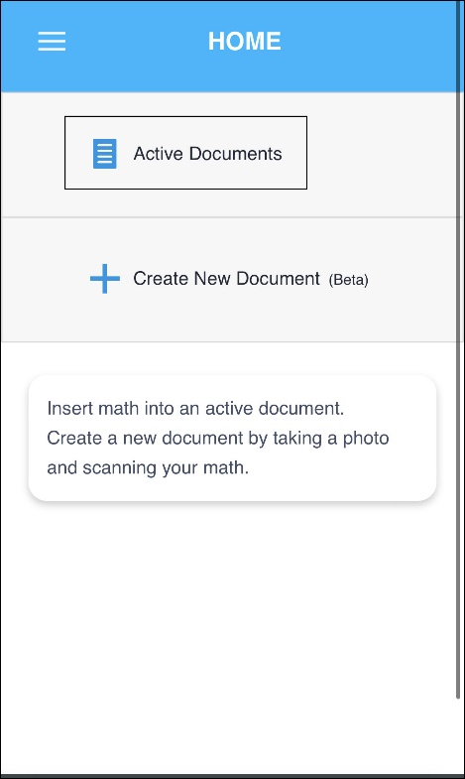
- Tap on the Active document in which you wish to insert math
- Tap on the camera button (take a picture)
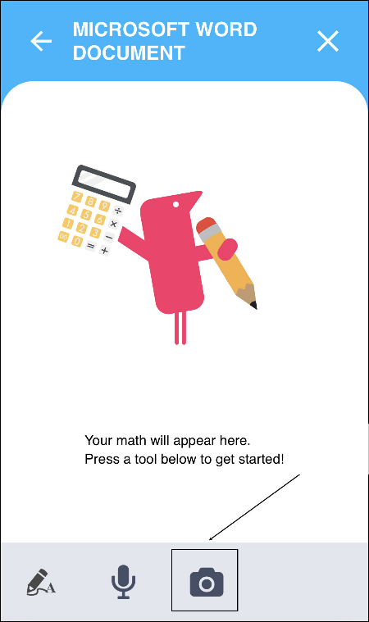
- Take a picture of the math, cropping the image as necessary, and then select the green check mark.
- Select Save as Math
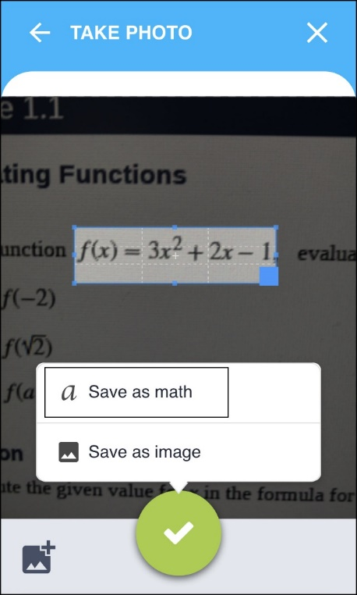
The math can now be inserted into your Microsoft Word file or Google Doc.
OCR tools
    - Pandoc and tex4ht conversion tools for (MS Word, PDF, LaTex)
    - GrindEQ Utility
    - EquatIO
    - PublishToMathPage and DOCX-HTML.sh (HTML)
    - Central Access Reader and DOCX-MP3.sh (MP3)
  - What they are
  - How they work
  - How to get them
  - How to use the math after conversion

GrindEQ
GrindEQ is a software suite that converts one math notation format into another. There are three conversions that the GrindEQ program can perform:
- LaTeX to Word (Office Math),
- MathType to Equation (Office Math), and
- Word (Office Math) to LaTeX
You can purchase all three conversion types as a suite or the individual conversion you need. After installation, the program is added to the MS Word ribbon.
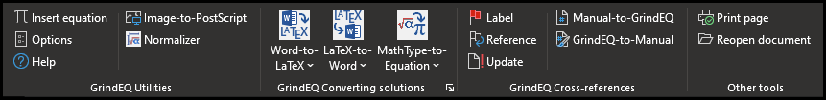
GrindEQ will help out when you need math to be in a specific notation format in your accessibility workflow.
For example, if you have a MS Word document that contains MathType equations, not Office Math equations, you may not be able to use another tool that can just convert MS Word documents whose math notation is Office Math. If you used that other tool, in that case, the math would be lost.

Using GrindEQ to Convert Math
GrindEQ’s MathType-to-Equation conversion utility will batch convert all the MathType equations in your document into the Office Math format.
Since the Office Math format is recognized by Pandoc, you will now be able to convert your MS Word document to HTML and all of the mathematical content will be retained.
GrindEQ’s LaTeX to Word conversion utility will transform the LaTeX file into a MS Word document with Office Math equations.
GrindEQ’s Word to LaTeX conversion utility will transform the MS Word file into a LaTeX document with LaTeX math notation for the math.
The following steps outline how to use the MathType to Equation conversion utility in GrindEQ.to convert a MS Word document with MathType equations into a MS Word document with Office Math equations.
Note: We recommend saving a copy of your MS Word document before following these steps.
- In the GrindEQ toolbar, select Convert document from the MathType-to-Equation dropdown menu.
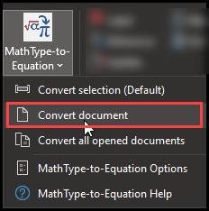
- At the Grind EQ MathType-to-Equation screen, make sure that the following options are selected (other options should not be checked):
- Microsoft Equation
- Force Unicode
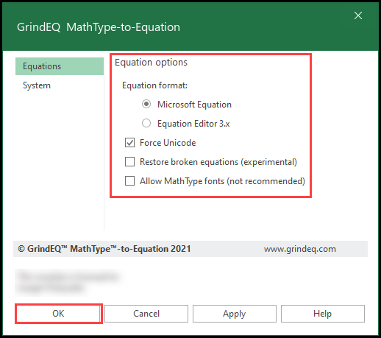
- Press OK
Your MS Word document will now have Office Math equations.

Glossary

Accessible Math : Math that is perceivable, interactive, and operable.

Ascii Math: Ascii math is a markup language for displaying mathematical expressions in web browsers.

assistive technology: software or hardware that individuals with disabilities use to interact more easily with the web

Desmos: a set of free, online math tools, including a graphing calculator, which are accessible to assistive technologies

EquatIO: a commercial software product that enables users to input math content in a variety of ways including word prediction, LaTeX, OCR, and speech.

LaTeX: a document preparation system used by many STEM professionals

Math Mode: the method used in LaTeX to distinguish math formulae from regular text (e.g., a dollar sign symbol surrounds the math; $ formula $)

MathJax: a JavaScript library that ensures that LaTeX, MathML, or AsciiMath will be displayed properly on all web browsers

MathML: Mathematical Markup Language. A method of encoding math on the web

MathPix: a commercial OCR product the recognizes math content and outputs it to MathML, LaTeX,

MathType: a commercial math editing software product that works as a stand-alone tool and integrates in many Learning Management Systems (LMS) and word processing programs

Office Math: native equation format for MS Office equations

OMML: an acronym for Microsoft's Office Math Markup Language, the language Microsoft Office uses to encode equations. The built-in equation editor within Microsoft Office produces OMML. OMML does not produce accessible STEM content.

Optical Character Recognition (OCR) : The process of converting images of text or math into actual selectable and discoverable text

Pandoc: a free command line utility that enables the conversion of files from one format to another (e.g., a MS Word file with math is converted to HTML + MathML)

Publish to Mathpage: A MathType menu item which saves the MS Word file as an HTML document. There are various export options, such as HTML + MathJax

