Optimizing Accessibility | Word Practice

Headings

Create headings
Assign the proper heading levels to the following text.
Branches of Government in the United States
There are three branches of government in the United States. These branches are defined in the U.S. Constitution.
Executive
The President of the United States administers the Executive Branch of our government. The President enforces the laws that the Legislative Branch makes.
Legislative
The Legislative part of our government is called Congress. Congress makes our laws. Congress is divided into two parts.
The Senate. There are 100 Senators––2 from each state. Senators serve for a term of 6 years.
The House of Representatives. Representatives meet to discuss ideas and decide if ideas (bills) should become laws. There are 435 Representatives. Representatives serve for a term of 2 years.
Judicial
The Judicial Branch is the court system. It explains and applies the laws. This branch does this by hearing and making decisions on various legal cases.

Help
- Select the Home tab.
- Make sure the heading is on its own line (e.g., "The Senate")
- Click on the text you are converting to a heading.
- Choose heading level in the Styles gallery, e.g., Heading 2
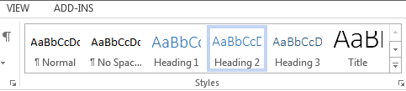
Note: Use Control + Alt (Windows)or command + option (Mac) and 1, 2, or 3 to create Headings 1, 2, or 3.
The correct heading levels:
- Heading 1 - Branches of the Government in the United States
  - Heading 2 – Executive
  - Heading 2 – Legislative
    - Heading 3 - The Senate
    - Heading 3 - The House of Representatives
  - Heading 2 – Judicial

Modify the appearance of an existing Style
Modify the appearance of every Heading 2 on the page to a so that it has the following appearance: 16-point text size, bold, dark red color, extra paragraph spacing.

Help
- In the Home tab, Right-click on the "Heading 2" Style in the Styles Gallery.
- Select "Modify"
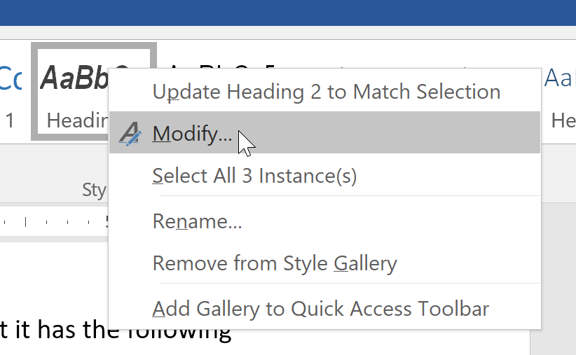
- Apply the styles in the "Modify Style" window.
- To add a bottom border, select Format > Border.

Modify a Style's appearance to match a selection
In the previous example, you changed the appearance of the existing Heading 2 style. Now update the Heading 3 style so that it matches the appearance of the following text:
Every Heading 3 should look like me

Help
- Highlight the selection (the "Every Heading 3 should look like me" text above).
- In the Home tab, right-click on the Heading 3 in the Styles gallery.
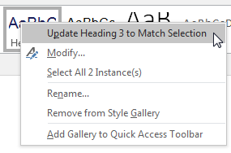
- Select Update Heading 3 to Match Selection.
Note: This will also turn the highlighted text to a Heading 3.

Images

Alt text
Give this image descriptive alternative text.

Help
- Right-click on the image and select Edit Alt Text.
- Enter appropriate alternative text in the field.
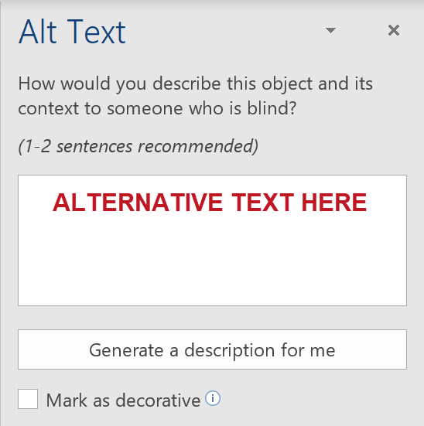

Image layout
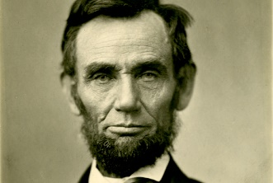
Change the image's layout so it is in line with text.
As the sixteenth president of the United States, Abraham Lincoln served as Commander-in -Chief during the Civil War. He was assassinated five days after the surrender of the confederate army.

Help
- Right-click the image and select the Wrap Text style of "In Line with Text".
- Ensure that the image has the correct alternative text, if required.

Tables

Define table headers
Identify and define the headers in this table.
First name | Last name | Office number | Email
Jenna | Danka | B105 | jenna.danka@example.com
Martin | Dell | B220 | martin.dell@example.com

Help
- Click inside the table and select the Table Design tab (Table Tools > Design in Word 2016 for Windows)
- Because this has row headers but not column headers, uncheck First Column.
Note: When creating a new table:
- In Word 2016, "Header Row" is checked by default.
- In Word 365, "Header Row" and "First Column" is checked by default.

Change table styles
In the above table, choose a table "Style" clearly presents its structure. Be sure to choose a style with good contrast.

Help
- In the above table, click inside the table and select the Table Design tab (Table Tools > Design in Word 2016 for Windows)
- In the Table Styles section, change the appearance of the table so the column and row headers are clearly identified, with good contrast.
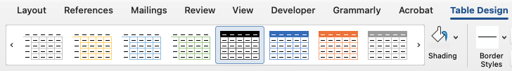

Links, Lists, Columns, and Language

Links
Change this default link text to descriptive text.
Learn how to create accessible Word documents: https://webaim.org/techniques/word/

Help
- Right-click the link and select Edit Hyperlink.
- Change the text in the Text to display field to " create accessible Word documents" (or similar link text).
- Delete the redundant text before the link.

Lists
Convert the following text into a list. Make sure you use the correct list type.
-Cover the eggs in a saucepan with water.
-Heat the pot on high heat and bring the water to a full rolling boil.
-Turn off the heat, keep the pan on the hot burner, cover, and let sit for 10-12 minutes.
-Strain the water from the pan and run cold water over the eggs to cool them quickly and stop them from cooking further.

Help
- Highlight the text.
- Select the Home tab.
- Choose the Numbered List option from the Paragraph group.
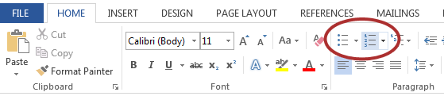
This should be a numbered list because there is an order to the options in the list.
- Separate each item in the list with the Enter key.
- Delete the dashes before each item in the list.

Columns
The following text divided into "columns" using the Tab key. Restructure this text so that it uses true columns.
Don't use the Tab key and/or They may look OK, but the
Space bar to create "columns" reading order is all wrong. Plus,
in Microsoft Word documents. they are a pain to create and edit.

Help
- Change to a single block of text:
  - Use Alt + mouse (Windows) or option + mouse (Mac) to select second column (start bottom right corner).
  - Cut the selected text (Ctrl/command + X).
  - Add 3 empty lines.
  - Paste the text in the empty lines.
  - Remove empty tabs, spaces, and line breaks so that the text forms a single paragraph.
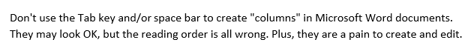
- Create the correct two-column layout:
  - Select the text.
  - Open the Layout tab and select Columns.
  - Choose 2 columns.
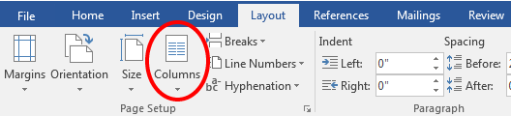

Other Principles

Text language
Identify sections of text in a language that differs from the document's main language.
Yo soy un hombre sincero
De donde crece la palma,
Y antes de morirme quiero
Echar mis versos del alma.

Help

Windows:
- Highlight the text.
- On the Review tab, select Language > Set Proofing Language
- Choose Spanish (Spain)
- Click OK

Mac:
- Highlight the text
- On the Review tab, select Language
- Choose Spanish
- Click OK
Note:
- When multiple versions of a language are available, chose the Language’s country of origin (e.g., "Spanish (Spain)" instead of "Spanish (Latin America).”
  - The exception is “English (United States)”.
- To change the language of the entire document, select all the text (Ctrl/command + A).

Text contrast
Evaluate and repair the contrast of the text below and make any needed changes.
Does this text need more contrast?
Does this larger text need more contrast?

Help

Office 365
- Select the Review tab > Check Accessibility
- In the Accessibility report, look for Warnings > Hard-to-read text contrast
- To change the text color:
  - Highlight the low-contrast text and then select Home tab, select Font Color > More Colors > Custom
  - Use the light/dark slider to choose a darker shade of red and choose OK
- The accessibility warning disappears automatically when the text has enough contrast

Office 2016
- Download, install, and run the Colour Contrast Analyser (CCA).
- In CCA, use the Eyedropper to evaluate each line of red text.
  - The first line needs at least 4.5:1 text. It fails.
  - The second line is "large text" (≥18pt or ≥14pt + bold) and requires 3:1 contrast. It passes.
- Find a shade of red with at least 4.5:1 contrast.
  - In CCA, Click the sliders button ().
  - Check “Synchronize colour values”.
  - Use the sliders to find a color with enough contrast.
- To change the text color:
  - Highlight the low-contrast text and then select Home tab, select Font Color > More Colors > Custom
  - Enter the correct Red/Green/Blue values and choose OK.

Use of color
Change the following example so that there is no information that is only available through color.
Assignment | Complete
1- Introduction | X
2- Lab | X

Help
- Change the red text to "No or Incomplete".
- Change the green X to "Yes" or "Complete".
Note: Do not remove the red and green colors. This color difference is useful for people who can distinguish red and green.

Small text
Make the small text larger.
Text that is small can be difficult to read.

Help
- Select the small text
- On the Home tab, select the Clear All Formatting button to apply the default text size for the document.

Finalize Document

Check accessibility
Run the accessibility checker and make the appropriate changes.

Help
- Open the Accessibility Checker
  - In Office 365 (Windows and Mac) or Office 2016 for Mac: Select the Review tab > Check Accessibility.
  - In Office 2016 for Windows: Select File, click the Check for Issues dropdown and select Check Accessibility.
Note: See our Word and PowerPoint evaluation checklist for more details on combining this checker and manual checks for a thorough accessibility evaluation.

Add document title
Add a document title so that it will carry forward when creating a PDF

Help
- Mac: File application menu (not tab) > Properties > Under Summary > Title field
- 365 for Windows: File tab > Info > Title field (on the right side)
- 2016 for Windows: File tab > Add a title field (on the right side)

Convert to PDF
Convert this document to a PDF.

Help
Use the Acrobat plugin (automatically installed by Adobe Acrobat) when it is available.
- Select Create PDF from the Acrobat tab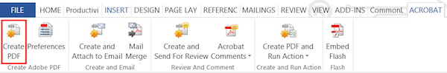
- Select Save
If the Acrobat tab is not available see our article on creating a PDF with "Save As" in Office.

