Optimizing Accessibility |Acrobat Practice
- Set up workspace
  - Tags Pane: View > Show/Hide > Navigation Panes > Tags
  - Accessibility Tools: Tools tab > Search for Accessibility > Select “Add”
- Run accessibility “Full Check”
  - Make easy repairs
- Repair tag structure with “Reading Order” tool
  - Hide Decorative images
  - Improve tables
  - Headers/Footers?
  - Headings?
- Verify/Repair content reading order in “Reading Order” tool (optional)
- Verify tag structure and order in “Tags” pane (if needed)

Practice

Images
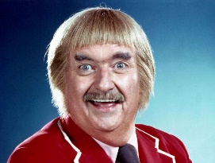
Captain Kangaroo

Tables

Spring Semester

Course | Day | Start Time | End Time | Instructor
BIO 100 | M, W, F | 08:00 | 09:20 | Miller
BIO 110 | T, Th | 09:00 | 10:20 | Smith
BIO 120 | M, W, F | 13:00 | 14:20 | Williams
BUS 100 | T, Th | 10:00 | 11:20 | Brown
BUS 110 | M, W, F | 10:00 | 11:20 | Wilson
BUS 120 | M, W, F | 14:00 | 15:20 | Jones

