Notetaking Strategies: Additional Resources

QuickTime Audio Recorder
- Open QuickTime Player
- Windows: Select File > New Audio Recording
- MAC iOS may need 3rd party application to record system audio.
[IMAGE: QuickTime logo.]

QuickTime Audio Recorder: Preferences
- Set recording preferences
- Edit > Preferences > QuickTime Preferences
- MAC iOS may need 3rd party application to record system audio.
[IMAGE: QuickTime Preferences]
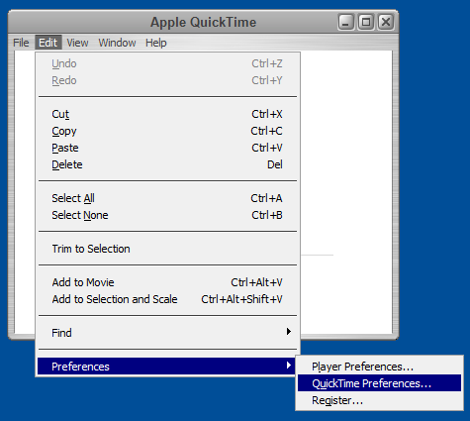

QuickTime Audio Recorder: Playback and Recording Devices
Audio Playback and Recording Devices
Windows Audio Session
[IMAGE: Audio Playback and Recording Devices]
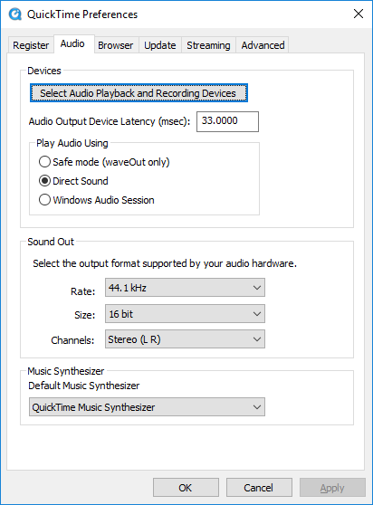

QuickTime Audio Recorder: System Audio Selection
- Audio Playback and Recording Devices
- Select internal system audio card
[IMAGE: System Audio Selection]
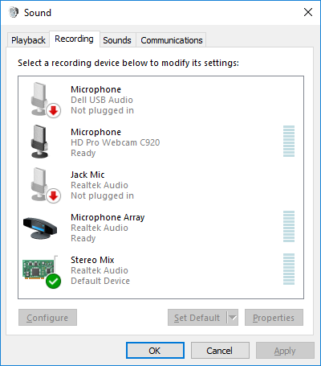

QuickTime: Start Recording
You may need to set your QuickTime player preferences to select the internal system audio as the recording source.
[IMAGE: QuickTime Start Recording]
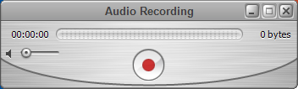

QuickTime: Stop Recording
The recorded file can be either a .mov or .m4a format.
[IMAGE: QuickTime Stop Recording]
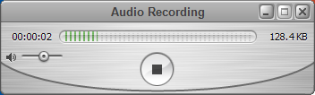

Windows 10 Recording
- Open the application you want to record
- Press the Windows key + G to open the Game Bar dialog
- Check the "Yes, this is a game" checkbox
[IMAGE: Windows 10 Game Bar Dialog]

Windows 10 Recording: Control Bar
- Select the Start Recording button (or Win + Alt + R) to capture video/audio
- Stop recording: select red recording bar in the top right of the program window. (Press Win + G again to bring the Game Bar back.)
[IMAGE: Windows 10 Recording Control Bar]

