Mathshare

Overview
Mathshare is a free-to-use online platform intended to make solving mathematical equations easier and more accessible. Users are prompted to share their steps as they solve each problem, giving instructors a look into their thought process rather than just seeing their answers. Instructors can also create and share their own sets of problems and solutions.

Creating a Problem Set
After logging into Mathshare, select the Create a Problem Set button to begin creating a problem set. The first step is to determine which button palettes you want to include in the problem set. These include:
- Edit: Stacking, crossing out, changing colors
- Operators: Plus, minus, equals, etc.
- Notations: Writing numbers as fractions, exponents, square roots, etc.
- Geometry: Symbols such as pi, angular notation, parallel lines, etc.
After selecting the button palette, the problem set will be created with “New Problem Set” and the current date as the name. The button palettes can be changed at any time by selecting the Change Symbols button.
To change the name of a problem set, select the box and pencil icon next to the name. A text box will appear with the name of the problem set inside. Erase the current name, type in the new name, and then select Save. You can also set controls to require explanations for every problem and include creator’s solutions when sharing.

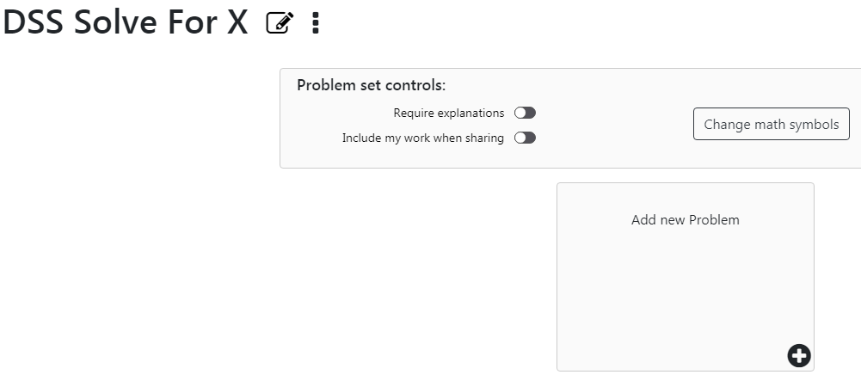
Figure 1: A blank problem set.

Adding Problems
To get started, select the Add new problem button. A box will appear with a group of tools that can be used to create equations, including the button palettes you specified. You will need to specify both a problem and a descriptive prompt in their respective text boxes. You can use the Dictate button to speak your problem and your prompt instead of typing them.
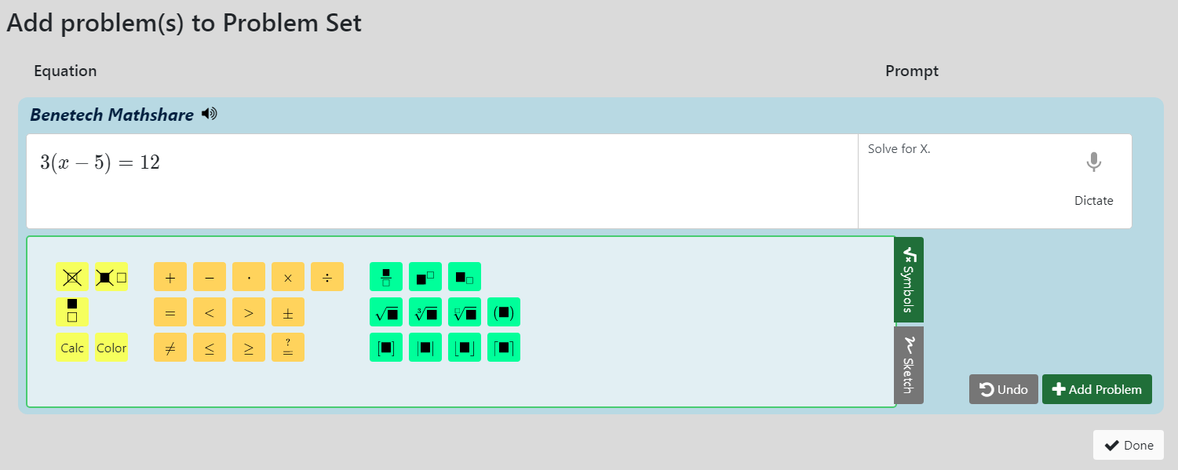
Figure 2: Adding a problem to a problem set.
When you are done with your first problem, select the green Add Problem button in the bottom right of the blue box to create a new problem.
Another way of entering problems is using the sketchpad. You can access the sketchpad by selecting the gray Sketch button on the right side of the symbols menu. When selected, a blank canvas will appear in place of the symbols menu. You can draw freehand, create shapes, or even load in other images. You can use both symbols and sketches in a problem. You can return to using symbols at any time by selecting Symbols from the right side of the sketchpad.
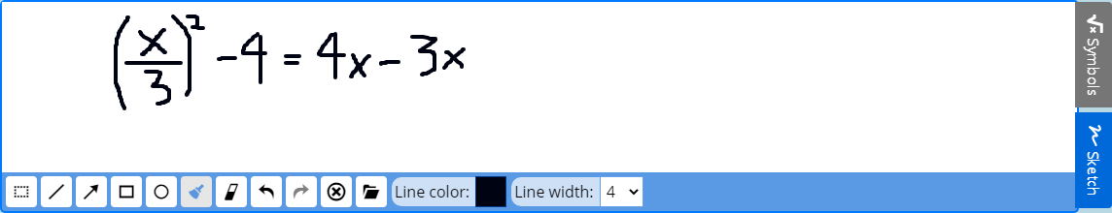
Figure 3: Using the sketchpad to create a problem.
When you are finished with your problem set, select Done to save your problems and exit the problem editor.

Editing and Removing Problems
Once you have finished a problem set, you can edit or delete problems at any time. Select the three dots icon at the bottom right of a problem, and you will have the option to edit or remove the problem. Choosing to edit the problem will open the problem editor, allowing you to make any changes necessary.

Sharing Problem Sets
Once you have completed a problem set, you can share it by selecting the three dots to the right of the name and selecting Share Problem Set. Sharing the problem set will give you three different sharing options; Google Classroom, Microsoft Teams, or a shareable link.
You can also share your answers by selecting Share My Answers from the top right of the window. You will have the same sharing options as you would when sharing the problem set. To create answers for your problems, you will need to select each one and solve it.

Solving a Problem
Mathshare uses a step-based formula for solving problems. When beginning a problem, you will begin on step 2, as step 1 is reserved for the problem itself. Solving a problem is very similar to creating a problem set, as you can use both the selected button palettes and the sketchpad to show your work. You can also type or dictate your answers as you would a prompt. Once you complete a step, select the green Add Step button to create a new one.
Additionally, if you have made a mistake, select the pencil icon to the right side of a previous step to update it. From here, you can either edit the content of the step or select the red garbage can icon that takes the place of the edit icon to delete it.
Selecting the speaker icon next to your current work or each step will read it aloud. This text-to-speech option is also available when creating problem sets.
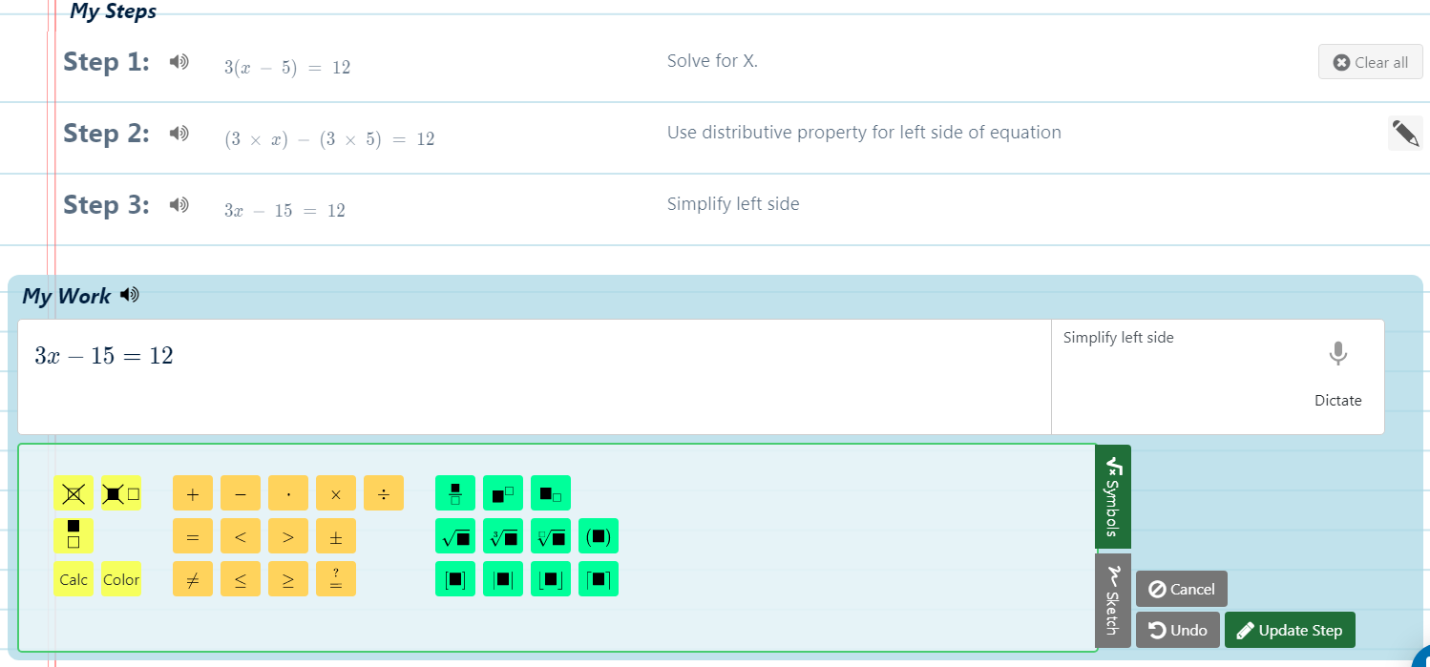
Figure 4: Solving a problem.

Crossing Out
Mathshare’s Edit panel includes some simple yet effective features. One of these is the ability to cross out parts of an equation. Highlighting part of an equation and then selecting the yellow crossed-out box icon near the left side of the Symbols menu will cross it out. You can also press Shift+Delete on your keyboard to cross out. When adding a step after crossing out, a cleaned-up step will automatically be generated with the crossed out sections removed.
Additionally, you can select the black crossed-out box and transparent box icon next to the Cross Out icon to cross out and replace part of an equation. When doing this, your cursor will appear next to the crossed-out section, prompting you to type a replacement. The hotkey to cross out and replace is Ctrl+Shift+Delete.
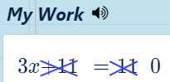
Figure 5: The result of crossing out parts of an equation. The 0 on the right was typed in by using the cross out and replace feature.

Calculate
Mathshare includes a built-in feature which automatically calculates a mathematical expression. The Edit palette must be included in order to use this feature. Highlight the expression you want to calculate and then select the yellow Calc button. You can also use Ctrl+Alt+Enter on Windows computers or Opt+Cmd+Return on Apple computers. The original expression will become crossed out, and the result will appear next to it.
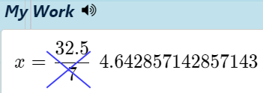
Figure 6: The result of using the Calculate feature.

Changing Font Colors
One of Mathshare’s smaller features which can be vital to those with visual or learning difficulties is the ability to change the font color. Select the text you want to change the color of and then the yellow Color button from the leftmost palette. Then use the hue slider and the saturation box to select your color. Mathshare offers a comprehensive color picker which includes color values in hexadecimal codes, RGB, HSL, HSV, and CMYK.
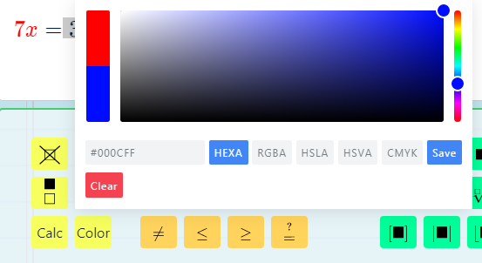
Figure 7: Changing the font color.

Accessibility
Making Math Accessible video
Mathshare has a wide variety of accessibility features designed to aid almost every user, no matter their impairment. The sketchpad, different font colors, adjustable line spacing, and text to speech with synchronized highlighting can help those with reading and comprehension issues. Keyboard shortcuts, along with many of the other features listed before, can help those with blindness or low vision. Mathshare’s layout has also been designed to be as clear as possible so those with cognitive and learning disabilities will not become distracted or overwhelmed. For a full list of accessibility features, see the Mathshare Accessibility Accommodations List.
Screen reader support for Mathshare is only partially included. However, it has been tested with NVDA and VoiceOver. Tab and keyboard navigation has also not been fully implemented as of November 2020.

