Mathpix Snip

Overview
Mathpix Snip is a program that captures screenshots of mathematical equations and converts them to digital formats. This saves time and stress that would otherwise be spent typing out complex equations or long strings of code.
Mathpix Snip is available for Windows, Apple, Linux, iOS, and Android. Download links are available in the link above. You will need to create a Mathpix account to use Snip.

Capturing Screenshots
There are two ways to take a screenshot. You can either select the computer monitor icon in the top left of the screen or use the keyboard shortcut Ctrl+Alt+M (or Ctrl+⌘+M if using Apple). The window will disappear, and your cursor will turn into a crosshair. Select an area to capture, which will be surrounded by a red rectangle as you click and drag.
Mathpix Snip is optimized to capture both digitally typed and handwritten equations from any source you can access on your computer. It can also scan blocks of text, although formatting will not be counted.
Once you are done selecting the equation you want to scan, Mathpix Snip will scan the equation and convert it to LaTeX code. This code is designed to display complex mathematical equations and is used by mathematicians, scientists, and professors alike. Mathpix Snip allows four different LaTeX options; the equation itself without any way to display it, written in inline basic math mode ($), block basic math mode ($$), and display math mode (begin{equation}). You can select the clipboard icon next to the code to copy it or the box and pen icon to view the entire string of code as text.
The confidence meter at the bottom of the screen is a visual representation of how confident Mathpix was in capturing the equation. You can confirm or deny this by using the thumbs up and thumbs down buttons at the top of the screen. Your input will be sent to Mathpix to help them further optimize their OCR.
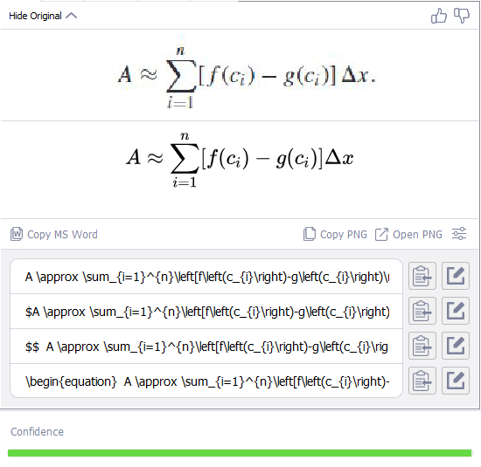
Figure 1: Mathpix Snip scanning a calculus formula for the area between two curves. From top to bottom, the LaTeX code is written as plain LaTex, inline basic math, block basic math, and display math. Note the full confidence meter.

Math to PNG
Once you have scanned an equation, you can either copy a PNG image of the equation or open the image in your default photo viewer software. From here, you can copy or save the PNG equation.
Selecting the sliders icon next to the PNG options will open the image settings. You can optimize your exported images for different software or change the text and background colors. A transparent background is useful for Word or PowerPoint but will not work in other applications.

More Formats
Selecting the Data tab at the top of the screen will show your equation in more formats, including MathML, Word-style MathML, AsciiMath, and an SVG vector image. The formats in this menu can be enabled or disabled by selecting the gear icon in the top right of the screen, going to Settings, going to the Formatting tab, and checking or unchecking any of the four checkboxes.

Original Image
Additionally, selecting the Original tab will preview the original image and a web address to the image in three different formats; as a web link, a markdown link for use with markdown editors (![](…)), or a HTML tag for websites (<img src=”…”></img>).

Search
Mathpix Snip offers several helpful features outside of capturing and converting equations. The Search tab is useful if you want to identify an equation. Select the search tab and Mathpix Snip will automatically search the internet for the scanned equation and display any matching results.
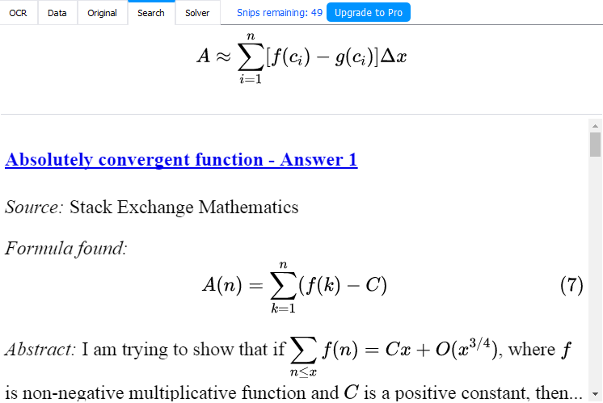
Figure 2: The Search tool displaying results from the equation seen in Figure 1.

Solver
The Solver tab can perform a multitude of operations on a scanned equation, including solving for a variable, finding roots, simplifying or expanding equations, and graphing. Selecting the piece of paper icon to the right side of the screen under the equation will copy the Solver’s results in LaTeX format.
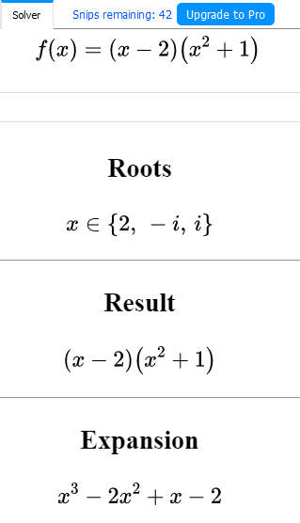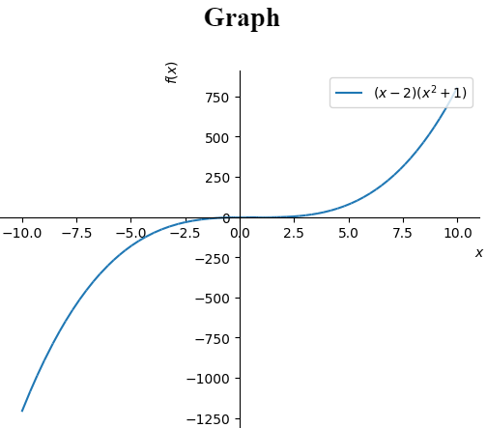
Figure 3: The Solver tab finding the roots of an equation, expanding it, and graphing it.

Compatibility
Mathpix Snip offers compatibility with other applications, including Word, Excel, Google Sheets, Overleaf, and Typora. For detailed steps on how to use Snip with these programs, view the compatibility section in the User Guide.

Word
You can copy scanned equations as MathML format and paste them directly into Word as an equation. To do this, either select the Copy MS Word button from the OCR tab or copy the MathML (Word) link from the Data tab. For example, copying the equation from Figure 1 into a Word document will look like this.
$$A≈\sum_{i=1}^{n}{ }\left[f\left(c_{i}\right)-g\left(c_{i}\right)\right]Δx$$

Excel and Google Sheets
Snip can also scan tables and export as TSV format for use in a spreadsheet. To copy the contents of a table into a spreadsheet, copy the table as TSV from either the OCR or the Data tab and paste it into the spreadsheet editor of your choosing. You can also copy tables as HTML for use in websites.
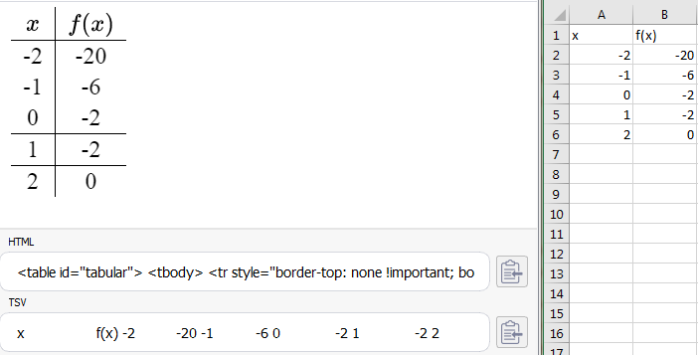
Figure 4: A table scanned into Mathpix Snip and the results when copying as TSV and pasting into Excel. The contents of the table are based on the equation from Figure 3.

Syncing Notes
Mathpix Snip is designed to automatically sync notes in your account, allowing you to access them from both your computer and your mobile device. This video shows a user drawing and scanning equations on their mobile device and the equation immediately showing up in the desktop app.

Pricing
Mathpix Snip is available for free, but as a limited-use trial. To get unlimited use out of Mathpix Snip, you will need to purchase a Mathpix Pro subscription.
- Mathpix Free: Allows up to 50 snips.
- Student: Logging in with your school email will give you 100 free snips.
- Mathpix Pro: Removes the snip limit for $4.99 a month. You can cancel your subscription at any time.
- Organizations: For $9.99 a month or $99.90 a year, you can create an organization for multiple users. The first two students are free, 3-49 users will cost $4.49 per user, and 50+ users will cost $3.99 per user.

