Desmos

Overview
Desmos is a free and powerful online graphing calculator. Graphs containing multiple equations can be entered, customized, and shared. Desmos is also compatible with assistive technology to ensure any student can use it.

Entering Equations
Upon loading Desmos, you will see a 2D graph on the right side of the screen and a text box on the left. Simply type an equation into the text box and the result will appear in the graph.
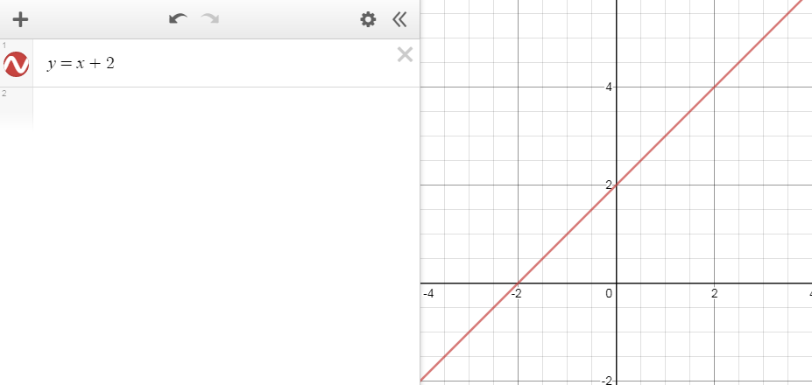
Figure 1: The equation y=x+2 in both the text box and as a line on the graph.
You can also select the Show Keypad button at the bottom left of the screen to open a list of symbols and functions. Select a symbol to add it directly into your equation.
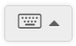
Figure 2: The Show Keypad button.
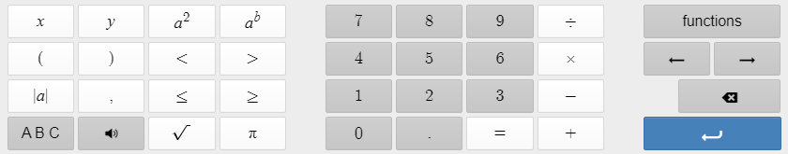
Figure 3: The keypad.
You can also enter multiple equations and show them on a graph. After you have entered an equation, either press Enter or select the plus button near the top left corner of the screen and select Expression.
Sometimes, you can have so many equations on your graph it can become hard to view them. To hide an equation, select the colored circle icon with the squiggly line next to it. The circle will become white and the equation will disappear. Select it again to show the equation. If you want to remove the equation outright, select the gray X to the right of the equation.
If you are unhappy with an equation or made a mistake while entering one, press Ctrl+Z on your keyboard or select the left-facing arrow in the toolbar above the equations to undo.
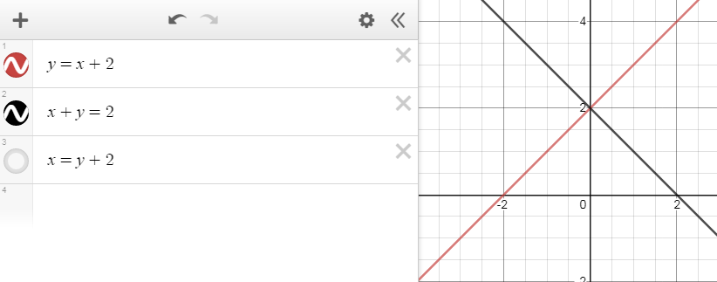
Figure 4: Multiple equations in a graph. Note the equation x=y+2 which is hidden.
Entering an equation which results in a straight line includes a slider you can use to change the position of the line.
Figure 5: An equation for a horizontal line with a slider used to change its position underneath.

Equation Templates
You can also start a new graph by selecting the three white horizontal lines at the top left corner of the screen. This will open a menu of graph templates pertaining to algebra, trigonometry, statistics, and calculus. You can also create a new blank graph from this menu. If you have an account, this is also where you can save and load your own graphs.
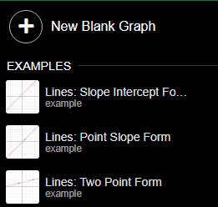
Figure 6: The Open Graph menu.

Edit List
Selecting the gear icon at the top of the equation menu will reveal extra options for your equations. By selecting the colored circle to the left of an equation, you can choose from one of three line styles or six colors.
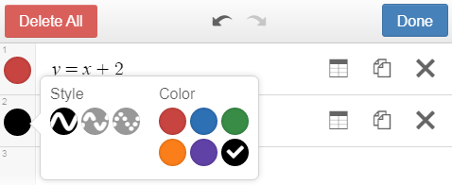
Figure 7: Changing the color of a line. Note the different interface at the top of the menu and the table and duplicate icons to the right of each equation.
Every equation will contain an icon showing two pieces of paper. Selecting this icon will duplicate the equation.
If your equation has Y isolated on one side, a table icon will appear next to the equation. Selecting this icon will change the expression from an equation to a table containing the Y values between X=−2 and X=2. You can change the table back to an equation by undoing it.
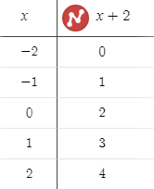
Figure 8: An equation that has been converted to a table.
For equations which result in horizontal or vertical lines, you can adjust both the step and the endpoints for the slider, limiting the positions the line can be set to.
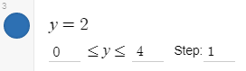
Figure 9: A horizontal line with the slider range and step changed.
When the Edit List icon is selected, the Delete All button removes all equations from the list. Select the Done button when you are done editing.

Sharing Graphs
Sharing graphs in Desmos is fast and easy, even without an account. To share a graph, select the box with the arrow inside near the top right corner of the screen. A dialog box will appear with four options you can use to share your graph. You can either copy a link which contains your graphs and equations, print the graph, export it as an image, or generate a HTML embed code you can paste into a web page. Using the embed code will display an interactive graph directly in the webpage rather than a static image or a link.
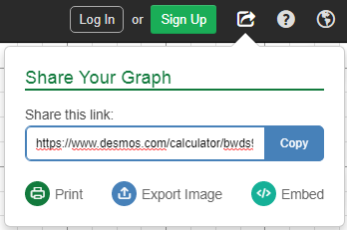
Figure 10: The Share Your Graph dialog box.

Accessibility
Accessibility support link
Accessibility Features in the Desmos Calculator video
Desmos is designed so anyone can learn and enjoy math, and users with disabilities are no exception.

Screen Readers
The screen readers Desmos supports include JAWS, NVDA, Microsoft Narrator, VoiceOver in Mac and iOS, TalkBack in Android, and ChromeVox in ChromeOS. Refer to the Desmos accessibility guide on how to setup and use a screen reader with Desmos.

Braille
Braille Mode in the Desmos Calculator video
Desmos also includes braille functionality for screen reader users. To enable Braille typing in Desmos, open the Settings menu by selecting the wrench icon in the top right of the graph and selecting one of the buttons corresponding to the type of Braille you use. Desmos offers support for Nemeth and United English Braille.
Desmos supports Braille typing with both a Braille device and your keyboard. To type Braille on your keyboard, either check the box captioned Six Key Braille Input or press Alt+6 on your keyboard. When Six Key Braille Input is enabled, the S, D, F, J, K, and L keys correspond to Braille dots 3, 2, 1, 4, 5, and 6 respectively.
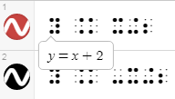
Figure 11: Desmos with the Nemeth Braille setting enabled. The callout with the equation y=x+2 is displayed by hovering the mouse over the equation.

Desmos for Teachers
Desmos can also be used by instructors to create classes and share activities. Classes are created by using codes, which students enter after the Desmos URL to access. Desmos also includes an activity builder which supports graphs, math text, screenshots, videos, and even graphs from other activities. For in-depth information on creating classes and activities, visit the Desmos Teacher Support Guide.

