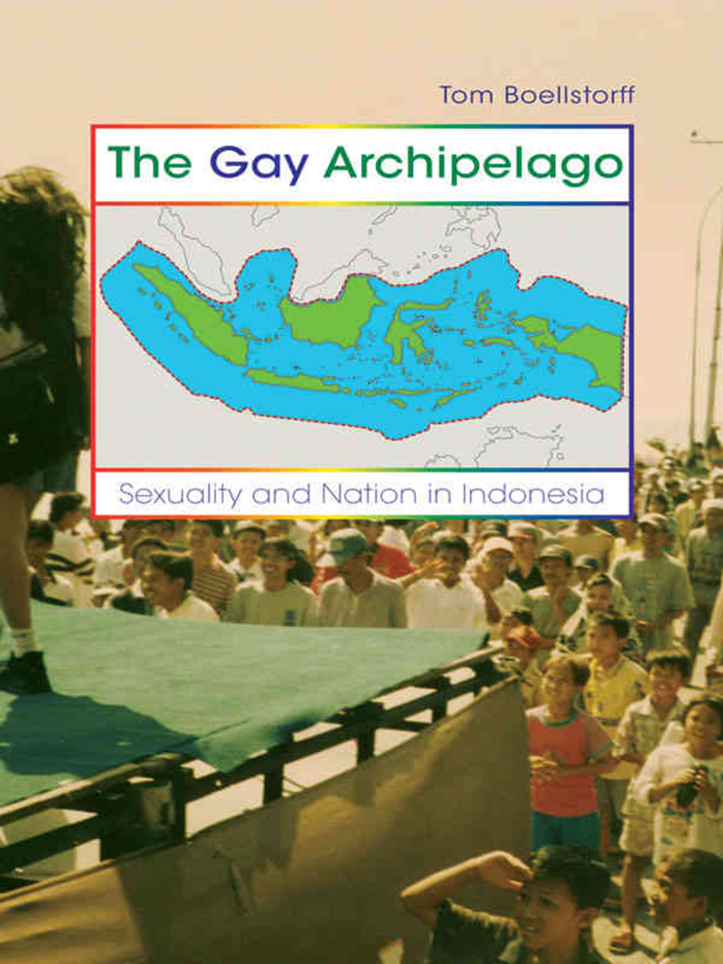

The Gay Archipelago

The Gay Archipelago
SEXUALITY AND NATION IN INDONESIA
Tom Boellstorff
PRINCETON UNIVERSITY PRESSPRINCETON AND OXFORD

Copyright © 2005 by Princeton University Press Published by Princeton University Press, 41 William Street, Princeton, New Jersey 08540 In the United Kingdom: Princeton University Press, 3 Market Place, Woodstock, Oxfordshire OX20 1SY
All Rights Reserved.
LIBRARY OF CONGRESS CATALOGING-IN-PUBLICATION DATA
Boellstorff, Tom, 1969– The gay archipelago: sexuality and nation in Indonesia / Tom Boellstorff. p. cm. Includes bibliographical references and index. ISBN 0–691–12333–0 (hardcover: alk. paper)— ISBN 0–691–12334–9 (pbk. : alk. paper) 1. Gay men—Indonesia—Identity. 2. Lesbians—Indonesia—Identity. 3. Gay men—Indonesia—Social conditions. 4. Lesbians—Indonesia— Social conditions. 5. Gender identity—Indonesia. 6. Homosexuality— Political aspects—Indonesia. I. Title. HQ76.3.I5B64 2005 306.76′6′09598—dc22 200500187
British Library Cataloging-in-Publication Data is available.
This book has been composed in Sabon
Printed on acid-free paper. ∞
pup.princeton.edu
Printed in the United States of America
10 9 8 7 6 5 4 3 2 1

FOR BILL AND DÉDÉ

Contents
List of Illustrations ix
Acknowledgments xi
Note on Indonesian Terms and Italicization xv
PART ONE The Indonesian Subject 1
CHAPTER ONE: Introduction 3
CHAPTER TWO: Historical Temptations 35
CHAPTER THREE: Dubbing Culture 58
PART TWO Opening to Gay and Lesbi Worlds 89
CHAPTER FOUR: Islands of Desire 91
CHAPTER FIVE: Geographies of Belonging 126
CHAPTER SIX: Practices of Self, Tests of Faith 157
PART THREE Sexuality and Nation 185
CHAPTER SEVEN: The Postcolonial State and Gay and Lesbi Subjectivities 187
CHAPTER EIGHT: The Gay Archipelago 216
Notes 233
Works Cited 243
Index 267

Illustrations

FIGURES
FIGURE 1–1. An Independence Day performance. 15
FIGURE 1–2. Map of Indonesia (before East Timor’s independence). 16
FIGURE 3–1. "First in Indonesia: Lesbian Wedding, Attended by 120 Guests." 63
FIGURE 3–2. Ways in which one sample of 35 gay Indonesians first learned of the term. 69
FIGURE 3–3. Gay men portrayed as possessed by animal lust. 73
FIGURE 4–1. The fatherly modern male. 96
FIGURE 4–2. Image accompanying article on "Lesbians and Lifestyle." 98
FIGURE 4–3. Love should make gay and lesbi Indonesians equal to normal ones. 106
FIGURE 4–4. "A poor hetero family that does not follow Family Planning." 120
FIGURE 4–5. "A lesbi couple who are professionals." 121
FIGURE 4–6. "A young gay couple who, besides being happy, also can enjoy life optimally." 122
FIGURE 5–1. Sexuality and nation intersecting. 142
FIGURE 5–2. "Kalifornia," a bridge in downtown Surabaya. 154
FIGURE 5–3. Intersecting global, national, and local discourses. 155
FIGURE 7–1. Indonesia’s borders before the invention of the archipelago concept, as inherited
from a 1939 colonial law. 192
FIGURE 7–2. Indonesia’s borders after the invention of the archipelago concept in December 1957. 192
FIGURE 7–3. The nation subsumes the ethnolocal. 194
FIGURE 7–4. The "traditional" family. 199
FIGURE 7–5. The "modern" family. 199
FIGURE 7–6. Heterosexual and ethnolocalized couples constituting the nation. 200
FIGURE 7–7. Confessional self, archipelagic self. 206
FIGURE 8–1. Outside Ngurah Rai airport, Bali. 229

TABLES
TABLE 1–1. Two tropes of globalization and sexuality. 28
TABLE 8–1. Apparent isomorphisms. 219

Acknowledgments
THERE IS NO WAY I can do justice to all that I have been given. While for reasons of confidentiality I name none of my Indonesian interlocutors besides Dédé Oetomo, it is they who have made this book possible. Through all my time in Indonesia, all my mistakes and confusions and moments of insight, they have patiently taught me about their worlds. They have protected me, entertained me, and given me gifts beyond measure.
I dedicate this book to Bill Maurer and leave it at that. His generosity, good humor, and unfailing support made this book possible, and the intellectual and emotional debt is too great to enumerate. I also dedicate this book to Dédé Oetomo. He has been my greatest teacher, and I stand in awe of his intellect, courage, and grace. My debt to him can never be repaid, only honored.
Lawrence Cohen was my partner during the first phases of this project. His kindness, brilliance, and facility with the written word remain an inspiration. He will see himself on every page.
My mother, Neva Cozine, stood up for me early and often. She taught me how to cherish safety as well as take risks. Her advocacy for gay and lesbian rights in Nebraska and beyond has been inspiring; her ability to reinvent herself through life, a model I keep with me always. My father, John Boellstorff, taught me to persevere. My sister, Darcy Boellstorff, has been with me through it all. My stepfather, Daryl Hansen, has been a constant source of support and good cheer. Ruth Boellstorff, my grandmother, taught me how to find strength in every moment. Lisa Maurer and Maureen Kelly have been comrades in arms.
At Stanford University I found a group of colleagues who helped me frame this project in an anthropological light and continue to shape my intellectual growth. These include Katherine Coll, George Collier, Jane Collier, Carol Delaney, Paula Ebron, Akhil Gupta, Purnima Mankekar, Renato Rosaldo, and, above all, my dissertation advisor Sylvia Yanagisako.
Through the years I have been lucky to have many colleagues whose insights have helped shape this book. These include Anne Allison, Dennis Altman, Leena Avonius, Geremie Barmé, Evelyn Blackwood, Pheng Cheah, Jean Comaroff, Robert Corber, Tony Crook, Deborah Elliston, Shelly Errington, Judith Farquhar, James Ferguson, Thamora Fishel,

Katherine Gibson, Byron Good, Sharyn Graham, Stefan Helmreich, Terrence Hull, Peter Jackson, Iris Jean-Klein, Margaret Jolly, Carla Jones, Bruce Knauft, William Leap, Liisa Malkki, Hirokazu Miyazaki, David Murray, Diane Nelson, Don Nonini, Pat Norman, William O’Barr, Aihwa Ong, James Peacock, Charles Piot, Janice Radway, Vincente Rafael, Adam Reed, Annelise Riles, Kathryn Robinson, Lisa Rofel, Louisa Schein, Patricia Spyer, Mary Steedly, Anna Tsing, Margaret Weiner, Robyn Wiegman, and Saskia Wieringa.
I have benefited from the work and intellectual engagement of a community of scholars at Irvine, including Victoria Bernal, Mike Burton, Teresa Caldeira, Leo Chavez, Susan Coutin, Susan Greenhalgh, Inderpal Grewal, Karen Leonard, Michael Montoya, Kaushik Sunder Rajan, and Mei Zhan. Two dear friends in Long Beach, Brian Ulaszewski and Gina Wallar, offered me crucial emotional support. Tom Douglas helped keep me sane.
My participation in the "Queer Locations" group at the University of California Humanities Research Institute from January to June 2004 provided an important venue for revising this text. My thanks to Alicia Arrizon, Roderick A. Ferguson, Judith Halberstam, Glen Mimura, Chandan Reddy, Jennifer Terry, and Karen Tongson, as well as David Theo Goldberg.
My engagement with scholars in Indonesia has contributed significantly to my thinking. These include Mamoto Gultom, Irwan M. Hidayana, Nurul Ilmi Idrus, Marcel Latuihamallo, John H. McGlynn, Tuti Parwati Merati, Abby Ruddick, Pinky Saptandari, Yunita T. Winarto, and Danny Yatim.
Four colleagues read the first draft of this book in its entirety and offered extremely generous and helpful comments: Margaret Jolly, Johan Lindquist, Martin Manalansan, and Dédé Oetomo. I owe you one. Gilbert Herdt provided encouragement when it was needed the most.
At Princeton University Press, Mary Murrell saw this book begin and Fred Appel saw it through to its completion. My deepest thanks to them, as well as to Jennifer Nippins, Anita O’Brien, Debbie Tegarden, and my indexer, J. Naomi Linzer.
Support for research in Indonesia has been provided by the Social Science Research Council; National Science Foundation; Department of Social and Cultural Anthropology at Stanford University; Morrison Institute for Population and Resource Studies; Ford Foundation; Center for Asian Studies and Academic Senate Council on Research, Computing, and Library Resources at the University of California, Irvine; and Center for the Teaching of Malay and Indonesian.
Parts of chapters 1 and 4 were developed from "The Perfect Path: Gay Men, Marriage, Indonesia," GLQ: A Journal of Gay and Lesbian Studies

5(4):475–510. Parts of chapter 2 were developed from "Ethnolocality," The Asia Pacific Journal of Anthropology 3(1) (2002):24–48. Parts of chapters 1, 3, 4, and 6 were developed from "Dubbing Culture: Indonesian Gay and Lesbi Subjectivities and Ethnography in an Already Globalized World," American Ethnologist 30(2) (2003):225–242. Parts of chapter 4 were developed from "Zines and Zones of Desire: Mass Mediated Love, National Romance, and Sexual Citizenship in Gay Indonesia," Journal of Asian Studies 63(2) (2004):367–402.

Note on Indonesian Terms and Italicization
ALL NON-ENGLISH TERMS are Indonesian unless otherwise noted. Following standard practice, I italicize Indonesian terms on first use only, except for the following three terms: gay, lesbi, and normal. I italicize these throughout due to their similarity to English terms. I follow standard Indonesian orthography except that when writing gay language terms the front unrounded vowel /é/ (spelled "e" in Indonesian, along with the schwa) is written as "é" for clarity. Indonesian usually marks plurals by reduplication (buku, "book"; buku-buku, "books") or not at all if clear from context (dua buku, "two books"). I use English plural markers on Indonesian terms; for example, warias, tempat ngebers. All translations are my own unless noted otherwise.

