Technology for Notetaking Accommodations

Strategies for Student Notetaking Support

Will Pines
Accessible Technology Specialist
Student Disability Resource Center (SDRC)
University of California, Riverside

UCR Land Acknowledgement
We at UCR would like to respectfully acknowledge and recognize our responsibility to the original and current caretakers of this land, water and air: the Cahuilla [ka-wee-ahh], Tongva [tong-va], Luiseño [loo-say-ngo], and Serrano [se-ran-oh] peoples and all of their ancestors and descendants, past, present and future. Today this meeting place is home to many Indigenous peoples from all over the world, including UCR faculty, students, and staff, and we are grateful to have the opportunity to live and work on these homelands.

Overview
- Audio Recording Accommodations / Technology
- Technology Resources: Otter Voice & Smart Pens
- Student Interaction

Otter Voice
- Recorded audio
- Imported images
- Transcription
- Synchronization

Otter Voice: Mobile
- Open Otter Mobile App
- Tap the MICROPHONE icon to start recording
- To pause the recording, tap PAUSE icon.
- Tap STOP icon to stop recording
- Recording is saved and processed
[IMAGE: Otter Voice application on mobile device.]
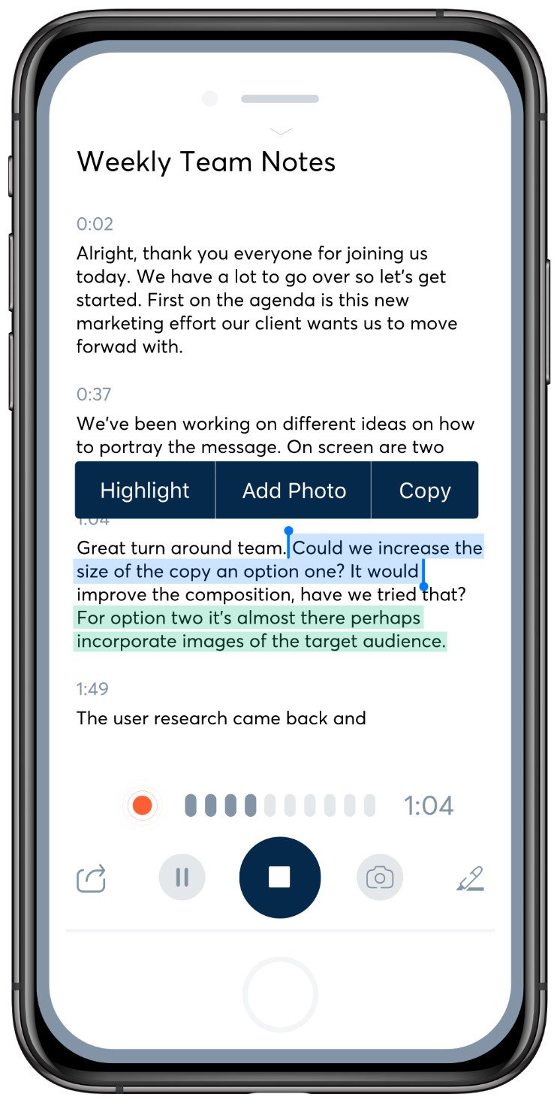

Otter Voice: Web Browser
- Sign in to Otter at https://otter.ai
- Select the MICROPHONE / RECORD icon to start recording
- To pause the recording, select PAUSE icon
- Select STOP icon to stop recording
- Recording is saved and processed
[IMAGE: Otter Voice application in web browser.]
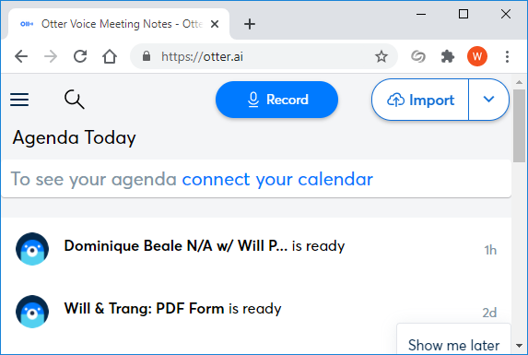

Otter Voice: Recording Complete
- Recording is saved and processed
- Process: speech segments
- Processing time
- E-mail notification

Otter Voice: Other Features
- Insert images
- Sync photos from camera app
- Highlight text

Livescribe Smart Pen
- Tool / Resource
- Parts
- Record audio
- Write notes on dot paper

[IMAGE: Livescribe Smart Pen with labeled parts.]
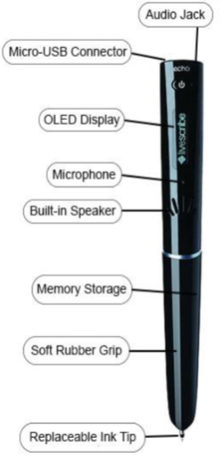
[IMAGE: Smart Pen Dot paper.]
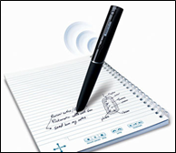

[IMAGE: Smart Pen Dot paper.]
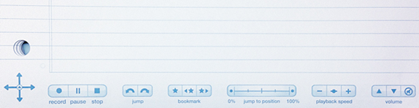

Livescribe Smart Pen: Student Use
- Capture auditory lecture information linked to the student's class notes
- Access the auditory data, review specific parts of a lecture by tapping the pen on the corresponding locations choosing to on the page

Livescribe Smart Pen: Outcomes
- Ability to capture all of the information
- Less anxiety
- Opportunity to hear parts or all of a class presentation many times
- Clarity of instructors’ feedback
- Independence from note takers

Questions?

THANK YOU!
Will Pines
Accessible Technology Specialist
Student Disability Resource Center (SDRC)
University of California, Riverside
sdrc-at@ucr.edu
wilbert.pines@ucr.edu

