An Instructional Design Approach to Accessibility – Lessons Learned
Presenter: Justin Tumelaire, Cengage Learning

Agenda
- accessibility and its relationship to your institution
- Instructional Design and Delivery (IDD) in context
- how accessibility fits into the IDD development process
- how ensuring accessibility affects cost and schedule
- addressing challenges associated with non-compliant learning content

Discussion
- What are some of the things that your institution currently does to support the delivery of accessible content?
- What are some of the challenges that your institution has encountered when trying to deliver accessible content?

What is Cengage’s IDD Team?
Instructional Design and Delivery (IDD) delivers unique end-to-end outcome-based academic services that integrates technology, content, and design to support institutions’ goals.
IDD partners with:
- For-profit, private career, trades, etc.
- Not-for-profit, traditional colleges and universities
- Community colleges and online college systems
- Cengage product teams

Roles
- Project Teams
  - Project Manager
  - Lead ID
  - Educational Technologist
  - Copyeditor
- Accessibility ID
- Learning Center of Excellence
  - Director of UDL and Accessible Technology
  - Accessibility/UDL Specialist

Phases of a Project
Scoping | Pre-Launch | Launch | Development and Production | Project Close
- Work with sales to identify the scope of work for the project.  - Accessibility IDs (designated IDs) support scoping—fill out Scoping Gap Analysis and handoff docs for accessibility. | - Create design prototype  - Run design summit, get customer feedback  - Update docs & plan  - Accessibility IDs evaluate all content and fill out the Full Gap Analysis for accessibility, answer questions about design. | - Confirm and go over detailed schedule and design prototype with stakeholders  - ID shows design prototype to the customer and talks about how accessibility will be addressed in the solution. | - Create deliverables using decisions from design prototype  - IDs design deliverables to meet accessibility requirements.  - Accessibility IDs answer questions. | - Discuss lessons learned  - Send any updated materials to the Product Team  - IDs discuss lessons learned and content updated for accessibility

Our Sphere of Influence
- Student-facing Office docs or PDFs we include or content we write has:
  - Screen-readability
  - Appropriate color contrast
  - Appropriate reading order
  - Descriptive links
  - Accessible form functions
- Images in editable files (test bank questions, PPTs, lectures) have:
  - Appropriate alt text
  - No text in the images
- Videos, including those in a platform, have:
  - Closed captioning
  - Transcripts
* We will check much more than this in scoping, to ensure that the customer knows, and we design for, what we cannot change (by including alternate activities etc.)

Scoping Gap Analysis
- Expanded Gap Analysis to include both content and accessibility
- Review a sample of the content for the project (based on project size)
- Determine where content lacks accessibility
  - Effort
  - Cost
  - Schedule
- Focus on the content that aligns to learning objectives

Scoping Gap Analysis (Example Spreadsheet)
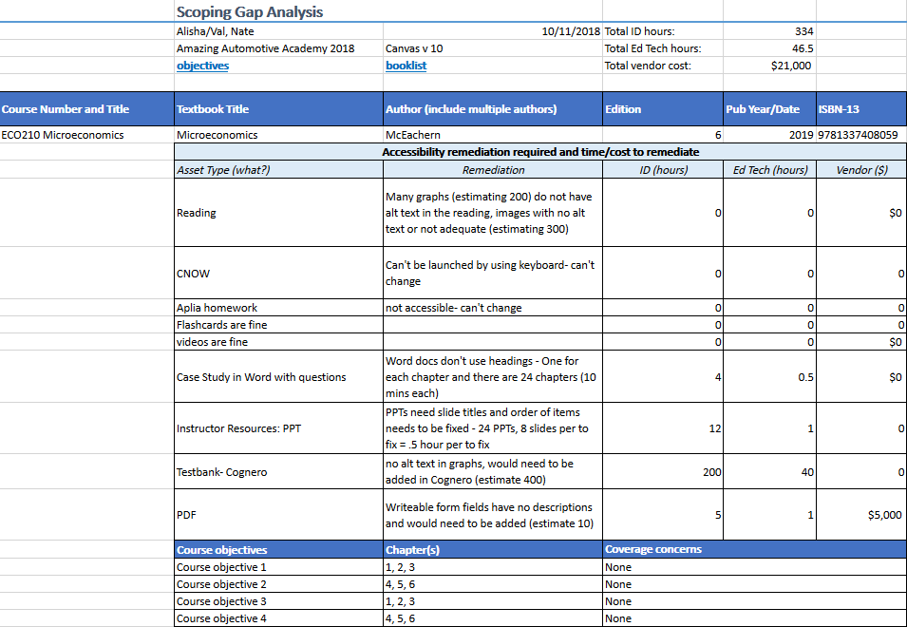

Full Gap Analysis
- Pre-launch: Full Gap Analysis
  - All courses are considered
  - Confirm there are no major deviations from scoping
- Prototyping and Development:
  - Full Gap Analysis informs design – make sure that design reflects the accessibility decisions
  - Log newly uncovered accessibility issues to the Full Gap Analysis as they are uncovered
- Project Close:
  - Send updated files to Product

Full Gap Analysis (Example Spreadsheet)
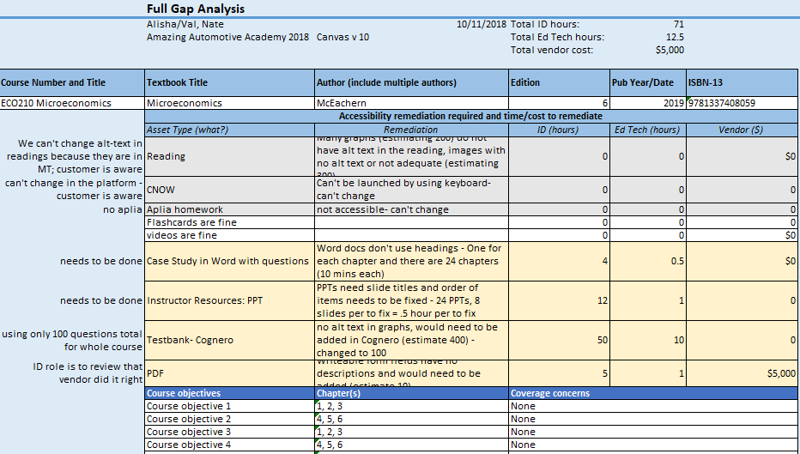

Discussion, Part 2
- What have you learned in this presentation that you can implement at your institution?
- What suggestions do you have for improving our process?

