Texts Used in Winter 2018
This survey was distributed to professors of students whom requested Accessible Instructional Materials in Winter 2018.

There were 133 respondents.
Table of Contents
Texts Used in Winter 2018 1
What class are you teaching? This was identified in the email that contained a link to this survey. (109 responses) 2
Which option best describes this class? (133 responses) 5
Which type of texts are you requiring students to read? Please check all that apply. (133 responses) 6
Do you require that students have a specific edition of your texts? (129 responses) 8
How soon before the class starts do you determine your REQUIRED readings? (130 responses) 9
How soon before the class starts do you determine your SUPPLEMENTAL readings? (124 responses) 12
What information would be helpful to have on the http://depts.washington.edu/uwdrs/accessible-instructional-materials/ page that is currently missing? (49 responses) 15
Have you been asked to provide Accessible Instructional Materials to a student with a disability before? (133 responses) 17

What class are you teaching? This was identified in the email that contained a link to this survey. (109 responses)
- ACCT 225A
- Amath 383
- AMATH 402.00A
- Amath 423/523
- Anth 215
- Architecture 151
- ART 290.00A - BEG DRAWING FIGURE (CRN: 10461)
- art190 Intro to Drawing
- ASTR 300.00A - ASTRO PROGRAMMING (CRN: 10598)
- ASTR160
- BCHEM 402
- Behavioral Medicine
- Biol 118
- BIOL 180
- Biology 401
- Biology 440
- BIOST 512
- BIS 301A
- BIS 340.00A - APPRS CULTURAL RES (CRN: 11759)
- BIS 393C Critical Animal Studies
- BIS341
- BIS499
- BISCP 343: Community Psychology
- CEE 220
- CHEM 142C
- CMS 370 basic screenwriting
- COM 289
- COM 597 E
- Constitutional Law II
- contracts (law school) A501
- CSE 312B
- CSE 473
- DIS ST 419
- EMBA 511
- EMBA 521.00B - ORG LEADERSHIP (CRN: 14061)
- ENGL 281F
- ENGL 298.00I - INTERMED WRIT SOC S (CRN: 14318)
- English 131
- English 281
- ENGR 121.00A - STARS CHEM PROBSOLV (CRN: 14396)
- ENGR 202 - Introduction to Engineering
- FISH 101 Water And Society
- Geog 205
- Global Health 101/JSIS 180/Geog 180
- HONORS 345
- Honors 394D
- I BUS 300
- Individuality & Individualism
- INFO 200-B
- INFO 343-B
- INFO 360
- Introduction to Ethics, PHIL240
- JEW ST 289.00A
- Law A515 Busines Organizations Winter Qrt 2018
- M E 230.00A - KINEMATICS & DYNS (CRN: 16982)
- Maternal Child Health
- Math 111
- Math 120
- Math 125
- Math 125B
- MATH 408
- MATH 442.00A - DIFFERENTIAL GEOMETRY
- MEDEX 568 Emergency Medicine
- MEDEX 574.00A Technical Skills
- MGMT504
- MUS 162
- NSG 560
- NURS 310 Pharmacotherapeutics in Nursing
- NURS 401
- NURS 415
- NURS 518
- NURS 548
- NUTR 200
- OCEAN 497.00D - ADV SPEC TOP: OCEAN (CRN: 22428)
- Other (9)
- PHARM 514
- Physics 294
- Physics 334 - Electronics I
- POL S 349.00A - STRATEGY & WAR (CRN: 19451)
- Psych 101C
- SCAND 370 A
- SCAND 370 A / HSTAM 370 A :The Vikings
- SEFS 571
- SOC 300
- SOC W 505.00A - SOC WELF RES
- SOC W 512
- SOCW 572A
- SPH 381
- Stat 311
- STMATH 124
- T FIN 422.00A - INVESTMNT VALUATION (CRN: 20943)
- T HLTH 310
- T SOCW 525A
- T SOCW 533.00A - ADV INT PRACTICE II (CRN: 21124)
- TCULTR 410: Studies in US Popular Culture
- TFIN 426 (Portfolio Management)
- TFIN 430 (Intermediate Business Finance)
- THAI 212 A
- THIST 377 Art of the Americas
- TINST 311
- TSOCWF 320.00B - COMTEMP SOC WELFARE (CRN: 21575)

Which option best describes this class? (133 responses)

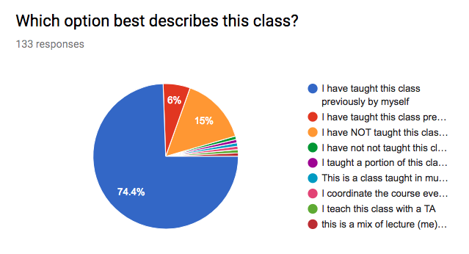

Value | Count
I have taught this class previously by myself | 99
I have NOT taught this class previously | 20
I have taught this class previously with another | 8
I have not not taught this class previously, but I have been a teaching assistant for this class multiple times. | 1
I taught a portion of this class last year. This year I have a full section of 28 students. This is a class with several sections that are closely coordinated. All readings are identical. | 1
This is a class taught in multiple sections, many of which share common texts | 1
I coordinate the course every quarter; lecturer varies | 1
I teach this class with a TA | 1
this is a mix of lecture (me) and lab sessions (TAs) | 1

Which type of texts are you requiring students to read? Please check all that apply. (133 responses)

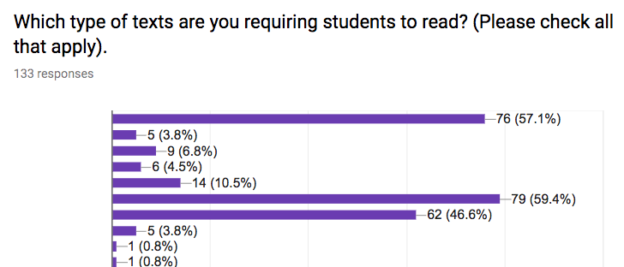

Value | Count
Articles (several digital files) | 79
Textbook(s) | 76
Websites | 62
Articles (physical handouts) | 14
Novel(s) | 5
Coursepack, Reader (a physical collection of articles) | 9
Coursepack, Reader (a single digital file that contains a collection of articles) | 6
I don't require reading in this class | 5
Worksheets of problems are handed out in class each day. Also on website in PDF format. | 1
PDF PowerPoint Slides | 1
New York Times either digital or physical copy | 1
lab manual, work sheets | 1
Material on Canvas (Panopto videos, notes, etc.) | 1
slides from a previous quarter | 1
Online homework, exams, quizzes, worksheets | 1
Webassign online homework, quizzes, exams | 1
in-class and homework worksheets | 1
other reading of plans and policies from city of Tacoma website for project purposes | 1
hanouts (written or typed) | 1
I produce the handouts with computer program, therefore I could forward the files to DRS as well. | 1
articles will be added based on students' interests | 1
Textbook is recommended | 1
Web-based programming assignments | 1
Assignments are done on webassign, an online homework platform, which comes with an electronic copy of the book. | 1
Optional textbook (not required) | 1
students can also use e-book version. | 1
Course Handouts (doc or pdf files which are meant for note taking during class) | 1
Instructional Videos | 1
Course readings are available on Canvas | 1
One additional social scientific text. | 1
All readings are digitally available via the class canvas page | 1
Student work | 1
I provide copies of slides | 1

Do you require that students have a specific edition of your texts? (129 responses)

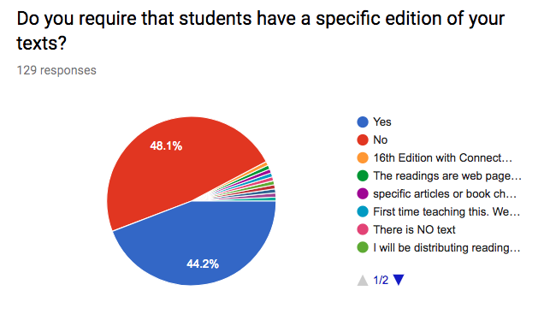

Value | Count
Yes | 57
No | 62
16th Edition with Connect Plus | 1
The readings are web pages, so this is not a relevant question | 1
specific articles or book chapters, all digitized. No editions | 1
First time teaching this. We are using the 9th edition, but I'm not sure how rigid other instructors will be about using the specific edition. I will follow suit. | 1
There is NO text | 1
I will be distributing readings through a course website | 1
Yes, but its up to them | 1
Not applicable | 1
All texts are specified on the class canvas page | 1
Although the previous 8th edition is fine for this quarater. | 1

How soon before the class starts do you determine your REQUIRED readings? (130 responses)

- 1 month before class
- 1 quarter
- 1 week (2)
- 2 weeks (6)
- 2 weeks before the start of the quarter
- 2-3 days
- 3 months
- 3 weeks (2)
- 4 weeks in advance
- a couple of weeks
- A couple weeks.
- A few days. It depends on whatever else I have to get done.
- About 2-4 weeks
- about a month
- About a week before each class... I can try to get a complete list by the end of next week (January 12th).
- about a week before each session
- All are determined
- All readings have been determined and will be posted by the end of this week (Dec. 22)
- All the files and links are on Canvas (syllabus states readings)
- Already decided.
- Already determined
- already determined
- Already determined. Text books have been ordered from the UW book store. Specific pages to be read are listed on the syllabus handed out during the first week of class. Online readings are also specified on the syllabus.
- Already established.
- At least 2 weeks
- At least a month
- At least one - two weeks prior to the start of class
- At least one month.
- At start of term, but not determined by me
- Before class starts
- Before the term starts
- determined by lead
- Everything is pretty much set prior to the beginning of the quarter. Revisions to the schedule as needed are usually provided 1 - 3 days in advance.
- First day
- First day of class
- first day of the quarter
- Greater than one week.
- I finalize readings a week or two before class starts
- I know most of them now. Sometimes a learning opportunity arises in the quarter and I might add something at that point
- I post the required reading on canvas 2-3 days before the class. (2)
- I should have it figured out by the end of December
- I will have them determined at least two weeks prior to the first day of instruction.
- I'll have a near final draft in the next couple weeks
- I'm trying very hard to get this determined before the quarter starts. At the very least I can get the first few week's readings to you if needed.
- in the syllabus at start of class
- It depends, some a year ahead of time, some are chosen during the quarter
- It's been decided. The coursepack is at the Copy Center.
- Largely same every quarter, e.g. see: https://courses.cs.washington.edu/courses/cse473/17au/
- Minimum of 3 weeks.
- Month
- Months
- Most readings and websites are identified well in advance. Occasionally I add a journal article, or chapter from a textbook, about one week before that particular lecture.
- N/a (9)
- No required readings
- Not until the class starts.
- Not with too much advance - 1-2 weeks
- One week (12/26)
- One year
- Other (17)
- Over summer our department determines the text for the academic year.
- Quarter before class starts
- Readings are communicated the first day of class.
- Readings will begin week 2 of the quarter
- Required reading is already determined - Required reading is listed on the syllabus handed out to students on the first day of class. I will email a copy to drs if needed earlier. Simply send me an email request. My email: <leiren@uw.edu>
- Required readings may not be posted until 2 weeks before each lecture
- Roughly 2 weeks
- Several months
- Several months.
- six months
- Some I know now, some depend on the interests of the students and will be decided as the quarter progresses.
- Soon
- Specific pages (sections) assigned per class are typically set by the start of the quarter.
- Supplemental textbook and lecture notes can be read after lecture
- Text is determined months in advance; specific pages weeks in advance
- Textbook is already determined, I am finishing up the articles required for the readings. This might not be all the way done until one week before class.
- The class is offered multiple times a year. The readings are already chosen and available. You have made this course "accessible" before
- The course schedule is set at the beginning of the quarter and announced to the students on the course website. It will be available at https://sites.math.washington.edu/~ebekyel/Math111/ once the quarter starts. Currently the old version (Winter 2017) is online. Most information will remain the same updated with the Winter 2018 dates.
- The required material is available now.
- The text is already chosen based on the pre-requisite for this course, T SOCW 532.
- The week before
- There are already determined (one month in advance)
- They are all posted on canvas.
- They are already determined (2)
- they are already determined.
- They are determined now.
- They are tentatively set at the beginning of the term but may change as the term progresses.
- They don't need to read the material prior to class.
- they have all been determined
- They have already been determined (available on the bookstore website)
- They should be finalized in the next 3 weeks.
- They will be provided in advance in the syllabus.
- three-four weeks
- two weeks before the end of the previous quarter
- Two weeks before the term begins.
- usually a week before everything is finalizing
- Waiting on finalized syllabus from lead instructor
- way before, posted online
- We have been using the same book for three years
- Working on syllabus with readings now to have ready end of this week.

How soon before the class starts do you determine your SUPPLEMENTAL readings? (124 responses)

- 1 month before class
- 1 quarter
- 1 week
- 1-2 weeks
- 2 weeks (4)
- 2 weeks before the start of the quarter
- 2-3 days
- 3 months
- 3 weeks
- 3-7 days
- 4 weeks
- 5 days
- A couple weeks.
- A few months
- a few weeks
- about a month
- about a week
- Again, each day. Students are mostly responsible for finding their own sources.
- All are determined
- All readings are required and are part of homework assignments
- All required online readings and assignments are made available every Sun at 11:59p on Canvas and due the following Sunday at 11:59p. The lectures are on Tue/Thu so the student has the whole week to complete required readings and assignments and can access them 24hrs before the class begins each week. Students were given the course pack on the first day of classes (Wed Jan 3).
- All supplemental readings are currently available either as the optional textbook or as lecture notes that have already been posted to the course web page. The lecture notes are, however, are subject to change.
- already determined (2)
- Already established.
- already posted online
- as needed
- As the class goes.
- At least 2 weeks
- At least one - two weeks prior to the start of class
- At least one month.
- At least two weeks before the first day of instruction.
- At start of term, but not determined by me
- Before the term starts
- could be as soon as a week before
- determined by lead instructor
- Don't generally have these
- During class
- Everything is pretty much set prior to the beginning of the quarter.
- First day of class
- first day of the quarter
- For this class, weeks before hand. All supplemental readings are uploaded to Canvas before class even starts.
- Greater than one week.
- I choose them along the way
- I do not have any.
- I do not use supplemental readings. All readings are made available at the start of the quarter.
- I finalize readings a week or two before class starts
- I provide supplemental websites, those will be determined as I update each lecture ~3 days before each class
- If any, during the quarter, usually
- Most are already determined, will add some 2 weeks before class
- N/a
- N/A (16)
- n/a (5)
- No supplemental other than reading writing produced by students in the class and/or watching videos & film.
- No supplemental reading is required.
- no supplemental readings
- NO supplemental readings
- No supplemental readings (3)
- No supplemental readings for the class.
- No supplemental readings.
- none
- None
- Not applicable
- One week (12/26)
- One year
- Prior to the start of the quarter
- Prior to the start of the quarter.
- Quarter before class starts
- Same as above.
- Same.
- same. all posted on CANVAS
- see above
- see above
- See above.
- Several months
- several weeks
- Soon
- students develop a major research project throughout the quarter and will find additional articles to include in the class based on the topic of the paper
- Students need to read the NYT during throughout the whole course
- Supplemental readings may not be posted until a week before each lecture
- The material is available now.
- There is no supplemental readings in this class.
- There really aren't any.
- There will be no supplemental readings.
- There will be none
- These are sometimes added during the quarter based on student interest
- They are already determined
- They don't need to read the material prior to class.
- They will all be finalized by the start of the winter quarter.
- Those are available now, again some could be added as learning opportunities arise.
- two weeks
- two weeks before end of previous quarter
- Two weeks before the term begins unless I come across an article in the literature that I think is relevant and then add that onto Canvas right away.
- Usually at the same time as the text book/required reading. Occasionally an article will be introduced later in the quarter to supplement the material being covered.
- Varies
- waiting on finalized syllabus from lead instructor
- We determine on Fridays for the following week
- Weeks
- Weeks in advance
- when class starts - students make individual choices

What information would be helpful to have on the http://depts.washington.edu/uwdrs/accessible-instructional-materials/ page that is currently missing? (49 responses)

- Can't think of anything
- easier to read, easier to find what I need when I need it
- how to better attract notetakers. I did not have an issue with this before but tis time no one wants to volunteer
- How to contact the UW Bookstore to provide them with a list of all texts used in the class. I was able to contact them through the department's curriculum coordinator.
- How to deal with online quizzes? How to deal with in-class weekly quizzes and/or exams? (The quizzes are sometimes made at the last minute.)
- I am not sure of what the student needs, but the text is available online and in paper form, but I don't think it is an audiobook.
- I do not have adequate experience with accessible instructional materials to respond thoughtfully
- I do not know
- I don't know. I'm not proofreading and evaluating your website at this time.
- I haven't had a chance to look at this web page yet. (I'm still dealing with this quarter's two courses.)
- I'm not sure, I just learned about accessible materials a few months ago when we were visited in our department.
- I'm unclear exactly what an accessible PDF means
- If a student needs accommodations that require scanning textbooks, having more than one week's notice before the quarter starts would be optimal.
- If the texts aren't easily converted to spoken text, then I will need to know if advance how to make them accessible.
- It is fine. My course is lecture based, power point presentations, with labs that require 4 hours/wk., extensive use of the compound microscope, high quality drawings by the students, work sheets and white board discussions each week, a midterm and a final, essay exams!
- It is useful
- It looks fine to me.
- It looks pretty extensive to me, but I'm quite familiar with accessibility issues in instruction.
- Much lab work involves diagrams and pictures. The content is not easily translated into text (in some cases it may be impossible). What can be done in these cases?
- My class uses a great deal of digital visual material: films, at videos, interviews, etc.
- n/a
- N/A
- NA (2)
- None (4)
- none (6)
- None that I can see.
- None.
- None. It already has enough.
- Not really sure. This is a fully online class. All material are on the course Canvas page.
- Not sure....I am just confused on how to meet these accessibility requirements in a writing workshop class, as many of the specified accommodations do not apply, and much of the course material is the work of other students.
- Nothing comes to mind
- Nothing that is not already included.
- outreach -- this is the first I've heard of the service
- The page is comprehensive--it's the DRS interface for faculty that is consistently confusing and difficult to use. Also, for people like me who get many DRS requests for one class, it would be nice to have instructions on how to minimize duplication, etc.
- The site is very helpful and I can think of no additions at this time.
- The specific needs of my student regarding accessibility to the materials.
- un sure
- Unknown
- Upon first glance, nothing.
- Why DRS is requesting material the first week of a quarter while stating that it will take at least 6 weeks to provide support for the demanded material.

Have you been asked to provide Accessible Instructional Materials to a student with a disability before? (133 responses)

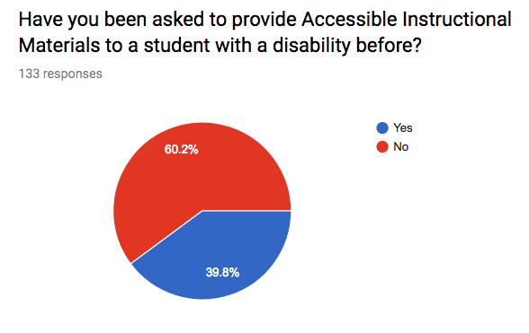

Value | Count
Yes | 80
No | 53

