Texts Used in Spring 2016
This survey was distributed to professors of students whom requested Accessible Instructional Materials in Spring 2016.

There were 94 respondents.
Table of Contents
Texts Used in Spring 2016 1
What class are you teaching? This was identified in the email that contained a link to this survey. (65 responses) 2
Which type of texts are you requiring students to read? (94 responses) 4
Are you using PDFs in this Spring 2016 course? (92 responses) 5
In what ways are you using PDF documents in this Spring 2016 course? (87 responses) 6
Where did you find the PDFs used in this Spring 2016 course? (87 responses) 7
Once you found a PDF you wanted to use, please indicate if you did any of the following: (84 responses) 8
Did you use the built-in PDF Accessibility checker in Adobe Acrobat software? (94 responses) 9
In what ways are you using Microsoft Word documents in this Spring 2016 course? (91 responses) 10
Where do you typically find Word documents you use in class? (87 responses) 11
When you created a Word document, please indicate if you did any of the following: (94 responses) 12
Do you know what heading styles are in MS Word? (94 responses) 13
Do you regularly use heading styles in MS Word? (94 responses) 14
Do you use the built-in Accessibility checker in Microsoft Word software? (94 responses) 15
Have you been asked to provide accessible files to a student with a disability before? (94 responses) 16
Do you know what a screen reader is? (94 responses) 17
Do you know what text-to-speech is? (94 responses) 18
Do you know what Optical Character Recognition is? (94 responses) 19
Do you know what Speech Recognition is? (94 responses) 20
Have you ever referenced the http://www.washington.edu/accessibility/ page for document accessibility guidance? (93 responses) 21
What type of training resource would you most likely use to learn more about creating/finding accessible files? (94 responses) 22

What class are you teaching? This was identified in the email that contained a link to this survey. (65 responses)
- AES 151
- AES 498
- Anth 213
- Arch 150
- ARCHY 369C
- ASTR101
- Astro 101 B
- B Bio 355
- BBIO 293A - Scientific Writing
- BIOL220
- Biology 180
- BIS 325: Disability & Human Rights
- CHEM 162
- CHEM 237
- CHEM 242
- CHID 480 A
- COM 301
- COM 340
- Dance 100
- Econ 201 B
- Epi 542
- EPI 549
- ESS 102
- ESS 495 - Intro to NASA Research
- GenST297 Inspiration From Contemporary Thinkers
- GH 523
- hstlac 289
- INFO 200
- INFX561.00A Visualization Dsgn
- Introduction to Drawing ART 190
- LING 200
- LING 400
- LING 480 A Topics in Linguistics
- LIS 587
- LSJ 401
- Mass Media Law
- Math 125 D
- Math 300 C
- Math309D
- ME 426
- MEDEX 469/569; MEDEX 472/572; MEDEX 462/562; MEDEX 475/575; MEDEX 455/555; MEDEX 459/559; MEDEX 461/561
- MKTG 335 B PRINCIPLES OF SELLING
- Mktg. 335 & 430
- NURS 404
- NURS 405 Care in Illness II
- NURS 410A - LEGAL ETHIC ISSUES (CRN: 17539)
- NUTR 241
- PHIL 332
- PHIL 401A
- PHYS 432
- Psych 318A
- SOC 271
- SOC 300 FOUND SOC INQUIRY
- SocW588
- SP16 ASTR 150E - The Planets (online)
- SPHSC 534
- SPHSC 536
- Spring 2016 BIOL 220.00A - INTRO BIOL (CRN: 11352)
- Spring 2016 OCEAN 201.00A - INTRO OCEAN LAB (CRN: 17678)
- Spring 2016 PHYS 123.00B - WAVES (CRN: 18464)
- TCOM353
- TWRT 387
- URBDP 507 General Urban Planning Lab
- URBDP 580A
- Urbdp598h

Which type of texts are you requiring students to read? (94 responses)

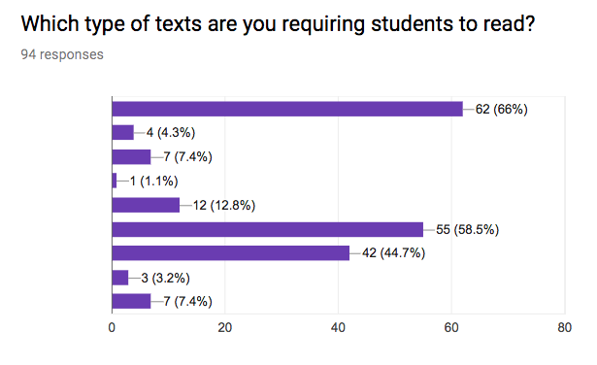

Value | Count
Textbook(s) | 62
Articles (several digital files) | 55
Websites | 42
Articles (physical handouts) | 12
Option not listed | 7
Coursepack, Reader (a physical collection of articles) | 7
Novel(s) | 4
I don't require reading in this class. | 3
Coursepack, Reader (a single digital file that contains a collection of articles) | 1

Are you using PDFs in this Spring 2016 course? (92 responses)

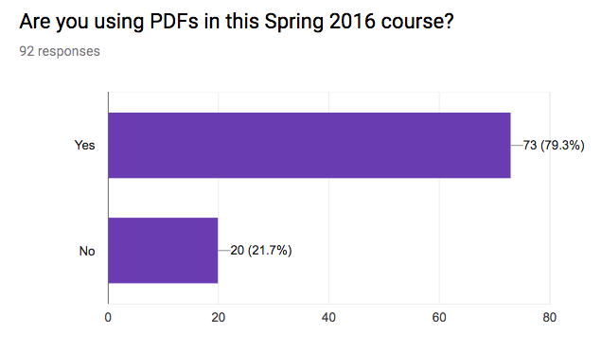

Value | Count
Yes | 73
No | 20

In what ways are you using PDF documents in this Spring 2016 course? (87 responses)

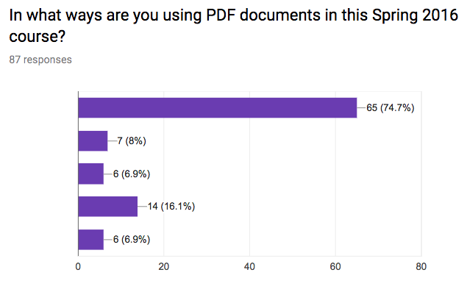

Value | Count
Have students read PDFs (e.g. journal articles, instructions) | 65
Have students create PDF (e.g. to submit an assignment) | 7
Have students complete a PDF (e.g. a handout or worksheet) | 6
I am not using PDFs in this Spring 2016 course | 14
Option not listed | 6

Where did you find the PDFs used in this Spring 2016 course? (87 responses)

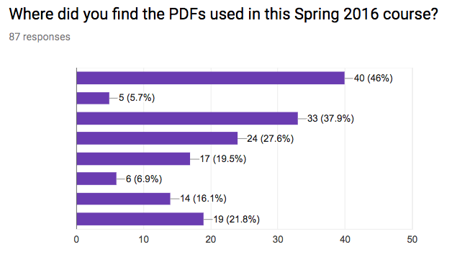

Value | Count
saved from previous quarters | 40
online journals | 33
hardcopies of texts that are scanned | 24
Option not listed | 19
internet searches | 17
I am not using PDFs in this Spring 2016 course | 14
publishers | 6
other instructors | 5

Once you found a PDF you wanted to use, please indicate if you did any of the following: (84 responses)

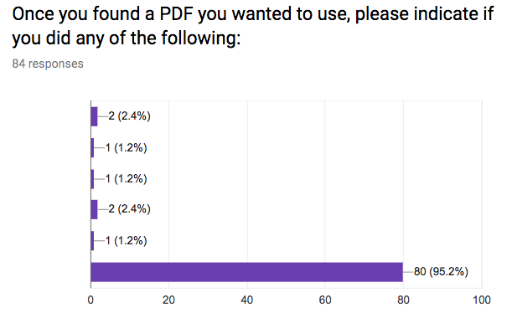

Value | Count
attempt to copy/paste text from the PDF into another file | 2
check the alternate text of images | 1
save the PDF as a word document | 1
use Optical Character Recognition to convert image text into copy/paste-able text | 2
check and/or add tags | 1
I did none of the options | 80

Did you use the built-in PDF Accessibility checker in Adobe Acrobat software? (94 responses)

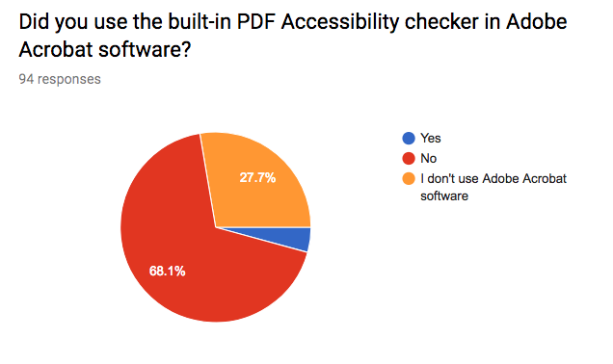

Value | Count
Yes | 4
No | 64
I don't use Adobe Acrobat software | 26

In what ways are you using Microsoft Word documents in this Spring 2016 course? (91 responses)

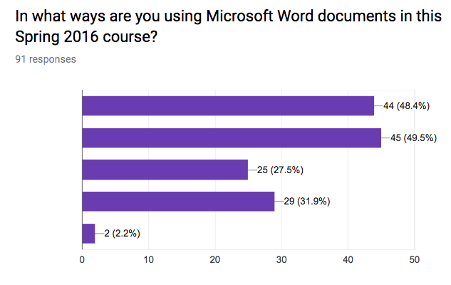

Value | Count
Require students to read Word document (e.g. instructions, example paper) | 44
Require students to create Word document (e.g. a paper) | 45
Require students to complete a Word document (e.g. a handout or worksheet) | 25
I'm not using Word documents | 29
Option not listed | 2

Where do you typically find Word documents you use in class? (87 responses)

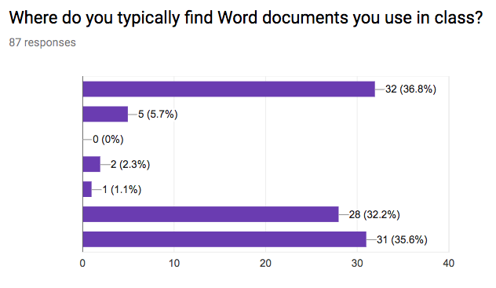

Value | Count
saved from previous quarters | 32
other instructors | 5
online journals | 0
internet searches | 2
publishers | 1
I'm not using Word Documents in this Spring 2016 course | 28
Option not listed | 31

When you created a Word document, please indicate if you did any of the following: (94 responses)

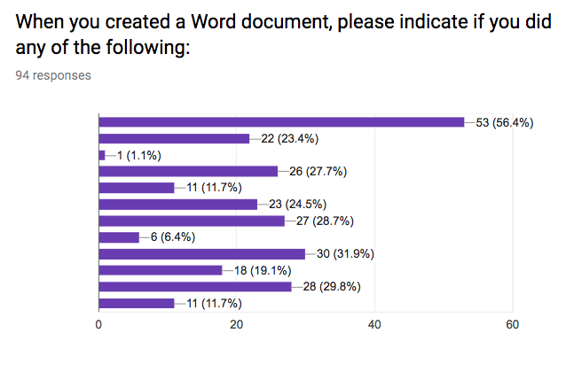

Value | Count
use bold, capitalization, different fonts, different colors to "structure" a document (e.g. organize sections of content) | 53
insert images | 22
insert alternate text for each image | 1
insert tables | 26
mark first row of a table as table headers | 11
use the built-in features to create numbered lists or a bulleted list | 23
save the word document as a PDF file | 27
insert textboxes or WordArt | 6
include URLs | 30
include good link text for URLs (so the user knows where the URL is taking them before clicking on it) | 18
I didn't create Word Documents for this Spring 2016 course | 28
I did none of the options | 11

Do you know what heading styles are in MS Word? (94 responses)

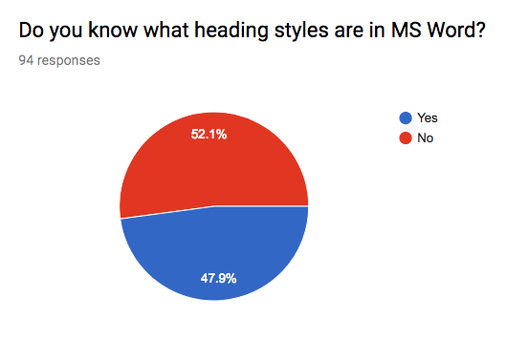

Value | Count
Yes | 45
No | 49

Do you regularly use heading styles in MS Word? (94 responses)

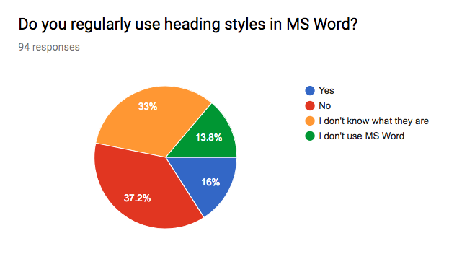

Value | Count
Yes | 15
No | 35
I don't know what they are | 31
I don't use MS Word | 13

Do you use the built-in Accessibility checker in Microsoft Word software? (94 responses)

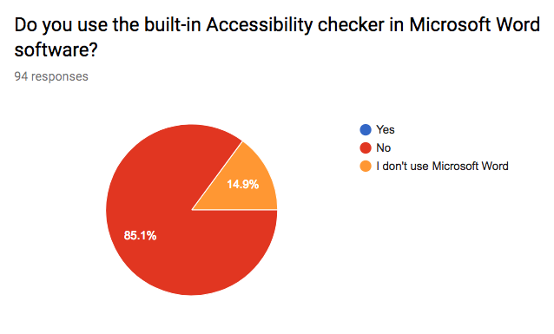

Value | Count
Yes | 0
No | 80
I don't use Microsoft Word | 14

Have you been asked to provide accessible files to a student with a disability before? (94 responses)

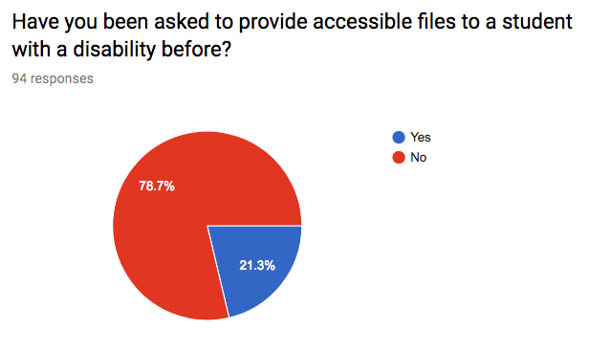

Value | Count
Yes | 20
No | 74

Do you know what a screen reader is? (94 responses)

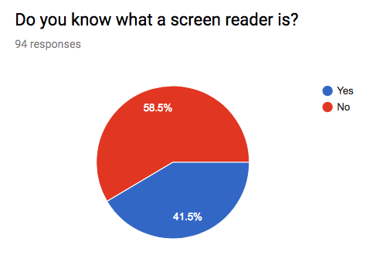

Value | Count
Yes | 39
No | 55

Do you know what text-to-speech is? (94 responses)

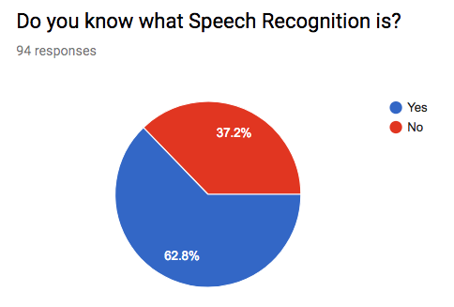

Value | Count
Yes | 67
No | 27

Do you know what Optical Character Recognition is? (94 responses)

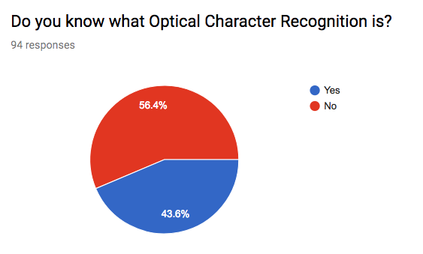

Value | Count
Yes | 41
No | 53

Do you know what Speech Recognition is? (94 responses)

Value | Count
Yes | 59
No | 35

Have you ever referenced the http://www.washington.edu/accessibility/ page for document accessibility guidance? (93 responses)

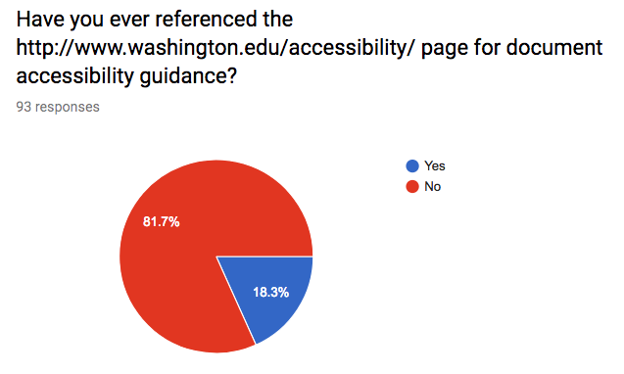

Value | Count
Yes | 17
No | 76

What type of training resource would you most likely use to learn more about creating/finding accessible files? (94 responses)

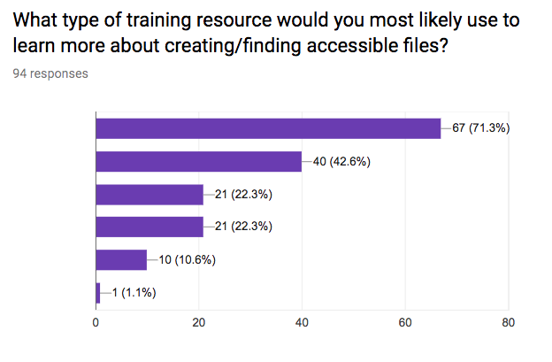

Value | Count
Step by step instructions written in text online | 67
5 min (or less) videos on website | 40
20 min (or less) phone call where you can see the instructor's computer screen | 21
30 min in-person workshops | 21
60 min in-person workshops | 10
Demonstrations/Open House during faculty “boot camp” | 1

