Accessibility Studies Program Library for 2018
Horton, S. & Quesenbery, W. (2013). A web for everyone. Rosenfeld.
Norman, D. (1995). The design of everyday things. Basic Books.
Null, R. (2013). Universal design: Principles and models. CRC Press.
Shapiro, J. (1994). No pity: People with disabilities forging a new civil rights movement. Crown.
Smart, J. (2015). Disability, society, and the individual. Pro-Ed.

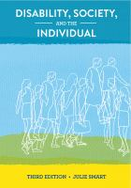
ASP 305 Accessibility & User Experience

DISABILITY, SOCIETY, AND THE INDIVIDUAL

BY SMART, JULIE

9781416410003

PUBLISHED BY PRO-ED, INCORPORATED

PUBLISHED ON 2015-01-01

EDITION: 3

LIST PRICE $68.00

BINDING: PAPERBACK

NO PITY : PEOPLE WITH DISABILITIES FORGING A NEW CIVIL RIGHTS MOVEMENT

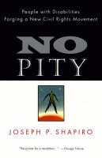
BY SHAPIRO, JOSEPH P.

9780812924121

PUBLISHED BY CROWN/ARCHETYPE

PUBLISHED ON 1994-10-25

BINDING: PAPERBACK

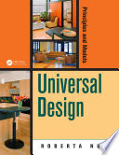
ASP 325 Universal Design

UNIVERSAL DESIGN: Principles & Models

BY Null, Roberta.

978-1466505292

PUBLISHED BY CRC Press

PUBLISHED ON 2013-09-26

BINDING: Online

ASP 435 Accessible Information Design

A WEB FOR EVERYONE : DESIGNING ACCESSIBLE USER EXPERIENCES

BY HORTON, SARAH, QUESENBERY, WHITNEY

9781933820972

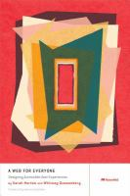
PUBLISHED BY ROSENFELD MEDIA, LLC

PUBLISHED ON 2013-01-01

LIST PRICE $39.00

BINDING: PAPERBACK

ASP 485 Accessibility Capstone

All texts required for ASP 305, ASP 325 and ASP 435 will be used as reference during ASP 485.
Recommended for all courses; required for ASP 485:

THE DESIGN OF EVERYDAY THINGS: REVISED AND EXPANDED EDITION

BY NORMAN, DONALD A.

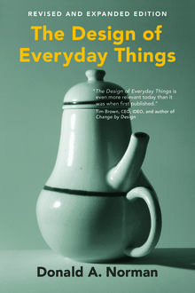
9780262525671

PUBLISHED BY BASIC BOOKS

PUBLISHED ON 2013-01-01

BINDING: PAPERBACK

