The Power of Partnerships
accessibility@swarthmore.edu

PRESENTERS
Corrine Schoeb, Technology Accessibility Coordinator
Mike Jones, Director of Language and Media Centers
Susan Smythe, ADA Coordinator

About Swarthmore College
- Small - 1600 students
- Highly selective
- 13% of our total students are international, 44% of our total are students of color, and 21% reflect underrepresented minority categories, 13% identify as having a disability
- Consensus-driven decision making
- Few dictates as far as course requirements e.g. syllabus, book adoption
- Very decentralized and non-hierarchical

Our partners

Accessibility involves everyone in the organization
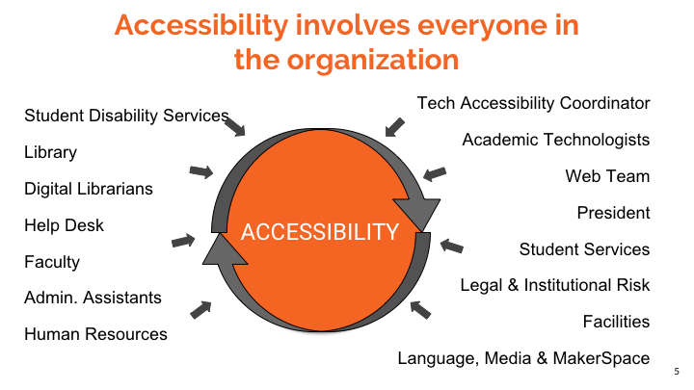

Motivations...
- Manage Risk
- Do the right thing
- Sustainable Processes

How in the world do we get “there”?
- Created Accessibility Working Group (AWG)
- Leveraged Rob Eveleigh’s Roadmap of Higher Ed OCR/DOJ Settlement Requirements
- Created Accessibility Task Force
- Created Policy Sub Group
- Created Procurement Subgroup

What do we have that we can leverage or hack for new uses?
- Exploit existing funding
- ITS Academic Technologists
- Librarians
- Move management of assistive software to ITS
- Worked with vendor to default all photocopiers to scan using Optical Character Recognition

What do we still need to do?
- Create Campus Awareness Training
- Create a culture that applies the principles of UDL
- Understand how to create minimally accessible content
- Community participation and “know how” around barriers to access and how to remove them
Accessibility Working Group (AWG)

Are...
- Bottom up drivers
- Moving towards proactive engagement & solutions

Key Members...
- Technology Accessibility Coordinator
- Library
- Media, Language & MakerSpace
- ADA Coordinator
- Student Disability Services

AWG - Day to Day Work
- Locate freely available or open access course documents using Haithi Trust, BookShare, Electronic Journals and E-books licensed by the library, Google Scholar, Internet Archive, AMAC, AccessText, Learning Ally
- In- house remediation
- Work with publishers
- Work with vendors
- Work with faculty & staff

AWG - Strategy Work
- Create agendas for higher level task force to drive organizational change
- Partner with Academic Technologists for accessibility competencies
- Enlist student employees to do remediation work and start conversations with faculty
- Centralized management of campus-wide assistive software
- Establish a baseline for assistive tech on public machines
- Document where assistive tech can be found around campus.

Accessibility Task Force

Are...
- Decision Makers
- Working Group
Key Members ...
- Provost
- Associate Provosts
- Chief Information Technology Officer
- College Librarian
- Chief Counsel

Strategic and Operational Wins

Moodle File Scan

Originally developed to help Library contain exploding cost of printing
- Adapted to recognize documents which are not text
- Critical tool to help us know scope of remediation need
- Now a Moodle block that appears on all Moodle courses - informs faculty of how much of their course material is inaccessible
- Helps us quickly find documents which need remediation when there is an accommodation request

Automated Student Disability Reporting
- Tie-in to registration
- Simplifies faculty contact
- Provides more timely notice to AWG of electronic accommodation requests

Copiers scan using Optical Character Recognition (OCR)
- Worked with Vendor to ensure all printers campus wide were delivered with OCR as default setting
- New course material is now automatically OCR’d
- Old material can be OCR’d

Vendor Questionnaire ties to both Security AND Accessibility
- Adds legitimacy
- Opportunity to train purchasers on questions to ask and basic testing techniques
- Sparks more conversation with disparate groups across campus
- Our CFO spontaneously stated in recent meeting … "accessibility not just to meet the letter of the law, but to the spirit of the institution.”

Increasing awareness & Getting the word out
- Accessibility is everyone’s responsibility
- Approval of Task Force to develop campus wide training
- Approval to add responsibility of accessibility to job descriptions
- Anecdotal evidence that more conversations are happening in many areas around campus

Questions we are grappling with ...
- Moving culture towards UDL Managing and addressing the fears, anxieties and myths faculty have around accessibility
- Remediating course documents
- How to distribute workload of making documents minimally accessible across campus Managing Software procurement
- Collaborating with other institutions with common vendors
- Consequences for vendors when they fail to meet or ignore stated roadmap expectations
- Boundaries and roles of Student Disability Services and Technology Accessibility Coordinator

Resources

Contract language:

Compliance with Laws/Policies
Other Party warrants and certifies that in performance of this Agreement, it will comply with all applicable statutes, rules, regulations, including laws and regulations pertaining to the subject matter of this Agreement. Other party also agrees to maintain compliance with WCAG 2.0 AA accessibility standards.

Policy:
https://goo.gl/1vzuYE

Faculty Syllabi Statement:
https://goo.gl/zNSBXQ

Website Footer language:
If you are experiencing difficulty accessing information on this site due to a disability, or if you have questions or concerns regarding the accessibility of content on this site, please tell us about the issue [italicized text links to accessible form] so we can assist

Moodle File Scan Git Repository:
https://goo.gl/sYe2La

Vendor Guidelines:
https://goo.gl/Y2h6N1

Rob Eveleigh's Roadmap:
https://goo.gl/vxLzkz

Contact us at:
accessibility@swarthmore.edu

