MATH TYPE
MathType is a powerful interactive equation editor for Windows and Macintosh that lets you create mathematical notation for word processing, web pages, desktop publishing, presentations, elearning, and for TeX, LaTeX, and MathML documents.
- MSWord 2010
- MathType 6.0 (CD version). Can download trial version or purchase download version from Design Science:
- Install MT
- Open MSWord
  - On FILE menu, go to OPTIONS
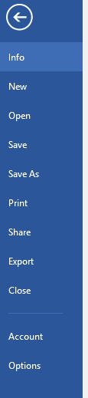
  - Select OPTIONS
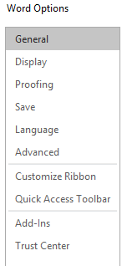

  - Select ADD-INS
From the MANAGE drop down, select MANAGE WORD ADD-INS and click GO
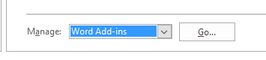
  - From TEMPLATES and ADD-INs, the add-ins for MathType should appear in the GLOBAL TEMPLATES and ADD-Ins. Check the box for MathTypeCommands for Word 2010.dotm and the box for WordCmds.dot
Then click OK

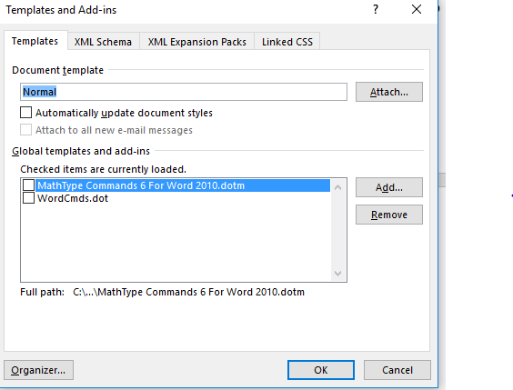
  - If the commands are not present, or the templates are not found automatically, try this fix from Design Science:
If the items from step 5 are not present, that's OK. Please try this:
  - Click the Add button. This will open a window titled Add Template.
  - In the window, navigate to one of these 2 paths (if the first one isn't on your computer, go to the second one):
C:\Program Files\MathType\Office Support\64
C:\Program Files (x86)\MathType\Office Support\64
  - You will see the following items in the folder (among others):
MathType Commands 6 for Word 2010.dotm
WordCmds.dot
  - Select one of them at a time, and click Open. This will bring it into the Add-Ins box. You will then need to click Add one more time to bring in the other add-in (either MathType Commands 6 for Word 2010.dotm or WordCmds.dot).
  - Once you have both of them listed under Templates and Add-ins, the boxes on the left side should have a checkmark inside, but if they don't, click to place a checkmark there. Click OK.
  - This will restore the MathType Tab to the Word Ribbon. Sometimes it takes a few seconds to load them in. Let us know if this helps.
If you have meticulously worked through this process and the MathType tab is still not on the ribbon in Word 2010 64-bit, please write and let us know you've gone through the steps here, and you still don't have a MathType tab. Please let us know what versions of Windows, Word, and MathType you're using, as well as your MathType product key.
Here’s a link to the DS Technical Support Notices: https://dessci.com/en/support/mathtype/tsn/tsn133-word2010-64.htm
NOTE: there are some quirks in the download & install steps between the older disc version of MT 6.0 used in this demo and how the new software & demo software behaves. Check with DS for more info!

