Instructions for outputting files from Mathtype to MathML

- Create your document using MathType, then save (Microsoft Word).

- With the document open, go to the MathType tab, and choose “Publish to Mathpage.” The following box will come up:
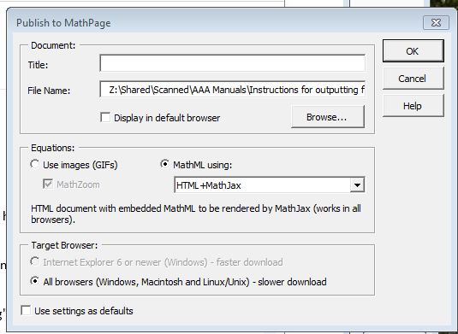
- In the “Title” box, enter the name of the file.
- In the File-name section, you need to click “browse”.
- In the file window that appears, create a new folder, calling it the same as the file name.
- Double-click the new folder to enter it.
- Click on save (the file window will close and you will see the above box again).

- In the Publish to Math Page Window, be sure the Equations are set to “MathML” using “HTML +Mathjax.

- Click okay. MathType will work on converting the document. Depending on how big the document is, it could take a few seconds or a couple of minutes. Once the file has been converted, it will open in a web browser (either Internet Explorer or Firefox).

- Close the Internet Browser window, and close the word file.

- In the folder where you saved the files, should be the new folder you created for the file. Double-click to open it.

- Select both the .htm file and the folder with all of the equations in it. Right click and “Send to: Compressed file.” This only takes a few seconds. Hit enter to accept the name when done.

- Send the zipped file directly to the student via email.

