EXAMPLES OF USING CHEMISTRY ADD-IN (CHEM4WORD) with Microsoft Word

Acetic Acid

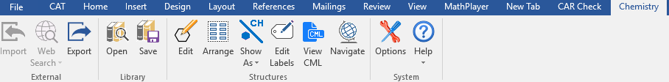

Shown is a 2-D graphic of the Acetic Acid molecule

Click on toolbar in MS Word, select CHEMISTRY tab, select SHOW AS, select RENDER AS A CONCISE FORMULA. The text box showing the 2-D structure changes to the CONCISE formula C2H4O2

Click on toolbar, select CHEMISTRY tab, click on VIEW CML (renders the molecule into chemistry markup language).

Adrenaline

Shown is a 2-D graphic of the Adrenaline molecule

Click on toolbar in MS Word, select CHEMISTRY tab, select SHOW AS, select RENDER AS A CONCISE FORMULA. The text box showing the 2-D structure changes to the CONCISE formula C2H4O2

Click on toolbar, select CHEMISTRY tab, click on VIEW CML (renders the molecule into chemistry markup language).

Caffeine

Shown is a 2-D graphic of the Caffeine molecule

Click on toolbar in MS Word, select CHEMISTRY tab, select SHOW AS, select RENDER AS A CONCISE FORMULA. The text box showing the 2-D structure changes to the CONCISE formula C2H4O2

Click on toolbar, select CHEMISTRY tab, click on VIEW CML (renders the molecule into chemistry markup language).