Links – Intro to Accessible PDF
There are three ways in which links are indicated within a document. Using the full URL, using an abbreviated URL, and embedding the link the text of the document (preferred).
Each approach presents unique challenges in making a PDF accessible to the screen reader user.
Embedding the link in the text of the document is the best approach as it provides the most readable and understandable form of the link. The following sentences demonstrate three ways to add a hyperlink to a document.

Embedded Hyperlink
Check out our Adobe accessibility website for more information about accessibility at Adobe.

Shortened URL
For more information on accessibility at Adobe click on the link, www.adobe.com/accessibility.

Full URL
Go to http://www.adobe.com/accessibility for more information Adobe accessibility.
A correctly tagged link has the <Link> tag, text associated with the link, and a Link – OBJR tag (the order of the last two is irrelevant.
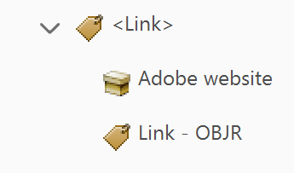
Figure 1: Link tagged in the order of <Link> tag, link text, and Link - OBJR tag
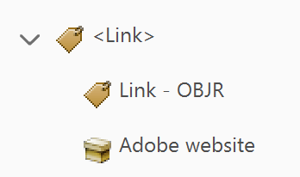
Figure 2:: Link tagged in the order of <Link> tag, Link - OBJR tag, and link text

