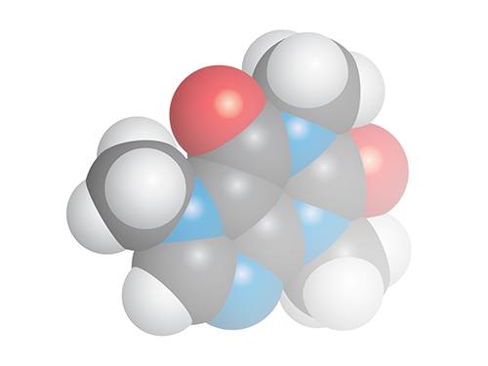

**Chemistry Add-in for**

**Microsoft Word**

**User Guide**

**Version 3.0**

Contents

Introduction 3

Prerequisites 4

System Requirements 4

Installation 4

To Install the Chemistry Add-in 4

Auto Update 5

Converting documents from the previous version of the Chemistry Add-in for Microsoft Word 7

How to add a chemical structure to a document 7

Draw a structure 8

Hydrogen Display 9

Flipping and mirroring structures. 10

Bond Lengths 10

Import a structure from a file 10

Add a structure from a web-search 11

PubChem search 11

ChEBI Search 12

How to edit an existing chemical structure 12

Convert text to Chemistry 13

Display options for Chemistry 14

The Library 15

The Navigator 15

Exporting chemistry files 16

ChemDoodle Web Commands 16

Editor Shortcuts 18

When Atoms are Hovered 18

When Bonds are Hovered 19

Setting Options 20

“Plug Ins” Options Tab 21

ChemDoodle Web Editor Options 21

Renderer Options 21

Searcher Options 22

“Web Services” Options Tab 23

“Library” Options Tab 24

“Maintenance” Options Tab 25

# Introduction

The Chemistry Add-in provides a simple and flexible way to include chemical information in a Word document.

With the Chemistry Add-in, you can:

* **Create inline "chemistry zones" to represent chemical data.**

Chemistry zones are controls that contain information about a molecule and display the information in a variety of ways. The underlying data is stored as Chemical Markup Language (CML), a widely used XML schema for representing chemical data. The data typically includes trivial and International Union of Pure and Applied Chemistry (IUPAC) names, the concise formula, and data for a 2-D structure.

* **Display chemical information in a variety of ways.**

A chemistry zone can display any representation that is supported by the underlying CML data. With a few clicks, you can switch from the molecule’s trivial name to its concise formula to its 2-D representation.

* **Draw and edit your own chemistry.**

The Chemistry Add-in supports ChemDoodle web, a fully featured structure editor. Draw your own structures from scratch or edit downloaded chemical structures. Export and import chemical structures from MDL Molfile format.

* **Display print-quality 2-D chemical structures.**

Chemistry zones can represent molecules by displaying a 2-D structure diagram using publication-quality, resolution-independent graphics. The Chemistry Add-in also includes an editor that enables you to modify the structure. The diagram is inserted into the document as a DrawingML image, so that others can view it, whether or not they have installed the Chemistry Add-in on their system[1]. You can also publish a document authored using the Chemistry Add-in as a PDF file.

* **Accept chemical data in a variety of formats.**

You can create a “chemistry zone” by typing a simple common name such as “water”, and then using the Chemistry Add-in to convert it to your preferred representation, assuming that the name you type exists in your library.

* **Import CML files from online web services**

Using the **Load From** option in the ribbon, you can look up existing molecular structures from the NCBI’s PubChem (<http://pubchem.ncbi.nlm.nih.gov/>), the Unilever Centre’s OPSIN (<http://opsin.ch.cam.ac.uk/>) or the European Bioinformatics Institute’s ChEBI (<https://www.ebi.ac.uk/chebi/>) databases.

* **Handle most molecules.**

The Chemistry Add-in can handle any molecule that has appropriate CML data.

* **Store and expose chemical information in a semantically rich manner.**

The Chemistry Add-in supports publishing and data-mining scenarios for authors, readers, publishers, and other vendors across the chemical information community.

This paper describes how to use the Chemistry Add-in to include chemical information in a Word document.

## Prerequisites

You should have a basic understanding of:

* Microsoft Word
* Chemical nomenclature and diagrams

An understanding of CML is helpful but not required.

## System Requirements

Hardware Requirements

Any Windows-based computer that can run Office 2010, Office 2013 or Office 2016.

Software Requirements

Your computer must have the following software:

Windows 7 or later, including Internet Explorer 11. All operating systems must have the latest Windows updates installed.

Word 2010 through to Word 2016.

.NET Framework 4.5.2

For Chem4Word to function correctly, an internet connection is required. Access to www.chem4word.co.uk is required during installation and for automatic checking for updates and should not be blocked by a firewall.

Note: Chem4Word does not work with Word for Mac, or online versions of Word because these programs do not work in the same way as the Windows versions of Word.

## Installation

The Chemistry Add-in is installed by running a setup executable:

* Chem4Word-Setup.exe

Depending upon your computer’s configuration, it may need to install the Visual Studio Tools for Office which corresponds to your current version of Office, and/or the Office Open XML Software Development Kit.

### To Install the Chemistry Add-in

1. Close all Word documents.

2. Download the file Chem4Word-Setup.exe to your hard drive from our releases area on GitHub at https://github.com/Chem4Word/Version3/releases

3. Navigate to your downloads folder, then run Chem4Word-Setup.exe

4. The setup bootstrapper will download and install any missing system components.

5. Once these the pre-requisites are installed the latest installer will be downloaded and will be started to install the Chemistry Add-in.

To verify the installation, launch Word. The ribbon should now include a Chemistry tab, as shown in the figure, below.



The Ribbon has four command groups

* External
  + Import
  + Web Search
  + Export
* Library
  + Open
  + Save
* Structures
  + Draw / Edit
  + Arrange
  + Show As
  + Edit Labels
  + View CML
  + Navigate
* System
  + Options
  + Help
    - About
    - User Manual
    - You Tube Videos
    - Check for Updates
    - Chem4Word Home

# Auto Update

The Chemistry Add-in for Microsoft Word checks for newer versions every 7 days during use and will prompt you to download updates. Please do not ignore updates, the shield displayed is either amber or red depending on how many versions you are behind.

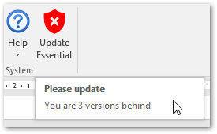

This screen is shown when updates have been detected. It can also be shown by clicking on the Update shield button.

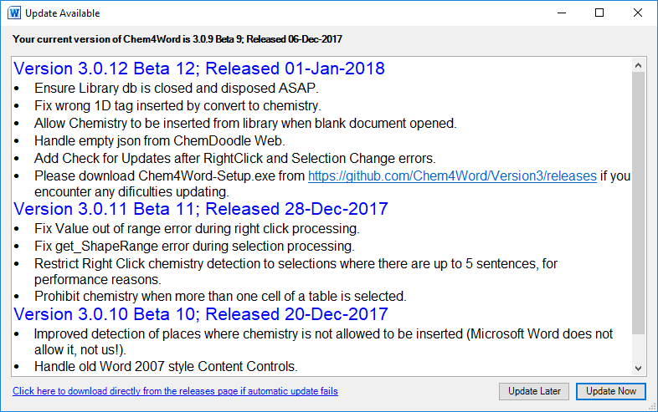

If you think you have missed an update you can check by using “Help” 🡪 “Check for Updates” from the Chemistry Ribbon

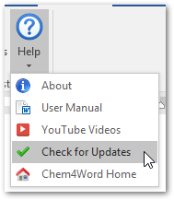

Clicking on “Update Now” will start the update downloading. If this fails, you may need to visit our GitHub page at <https://github.com/Chem4Word/Version3/releases/latest> to download the latest setup executable.

The image below shows the updater in action. It downloads the updated version of Chem4Word, then waits until you have closed all instances of Word [WINWORD] then installs the update.

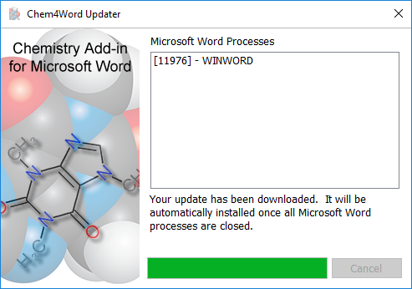

# Converting documents from the previous version of the Chemistry Add-in for Microsoft Word

Documents created with the previous version of the add-in can be automatically converted to the new format (you will be prompted when a document is opened). Once this conversion has completed, the chemistry can only be edited using version the new Add-In.

# How to add a chemical structure to a document

Chemical structures can be added to a Microsoft Word document in many ways. Structures can be drawn using the Chem4Word Editor tool. Structures can also be added from PubChem[2] and ChEBI (Chemical Entities of Biological Interest[3],[4]) searches as well as using the name-to-structure tool, OPSIN (Open Parser for Systematic IUPAC nomenclature[5],[6])

## Draw a structure

To draw a structure in a document, click the Draw button on the Chemistry Ribbon. This will activate the Chem4Word Editor tool.

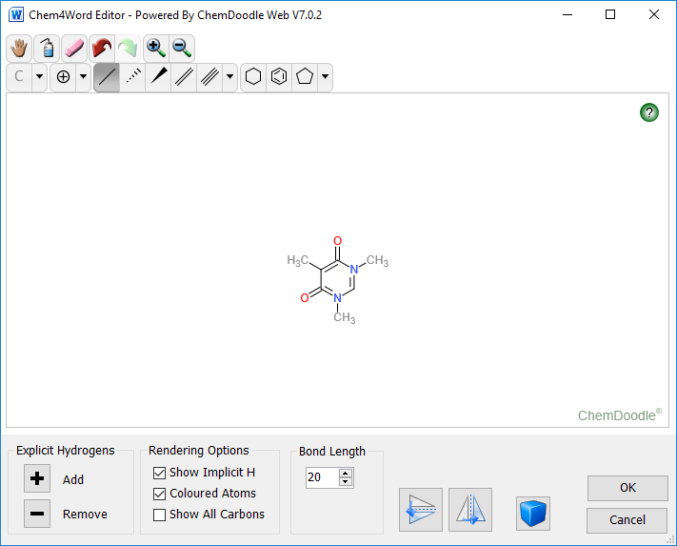

Use the bonds, rings and atoms tools to create a structure; at present, radicals and lone pairs are not supported in Chem4Word.

It is possible to change the default bond length in the drawing tool. Explicit hydrogen atoms can be added or removed from a structure by clicking the + and – buttons in this tool. There are also buttons to flip the structure horizontally or vertically.

|  |  |
| --- | --- |
|  | With the drawing tool, it is also possible to draw multiple structures in the same window. Clicking this button changes the drawing mode to multiple molecules. |

The final option in the drawing tool allows the drawing of explicit atoms with specific colours. Checking the “Coloured atoms” box will show atoms with coloured labels; without this option, all bonds and atoms will be drawn in black.

On clicking the OK button, the add-in runs a ChemSpider search to see if this chemistry is known. Labels such as names and synonyms will be returned. At this point, you have the option to add/edit/delete labels as you may need.

### Hydrogen Display

The editor allows you to manage display of hydrogen atoms. There are two kinds of hydrogens that can be displayed: explicit and implicit.

**NB: Using the Explicit hydrogen + or - buttons actually modifies the structure by adding hydrogen atoms to it or removing them. Implicit hydrogen display simply shows the presence of inferred hydrogens and does not modify the structure.**

#### Explicit Hydrogens

These may be added or removed to unused valences by clicking the + and – buttons under the Explicit Hydrogen group box.

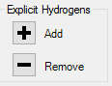

#### Rendering Options

The add-in infers the existence of these by counting unused valences. Click the checkbox for Implicit Hydrogens to toggle display:

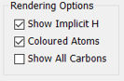

Here you can also toggle rendering of atom labels on colour or black.

This table shows the effect of these actions on structural display for a typical organic molecule (patulin):

|  |  |  |
| --- | --- | --- |
| **Implicit Hydrogen** | **Explicit Hydrogen** | **Structure** |
| Off or On | Added |  |
| Off | Removed |  |
| On | Removed |  |

### Flipping and mirroring structures.

The Flip and Mirror buttons reflect the structure in the vertical and horizontal planes:  
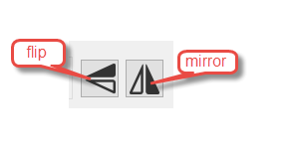

### Bond Lengths

The bond length control specifies the length in pixels of a bond. The default is 20, but you can change this in increments of 5 using the spinner buttons (or type a value in directly).

Changing the bond length affects existing as well as new bonds. You can use this to change the size of the rendered image in Microsoft Word

See section ChemDoodle Web Commands for keyboard shortcuts and explanation of ChemDoodle Web buttons.

After editing a structure the following dialogue is shown if we detect a change in the concise formula.

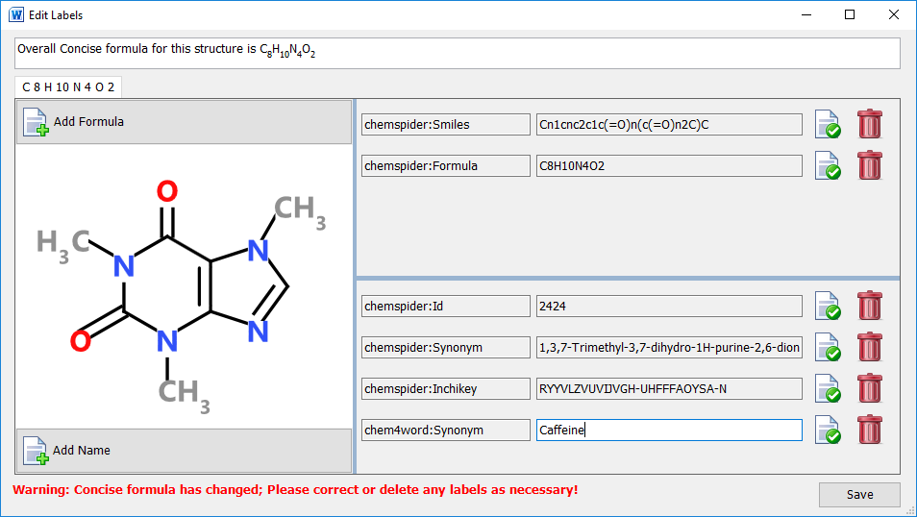

The image above shows the information retrieved when caffeine is drawn using the Chem4Word Editor. In addition to the retrieved information, an additional synonym, Caffeine, has been added.

## Import a structure from a file

The Chemistry Add-in for Microsoft Word supports importing chemistry from three file formats, CML, MolFile and SDFile.

The Import button allows you to browse to a folder containing supported file formats, to select a file and then import that file as a chemical structure into the current document. The structure will be displayed exactly as it was stored in the imported file. Further editing can be done, once the structure is added to the document.

## Add a structure from a web-search

There are three options for importing a structure from web searches.

|  |  |
| --- | --- |
| PubChem Logo | PubChem is a public repository of chemical structures and biological data maintained by National Center for Biotechnology Information (NCBI). |
| ChEBI logo ChEBI | Chemical Entities of Biological Interest (ChEBI) is a freely available dictionary of molecular entities focused on ‘small’ chemical compounds maintained by the European Molecular Biology Laboratory (EMBL). |
| University of CambridgeOPSIN | OPSIN is a tool developed at the University of Cambridge that converts chemical names into chemical structures |

### PubChem search

The PubChem search allows you to search by name or formula for structures in the PubChem database. Multiple records can be retrieved by such searches and are sorted by relevance.

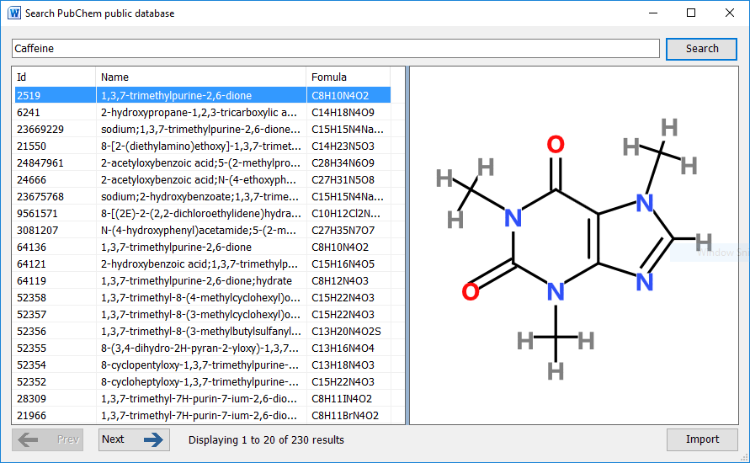

Selecting an entry in the returned results displays a structure as stored in the PubChem database. You can navigate forwards and backwards through all of the results and the selected result can be added to the document at the current position by clicking the Import button.

### ChEBI Search

The ChEBI search allows you to search by name for structures in the ChEBI database. Fewer results are returned by this search tool than the PubChem search as a scoring algorithm limits the number of possible structures returned.

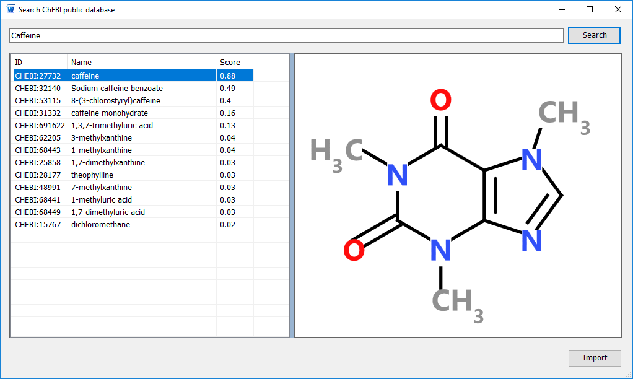

It is possible that there are entries in this database where no chemical structure is available. A message indicating this will be shown at the bottom of this window.

Clicking the Import button adds the displayed structure to the current document.

## How to edit an existing chemical structure

When you select a chemistry object in a document, you can edit the contents by clicking the edit button. Double-clicking a chemistry object also allows you to edit the structure.

If the chemistry object is changed by your edits, the add-in automatically runs a ChemSpider search to see if the new structure is known. You will be given the opportunity to add/change/delete labels associated with the new structure.

## Convert text to Chemistry

When you right click on a selection (which contains up to 5 sentences of plain text) it is analysed to see if it contains the names of any structures within your library.

This text contains Benzene when you right click the context menu will show a button for converting this to a chemistry object.

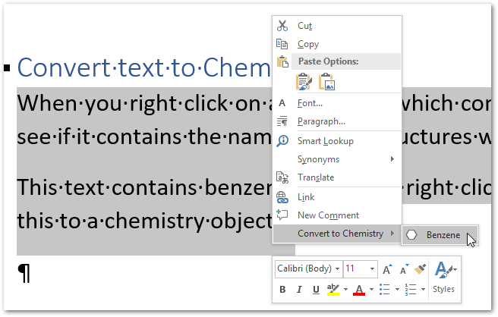

The converted object is shown below.

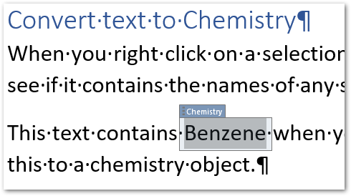

# Display options for Chemistry

The Chemistry Add-in for Microsoft Word allows chemistry to be represented in multiple formats. For structures imported from files and web sources, chemistry objects may have associated names and synonyms as well as formulae.

When you draw a structure in a document, the add-in searched ChemSpider to see if the structure is known, and any known names and synonyms are retrieved.

You can also add your own synonyms and formulae to any structure using the Edit Labels button.

The example on the right shows all of the depiction options for caffeine that available when this chemistry object is inserted from ChEBI. The currently displayed chemistry object can be changed to show any one of these alternative depictions.

By adding other chemistry objects to the document that are linked to another chemistry object will allow the editing of any one of them to be reflected in an automatic change to the automatically created formula label and those imported from ChemSpider. The Edit Labels button also allows you to delete labels and create your own labels to use as identifiers in your document.

# The Library

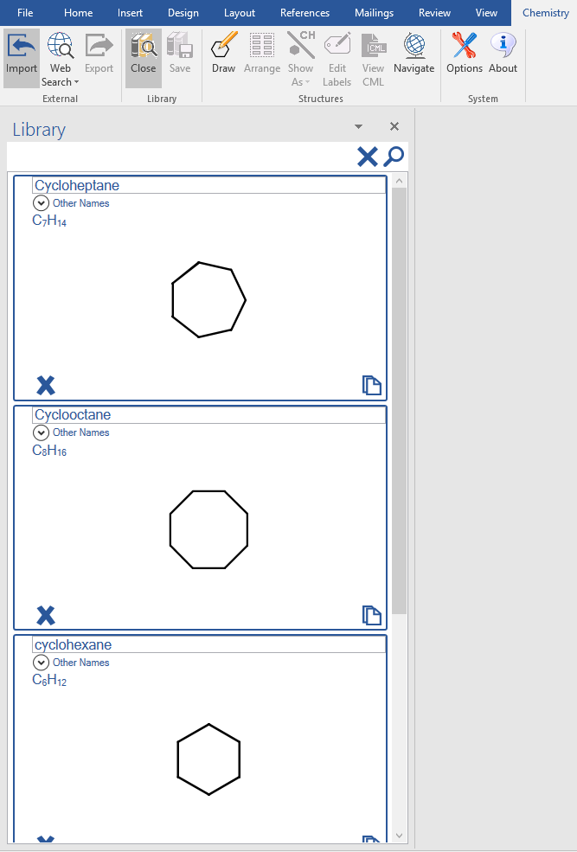The library is a store of re-usable chemical structures. Chem4Word provides only a small number of library entries. You can store your own structures in the Library for use in other documents.

The Library can be opened and closed using buttons on the ribbon.

There is a search button at the top of the Library panel, to help you to find structures by name. Type the name to search and click the magnifying glass. To show all molecules in the Library, click the cross next to the magnifying glass.

To insert a copy of a structure from the Library into the document at the current cursor position, simply click the paste icon  at the bottom right of the structure you want to add.

To add a structure that you’ve drawn in your document to your Library, simply select the structure in the document and click the Save button in the ribbon.

You can also delete structures from your Library by clicking the cross at the bottom left of the structure. Deleting a structure from the Library cannot be undone!

# The Navigator

The Navigator shows all the chemical structures in the document and allows you to find the location of chemistry objects throughout the document.

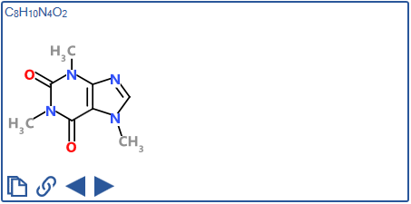The Navigator will contain one window for each unique structure in the current document. Each window in the Navigator shows the chemical structure and formula of each molecule. At the bottom of each window there are four buttons that are used to add structures to the document by either creating a linked copy or pasting a new copy of an existing structure at the current position in the document.

The Navigator buttons allow you to find individual and linked structures in the document by moving backwards or forwards through the current document.

|  |  |
| --- | --- |
|  | Duplicate the structure and add it to the document at the currently selected position. |
|  | Add a linked copy of the structure to the document at the currently selected position. |
|  | Move to the previous linked structure in the document. |
|  | Move to the next linked structure in the document. |

# Exporting chemistry files

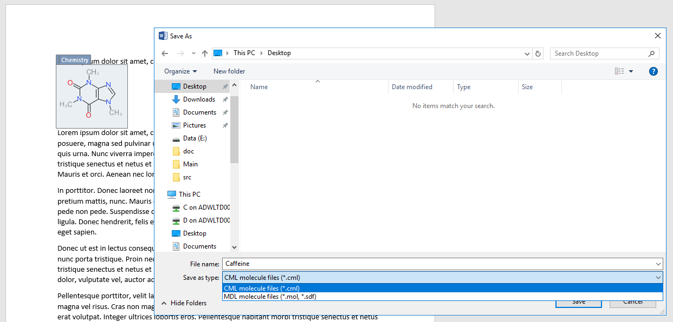Chem4Word allows you to export chemical structures as both CML files and MDL mol files.

To export a structure, simply select the chemistry object in the document and click the Export button in the ribbon.

Choose a folder and type a file name, select the appropriate file type, and click the Save button.

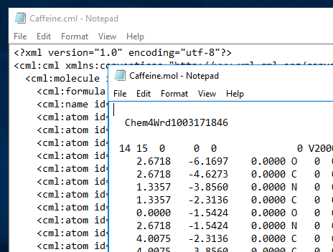The figure to the left shows example content of cml and mol files for caffeine exported from a Chem4Word document.

Both file formats are based on recognised standards, and should be suitable for import into other chemical-aware applications.

For more information on the cml format, see <http://www.xml-cml.org/>. Accelrys have a document that describes a number of chemical file formats, including the mol file format used by Chem4Word. A copy of this document can be obtained from the Accelrys website: <http://download.accelrys.com/freeware/ctfile-formats/ctfile-formats.zip>.

# ChemDoodle Web Commands

The buttons presented on top of the sketcher provide the following functionality It should also be noted, that in all states, the user can use the mouse wheel to scale the sketcher rendering. Users can also click and drag on the background, with nothing hovered, to move the entire molecule. If the shift key is held while dragging the background, the entire molecule will be rotated. Double-clicking on the background will centre the molecule

 **Move** – Puts the sketcher into move mode. Highlighting an atom or bond and then pressing the mouse down and dragging will translate those objects. This tool is only available in the Single Molecule Sketcher.

 **Clear** – Clears the sketcher. In the Single Molecule Sketcher, this leaves a single carbon atom.

 **Erase** – Puts the sketcher into erase mode. In the Full Sketcher, deleting a bond will remove that bond and deleting an atom will remove that atom and any attached bonds. In the Single Molecule Sketcher, highlighting an atom and clicking will remove that atom and any small disconnected fragments, leaving the largest fragment remaining. Highlighting a bond and clicking will only have an effect if that bond is part of a ring, and in that case it will remove that bond.

 **Undo** – Undoes the last performed action.

 **Redo** – Redoes the last undone action.

 **Zoom in** – Increases the rendering scale of the sketcher.

 **Zoom Out** – Decreases the rendering scale of the sketcher.



**Labels** – After an element has been selected, hover an atom and click to change that atom’s label to the selected element symbol. If you press the mouse down and drag to the edge of the optimize zone, a new bond will sprout from that atom to the label in an optimal position. Drag out of the optimize zone and/or use the *shift*/*alt* keys to place a bond to this label anywhere.

 **Periodic Table** – Pops up a periodic table to select a symbol. After a symbol has been selected, hover an atom and click to change that atom’s label to the selected element symbol. Press the **Close** button to close it.

 **Bonds** – After a bond type has been selected, hover an atom and press the mouse down to begin drawing a new bond of that type. Drag and place the preview to the preferred position and then release the mouse to place the bond. The optimize zone (blue circle) is provided to help place the bond in the optimal position when the mouse pointer is within the bounds of the circle. Hover a bond and click to change that bond’s type to the selected type. The single bond tool is special and will add to bond orders instead of overriding them. Hold down the *shift* key to modify standard lengths and hold down the *alt* key to modify standard angles.

 **Rings** – After a ring type has been selected, hover an atom and press the mouse down to begin drawing a new ring of that type. Drag and place the preview to the preferred position and then release the mouse to place the ring. The optimize zone (blue circle) is provided to help place the ring in the optimal position when the mouse pointer is within the bounds of the circle. Hover a bond and press the mouse down to begin drawing a ring from that bond. Drag the preview to either side of the bond and then release the mouse to place the ring. Hold down the *shift* key to modify standard lengths and hold down the *alt* key to modify standard angles.

** Charges** – After a charge sign has been selected, hover an atom and click the mouse to add or subtract from that atom’s charge amount.

 **Lone Pairs** – After a lone pair icon has been selected, hover an atom and click the mouse to add or remove a lone pair from that atom.

 **Radicals** – After a lone pair icon has been selected, hover an atom and click the mouse to add or remove a lone pair from that atom.

Group Buttons

 At the end of some button groups, there is a small button with a downwards facing arrow. This means that there are more options available for this button set. Just click on this downwards facing arrow and select an option. The button adjacent to the downwards facing arrow will pick up this option and will be automatically selected for use.

## Editor Shortcuts

Editor shortcuts are executed by holding down the Control key and pressing one of the following keys:

|  |  |
| --- | --- |
| **a** | Selects all content in the Full Sketcher. |
| **n** | Clears the sketcher, leaving a lone carbon atom. |
| **o** | Pops up a window to load a chemical file. |
| **s** | Pops up a window to save the structure in the sketcher in a chemical format. |
| **y** | Redoes the last undone action. |
| **z** | Undoes the last performed action. |
| **+** | Zooms in. |
| **-** | Zooms out. |

### When Atoms are Hovered

When an atom is hovered, the following shortcuts will be active. An atom is hovered if the mouse is close enough to the atom such that the atom is surrounded by an amber circle.

|  |  |
| --- | --- |
| **Alphabet** | Cycles the hovered atom’s label through the element symbols that begin with that letter of the alphabet. |
| **Digits** | Adds a carbon chain with length equal to the digit pressed in the most optimal orientation. The 0 key will add a chain of length 10. |
| **Shift+Digits** | Adds a ring with number of sides equal to the digit pressed (3+) in the most optimal orientation. |
| **Delete/Backspace** | Removes the hovered atom and any attached bonds and any small attached bonds. Leaves the largest fragment remaining in the Single Molecule Sketcher. |
| **+/-** | Increase/Decrease the charge amount of the atom. |

### When Bonds are Hovered

When a bond is hovered, the following shortcuts will be active. A bond is hovered if the mouse is close enough to the center of the bond such that the bond is encapsulated by two amber semicircles.

|  |  |
| --- | --- |
| **Digits** | Changes the bond’s order to the digit. Only 1-3 work. 7 will change the bond to a protruding bond and 8 will change it to a recessed bond. |
| **Shift+Digits** | Adds a ring with number of sides equal to the digit pressed (3+) in the most optimal orientation. |
| **Delete/Backspace** | Removes the hovered bond. In the Single Molecule Sketcher, the bond is removed if and only if that bond is a member of a ring. |
| **f** | Flip the bond orientation. |

# Setting Options

Click on the Options Button on the Chemistry Ribbon

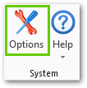

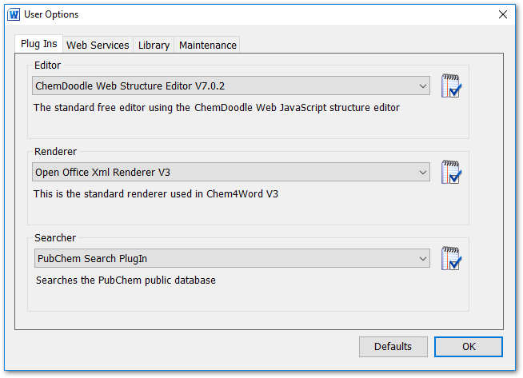

You will see there are four tabs “Plug Ins”, “Web Services”, “Library” and “Maintenance”

## “Plug Ins” Options Tab

This is where you set the options for each Plug In

### ChemDoodle Web Editor Options

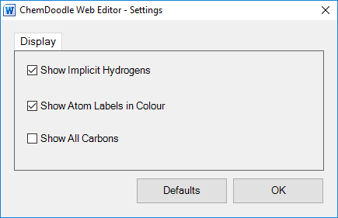

### Renderer Options

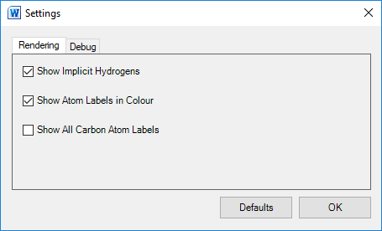

### Searcher Options

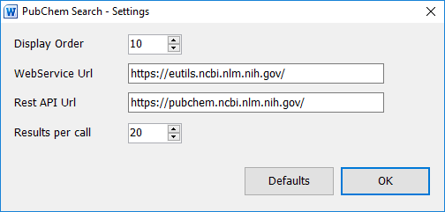

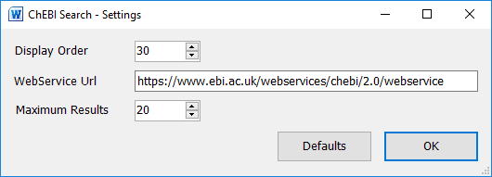

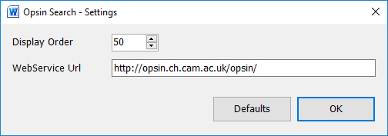

You should not normally need to change these values.

## “Web Services” Options Tab

This is where you can alter the url of the web services which Chem4Word uses to obtain the InChi-Key and Chemical data for structure which have been drawn. You should not normally need to change these values.

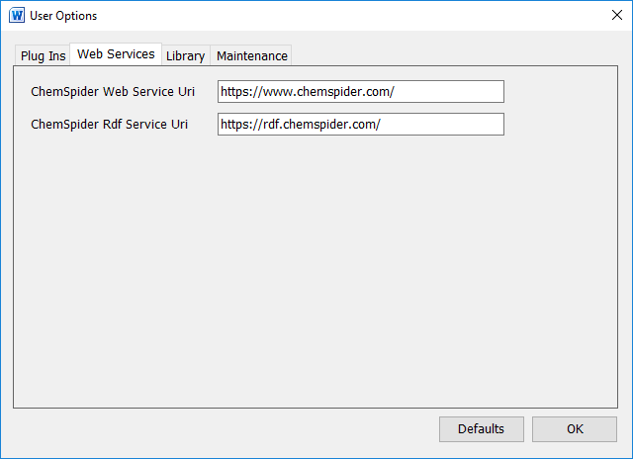

## “Library” Options Tab

This tab allows you to bulk import chemical structures into your library from a folder containing cml files.

It also has an option to clear the library.

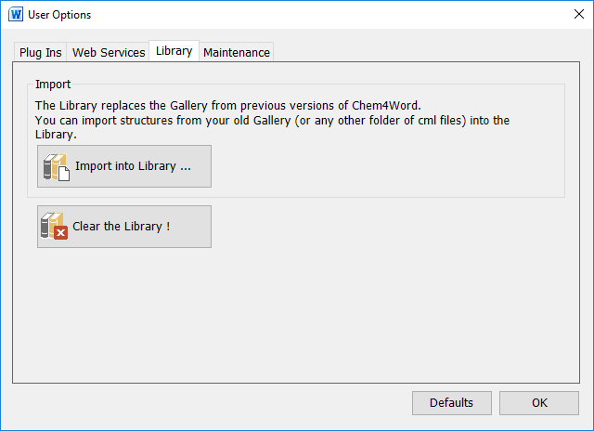

## “Maintenance” Options Tab

This gives quick access to various folders used by Chem4Word on your system, we may ask you to send us files from one of these if you are having difficulties.

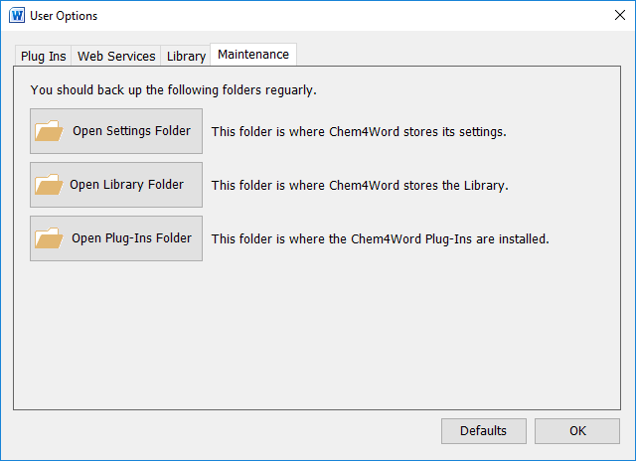

1. Only available in Word 2010 or later versions. Earlier versions display structures as PNG graphics.
2. Details about the PubChem search tool is available at <https://pubchem.ncbi.nlm.nih.gov/search/>.
3. Further information about ChEBI searching is can be found here <https://www.ebi.ac.uk/chebi/>.
4. Hastings, J., de Matos, P., Dekker, A., Ennis, M., Harsha, B., Kale, N., Muthukrishnan, V., Owen, G., Turner, S., Williams, M., and Steinbeck, C. (2013) The ChEBI reference database and ontology for biologically relevant chemistry: enhancements for 2013. [Nucleic Acids Res.](http://dx.doi.org/10.1093/nar/gks1146)
5. More information about OPSIN available from <http://opsin.ch.cam.ac.uk/>.
6. [Daniel M. Lowe](http://pubs.acs.org/author/Lowe%2C+Daniel+M), [Peter T. Corbett](http://pubs.acs.org/author/Corbett%2C+Peter+T), [Peter Murray-Rust](http://pubs.acs.org/author/Murray-Rust%2C+Peter), and [Robert C. Glen](http://pubs.acs.org/author/Glen%2C+Robert+C), J. Chem. Inf. Model., 2011, 51 (3), pp 739–753