CHEMISTRY PRACTICE
SOURCE: https://web.ung.edu/media/Chemistry2/Chemistry-LR.pdf
- FROM THE FOLLOWING DIAGRAM FROM CHAPTER 20, ORGANIC CHEMISTRY, OPENSTAX, PAGE 1127, USE MSW with MathType and CHEM4WORD to
  - Sketch the Lewis Structures using ChemDoodle for METHANE, ETHANE and PENTANE
  - Using MathType and CHEM4WORD with equation editor and Chemistry speech enabled, recreate the chemical molecules
  - Using MathPlayer and the Speech button, listen to the TTS
  - Retype the text from the example below with the inline equations you’ve created, then use NVDA and MathPlayer to listen.

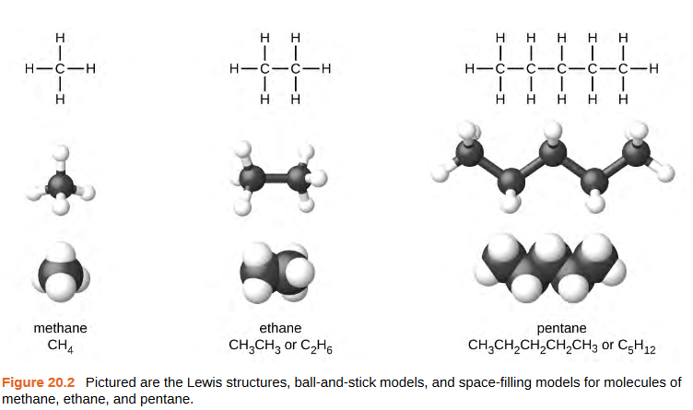

https://web.ung.edu/media/Chemistry2/Chemistry-LR.pdf

- FROM THE FOLLOWING DIAGRAM FROM CHAPTER 20, ORGANIC CHEMISTRY, OPENSTAX, PAGE 1127, USE MSW with MathType and CHEM4WORD to
  - Sketch the Lewis Structures using ChemDoodle for METHANE, ETHANE and PENTANE
  - Using MathType and CHEM4WORD with equation editor and Chemistry speech enabled, recreate the chemical molecules
  - Using MathPlayer and the Speech button, listen to the TTS
  - Retype the text from the example below with the inline equations you’ve created, then use NVDA and MathPlayer to listen.

A common method used by organic chemists to simplify the drawings of larger molecules is to use a skeletal structure (also called a line-angle structure). In this type of structure, carbon atoms are not symbolized with a C, but represented by each end of a line or bend in a line. Hydrogen atoms are not drawn if they are attached to a carbon. Other atoms besides carbon and hydrogen are represented by their elemental symbols.

Figure 20.3 shows three different ways to draw the same structure.

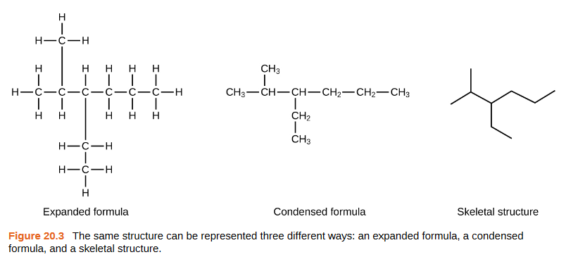

- DENSITY OF A NEUTRON STAR FROM THE FOLLOWING DIAGRAM FROM CHAPTER 21, ORGANIC CHEMISTRY, OPENSTAX, PAGES 1184-85, USE MSW with MathType and CHEM4WORD to

  - Use MathType and CHEM4WORD with in-line equation editor and Chemistry speech enabled, retype the figures in brackets from The Following paragraph. The first paragraph is in Microsoft Word (editable), and the second is an image from the text.
  - Use MathPlayer and the Speech button, listen to the TTS of the individual equations.
  - Use NVDA and MathPlayer to listen.

EXAMPLE:
Nuclear Chemistry Is the study of reactions that involve changes in nuclear structure. The chapter on atoms, molecules, and ions introduce the basic idea of nuclear structure, that the nucleus of an atom is composed of protons and, with the exception of [figure 1] neutrons. Recall that the number of protons in the nucleus is called the atomic number (Z) of the element, and the sum of the number of protons in the number of neutrons is the mass number (A). Atoms with the same atomic number but different mass numbers are isotopes of the same element. When referring to a single type of nucleus, we often use the term nuclide and identify it by the notation [figure 2]; where X is the symbol for the element, A is the mass of the number, and Z is the atomic number (for example, [figure 3]). Often, a nuclide is referenced by the name of the element followed by a hyphen in the mass number. For example, [figure 4] is called “carbon-14.” Protons and neutrons, collectively called nucleons, are packed together tightly in a nucleus. With the radius of about [figure 5] meters, a nucleus is quite small compared to the radius of the entire atom, which is about [figure 6] meters. Nuclei are extremely dense compared to bulk matter, averaging [figure 7] grams per cubic centimeter. For example, water has a density of one gram per cubic centimeter, and iridium, one of the densest elements known, has a density of [figure 8]. If the earth’s density were equal to the average nuclear density, the earth’s radius would be only about 200 m (earth’s actual radius is approximately [figure 9] meters, 30,000 times larger). Example 21.1 demonstrates just how great nuclear densities can be in the natural world.

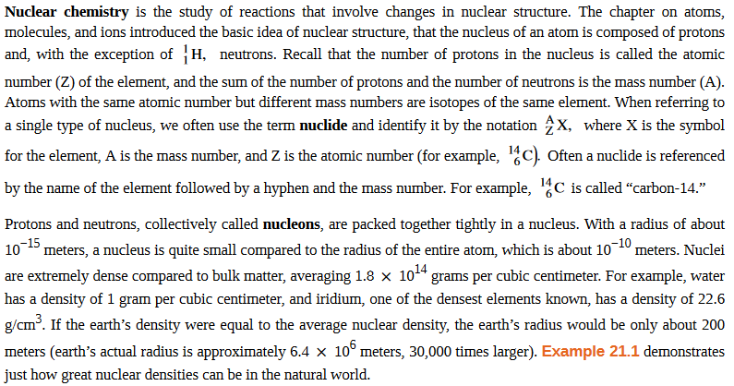

  - Then try simply retyping the in-line equations from the following example:

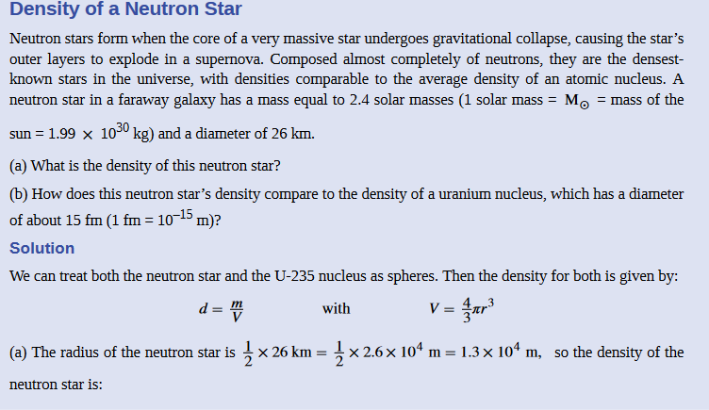

E. And if you’re really brave, try these in-line formulas:
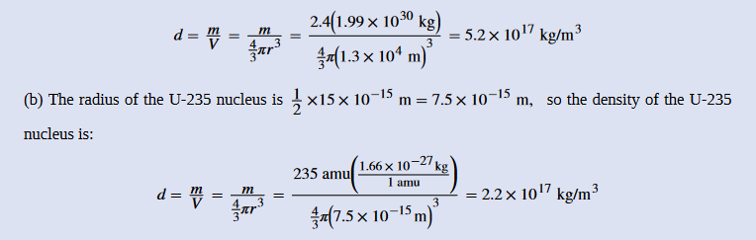

- More chemistry examples
  - Try this one: Calculation of Percent Abundance example 2.5, page 93
https://web.ung.edu/media/Chemistry2/Chemistry-LR.pdf

  - And this one on page 133 where you retype the ions. Note that where there are two ions separated by a comma, there are really two separate inline equations. Tab out of the first equation, type a comma, then open a new inline equation window.

