Accessibility Testing Instructions

The following process is the outline for how to approach testing products that Tufts intends to purchase for accessibility. This process is intended to give Tufts an accurate picture of whether or not to purchase the product, not to point out all areas of inaccessibility to vendors. The reports generated by this process will go directly to the purchasing office. That office, not you the tester, will decided whether or not to proceed with the purchase of the product.

Guidelines:
In order to maintain consistency across this process, we put together the following guidelines.
- You will need two pieces of information from the vendor: 1) a VPAT (Voluntary Product Accessibility Template) and 2) access to the product to test it’s accessibility. In order to gain access to both of these you should email or call the vendor. We strongly suggest a two-effort approach to getting these materials. If you are unable to have one or both of these needs fulfilled by the vendor, note it in the Accessibility Report.
- Pages/ areas to test: You do not need to test every webpage or screen associated with the product. Rather you should test these three things: 1) The Home or Main page, 2) Another random page or screen within the product and 3) the Help page.
- In testing on any of the three pages listed above you are unable to access something, tab, or find incorrect labels, Stop. Note the issue and location in the Accessibility Report and move on to the next step in testing.

Process:
Below is the process for testing the accessibility of the products:
- Connect with vendor. Sanjay Boolani will connect you with the vendor by email and request access to the product and a VPAT for you. Email the vendor, coping Sanjay, if you do not receive the VPAT and access to the product within 2 days of Sanjay’s initial contact email. Remember if the vendor does not respond to this email, note that in the Accessibility Report close the file.
  - Example of a follow-up email that you might use:
Hi [vendor contact],
I am from Tufts Technology Services and will be assessing your platform [vendor platform/product] for Accessibility.
In order to do that, I need both a copy of your VPAT and a guest account on your demo site to perform evaluation and testing. I would appreciate it if you would help me gain access to both.
Thank you,
[tester’s name]
  - It is not unusual for the vendor to either ask for your email/preferred username to set up an account for you, or for a vendor to supply a username/password for you.

- Review any materials provided during the Architecture Review Process. There will always be a section in the TTS checklist that refers to accessibility.
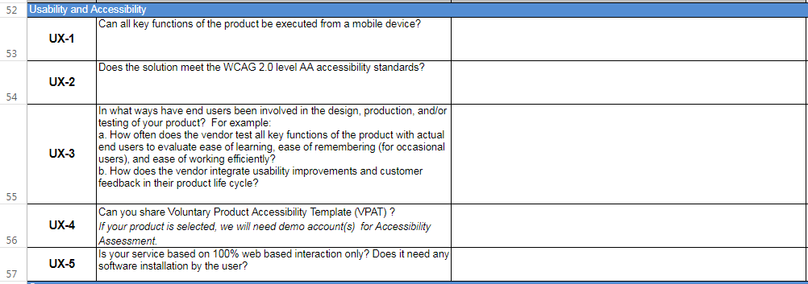
In the Questions Tab, the accessibility portion can be found in the UX sections. Pay particular attention to the answers to UX-1, UX-2 and UX-4 questions.

- Review VPAT, if provided:
  - Look at all of the categories that have the response: Supports with Exceptions
    - Check if report is valid
    - Check what the support looks like (Ex: “Is supporting but only in digital format”). Note this as a concern on the Accessibility Report.
  - Look at all of the categories that have the response: Inaccessible
  - Look at all of the categories that have the response: Do Not Apply
    - Are these critical functions to using the product? If so, note this as a concern on the Accessibility Report

- Test product, if provided, use the form provided:
Choose which tools to use based on which system you are using:

System | Mac | PC
Screen Reading tool | VoiceOver | NVDA
Platform | Safari | Chrome
Color | Sim Daltonism | High Contrast Extension Chrome

Check for 6 things:

  - Keyboard Accessibility: Using a keyboard, tab through the product to verify if it is compatible (Shift + Tab goes in reverse).
    - If the product has a “skip to navigation” and “skip to main content” this indicates the vendor thought about keyboard accessibility.
    - If the number of tabs it takes to get in the main working area is more than 7 note and whether or not a user can get to the Help documentation on the Accessibility Report.

  - Alt-tags: Check by turning on Alt-tags in Web Developer tools. Use a screen reader to determine if an image has a tag.
    - If any image is missing an alt-tags note it in the Accessibility Report. You do not need to continue checking the other images once you find one that is missing an alt-tag.
    - If links are labeled poorly or if hyperlinked text is not helpful (Ex: “click here” vs “Help documentation”) note it in the Accessibility Report.

  - Form field labels: Check with a screen reader to see if labels are identified
    - If you cannot go back and hear what you typed into the form note it in the Accessibility Report.
    - If you do not hear a description of what the field you are in is (ex: “blank” vs “first name”) note it in the Accessibility Report.
    - If you are unable to hear, or get to, all of the radio buttons or options for a response note it in the Accessibility Report.
    - If heading labels are not accurate for tables, and does not read what is presented to sighted users (ex: “void()” vs “Contractor”) note it in the Accessibility Report.

  - Color: Check the font/ color using the tools listed above.
    - Turn on the grayscale or high contrast in the product. Note if information disappears or otherwise difficult to understand on the Accessibility Report.
    - If there is information conveyed solely on the color, font or appearance of an item. (Ex: File uploaded vs File uploaded is inaccessible. Successful upload vs Failed upload is more accessible) note it on the Accessibility Report.

  - Captions: Some vendors do not have any audio or video, but just to be sure check the Help documentation before skipping this section.
    - If there is no way to turn on captions, usually a CC button or it can be found in the settings button, note it in the Accessibility Report.
    - If audio files are captioned (audio and video), sample a 30 second clip in the middle to be sure that what is being captioned is timed close to what is being said. If the captions do not run the length of the video, note it in the Accessibility Report.

  - CSS: turn it off using Web Developer tools.
    - If you see a box or iframe trying to load the page with the CSS you turned off note it in the Accessibility Report.
    - If there are parts that say “loading” and never load note it in the Accessibility Report.
    - Take a look at the html order, as this is the order information is passed to screen readers. If the order doesn’t make sense, note it in the Accessibility Report.

- Run an independent access report using the WAVE browser tool and save the report.
  - Press on the “No Styles” button, then print the webpage as a PDF.
  - Take a screen shot of the WAVE Summary as that will not be included in the print out.

- Finalize the Accessibility Report using the Procurement Protocol template, and attach the WAVE results of the home page and the screenshot.

- Depending on your findings, choose a color in the TTS Checklist on the Scoring tab for Accessibility (Red = weak, Yellow = okay or Green = Strong).
Color Rating | Possible reasons
Green | Everything is accessible already!
Yellow | There are fixes like providing alt-tags required, but navigation is fine. Predicted fixes should be quick to fix.  Vendor is willing to collaborate with us to make it accessible (this part is done with
Red | Vendor ignores all outreaches to allow for accessibility testing.  Vendor flat out says they will not make fixes.  The product has extreme navigation and keyboard accessibility problems (which would take longer to fix).
- Upload the Report to the Vendor’s Box folder, and send a copy to the Vendor and copy Sanjay on it.

Vendor Accessibility Report Form

- Product name:

- Vendor contact:

- Department requesting the product:

- Overview of the product (1 to 3 sentences):

- Name of the Tufts University staff and/or student who tested the product:

- Summary of Tufts University Testing (based on vendor report, Tufts testing and other materials as available):

Content | Issue

- Attach WAVE report
- Attach VPAT
Recommendation (Indicate one):
      - Product it is accessible
      - Product is inaccessible, purchase if vendor agrees to fix reported issues
      - Product is inaccessible, do not purchase as vendor will not fix reported issues

https://webaim.org/articles/voiceover/
https://webaim.org/articles/nvda/
https://wave.webaim.org/extension/

