## ALGEBRA SAMPLE IN DOCX format

## Slant Asymptotes

Examine the graph of , shown in Figure 3.38. Note that the degree of the numerator, 2, is greater than the degree of the denominator, 1. Thus, the graph of this function has no horizontal asymptote. However, the graph has a slant asymptote, y = x + 1.

The graph of a rational function has a slant asymptote if the degree of the numerator is one more than the degree of the denominator. The equation of the slant asymptote can be found by division. For example, to find the slant asymptote for the graph of , divide into :

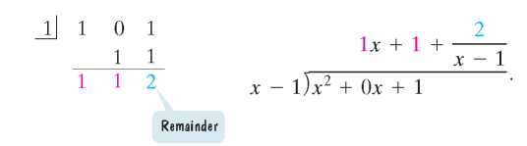

Observe that

Equation.
The equation of the slant asymptote is y= x+1. 

As , the value of  is approximately 0. Thus, when  is large, the function is very close to y = x + 1 + 0. This means that as or as the graph of f gets closer and closer to the line whose equation is y = x + 1. The line y = x + 1 is a slant asymptote of the graph.

In general, if , p and q have no common factors, and the degree of p is one greater than the degree of q, find the slant asymptote by dividing q(x) into p(x) . The division will take the form

Equation.
Slant asymptote, y=mx+b

The equation of the slant asymptote is obtained by dropping the term with the remainder. Thus, the equation of the slant asymptote is y = mx + b.