Teach Access Professor Bootcamp
Accessing Higher Ground, November 2017
Technology companies dedicated to accessibility have faced the common challenge of preparing internal designers, engineers and researchers to think and build inclusively. Similarly, academic programs in design, engineering and HCI are seeking ways to better prepare students to address the needs of diverse populations. Given this shared challenge, industry, academia and advocacy have now come together to create Teach Access (http://teachaccess.org/).
In addition to this workshop, we also offer a freely available online Teach Access Tutorial (https://teachaccess.github.io/tutorial/) that we strongly encourage you to leverage in your classrooms.
If your school or organization wants to become a member of Teach Access, please reach out to teachingaccessibility@gmail.com.

Agenda
- Welcome
- Disability in the Tech Industry
- Assistive Technology
- Break
- Accessibility by Design
- Testing
- Wrap-up / Q&A
- Lunch (for those attending in-person)

Activity #1
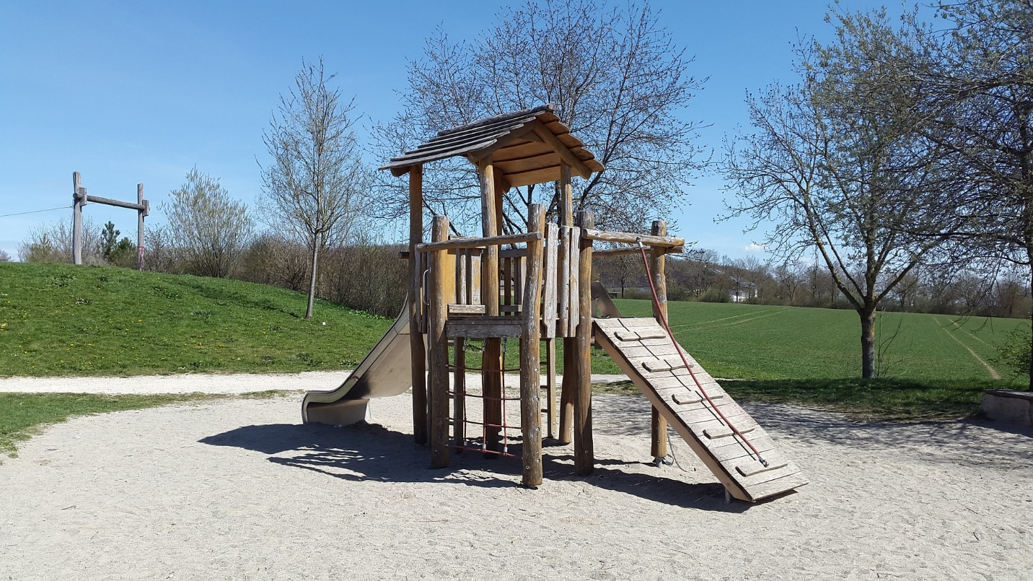If you had to retrofit this playground to make it accessible, what would you do? Make a list of things you would change. You have 60 seconds.
_________________________________________________________________________________________________________________________________________________________________________________________________________________________________________________________________________________________________________________________________________________________________________________________________________________________________________

Activity #2
Pretend you are a class of college students. Feel free to take notes during the lesson.
_________________________________________________________________________________________________________________________________________________________________________________________________________________________________________________________________________________________________________________________________________________________________________________________________________________________________________

Activity #3
How have you encountered disability in your classroom?
______________________________________________________________________________________________________________________________________________________________________________________________________________________________________________________________________________________________________________________________________________________________________________________________________________________________________________________________________________________________________________________________

Activity #4
Get out your mobile phone and try out any or all of the accessibility features. What did you experience?
Visit http://Aka.ms/voiceover and http://Aka.ms/Talkback for a comprehensive list of gestures.
Gesture | Action
Touch or move around the screen with one finger | Speaks and selects the item under your finger
Tap 2 times fast with one finger | Activates the selected item. (e.g. sopen app, press button, etc.)
Swipe left or right with one finger | Selects the previous or next item
Swipe up or down with one finger | Performs or moves to the selected rotor option/navigation setting
Tap once with two fingers | Pauses/resumes speech

_________________________________________________________________________________________________________________________________________________________________________________________________________________________________________________________________________________________________________________________________________________________________________________________________________________________________________

Activity #5
How do closed captions compare between different platforms? What about the email experience? Or messaging experience? Use your favorite apps to explore these scenarios.
_________________________________________________________________________________________________________________________________________________________________________________________________________________________________________________________________________________________________________________________________________________________________________________________________________________________________________

Activity #7
What learnings from today can be used in your classrooms? What do you need from industry to best teach these principles?
____________________________________________________________________________________________________________________________________________________________________________________________________________________________________________________________________________________________________________________________________________________
__________________________________________________________________________________________________________________________________________________________________________

Questions to ask your class:
How are we including Accessibility requirements in the design specification?
Are we creating custom UI controls that are not accessible?
Are the frameworks and SDKs we're choosing accessible or can they be made accessible?
Does the platform we're targeting support Accessibility?
How are we going to obtain and incorporate usability feedback from people with disabilities?
How do we plan to validate Accessibility?
How is our UI contrast and color palette being perceived by people with low vision?

