Acrobat Pro DC PDF Accessibility – The Basics
Converting to PDF for an Accessible Word Document
This is a test document to use for converting an accessible Word doc to and accessible PDF. This document uses the basic functionality in Word to create accessible documents.

Headings
Headings are essential for the structure of the document and for ease of navigation using a screen reader. Heading must be used in a hierarchical manner. Unlike in HTML, according to the PDF/UA standard, multiple Heading 1’s can be used in a PDF.

Text

Paragraphs
Indentations and paragraph spacing should be used in a Word document for structure. This prevents the screen reader from reading blank spaces and lines and avoids the need, upon conversion to PDF, to artifact those elements.

Color
It is always best to address color contrast issues in the original Word document. Although it may be possible to change text color in the PDF, it is difficult and may cause additional tagging issues. Below is a sample color wheel.
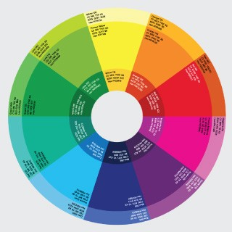

Lists
A correctly formatted list makes it easier for a screen reader user to understand the context within which the list is presented. Both bulleted and numbered lists, when created using the appropriate method in Word, will convert cleanly to well-tagged lists in a PDF.

Bulleted List
Bulleted lists are used commonly to delineate a list of information that may be too long or too detailed to present in sentence format. Type of bulleted lists include:
- A list of non-prioritized items.
- A list of resources which may be links (e.g. Adobe Corporate Accessibility page)
- A subset of detailed information that fleshes out a higher level comment or outline item.
- Other information that doesn’t need the hierarchy provided by a numbered list.

Numbered List
Frequently used to list thing in priority order. Like a list of countries I want to visit:
- United Kingdom
- Italy
- New Zealand
- Australia
- Japan
- China

Tables
Tables present unique challenges for screen reader users. When creating a table in Word note that although column and row headers can be identified the scope for the relative header cells will need to be set. Below is a table of the Adobe Accessibility team.
Name | Title | Roles & Responsibilities
Andrew Kirkpatrick | Group Product Manager | Standards & Accessibility
Matt May | Senior Product Manager | Corporate Accessibility
Amy Chen | Product Manager | Marketing Cloud Accessibility
Rob Haverty | Senior Product Manager | Document Cloud Accessibility
Jack Nicolai | Product Manager | Creative Cloud Accessibility

Images
Information conveyed in images needs to be conveyed in text as well. This can be done either through alt text as in the color wheel image above, or by using captions. When using captions, the author may want to artifact the image (set as background) so that the screen reader isn’t reading duplicative information.
Figure 1: A black and white photo of a camellia

