Transcripts, Captions and Audio Descriptions

Contents
Australian Public Services
Contents 2
Overview 3
Video accessibility principles 3
Impact on users 5
Creating a Transcript 8
Structure 8
Putting your transcript to use on OzPlayer 9
Example Transcript 10
Captioning 14
YouTube captioning 14
Audio Descriptions 27
Using Premiere Pro to produce an extended audio description video 28
Appendix 1 34
Resources 34
Online Examples 34
Appendix 2 35
WCAG2 Requirements 35
Transcripts 35
Captions 37
Audio Descriptions 39
Appendix 3 41
Using MAGpie to create captions 41
Appendix 4 43
Using MAGpie to create audio descriptions 43
Appendix 5 45
Further Examples 45
Company Bio 49
Contacts 50

Overview

Video accessibility principles
Video accessibility is the ability for a person with a disability to understand and use an online video. It allows people with disabilities to access information like anyone else; interact with others without being classed as “disabled” and allows them to undertake activities which they may not otherwise be able to do.
Video accessibility is important to people with the following disabilities:
- Blindness
- Colour-blindness
- Low vision
- Deafness
- Motor impairments
- Cognitive impairments.
Videos cannot be made fully accessible, but they can be made accessible to some people with disabilities; for example people using screen readers. A video is made accessible by:
- the way the video is created;
- how the video is inserted in the site;
- by providing a transcript;
- by providing audio descriptions; and
- by providing captions.
Accessibility needs to be considered both when creating the video content and when converting the video for web use.
When creating the video content:
- use only high contrast colours;
- do not convey information using colour alone;
- do not use patterned backgrounds etc.; and
- do not include any flashing or flickering content.
When converting the video for web use:
- use a consistent, accessible, video file format.
When inserting the video in the site in a particular way:
- Allow the user to skip over the video using the mouse only;
- Allow the user to skip over the video using the keyboard only;
- Ensure the site is functional and all content is available without the video; and
- Include information about how to access the video player.

Video player
The video player should:
- Allow users to control the video (e.g. pause, rewind, etc.) via the keyboard only;
- Allow users to control the video (e.g. pause, rewind, etc.) via the mouse only;
- Allow users to control the volume with mouse only and keyboard;
- Allow users to control the volume with the keyboard only;
- Ideally never start automatically or if it does then a mechanism to pause the video is provided at the start of the page;
- Allow users to turn on captions or audio descriptions with the mouse only; and
- Allow users to turn on captions or audio descriptions with the keyboard only.

Transcript
Video transcripts should:
- Identify the name of the speaker;
- Ensure that all speech content is included;
- Include relevant information about the speech;
- Include relevant non-speech audio;
- Include any textual or graphical information shown in the video;
- Be provided in an accessible format;
- Indicate the end of the transcript if on the same page as the video; and
- Provide a mechanism to return to the video if on another page.

Captions
Video captions should:
- Appear at the same time as the sound they are captioning;
- Ensure all important audio information has been captured;
- Appear on the screen for enough time for them to be read;
- Ensure the contrast between background and caption text colour is sufficient;
- Have no periods without captions; and
- Attribute speech to a particular speaker.

Audio Descriptions
It should be noted that audio descriptions are best done when creating the video as an alternative to the original video.
Video audio descriptions should:
- Adequately describe the visual information;
- Not impinge on other speech or important sounds;
- Be concise but sufficiently explanatory; and
- Be sufficiently distinguishable from other speech.

Impact on users
The following is an overview of common video errors relevant to the player, captions, transcripts and audio descriptions and the impact on users with a disability.

Video Player

Keyboard.
Some video players contain keyboard traps. This is critical to users who are unable to use the mouse as there is no way to exit the video player once caught in a keyboard trap. The only option is to close the browser and start again.
Some video players do not have the ability to use the video via the keyboard. This limits the video use to mouse users only.

Starting, stopping and controlling volume.
Some video players will automatically start when a page opens and there may not be a website mechanism to pause or stop the video. Therefore screen reader users and keyboard users have to manually search through the page until they find the video and stop it using the player controls.

Flash, JavaScript and style sheets.
Disabling browser functions can cause the video to disappear, move or appear actionable when it isn’t. Screen reader users will sometimes disable certain browser functions, e.g. JavaScript, to facilitate use of their assistive technology.

Content changes.
In some instances selecting the video will cause a change prior to the current focus. If a user is visually impaired and uses a screen reader, this change may not be apparent to the user.

Video link text.
Some links to video files can be non-descriptive and use file size, filename or file type. For users with assistive technologies such as screen readers, it can be difficult to know what the video is about, especially if there is more than one video.

Video as a text alternative.
On some occasions videos are provided as an alternative to text and images. In these instances, the video needs to be labelled as a text alternative so that users know what the purpose of the video is and that it is not the main source of the content.

Flashing video content
Videos with flashing content which flashes more than three times in any one second period can induce seizures in users with photosensitive seizure disorder. It can also trigger migraines in sensitive users.

Transcript

Missing or inadequate transcripts.
Videos which do not have a transcript or have inadequate transcripts greatly affect the users who rely on the transcript to obtain the information.

Additional information.
The transcript sometimes includes information that is not included in the video. Users who are able to access the video and do not use the transcript will therefore miss this additional information.

Accessibility.
Transcripts are sometimes provided, however the transcripts may be inaccessible because they have been provided as a PDF. A PDF is inaccessible even when tagged and many screen reader users will not even attempt to read one.

Location and link text.
Transcripts are sometimes provided but the link to it is not located immediately before or after the video. A screen reader user will then often assume there isn’t a transcript provided and move on without obtaining the information from the video.
Similarly, a user may assume that there isn’t a transcript provided if the link text to the transcript is not clear.

End of transcript.
If the transcript is on the same page as the video, it will affect users if the end of the transcript is not marked. Screen reader users will not know that the transcript has finished as the assistive technology will continue on reading page content without indicating an end to the transcript.

Returning to the video.
When the transcript is provided on a separate page to the video, some transcripts provide no method of returning back to the original video. Some users may find it difficult to find their way back to where they were without a link or the use of the back button.

Interactive transcripts.
Interactive transcripts should keep track with the video content to minimise confusion to those with cognitive issues. The current position in the interactive transcript should not be marked with colour alone which can affect vision impaired users and those who use assistive technologies.

Captions

Missing or inadequate captions.
In some instances videos do not include captions or omit dialogue or important sound effects. Those who use captions will be unable to use the video or may miss out on important information.

Additional information.
Video captions sometimes include information that is not included in the video. Users who don’t have a need for the captions will therefore miss this information.

Colour contrast.
The captions can be difficult to read due to colour contrast between the background and the caption colour. Users dependent on the captions may therefore not be able to read important information conveyed by the captions.

Audio description

Missing audio descriptions.
Videos which do not include audio descriptions means a vision impaired user will miss important information. Important background information may be provided in the video that isn’t conveyed with audio.

Online video checklist: http://wiki.accessibilityoz.com.au/doku.php/checklists/video/start

Creating a Transcript
It is a requirement for videos to have a text alternative. Therefore a transcript must be provided as either a downloadable link directly before or after the video, or as text directly after the video. A transcript must include both word for word descriptions as well as descriptions of what is happening on screen.
Creating a transcript is also necessary and helpful in creating captions and audio descriptions.
Note: For one minute of video, it takes approximately 30 minutes to create a transcript.

Structure

Accessibility Practices
- Ensure you transcript is created in an accessible format, using the following features
  - Headings
  - Styles

Speech descriptions
- It must be acknowledged who is speaking.
- A change in speaker must be noted.
- All speech content must be in the transcript. If there is speech which is not relevant, then indicate that it has been excluded from the transcript.
- Relevant information about the speech should be added, usually in brackets.
- Transcript showing speech descriptions
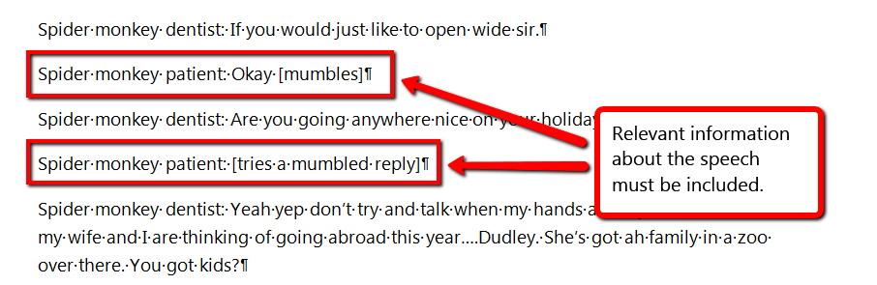

Visual descriptions
- Relevant changes in visual content must be noted.
- Include any textual or graphical information shown in the video
- Transcript showing visual descriptions
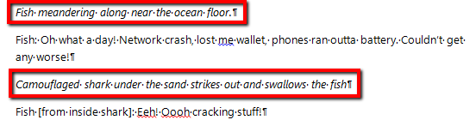

General transcript practices
- Relevant non-speech audio should be included in the transcript
- The end of the transcript should be indicated.
- Transcript showing general transcript practices
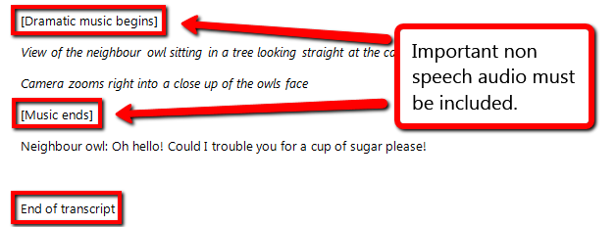

Putting your transcript to use on OzPlayer
- OzPlayer uses an interactive transcript. An interactive transcript must:
  - Keep track with the video
  - Not mark the current position in the transcript with colour alone.
- To make the transcript interactive for OzPlayer, it uses the timed captions track to move through the transcript at the right times. However, there needs to be two tracks for the timing, one for the captions and one for the audio descriptions.
- The captioning section of this training document will take you through how to create both tracks for the interactive transcript.

Example Transcript
To see the video, go to: http://www.youtube.com/watch?v=f-Kt_kuYVtU
[Music begins (Billie Jean - Michael Jackson)]
Landscape view of the Amazon
Zooms into red-capped manakin.
Red-capped manakin bird (Kevin) moonwalking up and down tree branch
Kevin: Oww! Heee heee! Heee heee!
Kevin’s mother flies onto the branch too.
Kevin’s mother: Oh Kevin, that’s a lovely tribute
Kevin: I just miss him mum.
[Music stops]

Marmot sitting up yelling at top of lungs
Marmot: Alan! Alan! Alan! Alan! Alan! Al! Alan!

Bird waving its left wing awkwardly in open field
Bird: Scuse me, I’m have a bit of trouble with my wing I think it’s broken.
Close up of the bird
Can anyone help?
View of second bird
Preacher bird: Do I know anyone who can help?!
[Gospel music begins]
Preacher bird stands up straight with both wings up in the air
Preacher Bird: Gather round brothers and sisters, join me!
More birds gather around the preacher bird.
Are you ready to receive the healing, ready to receive the love?!
[Music ends]

Wetlands with a black heron covering its head repeatedly with its wings and popping its head out from under them.
Black heron: Night time…DAYTIME! Night time…DAYTIME! Night time…DAYTIME!
A spoonbill walks up beside the black heron.
Spoonbill: What are you doing?
Black heron: Having a game of night time day time. You wanna play?
Spoonbill: No, I’ve got an Xbox

[Music starts (Low – Flo Rid feat T-Pain)]
Badgers twisting from side to side looking like they are DJing.
[Music ends]

Back to marmot sitting up yelling at top of lungs
Marmot: Alan! Alan! Alan! Alan! Alan!

Two roatan spider monkey’s sitting on a branch with one looking into the others mouth.
Spider monkey dentist: If you would just like to open wide sir.
Spider monkey patient: Okay [mumbles]
Spider monkey dentist: Are you going anywhere nice on your holidays?
Spider monkey patient: [tries a mumbled reply]
Spider monkey dentist: Yeah yep don’t try and talk when my hands are in your mouth sir. Ah my wife and I are thinking of going abroad this year….Dudley. She’s got ah family in a zoo over there. You got kids?
Spider monkey patient: [tries a mumbled reply]
Spider monkey dentist: Please, please don’t talk when my hands are in your mouth sir. Could do with a filling here at the back. Is it mainly bananas you eat?
Spider monkey patient: [tries a mumbled reply]
Spider monkey dentist: I won’t, I won’t tell you again sir. Please don’t try and speak when I am working inside your mouth. Right, I’m just gonna try a cheeky little taste.
Spider monkey dentist tastes finger which had been in patients mouth.
That’s um not bad actually. Um almost done, just need to smell your breath.
Spider monkey dentist smells patients breath
Spider monkey dentist: Oh, oh……oh that is rank, I think I need to lie down
Spider monkey dentist falls backwards and lies down.

Two Giraffes standing side by side.
Giraffe female: She’s all neck and legs, look at her!
Giraffe male: Oh I am looking at her.
Giraffe female: Stop looking at her!
Female giraffe bashes male with head
Giraffe male: You just told me to look at her!
Both giraffes beging bashing each other with heads
Female giraffe: Ow!
Male giraffe: Ow!
Female giraffe: Ow!
Male giraffe: Ow!

Close up of a gorillas face.
Gorilla: I don’t know why but I don’t seem to have a lot of luck with women. I mean I’m kind and caring
[Farting]
Gorilla: No it’s a mystery that.

Chip monk standing on a rock with its hands at its mouth.
Chip monk: [beatboxing]

A field mouse looking over a rock shouting.
Field mouse: Shoot! Shoot! Shoot! Shoot! Shoot! Shoot! Shoot! Shoot! Shoot! Shoot!
[Gun shot sound]
Field mouse: Aah! I didn’t think he’d do it!

Otter floating in the water on its back.
Otter: At the Copa, Copacabana. Music and fashion were always the passion at the Copa….HEY!
The otter stops and stares at the camera
Are you filming me in bath? Get out! Away with ya I’m naked you better not put it on YouTube!

Fish meandering along near the ocean floor.
Fish: Oh what a day! Network crash, lost me wallet, phones ran outta battery. Couldn’t get any worse!
Camouflaged shark under the sand strikes out and swallows the fish
Fish [from inside shark]: Eeh! Oooh cracking stuff!

Back to marmot sitting up yelling at top of lungs
Marmot: Ooh that’s not Alan. Steve that’s Steve……Steve! Steve! Steve! Steve! Steve! Steve!

Small group of meerkats standing on their hind legs all facing the same way
Meerkat 1: John, I don’t think we are allowed to wee here.
Meerkat 2: It’s fine, just keep a look out!
[zipper sound]
Meerkat 1: What was that!
Meerkat 2: That was me zip!
Camera zooms out to show a large group of meerkats all standing in the same place facing the same way
Meerkat 1: Wooow! Wh…where’d all these come from! You know me lads, I can’t wee with an audience!

Owl standing on the ground looking around
Owl 1: Oh I tell you what, I don’t like that man that’s just moved in next door. Oh he’s really creepy.
[Dramatic music begins]
View of the neighbour owl sitting in a tree looking straight at the camera.
Camera zooms right into a close up of the owls face
[Music ends]
Neighbour owl: Oh hello! Could I trouble you for a cup of sugar please!

End of transcript

Captioning
Captions provide a way for people who have hearing impairments or otherwise have trouble hearing the dialogue in synchronized media material to be able to view the material and see the dialogue and sounds.
Video captions should
- Appear at the same time as the sound they are captioning;
- Ensure all important audio information has been captured;
- Appear on the screen for enough time for them to be read;
- Ensure the contrast between background and caption text colour is sufficient;
- Have no periods without captions; and
- Attribute speech to a particular speaker.
The easiest method of creating captions is to use the YouTube service that automatically creates captions for videos. It can generate captions from an uploaded transcript.
However, another tool that is often used for captioning is MAGpie. MAGpie takes approximately 1 hour per minute of video. To see instructions on how to use MAGpie to create captions, see Appendix 3 on page 48.
Note: Captions should not be confused with subtitles and translations. Subtitles and translations provide text of only the dialogue and do not include important sounds.
Note: When using the YouTube service to create captions, one minute of video takes approximately 10 - 30 minutes to create the caption file if a transcript is already written.

YouTube captioning
For this captioning, a YouTube account is needed.
- To add captions to your video using YouTube, a transcript needs to be used.
- Do not use YouTube’s automated captioning feature.
  - See why not to use YouTube’s automated captioning feature (http://www.youtube.com/watch?v=23H8IdaS3tk)
- Example of YouTube’s automated captioning
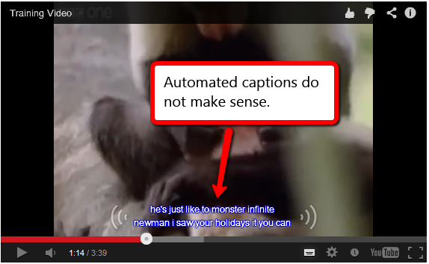

Preparing your transcript
- When normally preparing a transcript for captioning, you would remove all the visual descriptions as these are not necessary for captions. However, to create the two tracks for OzPlayer the easiest method is to leave them in and only remove them right at the end.
- Remove the end of transcript signal.
- Resave the transcript as plain text (.txt)
  - Go to ‘Save As’ and change ‘Save as type’ to ‘Plain Text (*.txt)’ by using the dropdown.
- Saving your transcript as plain text
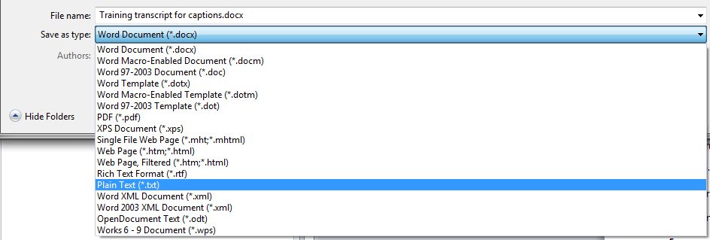

Uploading your transcript
- Log into your YouTube account
- Select the Upload option
- YouTube Upload option
- Select the page to find the video you wish to upload.
- Uploading your video to YouTube
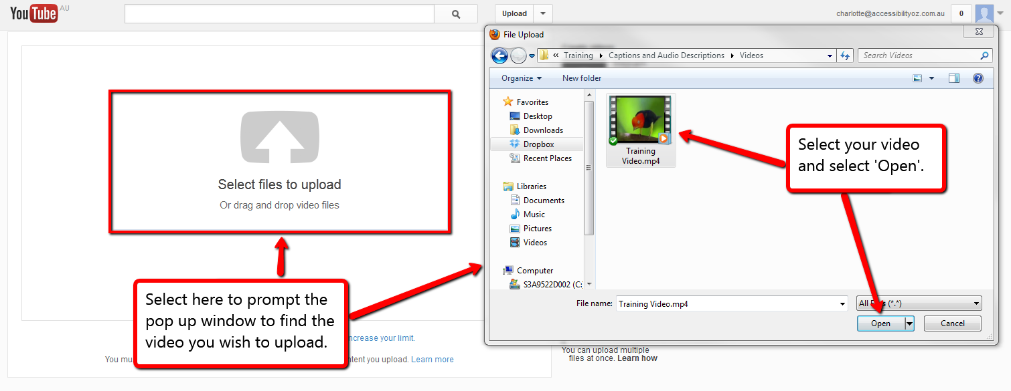
- Once the upload is complete, go to the YouTube Video Manager.
- Select the dropdown beside the ‘Edit’ button on your video.

- From the dropdown menu, select ‘Captions’.
- YouTube Captions Edit option
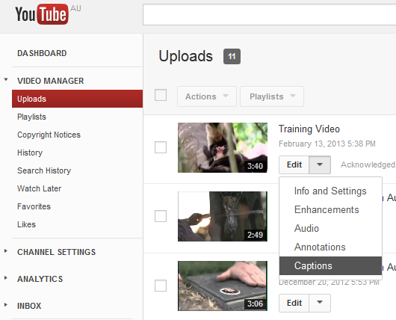
- Select ‘Add subtitles or CC’.
- Prompting the adding caption features
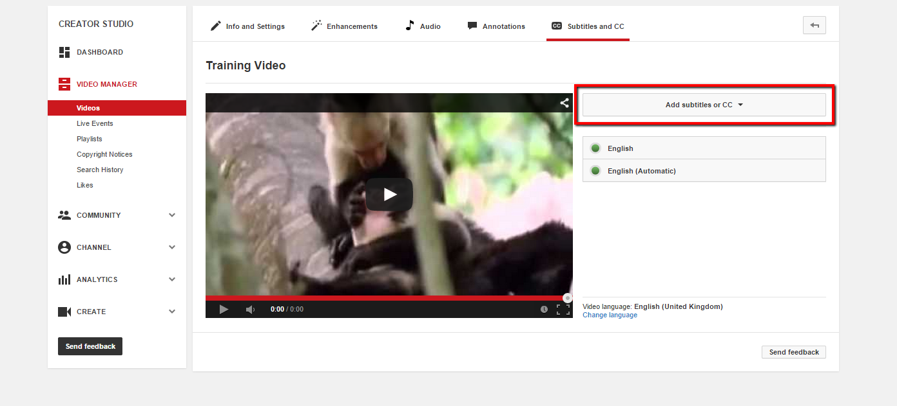
- A dropdown will appear, select your language.
- Select ‘Upload a file’.
- Select your file type as ‘Transcript’ and then ‘Choose File’ to upload your transcript.
- Uploading your caption file
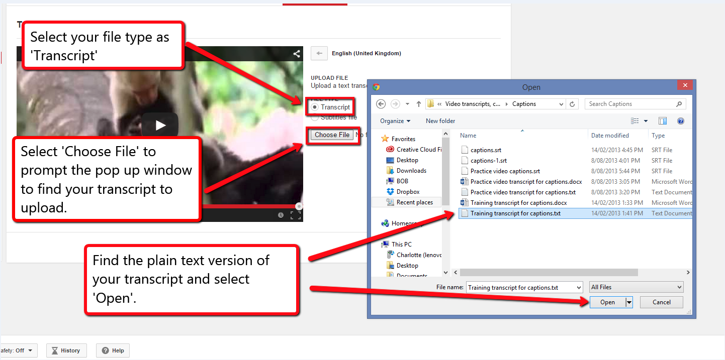
- Select ‘Upload’.
- Select ‘Set timings’.
- Transcript upload options
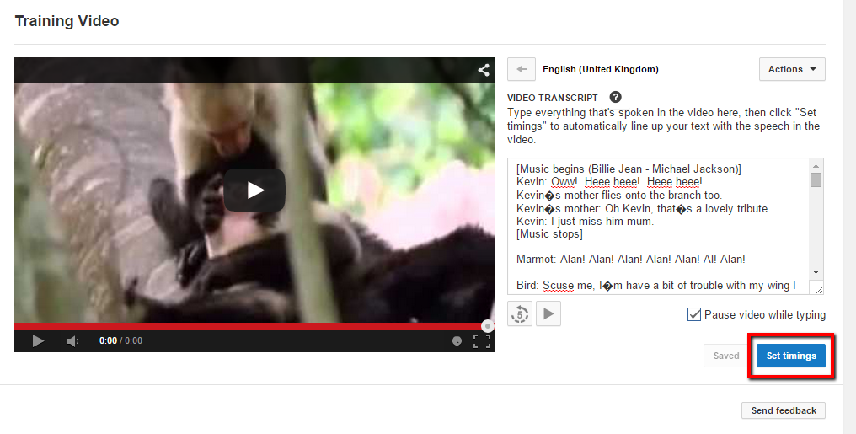
- Once the video has finished syncing, select your track to see the captions and their time codes.
- You can now play the video to see the captions appear.
- You will have the position of the captions in the running track below the video and the captions with their time codes to the right of the video.
- YouTube captioning features
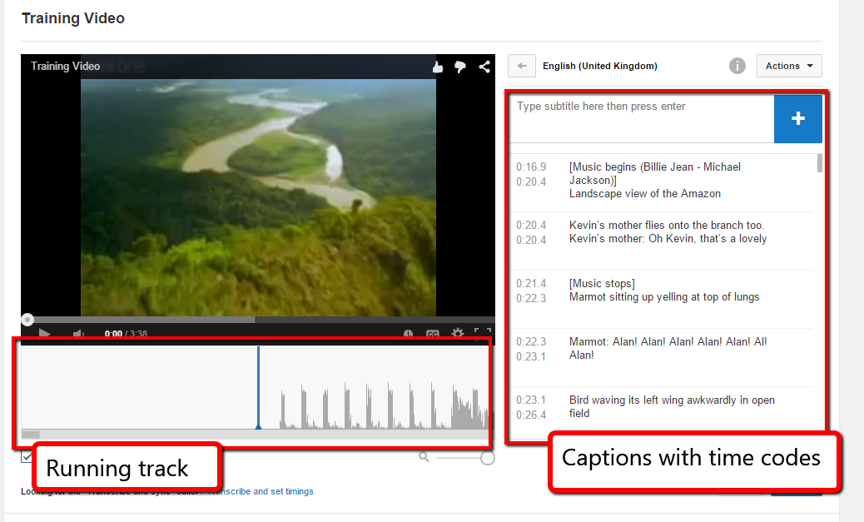
- You will have to play the video to run through and check the position of the captions as YouTube is not completely accurate. However it gives a good base to work with and is easy to use for changing the caption times.

Altering the caption’s time codes
- Play the video to determine where YouTube has placed the captions.
- To move the position of a caption, use the mouse to select the caption from the running track and drag it to a new position.
- Moving the caption text position
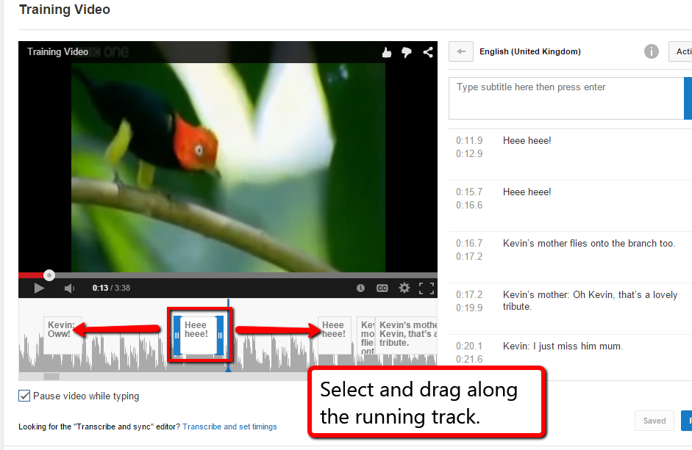

- You can change the time of the track to last longer or shorter by selecting the edge of the caption in the running track and dragging it smaller or bigger.
- Making the caption time longer or smaller
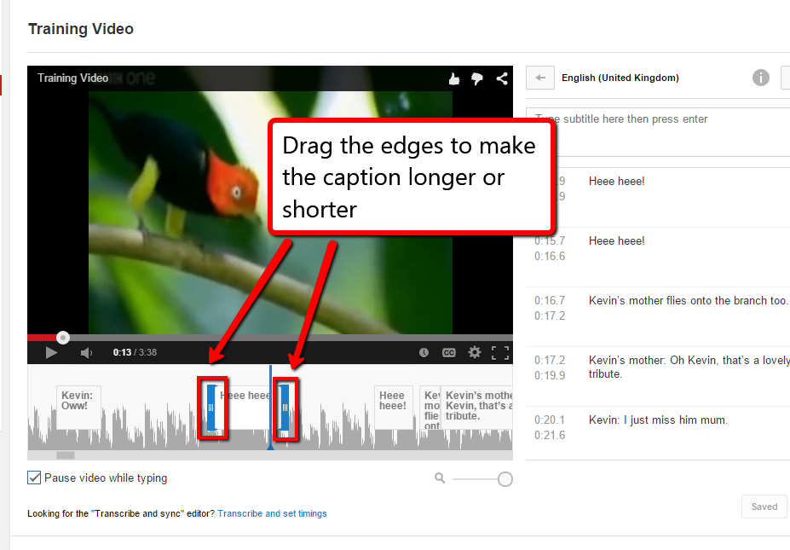
- Edit the captions to line up appropriately in the video.
- Make sure the visual descriptions have separate time codes to any captions.

- Once the captions and visual descriptions line up with the video, select ‘Publish’.
- Publishing the caption track
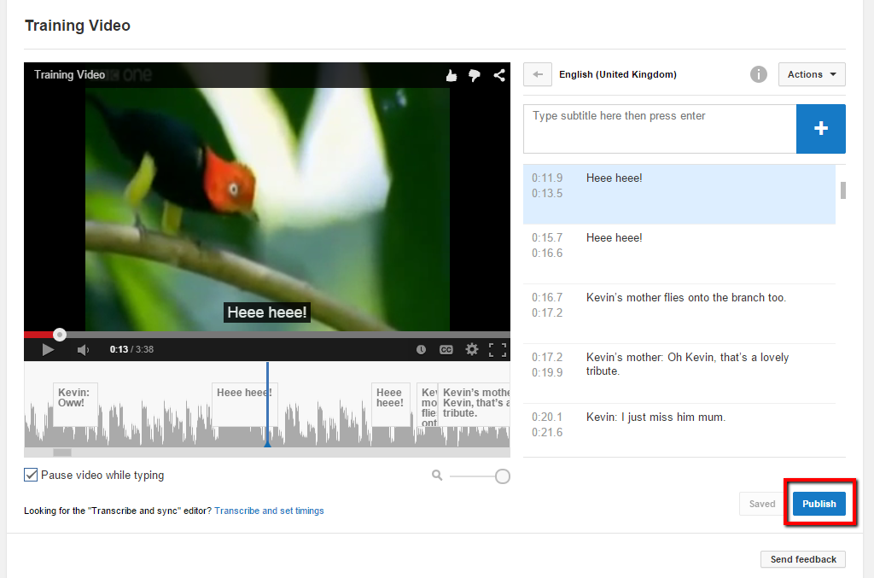
- This will publish your track and take you back to the upload page.

Downloading the caption track
- Select your caption track.
- Selecting your track
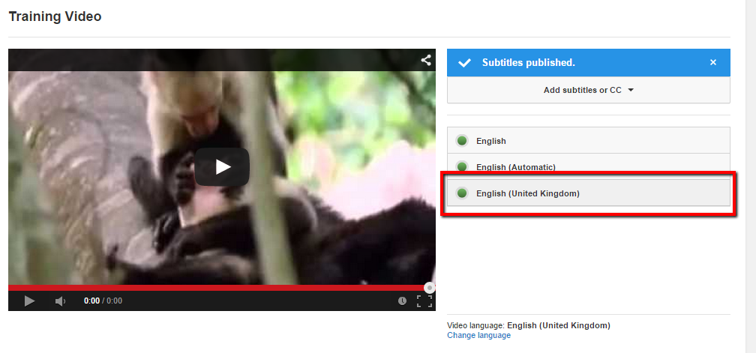
- Once the captions track opens, select the ‘Actions’ dropdown.
- From the dropdown, select the ‘.vtt’ download option.
- Downloading the caption file
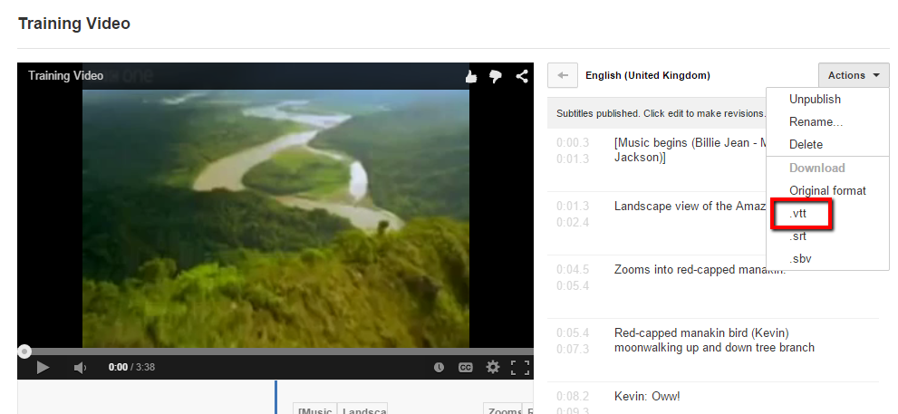
- The downloaded .vtt file is the master track which has both captions and visual descriptions. We will use this track later to create our second track visual descriptions track.
- Once we have the copy of the master track, it is time to remove the visual descriptions so that we have just a caption track.
- Once the master track has been downloaded, do not change any of the times in the tracks or it will mean the interactive transcript won’t work.

- Select ‘Edit’
- Editing the published captions
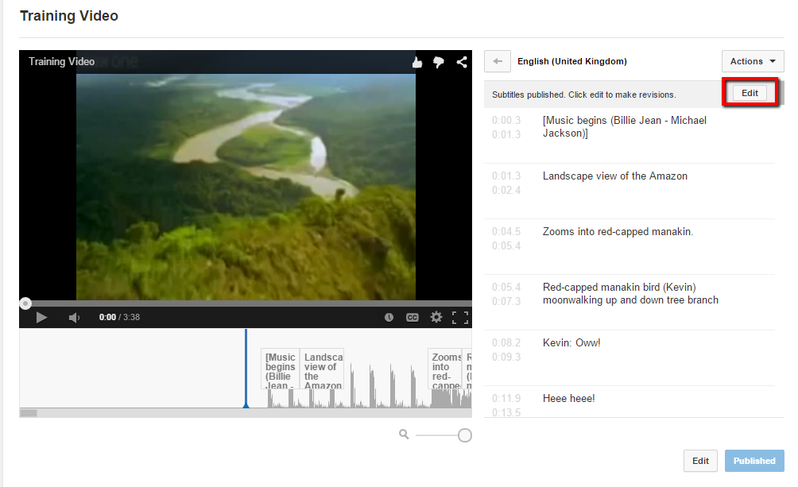
- Now go through the time codes and delete any visual descriptions. This can be done quickly by selected the delete button that appears on mouse over.
- This will not change the times on any of the other captions in the time code section.

- Make sure you do not move around or edit any of the caption times.
- Deleting visual descriptions
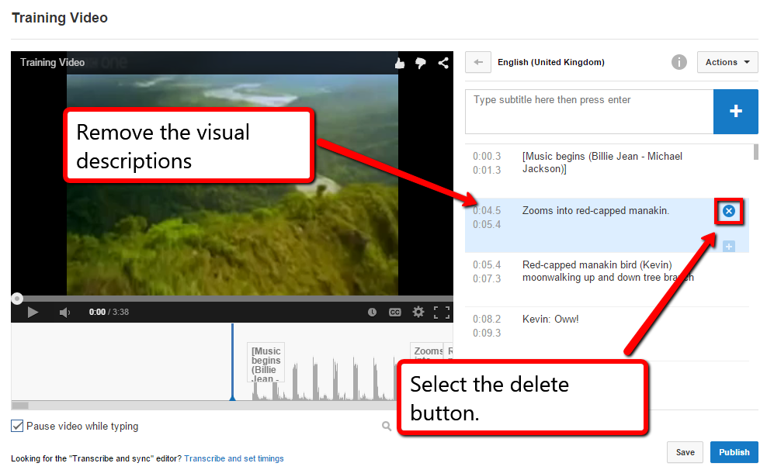
- Once you have deleted all the visual descriptions, select the ‘Publish’ button to save the new caption track.
- Repeat steps 41 to 43 to download the .vtt track which is solely a caption track.

Creating the second track for OzPlayer’s interactive transcript
- As was mentioned earlier, OzPlayer requires two timed tracks for the interactive transcript to work, one for the captions and one for the visual descriptions. The caption track has already been created in the previous section, so this section with show how to create the descriptions track.
- In step 41 to 43 a master .vtt track was created which contained both captions and visual descriptions. This track will be used to create the visual descriptions track.
- Follow steps 24 to 26 to bring up the options for uploading a transcript file.
- Once on this page, instead of selecting the file type as ‘Transcript’ like before, now select ‘Subtitles file’.
  - This is because the master .vtt file we will upload already has the timings set so does not require YouTube to set the timings for you.
- Uploading the master .vtt track
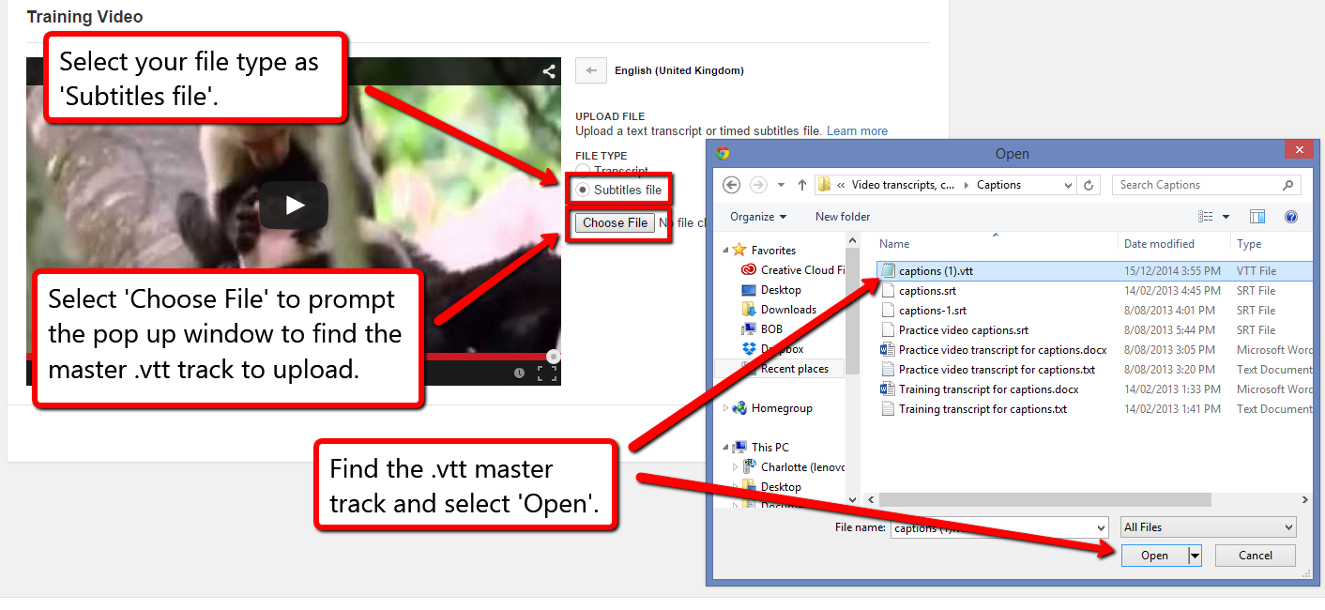
- Select ‘Upload’.
- Select ‘Publish’.
- Select the master track from you captions list.
- Selecting the master track
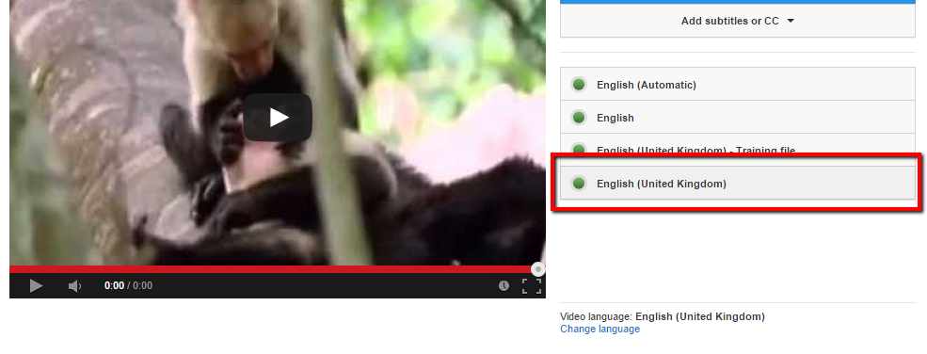
- Select ‘Edit’.
- Repeat the same process as in steps 48 to 51 but instead of deleting the visual descriptions, delete the captions.
- This will leave you with the visual descriptions track.
- Repeat the download process from steps 41 to 43 to download the .vtt file for the visual descriptions.
- Now you have two timed tracks, captions and visual descriptions, which are ready to be add to OzPlayer for the interactive transcript.

Audio Descriptions
It should be noted that audio descriptions are best done when creating the video as an alternative to the original video. This is often not practised, therefore audio descriptions have to be added after. However, the narrator sometimes has to provide a lot of information during very short pauses in dialogue. Therefore, the video has to be temporarily paused to allow critical information to be delivered when pauses in dialogue are insufficient for adequate description, such as:
- Actions
- Characters
- Scene changes
- On-screen text (not captions)
Video audio descriptions should:
- Adequately describe the visual information;
- Not impinge on other speech or important sounds;
- Be concise but sufficiently explanatory; and
- Be sufficiently distinguishable from other speech.
The easiest method of creating audio descriptions is to use Adobe Premiere. A thirty day free trial can be downloaded from Adobe.
However, another tool that is often used for creating audio descriptions is MAGpie. MAGpie takes approximately 1 hour per minute of video. To see instructions on how to use MAGpie to create audio descriptions, see Appendix 4 on page 50.
Note: When using Adobe Premiere to create audio descriptions, one minute of video takes approximately 1 hour create an audio described file if a transcript is already written.

Using Premiere Pro to produce an extended audio description video

Create a new project
- Open Premiere, create a new project. Give it a name, leave the other options alone.
- Ensure you specify the right directory.

Add the video
- Drag the video into the lower-left pane. This will import the video into the project.
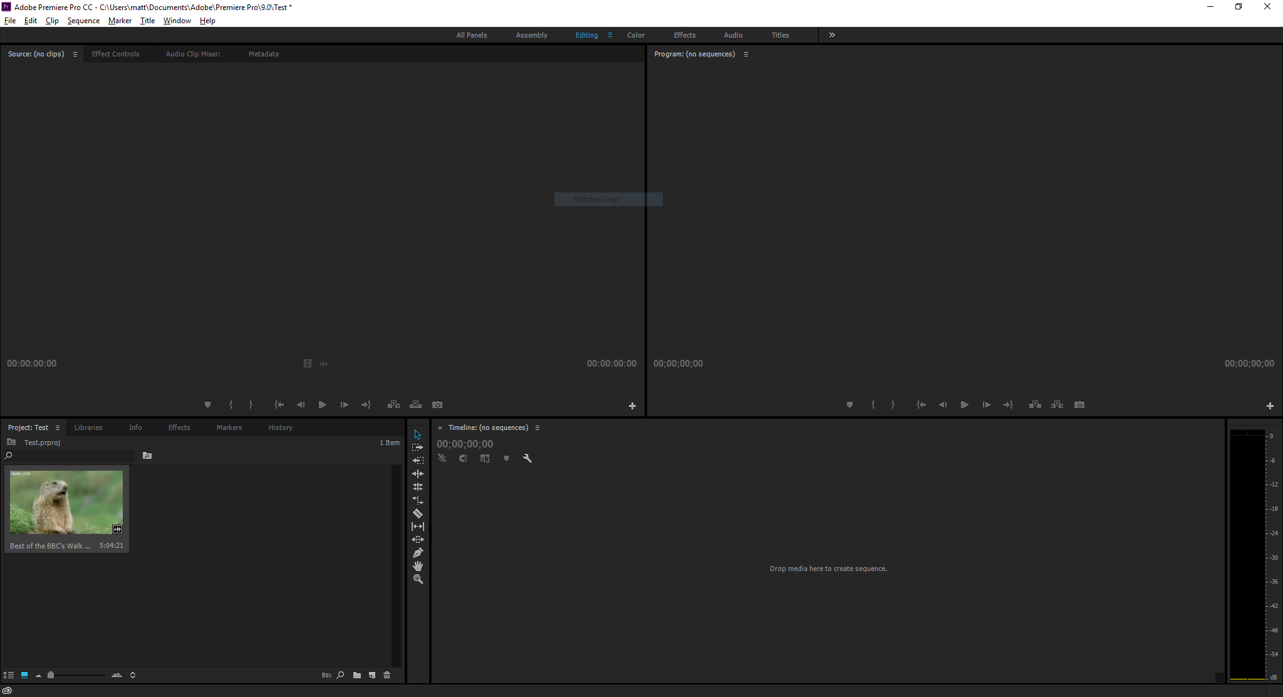
- Adobe Premiere

Extract clips
- Double-click the video in the lower-left pane to open it in the source viewer:
- Adobe Premiere
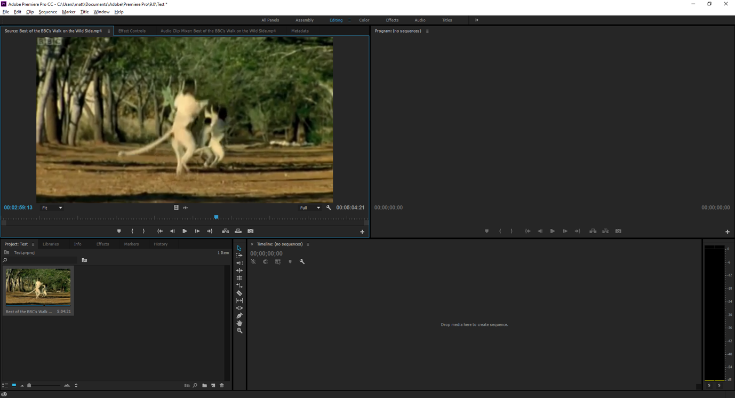
To extract the first clip:
- Make sure the video in the source viewer is at the start, then press space to play
- When you hit the end of the section you want, press “o” to drop the “out marker”
- Note that you can “scrub” back and forth using the left and right arrow keys to help find the right place to put the out marker

- Once the correct region is selected, use the mouse to drag the video in to the bottom-right timeline section. Drag from the video itself.
- Dragging the video to the bottom right adds it to the new version
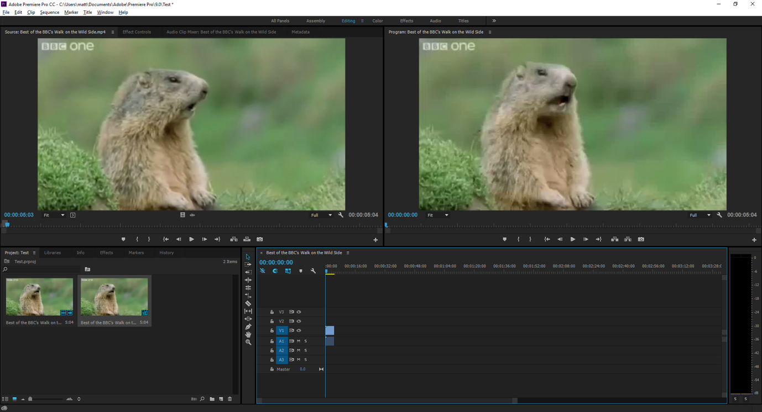
- Capture the frame as an image. In the source viewer click the “camera” icon at the bottom-right. Don’t worry about the image format, but make sure the name is unique and tick the “import into project” checkbox
- Grab the new image and drag it into the timeline as a new chunk of content. Drop it right next to the video. Video appears in light blue, stills in purple, and audio in darker blue
- The image appears in pink
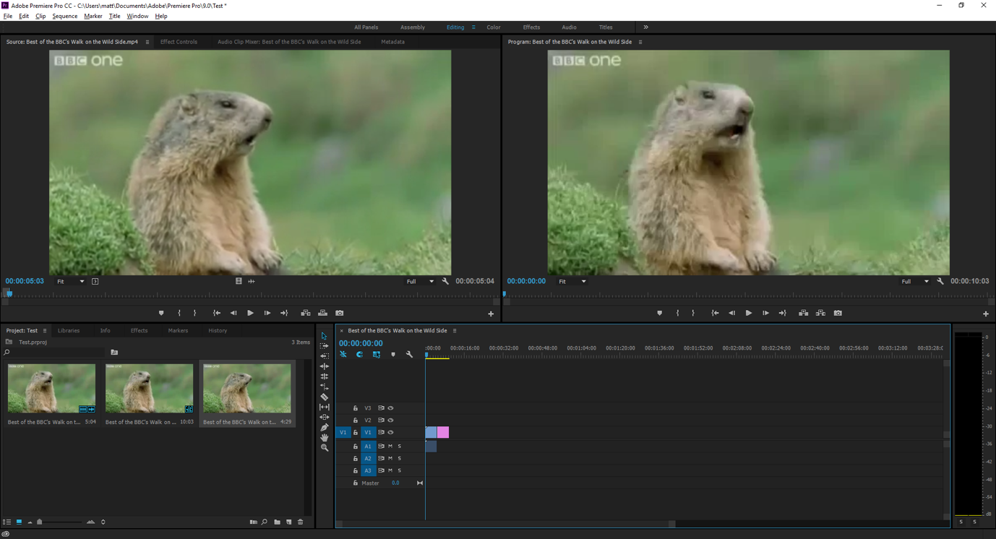
To extract further clips:
- Click in the source viewer to make sure that has focus
- Press shift-o to make sure you’re at the out marker
- Press “I” to drop the “in marker” here
- Press space to start playback
- When you’re at the end of the next clip, press “o” to drop the out marker
- Again, you can use the left and right arrow keys to move around more precisely
- Drag the video into the timeline
- Capture the still image of the last frame
- Drag that image into the timeline
- Rinse, repeat, as needed
- A completed video
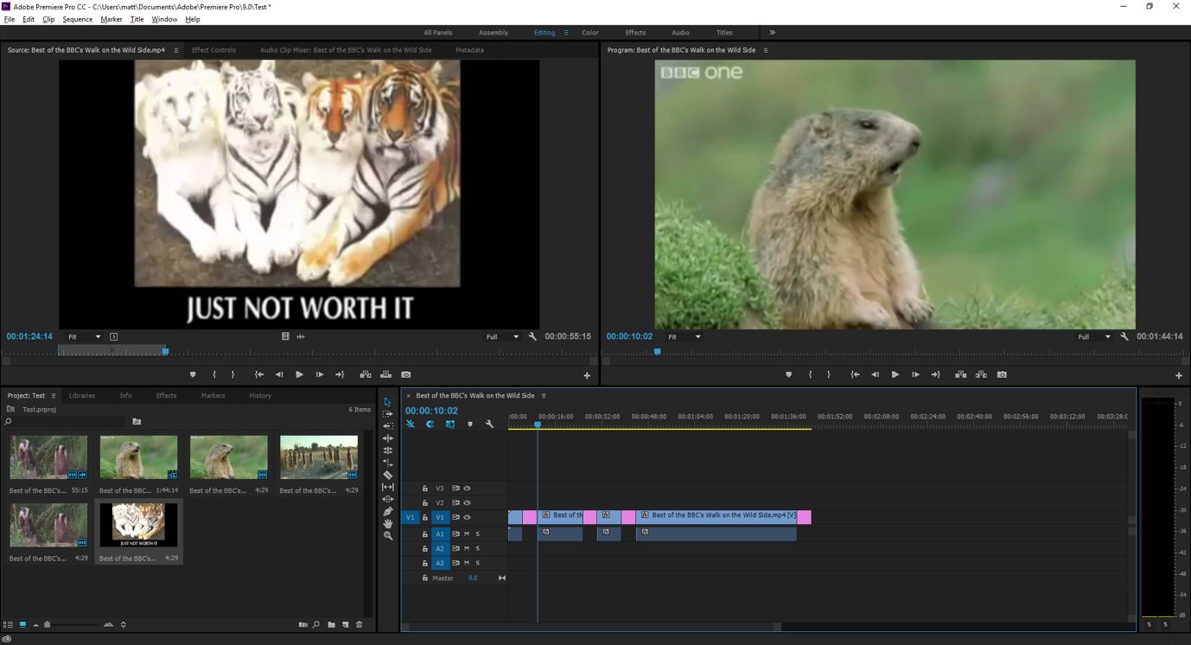

Adding audio
- Click the “audio” button in the workspace list at the top of the window
- Audio
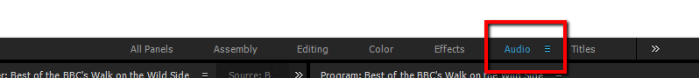

- On the second audio track mixer, click the “R” button to allow recording
- The Recording button
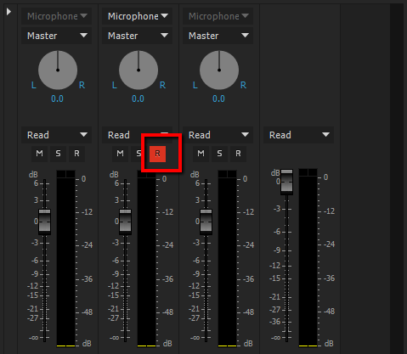
- Drag the timeline cursor to where you want to record the first audio section
- Click the “record” button
- Press space to start playback
- Speak into the microphone
- Press space when you’re done with this section
- The second audio track
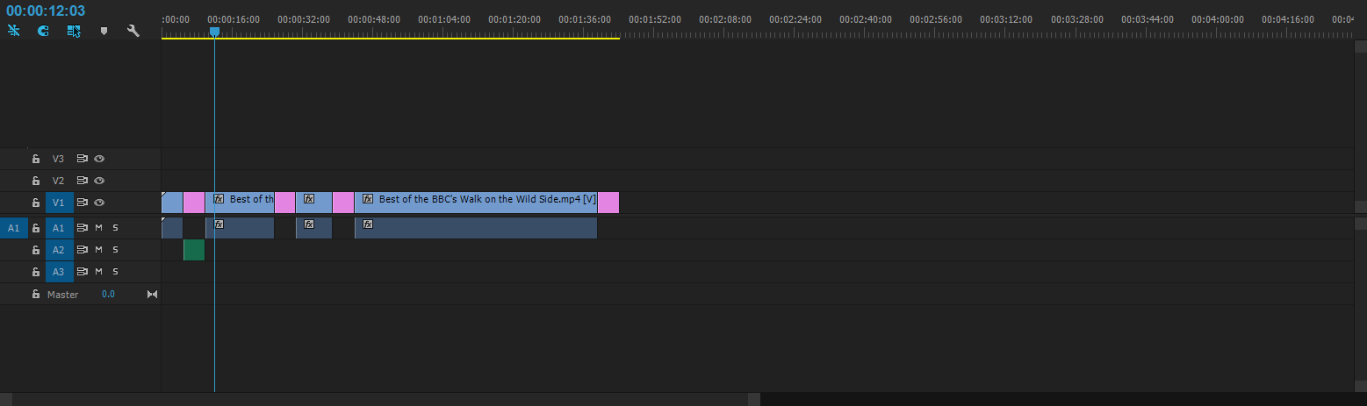
(The second audio track appears in green in the screenshot above)

Saving the completed work
- Make sure to save a copy in the Premiere project format, but for use online it has to be exported.
- File->Export->Media
- Set the format to “H264”
- The preset can be whatever the client prefers, but “Match source – medium bitrate” seems a reasonable choice
- Click “export”

If the video didn’t need pauses to insert audio descriptions…
Then you can simply record an additional audio track and then save that independently.
- Mute all audio tracks except for the one you want to export, then File->Export->Media, select “MP3” as the format, and click “Export”.

Putting your audio described video to use
- The audio described video should be provided as an alternative to the original video because it disrupts viewing for those who do not need the additional description. Options for this include:
  - A feature to turn the audio descriptions on or off; or
  - Separate versions with and without the descriptions.
- OzPlayer currently doesn’t support turning extended audio description on or off, therefore the extended audio description version should be provided with the original.

Appendix 1

Resources
- http://www.uiaccess.com/transcripts/transcripts_on_the_web.html
- http://wiki.accessibilityoz.com.au/doku.php/checklists/video/start
- http://www.w3.org/TR/WCAG/

Online Examples

Transport Accident Commission Pictures of You website
Video Stories: http://www.picturesofyou.com.au/

DareDevil
http://www.polygon.com/2015/4/17/8440687/daredevils-fight-narrator

Appendix 2

WCAG2 Requirements
http://www.w3.org/TR/WCAG20-TECHS/Overview.html#contents

Transcripts

WCAG 2.0 Guidelines
Guideline | Description
1.2 | Time-based Media: Provide alternatives for time-based media.
1.3 | Adaptable: Create content that can be presented in different ways (for example simpler layout) without losing information or structure.
2.4 | Navigable: Provide ways to help users navigate, find content, and determine where they are.

WCAG 2.0 Success Criteria
SC | Description
1.2.1 | Audio-only and Video-only (Prerecorded): For prerecorded audio-only and prerecorded video-only media, the following are true, except when the audio or video is a media alternative for text and is clearly labelled as such:  - Prerecorded Audio-only: An alternative for time-based media is provided that presents equivalent information for prerecorded audio-only content.  - Prerecorded Video-only: Either an alternative for time-based media or an audio track is provided that presents equivalent information for prerecorded video-only content.
1.2.3 | Audio Description or Media Alternative (Prerecorded): An alternative for time-based media or audio description of the prerecorded video content is provided for synchronized media, except when the media is a media alternative for text and is clearly labeled as such.
1.3.2 | Meaningful Sequence: When the sequence in which content is presented affects its meaning, a correct reading sequence can be programmatically determined.
2.4.4 | Link Purpose (In Context): The purpose of each link can be determined from the link text alone or from the link text together with its programmatically determined link context, except where the purpose of the link would be ambiguous to users in general.

WCAG 2.0 Techniques
Technique | Description
G58 | Placing a link to the alternative for time-based media immediately next to the non-text content: With this technique, a link to the collated document of captions and audio description is provided. The collated document could be at another location on the same Web page or at another URI. A link to the collated document is immediately adjacent to the non-text content. The link can be immediately before or after the synchronized media content. If the collated document is on the same Web page as other content then put "End of document" at the end so that they know when to stop reading and return to their previous place. If a "Back" button will not take the person back to the point from which they jumped, then a link back to the non-text content location is provided.
G69 | Providing an alternative for time based media: The purpose of this technique is to provide an accessible alternative way of presenting the information in a synchronized media presentation.  In a synchronized media presentation, information is presented in a variety of ways including:  - dialogue,  - sounds (natural and artificial),  - the setting and background,  - the actions and expressions of people, animals, etc.,  - text or graphics,  - and more.  In order to present the same information in accessible form, this technique involves creating a document that tells the same story and presents the same information as the synchronized media. Such a document is sometimes called a screenplay. It includes all the important dialogue and actions as well as descriptions of backgrounds etc. that are part of the story.  If an actual screenplay was used to create the synchronized media in the first place, this can be a good place to start. In production and editing however, the synchronized media usually changes from the screenplay. For this technique, the original screenplay would be corrected to match the dialogue and what actually happens in the final edited form of the synchronized media.  In addition, some special types of synchronized media include interaction that has to occur at particular places in the playing of the synchronized media. Sometimes it may result in an action taking place (e.g., something is purchased, sent, done, etc.). Sometimes it may change the course of the synchronized media (e.g., the synchronized media has multiple paths that are determined by user input). In those cases links or some other mechanism would be used in the alternative for time-based media to allow people using the alternative to be able to have the same options and abilities as those using the synchronized media.
G159 | Providing an alternative for time-based media for video-only content: The purpose of this technique is to provide an accessible alternative way of presenting the information in an video-only presentation.  In a video-only presentation, information is presented in a variety of ways including animation, text or graphics, the setting and background, the actions and expressions of people, animals, etc. In order to present the same information in accessible form, this technique involves creating a document that tells the same story and presents the same information as the prerecorded video-only content. In this technique, the document serves as a long description for the content and includes all of the important information as well as descriptions of scenery, actions, expressions, etc. that are part of the presentation.  If a screenplay for the video-only content was used to create the content in the first place, this can be a good place to start. In production and editing however, the final version often varies somewhat from the screenplay. To use the screenplay, it would need to be corrected to match the final edited form of the video-only presentation.

Captions

WCAG 2.0 Guidelines
Guideline | Description
1.2 | Time-based Media: Provide alternatives for time-based media.
1.4 | Distinguishable: Make it easier for users to see and hear content including separating foreground from background.

WCAG 2.0 Success Criteria
SC | Description
1.2.1 | Audio-only and Video-only (Prerecorded): For prerecorded audio-only and prerecorded video-only media, the following are true, except when the audio or video is a media alternative for text and is clearly labelled as such:  - Prerecorded Audio-only: An alternative for time-based media is provided that presents equivalent information for prerecorded audio-only content.  - Prerecorded Video-only: Either an alternative for time-based media or an audio track is provided that presents equivalent information for prerecorded video-only content.
1.2.2 | Captions (Prerecorded): Captions are provided for all prerecorded audio content in synchronized media, except when the media is a media alternative for text and is clearly labeled as such.
1.4.3 | Contrast (Minimum): The visual presentation of text and images of text has a contrast ratio of at least 4.5:1, except for the following:  - Large Text: Large-scale text and images of large-scale text have a contrast ratio of at least 3:1;  - Incidental: Text or images of text that are part of an inactive user interface component, that are pure decoration, that are not visible to anyone, or that are part of a picture that contains significant other visual content, have no contrast requirement.  - Logotypes: Text that is part of a logo or brand name has no minimum contrast requirement.

WCAG 2.0 Techniques
Technique | Description
G87 | Providing closed captions: The objective of this technique is to provide a way for people who have hearing impairments or otherwise have trouble hearing the dialogue in synchronized media material to be able to view the material and see the dialogue and sounds - without requiring people who are not deaf to watch the captions. With this technique all of the dialogue and important sounds are embedded as text in a fashion that causes the text not to be visible unless the user requests it. As a result they are visible only when needed. This requires special support for captioning in the user agent.  NOTE: Captions should not be confused with subtitles. Subtitles provide text of only the dialogue and do not include important sounds.
G93 | Providing open (always visible) captions: The objective of this technique is to provide a way for people who are deaf or otherwise have trouble hearing the dialogue in audio visual material to be able to view the material. With this technique all of the dialogue and important sounds are embedded as text in the video track. As a result they are always visible and no special support for captioning is required by the user agent.  NOTE: Captions should not be confused with subtitles. Subtitles provide text of only the dialogue and do not include important sounds.

Audio Descriptions

WCAG 2.0 Guidelines
Guideline | Description
1.2 | Time-based Media: Provide alternatives for time-based media.

WCAG 2.0 Success Criteria
SC | Description
1.2.5 | Audio Description (Prerecorded): Audio description is provided for all prerecorded video content in synchronized media.

WCAG 2.0 Techniques
Technique | Description
G8 | Providing a movie with extended audio descriptions: The objective of this technique is to provide a second version of video content that provides extended audio descriptions. One of the difficult things about creating traditional audio descriptions is that the narrator sometimes has to provide a lot of information during very short pauses in dialogue. Extended audio description temporarily pauses the audio and video to allow critical information to be delivered when pauses in dialogue are insufficient for adequate description.  Providing a second version of the movie with extended audio descriptions will make this content accessible for blind people who need to hear not only the dialogue but also the context and other aspects of the video that are not communicated by the characters' dialogue alone, and for which there is insufficient time during the natural dialogue.  Because it disrupts viewing for those who do not need the additional description, techniques that allow you to turn the feature on and off are often provided. Alternately, versions with and without the additional description can be provided.
G166 | Providing audio that describes the important video content and describing it as such: Video-only content is inaccessible to people who are blind and to some who have low vision. Therefore, it is important for them to have an audio alternative. One way of doing this is to provide an audio track describing the information in the video. The audio should be a common audio format used on the internet, such as MP3.
G173 | Providing a version of a movie with audio descriptions: The objective of this technique is to provide a second version of video content that provides audio desciptions so that it is possible for people who cannot see to be able to understand audio-visual material.  Since most user agents today cannot merge multiple sound tracks, this technique adds the additional audio information to synchronized media by providing a second version of the movie where the original soundtrack and additional audio description have been combined in a single track. This additional information focuses on actions, characters, scene changes and on-screen text (not captions) that are important to understanding the content.  Since it is not helpful to have this new information obscure key audio information in the original sound track (or be obscured by loud sound effects), the new information is added during pauses in dialogue and sound effects. This limits the amount of supplementary information that can be added to program.  Providing a second version of the movie that includes audio descriptions as the primary sound track will make this content accessible for blind people who need to hear not only the dialogue, but also the context and other aspects of the video that are not communicated by the characters' dialogue alone.

Appendix 3

Using MAGpie to create captions
MAGpie is very well-known accessible captioning software.
To download MAGpie, visit:
http://ncam.wgbh.org/invent_build/web_multimedia/tools-guidelines/download-magpie

Create a project:
- Under the File menu, select “New project”
- In the dialog box, select the “Browse” button and select your video file
- For “Caption styles” select 18pt, centred and click OK
- When the “Create new project track” dialog box opens, click OK

Create a caption:
- Press F6 to begin the video. After a sentence or two, press F6 again and type what you have heard into the “Caption” column.
  - Each caption should not exceed two lines
  - Speech does not need to be in quotes. Speech should be preceded by the name of the speaker in the first instance bracketed and in italics, eg:
[Vera] We teach maths, English and LOTE
  - Subsequent captions of speech do not need to be labeled unless there has been a change in speaker
  - Important audio information should be included, bracketed and in italics, e.g,:
[Laughs] Well we get all sorts in here.
  - Unimportant audio information should not be included, for example “um”, “ah” etc.
  - When there is a significant period of silence or background music without important audio information, then this should be captioned. Captions containing this information should be bracketed and in italics, e.g.:
[Music plays]
- When you have completed one caption, press Enter twice to create a new row for a new caption.

Setting the timestamp:
- Press F7 to rewind the video to the beginning
- Move to the first row and press F9 – this will set a timestamp of 0:00:00.00 and means that the first caption will appear as soon as the movie starts
- Press F6 to begin playing the video.
- When the beginning of the next caption is spoken press F9 – this will set a timestamp for the new caption The caption must appear on the screen at the same time as the speech, or sound, that is being captioned.
- Continue until all captions have timestamps
- MAGpie will automatically insert a new row at the end. Delete this row (right-click on the row and select “Delete selected rows”)

Checking your work:
- Under the “Export” menu select “Quicktime – SMIL 1.0 format”
- Open Quicktime and select the SMIL file that MAGpie created
- Play the video with the sound on. Check that:
  - Captions appear at the same time as the sound they are captioning; and
  - That all important audio information has been captioned
- Play the video with the sound off. Check that:
  - Captions appear on the screen for enough time to read (approximately 3 – 4 seconds for a two line caption);
  - There are no periods without captions; and
  - That speech has been attributed to a particular speaker.

Appendix 4

Using MAGpie to create audio descriptions
MAGpie is very well-known accessible captioning software.
To download MAGpie, visit:
http://ncam.wgbh.org/invent_build/web_multimedia/tools-guidelines/download-magpie

Create a project:
- Under the File menu, select “New project”
- In the dialog box, select the “Browse” button and select your video file
- Click OK
- When the “Create new project track” dialog box opens, select “Audio Descriptions” in the “Track Type” section
- Click OK

Create an audio description:
- Press F6 to begin the video. When important information is provided in the visual part of the video, stop the video and click the “Record description” button
- Select the “Use generated file name” option.
- When you are ready to record the description click “Record” (you will need a microphone for this)
- When you have finished recording, click “Stop” and then OK to close the dialog box
  - The audio description must fit between existing dialog or important sounds.
  - If there are time limits, describe only important visual information, such as people’s actions, or diagrams. If there is enough time, then describe other visual information
  - Describe information consistently, ie using the same names and terminology
  - Describe emotional states, but do not attribute reasoning or motivation (eg. do not say “Her prayers answered, Joan looks up with tearful eyes”, instead say “Joan looks up with tearful eyes”)
  - Ensure the voice is sufficiently distinguishable from other voices in the production
  - Read titles and credits
- When you have completed one recording, press Enter twice to create a new row for a new audio description.

Setting the timestamp:
- Press F7 to rewind the video to the beginning
- Press F6 to begin playing the video.
- When the audio description should be spoken press F9 – this will set a timestamp for the audio description
- Continue until all audio descriptions have timestamps
- MAGpie will automatically insert a new row at the end. Delete this row (right click on the row and select “Delete selected rows”)

Checking your work:
- Under the “Export” menu select “Quicktime – SMIL 1.0 format”. Save the file.
- Open Quicktime and select the SMIL file that MAGpie created in step 1
- Play and watch the video. Check that:
  - Audio descriptions adequately describe the visual information
  - The audio descriptions do not impinge on other speech or important sounds
- Play the video but do not watch it. Check that:
  - Audio descriptions are sufficiently explanatory
  - Audio descriptions are sufficiently distinguishable from other speech

Appendix 5

Further Examples

Transcripts
- Transcript example 1: An inaccessible video without a transcript
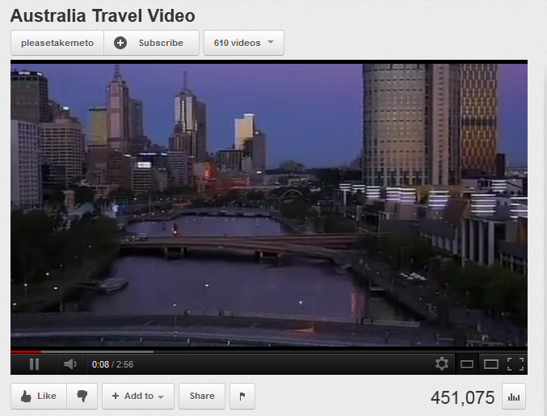
See: https://www.youtube.com/watch?v=6leHGHCKeSg

- Transcript example 2: Accessible video with a link to its transcript
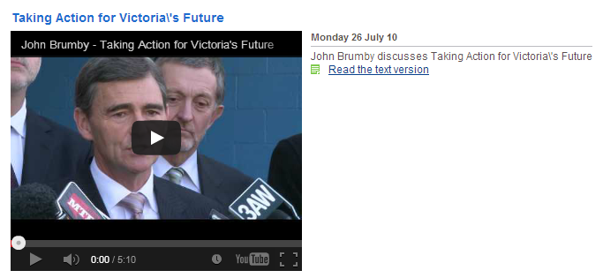
See: http://archive.premier.vic.gov.au/your-voice/video-a-audio/video-library.html?task=media&media_id=482
- Transcript example 3: Accessible vidoe with the transcript provided with the video
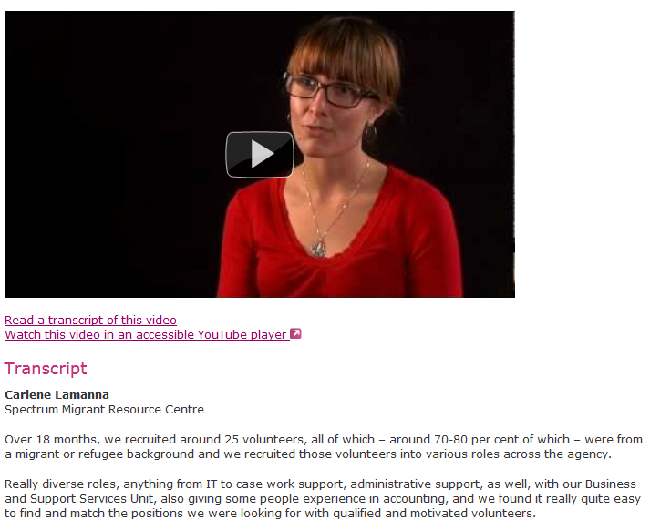
See: http://www.volunteer.vic.gov.au/about-volunteering/volunteer-stories/volunteer-organsation-stories/developing-a-volunteer-program-with-cultural-diversity-in-mind

Captions
- Captions example 1: Inaccessible video without captions
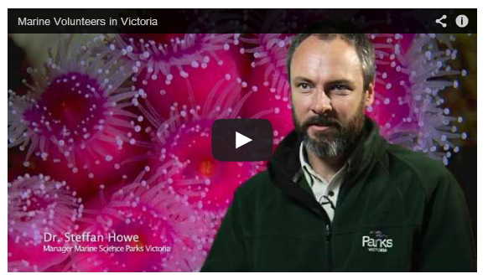
See: http://www.volunteer.vic.gov.au/information-for-volunteers/volunteers-tell-their-stories/barwon-south-west/marine-volunteers
- Captions example 2: Accessible YouTube video with captions
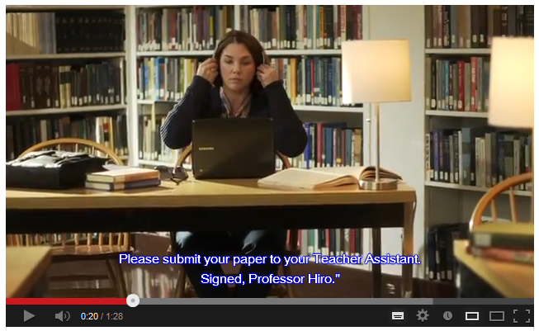
See: https://www.youtube.com/watch?v=gZJtLIHZb2s
- Captions example 3: Accessible video playing with open captions
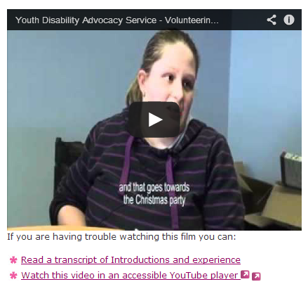
See: http://www.volunteer.vic.gov.au/information-for-volunteers/volunteers-tell-their-stories/disability/ydas-films-experiences-and-benefits

Audio Descriptions
- Audio descriptions example 1: Inaccessible video with incorrect audio descriptions
http://www.youtube.com/watch?v=Fa4kr9ohjBw
- Audio descriptions example 2: Accessible video with correct audio descriptions
http://www.youtube.com/watch?v=nwqzKyxETV0
- Audio descriptions example 3: Second accessible video with correct audio descriptions
http://www.youtube.com/watch?v=gZJtLIHZb2s

Company Bio
AccessibilityOz is an accessibility consultancy with clients across Australia. Gian Wild, the founder and Director, has worked on the accessibility of various Government projects for fourteen years. AccessibilityOz is a W3C Member and an IBM Business Partner.
AccessibilityOz has worked with the Australian Human Rights Commission, the Australian Government Information Management Office and, most recently, Victorian Government, in implementing the W3C Web Content Accessibility Guidelines in a national and/or state context.

We focus on accessibility so you don’t have to
Gian Wild, the founder and Director of AccessibilityOz spent six years on the international Working Group contributing to the development of the W3C Web Content Accessibility Guidelines, Version 2.0. These guidelines were recently endorsed by the Australian Human Rights Commission and the Australian Government Information Management Office for use across Australia. Recently all state governments and COAG have followed suit.
At a federal level, the Australian Government Information Management Office has released a Web Accessibility National Transition Strategy which AccessibilityOz is responsible for implementing for several federal Government departments (Australian Public Services Commission, Australian Centre for International Agricultural Research, GeoScience Australia and the Civil Aviation Safety Authority). At a Victorian level, AccessibilityOz wrote the updated eGovernment Accessibility Toolkit which is the Victorian standard for accessibility requirements.
Senior consultants at AccessibilityOz have been interviewed on the state of the web (most recently by The West Australian), written many articles on the area of accessibility (for example, A List Apart), run numerous seminars and spoken at many conferences (most recently at Edge of Web in Perth and the Local Government Web Network conference in Sydney).

Contacts

Gian Wild (CEO)
Phone: 415 621 9366
Email: gian@accessibilityoz.com
Web: www.accessibilityoz.com

