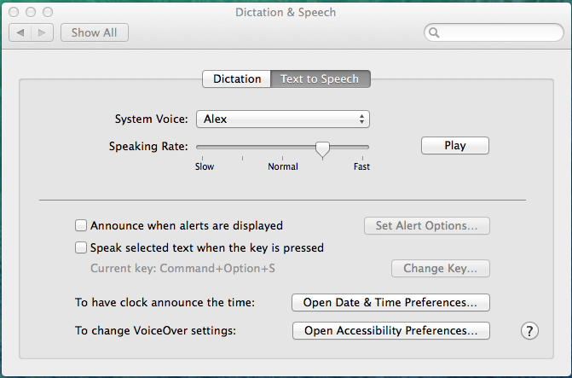
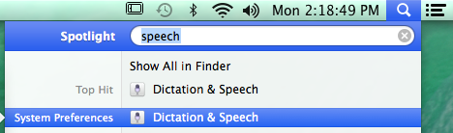
Step 1:
Go to Spotlight, (the search utility indicated by a magnifying glass in the upper right corner of your screen).

Step 2:
Type in "Speech", then press enter or select System Preference “Dictation & Speech” from the suggestions offered.

Step 3:
In the “Dictation & Speech” dialogue box that will appear, select the “Text to Speech” tab. Then click “Play” to test the various Speaking Rates.
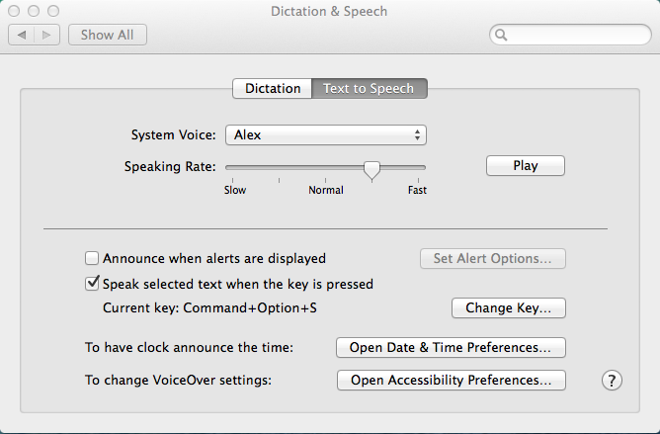
Use the slider to set slow, normal or fast. When the rate is right for you go on to the next step.
Hint: Vary the rate depending upon what material you are reading. Note that this is a great way to proof what you write.

Step 4:
Check the 3rd checkbox, which reads “Speak selected text when the key is pressed.”
A pop-up box will appear - enter the key combination you will use. If box does not appear, select the button labeled “Change Key…”
Press the keys you want to use (e.g.command-option-S), then press “OK”.
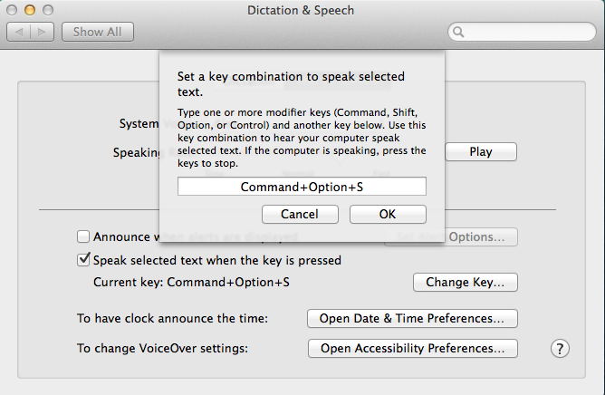
“Change Key…” allows you to create the command you will use to stop and start the speech.
Hint: Including R for Read S for Speech or V for Voice might help you remember your choice of command.

Step 5:
Select (highlight) the Material you want to hear, press the key combination you created, and start listening! Press again to stop.
Go to your document or to a web page. Highlight or select the text you would like to have read. Press the key combination to start speech. Wait for the section to finish reading or press the key combination again to stop speech.

Additional Notes:
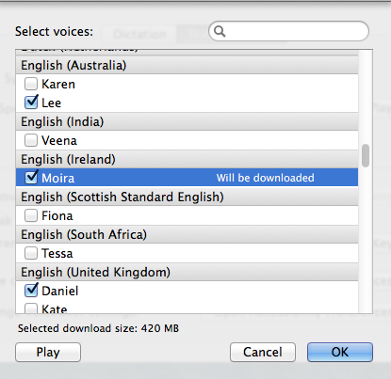
Changing the Voice: The voice can be selected from the drop down menu labeled “System Voice” under the “Text to Speech” tab in the “Dictation & Speech” window. There are several default voices that come installed with OSX, including both male and female voices in several different dialects. However, if you don’t like the default voices, more can be downloaded online from Apple or by looking on google. To get them from apple, use the dropdown menu labeled “System Voice” and select the option “Customize…” Then select the voice you want to download and click “OK”. Once the download is complete, select the voice from the “System Voice” dropdown menu.

