Logging in to Kurzweil 3000 Web Edition requires that the Kurzweil 3000 Web License Client software has been installed on the computer you want to use.
To log in:
Double-click the Kurzweil 3000 icon on the desktop to open the Login dialog
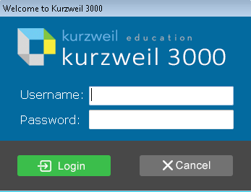
Enter Username and Password, and click Login.
Reading the Web
When you read the Web from Kurzweil 3000, you still have access to your Web browser's features. You can access other websites, search the Web, and so on.
To hear websites read aloud:
With a Web site open in your Web browser, click the Read button in the Kurzweil 3000 Web toolbar.
Kurzweil 3000 begins reading the site, with dual highlighting overlaying the text. To stop reading at any time, click the Pause button
Just as in a Kurzweil 3000 document, you can use the Read Mode, Reading Unit, and WPM features available from the Web toolbar to control the reading pace. You can also use the Forward and Back buttons in the Web toolbar to move by the current unit.
To refresh a Web page's display (Internet Explorer only):
If you receive a message saying there is no text to read, or if the dual highlighting during reading a Web page isn’t properly aligned, click the Refresh button in the Kurzweil 3000 Read the Web toolbar. Then try reading again.
Reading Options, Controls, and Tools
When you open the Read tabbed page, notice the two sets of tools: The Reading tools on the Ribbon and on the Toolbar. The Ribbon is beneath the Menu Bar. The Reading Toolbar is displayed vertically on the left side of the page beneath the ribbon. Reading options are accessible from the Audio Options menu on the right side of the ribbon as well as on the Read menu on the Menu Bar above the ribbon.
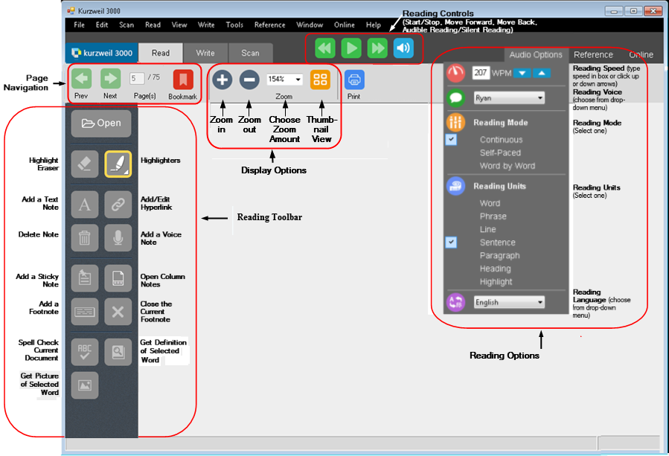
To read faster or slower:
Use the WPM (words per minute) arrows at the top of the to Audio Options menu to set the reading speed. Click the up arrow to read faster or the down arrow to read slower. You can also type the value you want, in words per minute, directly into the text box.
or
Open the Read menu, click Reading Speed, and then choose Increase or Decrease.
or
Press F11 on the keyboard to increase the speed by five words per minute, or F12 to decrease the speed by five words per minute.
To set Reading Options:
From the Tools menu, select Options to display the Options dialog box.
Click the Reading icon on the left to display the Reading Options pane.
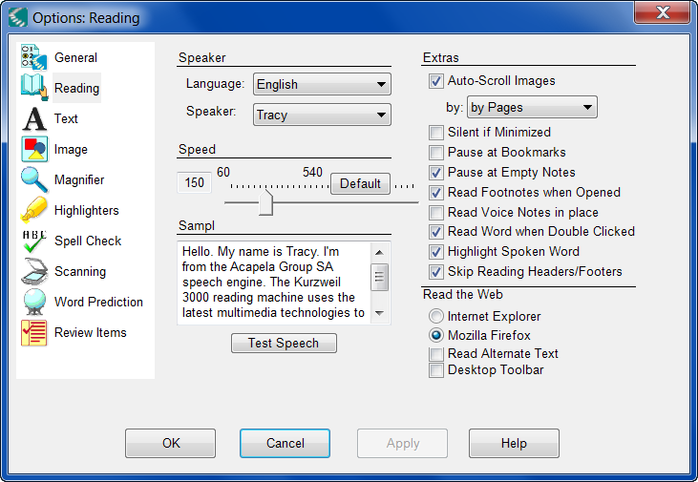
Set your options.
Click the Language arrow to select the language used to read scanned documents.
By default, Kurzweil 3000 automatically changes the Language selection in the Scanning Options pane to match what you select in this menu.
Click the Speaker arrow to select a reading voice from the list.
The default voice is Tracy.
In the Speed area, use the slider to set the speed for the reading voice. Click Default if you want to use the default reading speed. The default is different for different languages.
Click Test Speech to read the sample text with the volume, speed and speaker settings you've chosen. You can edit the sample text in the text field, but Kurzweil 3000 does not save your changes to this text once you close the pane. Click Stop Speech to stop the speech test.
The Extras area lets you choose additional reading features:
Auto-Scroll Images. Enables or disables image scrolling during reading. You can choose to scroll by line or by page.
Silent if Minimized. Causes Kurzweil 3000 to stop reading if you minimize the window.
Pause at Bookmarks. Causes Kurzweil 3000 to pause at each Bookmark while reading.
Pause at Empty Notes. Causes Kurzweil 3000 to pause at each empty Text Note while reading.
Read Footnotes When Opened. Lets you hear Footnotes read out loud as soon as they are opened. You do not need to click the Read button.
Read Voice Notes in place. Causes Kurzweil 3000 to read/play Voice Notes as it encounters them.
Read Word When Double-Clicked. Causes Kurzweil 3000 to read a word when you double-click on it. This works even when Silent Reading is selected in the Read menu.
Highlight Spoken Word. Causes Kurzweil 3000 to highlight the current word within a unit during reading.
Skip Reading Headers/Footers. Directs Kurzweil 3000 to not read text in areas that have been marked using the Header/Footer Editor.
The Read the Web area lets you select a default Web browser for the Read the Web feature.
Click OK when you have finished

