Installation Guide:

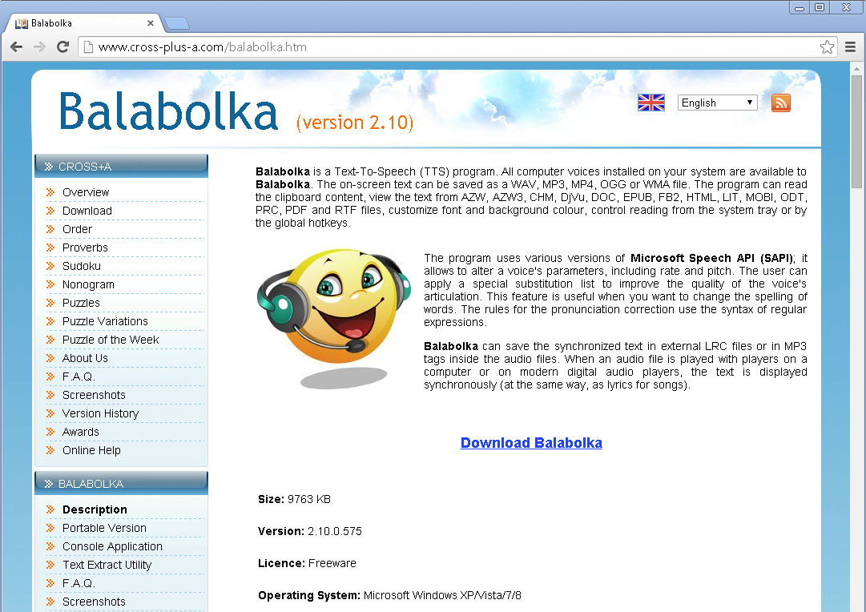

1. Navigate to <http://www.cross-plus-a.com/balabolka.htm>
2. Click the link “Download Balabolka”
3. Once it’s done downloading, double click to open the zip file.
   1. Click “Extract all Files”
   2. Click “Extract
4. Once the files have been extracted, double click “setup.exe”
   1. If there is a prompt to open the file, click “Yes”
5. Select the language and click “Next”
6. Click “Next”
7. Click “Next”
8. Click “Next”
9. Click “Finish”

