##### Introduction:

Balabolka is a free text-to-speech program that works with Windows XP, Vista, 7 and 8. It can read text from most text file formats such as Microsoft Word, PDF, txt, etc. as well as being able to read directly from a webpage or your clipboard. The text can not only be read but also saved to an audio file to be played back on the go or where you can’t or don’t have Balabolka installed such as a smart phone.

##### Window Overview:

Reading control icons

Document tabs

Current document or pasted text

Voice, rate, pitch and volume controls

Figure 1: Window Overview

# Reading Text:

To open a file, in the top menu click “File” then “Open…” then choose the file to be opened. You can also press CTRL+O on the keyboard or drag and drop the file(s) into the Balabolka window. If the text that you want to read is not in a document, then you can also copy and paste in the text to be read.

Once you have text open in Balabolka, there are several ways you can go about reading it. Labelled above in Figure 1, as “Reading control icons” can be used to read text as well as the keyboard shortcuts listed toward the end of this document. Figure 2 shows the play, pause and stop controls respectively listed from left to right. Hitting the play button in Figure 2 or pressing F5 on the keyboard will start reading from where the cursor is in the document you have open. F6 and F7 will pause and stop the playback respectively.



Figure 3



Figure 4



Figure 2

If you only want to play the selected text then hit the button shown in Figure 3 or press F8.

If you want to play content that you have copied but have not pasted into Balabolka you can play what’s in your clipboard by pressing the button shown in Figure 4 or by pressing F9

# Saving Audio Files:

Another great built in feature in Balabolka is that it can save what you are reading to an audio file so you can listen to it on anything that plays audio files. The only downside of this is that it will export all the text as an audio file, not just what you have selected. To save the text to an audio file, click “File” then “Save Audio File…” or press the button shown in Figure 5.



Figure 5

# Reading Text Outside of Balabolka

Select the text on the screen that you want to read. Then in the status icons in the bottom right corner of your screen right click the Balabolka icon and click “Read Selected Text”. This can be seen in Figure 6.

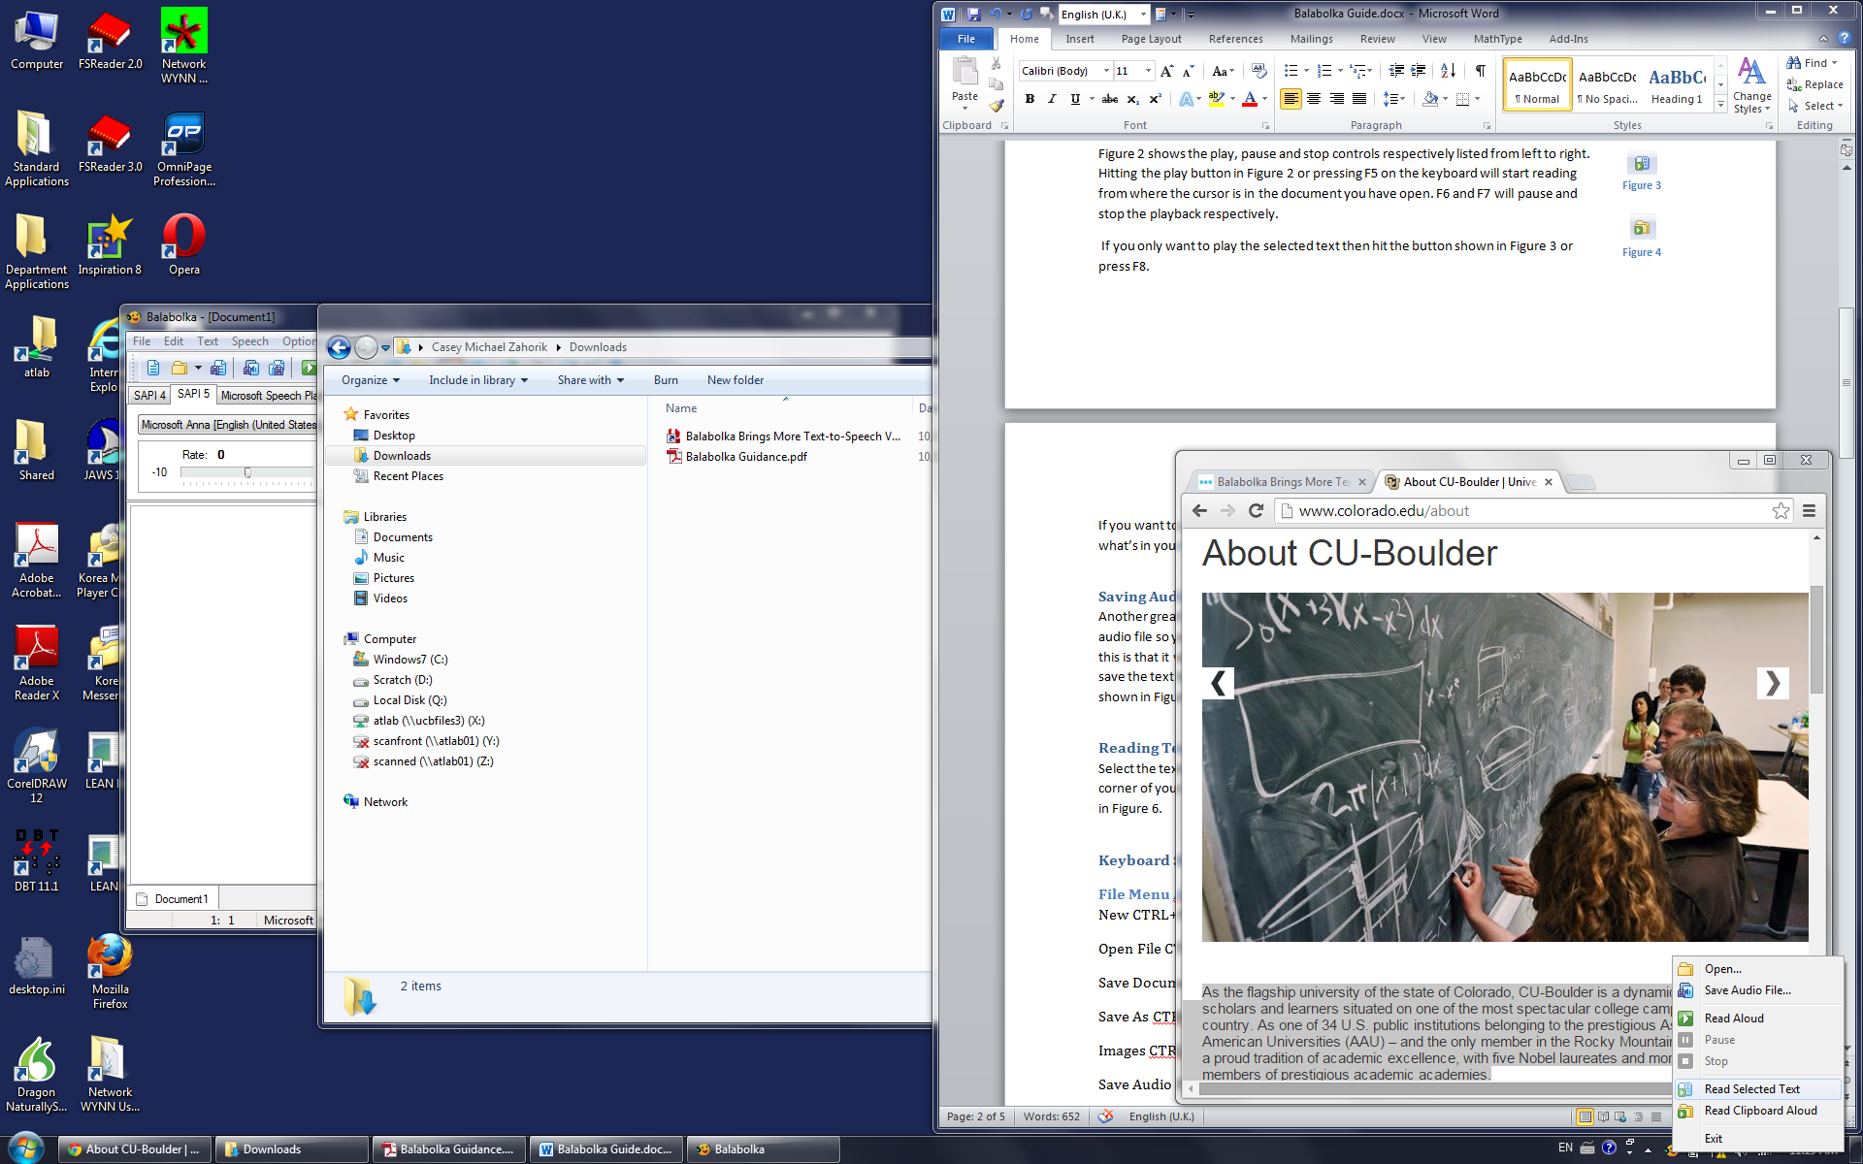

Figure 6

# Keyboard Shortcuts:

### File Menu Alt+F

New CTRL+N

Open File CTRL+O

Save Document CTRL+S

Save As CTRL+Alt+S

Images CTRL+Alt+I

Save Audio File CTRL+W

Split and Convert to Audio File CTRL+F8

ID3 Tag CTRL+I

Close Current Document CTRL+F4

Close All Documents CTRL+SHIFT+F4

### Edit Menu ALT+E

Undo CTRL+Z

Cut CTRL+X

Copy CTRL+C

Paste CTRL+V

Pronunciation CTRL+P

Find Text CTRL+F

Find Next F3

Replace CTRL+R

Select All CTRL+A

Clear Highlighting CTRL+H

### Text Menu ALT+T

Spellchecking F4

Format Text CTRL+L

Find Homographs CTRL+M

Replace Numbers with Words CTRL+G

Foreign Words SAPI5 CTRL+ALT F

Direct Speech SAPI5 CTRL+D

Audio Clip CTRL+ALT+INSERT

### Speech Menu ALT+S

Read Aloud F5

Pause F6

Stop F7

Read Selected Text F8

Read Clipboard Aloud F9

Skip to Next Paragraph CTRL+DOWN ARROW

Skip to Previous Paragraph CTRL+UP ARROW

Skip to Next Line CTRL+F11

Skip to Previous Line CTRL+F12

### Options Menu ALT+O

Increase Speech Rate CTRL+ALT+RIGHT ARROW

Decrease Speech Rate CTRL+ALT+LEFT ARROW

Raise Speech Pitch CTRL+ALT+UP ARROW

Lower Speech Pitch CTRL+ALT+DOWN ARROW

Increase Volume CTRL+ALT+PAGE UP

Decrease Volume CTRL+ALT+PAGE DOWN

Reset Rate and Pitch CTRL+D

Audio File SHIFT+F5

Settings SHIFT+F6

Spellchecker SHIFT+F7

Clipboard Watch CTRL+SHIFT+W

Timer SHIFT+F8

### View Menu ALT+V

Fonts and Colours CTRL+B

Skins CTRL+K

Show Configure Voice Panel F10

Show Panel of Dictionaries F11

Increase Font Size SHIFT+CTRL+.

Decrease Font Size SHIFT+CTRL+,

Full Screen F12

### Tools Menu ALT+L

File Splitter CTRL+U

Batch File Convertor CTRL+Y

Extract Text from File CTRL+SHIFT+F

Compare Two Files CTRL+E

Repeat Text CTRL+SHIFT+R

List of Spelling Errors CTRL+SHIFT+E

Translate CTRL+SHIFT+G

Save Audio File Google TTS CTRL+SHIFT+D

Magnifier F2

### Bookmark Menu ALT+B

Insert Quick Bookmark CTRL+ALT+Q

Go to Quick Bookmark CTRL+Q

Insert Named Bookmark CTRL+F3

Go to Named Bookmark CTRL+SHIFT+F3

### Help Menu ALT+SHIFT+?

Help Table of Contents F1