School of Social Work and Disability Resources: Working to Make Documents Distributed through LMS Accessible

Melinda McRae School of Social Work mmcrae@uw.edu
Krista Greear
Disability Resources for Students
greeark@uw.edu

We Love PDFs!

Not really.

You Should Walk Away With

> Understanding of how much content might be distributed electronically on your campus
> Case study of creating a collaborative relationship
> One idea to implement on your campus

Reminder of 2014 Presentation

> Professors distribute files through LMS
> The quality/accessibility of these files varies
> DRS was working mostly as a silo to evaluate and convert

2014 Data

 | Winter 2014 | Spring 2014 | Summer 2014 | Autumn 2014
# classes evaluated | 28 | 58 | 28 | 33
# ﬁles (pdfs, word docs, powerpoint, excel, text ﬁles) | 1,097 | 2,003 | 753 | 1,623
# pages (pdfs, word docs, powerpoint, excel, text ﬁles) distributed through LMS that DRS evaluated | 20,373 | 34,492 | 9,445 | 26,808

I asked myself -

> Has the data changed?
> Were Winter, Spring, Summer, Autumn of 2014 anomalies?

> Nope.

2015 Data

 | Winter 2015 | Spring 2015 | Summer 2015 | Autumn 2015
# classes evaluated | 30 | 26 | 2 | 29
# ﬁles (pdfs, word docs, powerpoint, excel, text ﬁles) | 669 | 1,045 | 52 | 1,068
# pages (pdfs, word docs, powerpoint, excel, text ﬁles) distributed through LMS that DRS evaluated | 11,973 | 17,106 | 1,116 | 18,269

Averages from past 8 quarters

> 35 files per course
> 596 pages per course

> This only includes word docs, pdfs, excel sheets, text files and powerpoints – what about other files (video, audio, publisher files, images)?

Let’s Assume

> Each UW course has 596 pages of content distributed electronically
> For Autumn 2015 of 13,207 classes that’s

7,871,372 pages of content

From Nov 2014 to Today

> Professors distribute files through LMS
> The quality/accessibility of these files varies
> DRS not a complete silo!

How SSW Got Involved

> Mutual benefit from partnering
> DRS shared files we had from previous quarters
> SSW started to set up their own conversion process

SSW Taming of the Files

> Content
> Process
> Product

SSW Numbers

> 7 classes
> Over 400 pdf files that were touched and further remediated by SSW

Lessons Learned

> Start Early
> Develop Process
> Think of the Big Picture

Trouble Areas

> Not enough lead time
> Access to content
> Quality of content

File Naming Conventions

> Global_agenda
> Frank_week3
> 30012162
> Smith_500a03
> 510_Millstein_ethics

The Good

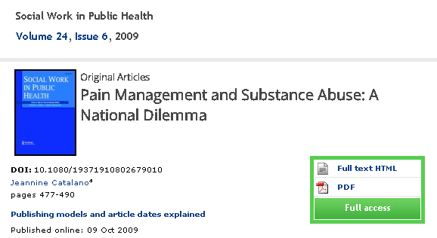

The Bad

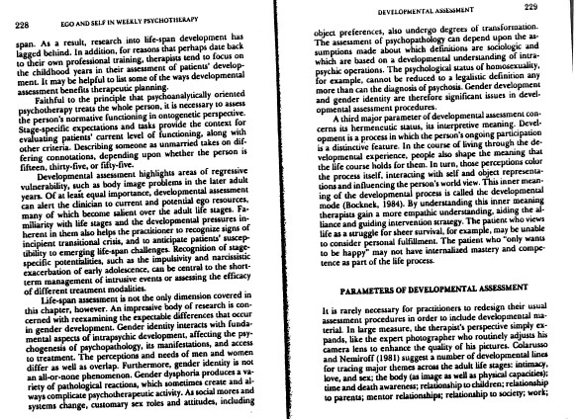

The Ugly

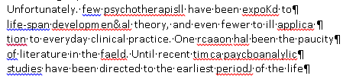

Successes - SSW

> Process Refined
> Faculty and Department buy-in
> Document Depository

Successes - DRS

> Access to all Canvas sites
> Use of SensusAccess (free online conversion tool)
> Reduced workload

Next Steps – SSW Wish List

> Promote campus model
> Faculty training

Next Steps – DRS Wish List

> More transparency between student, faculty and DRS
> Use data to promote change at departmental level
> Share best practices

“Consistent in its inconsistency”

Melinda McRae

Thank you!

Melinda McRae School of Social Work mmcrae@uw.edu
Krista Greear
Disability Resources for Students
greeark@uw.edu

