3d printing for Education
Quick Start Guide

3D Printing for Education
This project was made possible in part by the Institute of Museum and Library Services

ACKNOWLEDGEMENTS 2
INTRODUCTION 3
Project Overview 3
What is 3D Printing? 3
Who Should Use This Guide? 4
Libraries: 5
Museums: 6
School, Library, and Museum Administrators: 6
What is 3D Printing Technology? 7
3D PRINTED OBJECTS IN EDUCATION 7
Why Should You Consider 3D Printing? 8
Who Will Benefit From 3D Printed Tactiles? 10
What Should I Print? 10
When Is It Appropriate To Use A 3D Printed Tactile? 11
Curriculum Considerations 14
3D Do It Yourself 16
Setting Up a Makerspace 17
Considerations 19
Equipment 19
3D Printers 19
3D Scanners 20
3D Design Software 21
Obtaining Designs 22
Legal/Copyright Issues 23
CONCLUSION 24
RESOURCES 24
Links to Other 3D Printing, Design, and Maker Getting Started Guides: 24
Links to Tactile Standards Documents: 24
Additional URLs: 24

ACKNOWLEDGEMENTS
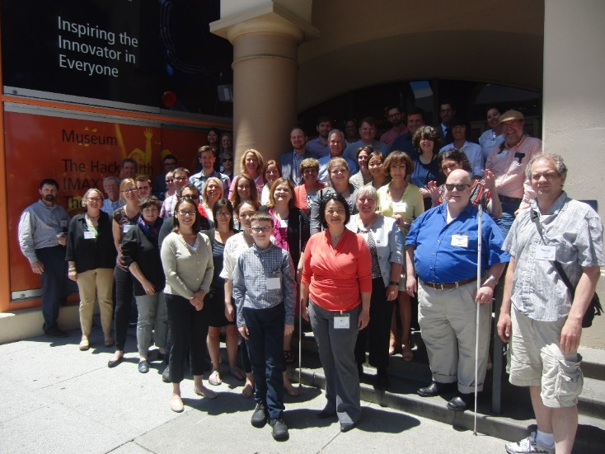
This project required a great amount of work and dedication and would not have been possible without the support of many individuals and organizations. We would like to acknowledge the Institute of Museum and Library Services for their financial and logistical support; their guidance made this project possible. We are also grateful to the 3D for Education advisory committee whose interest and expertise guided the planning and execution of the 3D forum that brought together thought leaders and innovators in the field of 3D printing for education. We gratefully acknowledge the members of the 3D for Education community for their extremely generous contributions of time and expertise that made this guide possible. Erica Compton, Bill Derry, Tricia DeGuilio, Lucia Hasty, Robert Jaquiss, Sue-Ann Ma, Mark Mintz, Matt Nupen, Lisa Wadors Verne, Amaya Webster, Kevin Yang, and many other community members have our undying thanks for supplying invaluable advice and much of the text found in this guide. Finally, we would like to thank the DIAGRAM Center and the DIAGRAM community who provided structure and guidance for setting up the 3D for Education Community.

INTRODUCTION

Project Overview
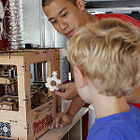
In June 2015, over 50 educators, libraries, museums, technologists, end users, and designers gathered to discuss the implications and opportunities for 3D printing technology in the classroom. This three-day intensive, hands-on working group debated the benefits of using 3D printed technology to increase learning opportunities for students who learn best with multi-modal educational opportunities. Although our research is just beginning, the group developed this guide as a reference for others to utilize 3D technology in the classroom. This evolving quick start guide is for information purposes only and will be updated as collaboration between educators, museums, and libraries increase and technology advances. Finally, this is a community-driven document, and we encourage collaboration for improvement. If you would like to contribute to the guide, please email 3D@benetech.org.

What is 3D Printing?
3D printing has the ability to revolutionize the educational landscape by creating the capacity to enable students to follow the motto: If you can think it, you can create it. If you want it, you can make it. 3D printers and 3D printed objects are already used in educational settings. Existing 3D objects in the educational marketplace (e.g. scientific models and counting blocks) can be expensive, difficult to acquire, and may be unsuited for a particular classroom or student. However, 3D technology opens the door to alternative access to concepts and images that may be problematic for people who learn best through tactile exploration. 3D printing as a technology can help make such objects cheaper, easier to find, customizable, and more readily available for student engagement. Libraries, museums and schools have already started building makerspaces that allow people to create tactiles using 3D printers in public locations. In addition, the increased mainstream availability of Computer Aided Design (CAD) software for 3D design and 3D printers has made this a technology that people from different communities can access and utilize. This guide will not only look at 3D technology as a way to address accessibility issues in the classroom, but it will also explore opportunities for educators to collaborate with museums and libraries to get 3D printed tactiles into the hands of students in a faster and more efficient way.

Who Should Use This Guide?
This guide was designed to support a variety of people interested in learning how to use 3D printed objects for educational purposes. Teachers who support tactile learners in the classroom will benefit as well as people who work or volunteer at libraries and museums. In addition, this resource is for administrators of libraries, and museums who are interested in supporting schools and the general public by making their lessons, environments, and exhibits more accessible with 3D technology.
Educators:
Educators who are interested in exploring alternative means to communicate complex ideas will find that 3D tactiles provide opportunities to interact with content and help create active learners. While our interest is rooted in providing image accessibility (in the form of 3D files ready to be printed on 3D printers) to students who have print disabilities (visual, physical and/or learning), the 3D accessibility community, through research and exploration, have found that many people without disabilities can benefit from access to 3D objects as well.
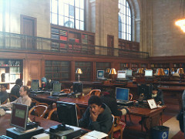
Educators will discover additional opportunities for conveying complex information particularly around science, technology, engineering, and math (STEM) concepts. They will also learn about the importance of 3D tactiles, how to determine who will benefit from 3D printing technology, and what should and should not be printed. Equally as important educators will uncover where they can find resources for objects and production through collaborating with museums and libraries.

Libraries:
Libraries play an important role in facilitating 3D printed tactiles for education. While many schools may have access to 3D technology, often printers are underutilized because of limited time and available expertise to teach and learn this technology. Libraries offer access to resources beyond the classroom. Embedded in a variety of communities and often leaders in the maker movement, an initiative that encourages innovation and exploration, libraries are well situated to coach and act as a hub for 3D printing customization and delivery. Although libraries might be a central location for training and making expertise, they have printers that are underutilized. In an effort to utilize available 3D technology, this guide will help libraries learn basic information about 3D technology, how to set up a makerspace, and provide on-line repositories of images used for printing.

Museums:
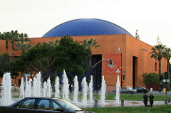
Similar to libraries, museums are the purveyor of a wealth of information and content. While not physically located in every community, museums offer educational content and access to a variety of historical, scientific and cultural tactiles. Some have even set up online repositories of 3D printable files based on exhibits located in their buildings.
Museum innovators can play an important role in providing 3D printed tactiles for learners. This guide offers suggestions for collaboration and identifies opportunities for museums to share their content with schools and libraries.

School, Library, and Museum Administrators:
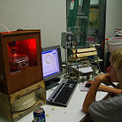
While individuals may drive interest in 3D design, object creation, and collaboration between institutions, the success of 3D technology for educational purposes, relies on administrative support for this technology. Administrators will not only learn about the importance of 3D printing and technology, but they will also gain a basic understanding of the key details to consider when purchasing equipment or collaborating with other institutions.

What is 3D Printing Technology?
In the 1980’s 3D printing or additive manufacturing, was conceived as a way to rapidly prototype objects as a test before being mass-produced in large manufacturing processes. Through this technique, material is layered on top of itself to produce a three dimensional object. Although the additive process has not varied much since it originated, 3D printers have become more mainstream. The cost of printers continues to drop and technology advances, which means they are not only widely available, but also easier to use.

3D PRINTED OBJECTS IN EDUCATION
There are many questions that need to be answered when considering 3D printing uses in the classroom: Why should you consider 3D printing? Who will benefit from 3D printed tactiles? What should I print? When is it appropriate to use a 3D printed tactile? Where can I find objects and where can I print them? These questions and many more will be answered in the sections below. However, before diving into practical applications, it is important to understand why we should even be talking about 3D printing and 3D printed objects in the
classroom.

Why Should You Consider 3D Printing?
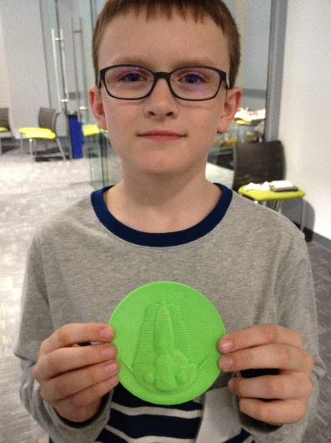
Many students with disabilities cannot access traditional print materials to learn. For these students, many who are blind or have learning disabilities, the inability to access accessible graphics is a reality and can make subjects like math and science impossible to learn. Already overworked, teachers are forced to buy specialized 2D tactile printers to make a limited set of graphics, or even go so far as squeezing lines with glue onto drawings to create their own simple objects. By high school, all but the few disabled students with significant support have dropped out of science and math. 3D printing technology brings a mainstream solution to this problem that is already less expensive than specialized solutions and can create more than just simple tactiles. By creating, customizing, and distributing objects in conjunction with standard curriculum (such as Common Core math), readily available STEM educational objects can bolster learning and outcomes for students with disabilities, and beyond.
Typically, the reason to use a 3D object boils down to a few reasons: the original (e.g. concept, object) is too big, too small, too rare, too inconvenient, or too dangerous to be utilized in the classroom (Lucia Hasty). A significant amount of images are better conveyed in a three dimensional mode, where their depth and relative shape is not obstructed by the angle. Although this is not an exhaustive list, it includes many benefits to using 3D printing technology to make learning an interactive and meaningful activity for all students:
- Provides opportunities to understand the full meaning of a concept
- Provides valuable tools for creating access for students with disabilities (3D tactiles)
- Provides useful instruments that create concrete examples for all students
- Trains students on new manufacturing techniques to prepare them for a future where 3D printing is more common
- Creates a fun and satisfying way to go from idea to reality
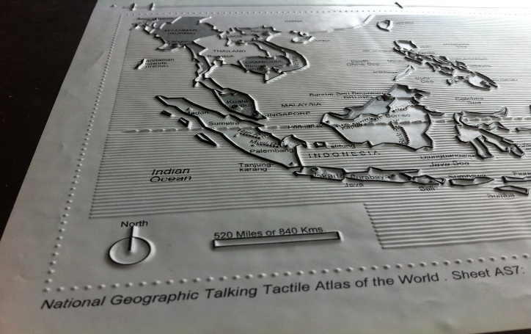

Who Will Benefit From 3D Printed Tactiles?
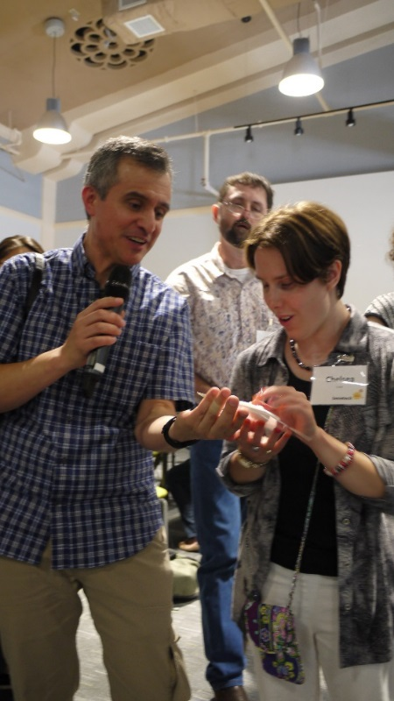
As previously discussed, many people benefit from 3D printed tactiles, especially those with visual and learning disabilities as well as tactile learners. Tactile learners are people who learn through touching and feeling. In addition to using 3D tactiles for multi-modal access however, having a physical representation of a concept can give direct access to material that might be otherwise inaccessible. This is critical for some students because images are often inconvenient if not unusable, and 2D tactile graphics are of limited value since they only convey an object with a few different textures.

What Should I Print?
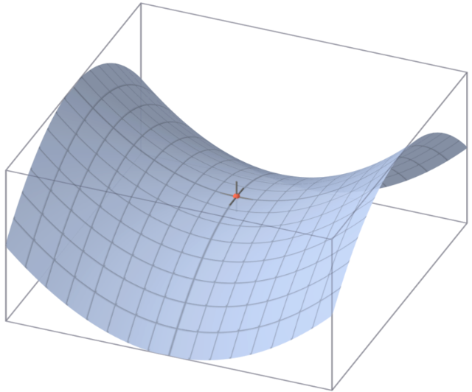
3D printed shapes may make more sense to many students than images using perspective for depth. For example, the complex idea of a saddle point (a stationary point in math that resembles a saddle or mountain range) is difficult for some students to grasp with access to a 2 dimensional picture. Therefore, learners may benefit from a 3 dimensional object.
Imagine teaching a unit on the Pleistocene Epoch when your students are not familiar with a Woolly Mammoth. The National Museum of Natural History has one on display but it is 3,000 miles away. What if you could print a model of the bones or better yet, an individual bone to help the class understand the sheer size of the extinct creature? Some museums and libraries are considering collaborating with schools and rural libraries to send kits of 3D printed objects to support a particular class unit. The opportunities are endless.

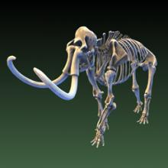
When Is It Appropriate To Use A 3D Printed Tactile?
While there are many ways to represent STEM concepts (e.g. 2D tactiles, image descriptions) there are times when a 3D representation is the most suitable modality. Determining when a 3D model is the best option and when an alternative format may be more helpful, is important. This section will help you understand when it is appropriate to print a 3D model for students as well as the types of concepts that lend themselves well to 3D printed models. While we recognize that not all people with disabilities need the same support, the chart below, created by Lucia Hasty, teacher of the visually impaired, can be used to determine the best approach.

DISABILITY | WHEN PRINTED 3D MODEL HELPS | WHEN PRINTED 3D MODEL DOESN'T HELP | NOTES
Blind/Low Vision | - When actual object is not available to explore through touch (too small, large, fragile, dangerous, not in proximity)  - When process, stages, progression are involved  - When moveable and/or removable parts are incorporated (e.g. model of the eye, electricity through a circuit)  - Color contrast helps learner with low vision distinguish the components of 3D model | - As a stand-alone source of information  - When 3D attempts to duplicate a 2D image  - When results are 2.5D — not fully 3D | - If the learner has never experienced the actual object, they will not be able to recognize the 3D model.  - The 3D model requires verbal explanation about details and features.  - The actual object will have different textures than the 3D model.  - The size and proportion of the actual object in comparison to the 3D model are difficult to project.  - If the model orientation is less than 360 degrees, the learner needs to know the view.
Deaf/Hard of Hearing | - When learner also has a reading deficit that results in difficulty understanding a caption or other written material in relation to actual object  - When learner has difficulty understanding sign language interpreter's explanation  - When learner's first language is not English/ASL | - When learner has same access to object as other students and meets their needs for comprehension
Learning Disabilities | - Learner with visual functioning difficulties will be able to have a hands-on opportunity to examine and manipulate object being taught more thoroughly  - Learner with auditory processing difficulties will be able to examine up close, ask questions, listen to directions/instructions while having the opportunity to manipulate object | - When object is not available for close-up examination and manipulation, but just for viewing at a distance | - Each student with learning disabilities has different skills. Encourage the student to use the 3D object as needed for a better understanding.  - The opportunity to ask questions and have discussion is very important in gaining understanding.
Physical Disabilities | - When actual object or parts of it are not accessible for viewing  - When using technology (e.g. microscope) is difficult for motor abilities | - When the actual object is not available for examination and manipulation | - Physical disabilities may include: mobility, motor skills in hands, balance, etc. The learner should be accommodated for specific needs.  - Each learner with physical disabilities has different skills. Therefore, Encourage the learner to use the 3D model as needed for better understanding.

In addition to understanding how 3D tactiles can support people with certain learning needs, it is equally important to know the types of objects that are better suited for 3D representation. Using an open-sourced high school biology textbook as a guide, we identified almost 100 images that were candidates for 3D design. While there were well over 100 images in the book, it was clear that some images were sufficient with a 2D representations and/or alternative text description (e.g. graphs).
A team of designers and end users of tactile objects collaborated to design the nearly 100 3D objects (See the complete list of files). Their feedback and contributions from other participants at the national forum helped create a list of the types of images you should consider printing.
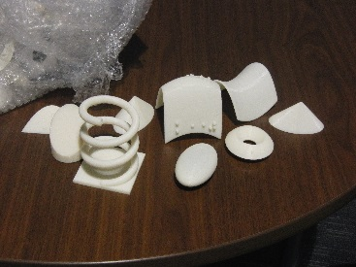
- Complex shapes (e.g. saddle point)
- Need multiple views/perception (e.g. plant cell)
- Relationship between parts (e.g. chemical compounds)
- Movement (e.g. gears)
- Complex shapes including cones and saddle points
- Chemical Compounds
- Plant cell
- Gears
A
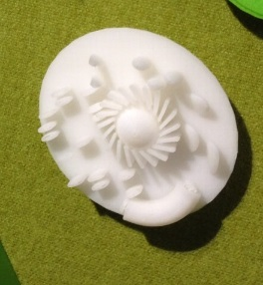

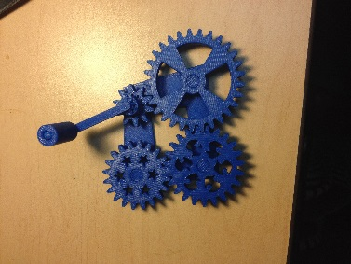
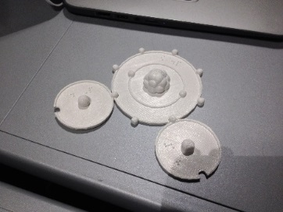

D
B
C

Curriculum Considerations
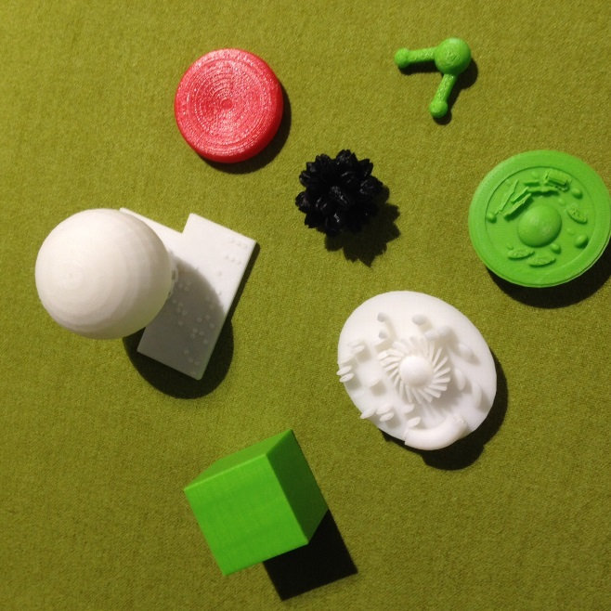
While there are many ways to incorporate 3D tactiles into the classroom, research suggests that students with and without disabilities learn better from physically manipulating objects. This is especially true when they are trying to fully comprehend complex STEM concepts (e.g., anatomical shapes, mathematical manipulatives, chemical compounds). This multi-modal access provides learners the opportunity to experience information in a much more meaningful way than text and description alone. While these objects can help many different types of learners, tactile representations of complex STEM concepts are especially critical for students who have disabilities, such as blindness, that prevent them from using traditional visual or 2D renditions.
Libraries and museums can also offer professional development workshops for teachers, both virtually and in person. These workshops can provide information about how 3D printers can be assimilated into the curriculum and connect to the Common Core State standards without adding much time or creating additional work.
Details libraries and museums should consider when collaborating with schools to plan professional development are listed below:
- Provide examples that show how 3D printed materials enhance learning for students in the classroom and guests that visit libraries and museums.
- Conduct multi-day workshops where educators can learn how to use 3D printers/scanners and use these tools to design tactile models that will enhance learning in their classroom.
- Introduce educators to on-line resources for software used to design 3D models as well as repositories for models already created.
- Present concrete examples of ways to integrate 3D printing into crosscutting concepts and curriculum.
- Use library and museum content to make direct connections to state and national standards and curriculum frameworks.

Where can I find objects and where can I print them?
This section provides a list of where you can find and print objects.
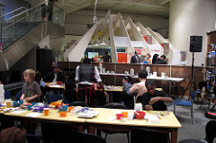
- School - Since 3D technology is becoming more mainstream, some schools already have printers on-site either in a design class or in a dedicated makerspace. Educators can use the design and printing process to help their learners identify ways to convey information in alternative formats. This is an example of participatory accessibility, which can help people pinpoint their learning supports and contribute to their learning experience, rather than relying on the teacher to guess what might work. This could potentially decrease the wait time a student requesting accommodations may face and help them learn faster.
- Community Makerspaces and Libraries - Many communities already have underutilized makerspaces, and 3D Hubs is a resource that can help you find a 3D printer in your community. Local libraries are a great resource for getting objects designed and printed faster, easier, and cheaper. One group of libraries in Idaho, for example, installed a software program to help with ordering and production of 3D printed objects. Now, people who are interested in purchasing or borrowing objects can log on to the library website, download a file, and then print it. Other libraries have held overnight design sessions to create objects for their collection, which could then be lent out to schools.
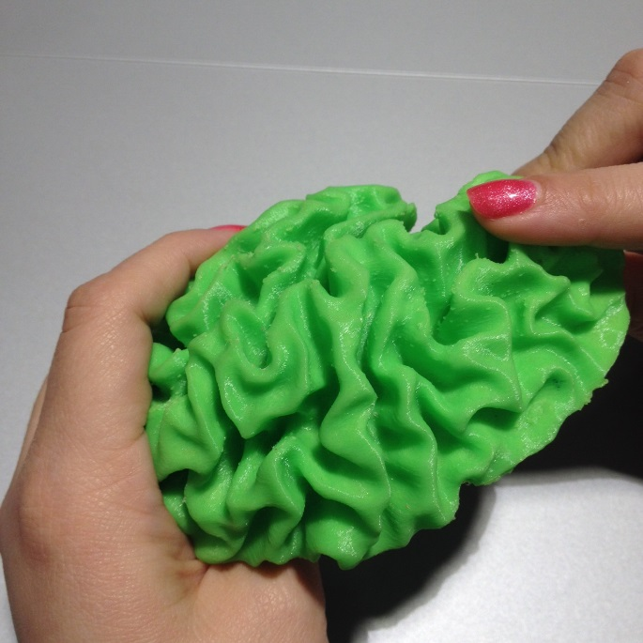
- 3D printing services - MakeXYZ, Staples, and UPS are just some of the business where you can send a 3D file for production. Unlike a community makerspace however, these options are expensive and rely on the requestor to either use a preexisting file or have a good understanding of design software.

3D Do It Yourself
We have discussed the use cases for 3D tactiles as well as when and where to print. If you are building your own makerspace or considering purchasing 3D hardware and software, this section will briefly touch upon related considerations.

Setting Up a Makerspace
Makerspaces are collaborative learning environments where people come together to share materials and learn new skills…makerspaces are not necessarily born out of a specific set of materials or spaces, but rather a mindset of community partnership, collaboration, and creation. (The Library as Incubator Project)
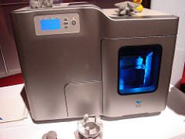
There are a variety of resources to help you determine if you want to start a makerspace. So much depends on the community. If there has been a number of requests for 3D printing or a makerspace, then you may need more than one 3D printer. The good thing about this is that you probably have more human resources in your community to help. Bill Derry, Director of Innovation at The Westport Library in Connecticut is one of the leaders of the creation of the makerspace. With over 30 years of classroom teaching and library media and information technology experience, he recommends the following when setting up a makerspace:
- Select a 3D printer - Look at your budget, read reviews, and talk to others who have printers. Select a printer based on reliability, ease of use, reputation for needing repairs, and cost of the printer and the filament. Selection should also be based on who will use your printer. For example, if you have inventors and entrepreneurs in your community who would like high-end prototyping you may look at printers of varying qualities and price-points.

- Identify staff to manage the project. (Staff should have a predisposition for playing with gadgets and an eagerness to learn).

- Identify a support person from IT, if possible.

- Identify one or more volunteers who have used a 3D printer and want to help other people learn how to use it.

- Purchase a printer.

- Create a teaching curriculum so instruction is consistent.

- Add TinkerCad and Sketchup, common 3D design software options, to the curriculum with a brief overview on how to use them. Some users will take advantage of the tutorials and teach themselves, but for those who do not learn that way, you will need to create classes in TinkerCad and Sketchup. Other CAD programs to consider teaching are Inventor, SolidWorks, PTC Creo, Blender and Maya.
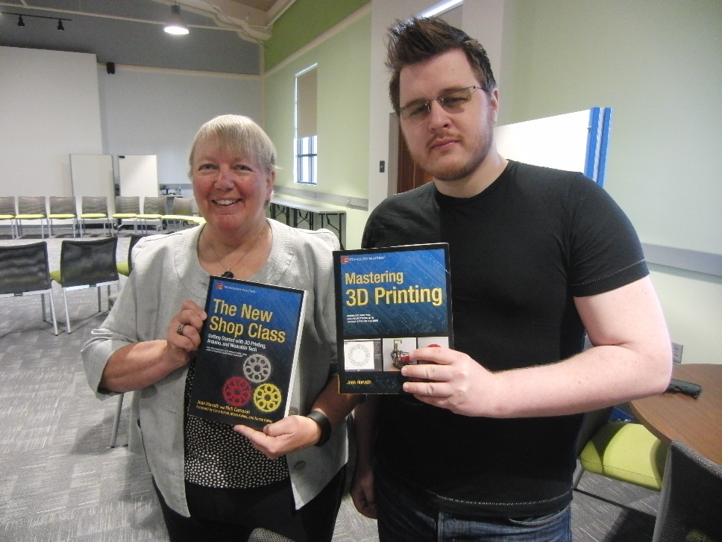
- In order to promote tinkering, experimenting, and creating models to print on 3D printers, libraries can partner with outside organizations, such as Benetech, to provide motivation for designing for a good cause. A company like Benetech will be able to offer resources like a checklist of items needed for a repository of items that will help those who are visually impaired learn through touching an object.
We also recommend reading The New Shop Class by Joan Horvath and Rich Cameron and 6 Things to Consider Before Starting Your Makerspace for more information on setting up a makerspace.

Considerations
- Create a policy about 3D printing; this could take a few months to a year.
- Investigate what education standards are required or aligned to 3D printed objects.
- 3D printers can be a fire hazard, so it is important to consider the following questions: What if the printer starts a fire? Does it need a fire extinguisher? How can we monitor the printer for fire? What is our plan if a fire occurs?
- 3D printers may create air quality problems due to airborne particles and toxic fumes. Printers should be in a ventilated room.
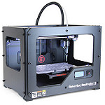
- 3D printers need electricity to run. Research the costs associated with each unit.
- Dedicate a space for the printers because they are sensitive and cannot be jostled.

Equipment
Once you have decided that you are ready to create your 3D lab it is important to understand some basic information about the hardware and software.

3D Printers
There are a wide variety of 3D printers encompassing a range of capabilities and sizes. There are printers small enough to carry with one hand and others so large they have been used to print houses. See Make Magazine’s Annual Guide to 3D Printing. The most common type of 3D printer is the Fused Deposition Modeling (FDM) printer. The majority of consumer 3D printers fall into this category. This type of printer works by placing down layer upon layer of melted plastic onto a printing surface. After a few hundred or even thousand layers, a 3D model is created. This type of 3D printing may not be as accurate as some of the more advanced types, but it makes up for this in ease of use. Some FDM 3D printers even work almost straight out of the box and come with custom software that requires little to no technical expertise.
The less expensive machines such as the Makerbot or Cubify printers, deposit segments of partially melted plastic filament to form an object. The slightly more expensive Form Labs system printers deposit photo curing epoxy. While other more costly systems, such as the McGor Matrix printers, use paper to form layers.
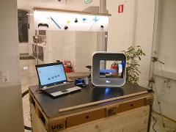
Additive 3D printers are the other type of well-known printers. They use layers of powder fused with a binder printed with an inkjet type printer. Additive printers are the most flexible type of 3D printers and can produce objects with very complex geometries. With proper design, it is even possible to create models with moving parts. This is especially true for higher end equipment.

3D Scanners
Scanners, as their name implies, scan objects and create files that can then be printed in 3D. Scanners range from low cost smartphone apps to large scale systems capable of scanning monuments such as Mt. Rushmore. The resolution of scanners can be either coarse, suitable for scanning a monument, or fine enough to digitize the mint mark on coins.
Scanning can be helpful in situations where you are trying to provide access to an object that is fragile or can’t be handled, such as archeological artifacts or pieces of art. It is also helpful if you are trying to enlarge something small like a coin or reduce the size of something large like a person.
Note: There may be legal issues around patents and trademarks that need to be taken into consideration when using 3D scanning technology. See the legal/copywriting section below.

3D Design Software
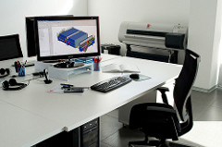
There are a number of software applications for 3D CAD, which is how you produce 3D printed designs. There are free and fee-based software packages that range from beginner friendly to software that requires advanced skills.

Basic
A simple option for 3D modeling is TinkerCAD, which is a web application (html5). It does not require that anything be downloaded or installed on the computer. This program has easy, but fairly limited design capability. One such limitation is a lack of font options, meaning braille has to be produced by hand. However, it is a useful program for learning the basics of 3D printing and producing simple 3D tactiles.

Moderate
123D Design can be downloaded to a computer and has many more capabilities than TinkerCAD. It is free to use with an online market where you can buy already created designs. In addition, you can get a certain number of free designs per month).

Advanced
Autodesk Fusion 360 can be downloaded to a computer and provides free licenses for educators but otherwise needs to be purchased. It is made by the same company as TinkerCAD and 123D Design and will likely be familiar to you if you have tried the previous two. It requires installation.
OpenSCAD, an open-source scripted CAD, uses a scripting language to produce shapes (more similar to 3D graphics programming than the other drafting/design programs). This is a free and open-source software.
OnShape is a cloud-based, Free Beta Key (Freemium Model).

Obtaining Designs
Many 3D file repositories are already available, although, not all files are open-source. Here are a few repositories to help you get started:
- 3DAGOGO – Share or sell your prints.
- Advanced Distributed Learning (ADL) - Sharable Content Object Reference Model
- Autodesk 123D – A website that offers ten free downloads a month.

- Cubify - A website where you can purchase 3D printers and hardware as well as 3D printed objects from jewelry and clothing to musical instruments and sports accessories. There are also files that you can download for free, and the kid’s section has files like the western cityscape that you can customize and download for free.
- Google Earth/SketchUp – Easy way to draw in 3D and promote your models.
- Grabcad - A free cloud-based collaboration solution that helps engineering teams manage, view, and share CAD files.
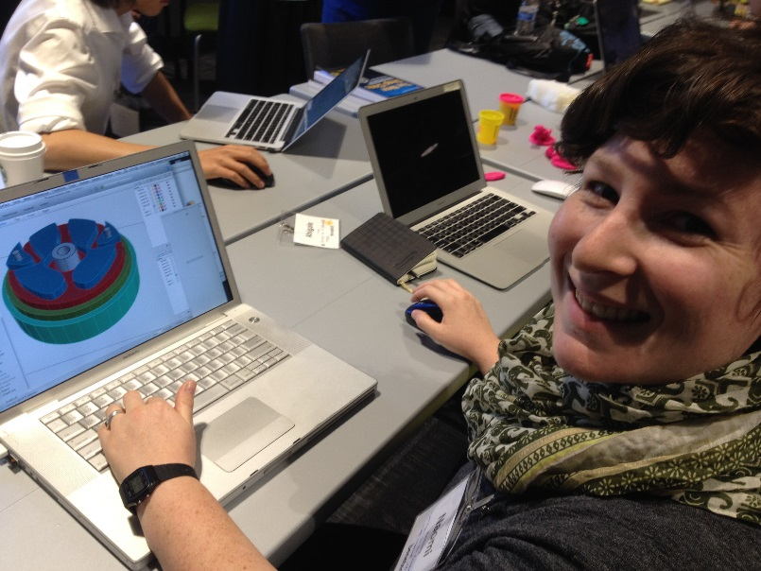
- Libre 3D - An open-source repository for 3D enthusiasts. There are free downloads and printers and other hardware for purchase.
- LibraryLyna - A free library of tested 3D models for the visually impaired, as well as a free requesting service for models that are not available in any other medium.
- pinshape – An online community and marketplace for designers and users with free images and images for sale. Designers can share and sell their 3D printable designs and users can download designs to print on their own.
- Shapeways – 3D printing service and marketplace.
- Smithsonian X3D – Iconic collection of Smithsonian objects.
- Thingverse - A repository of free, open-source downloads. Several files can be customized and remixed.
- youmagine - An online repository of open-source designs that users can download and print on their own.

Legal/Copyright Issues
If you have any doubt about whether your reproduction is acceptable for your proposed use and audience, contact a legal authority. A list of considerations is provided:
- Many 3D designs are available on the Internet, which may or may not be freely reproduced for educational purposes. Refer to their license before printing.
- If you are utilizing a 3D scanner to scan and print a 3D object, there may be copyright, trademark or patent issues that require authorization of the copyright holder. For instance, a statue scanned and reproduced may require permission of the artist, owner, or museum.
- Production for students with disabilities may fall under applicable education laws, such as the IDEA or Section 508. Generally, a stylized object produced for the education of a blind student would be acceptable, such as a 3D production of an artist rendered picture.

CONCLUSION
This document is forever evolving. As technology and access to printers increases so will the depth of this document. If you would like to learn more about the 3D for Education Community, 3D printing projects at Benetech or to contribute to the information , please email 3D@benetech.org.

RESOURCES
There are a number of other resources, guides, and organizations that are dedicated to 3D printing, makerspaces, and accessible learning. Depending on your needs and interests there are a number sources to get more information, ideas, and inspiration.

Links to Other 3D Printing, Design, and Maker Getting Started Guides:
- Maker Ed Getting Started Guide http://makered.org/resources/getting-started/

Links to Tactile Standards Documents:
- PDF on the size and spacing of Braille characters http://www.brailleauthority.org/sizespacingofbraille/sizespacingofbraille.pdf
- Guidelines and Standards for Tactile Graphics http://www.brailleauthority.org/tg/

Additional URLs:
- Wikipedia article on 3d printing https://en.wikipedia.org/wiki/3D_printing
- An overview of 3d Printing http://www.3dprinter.net/reference/what-is-3d-printing
- Other information about 3d printing http://3dprinting.com/what-is-3d-printing/

