3D Printer Features
AHG 2015 Preconference Session

What is a 3D Printer?
Essentially a 3D printer is a robot. It is a machine that creates three dimensional objects through additive manufacturing in which successive layers of a material are laid down under computer control.
Technically there are all types of processes that fit the bill, including use of inkjet printers with plaster powder laid down sequentially or laser melting or sintering of metal or ceramic powders. Sintering refers to the process by which a solid mass is made by compacting and forming material using heat and/or pressure but without melting it to the point of liquefaction.
For the purpose of this session, we are focusing on extrusion. We are looking at 3D printers that use thermoplastics such as PLA, ABS, or other filaments to create models one layer at a time.

What are some of the key differences in printers of this type?
There are many printers on the market, and many more coming out every month. Prices shift and features evolve. Below are descriptions of some of the key features to keep in mind when evaluating options.
Key Features | What it means
Bed Features | - Smaller bed sizes mean needing to print pieces one at a time (or in pieces)  - Larger bed sizes allows for printing larger pieces or multiple pieces at once  - Self-leveling are easier to use  - Heated beds help with adhesion (making sure filament sticks to glass in printing)
Filament Spool Load | - Closed holders are more common with manufacturer specific cartridges  - Open designs allow for more flexibility and easier access for cleaning
Printing Speed | - Faster print speeds require higher temperatures (melt filament more quickly)  - Corners and edges are slower than curves - high res takes longer than low res
Resolution (layer height) | - Thinner layers render prints with more detail (.1mm or smaller)  - Thicker layers print faster (.5mm is considered thick)
Extruders | - The extruder is the combination of the nozzle that melts the filament, the motor that pushes the filament, and the temperature sensor and fan that maintain an appropriate temperature  - Some systems have a single extruder – others offer multiple extruders  - The max temperature of the nozzle dictates which filaments can be used
Control of Unit | - SD Cards or USB Drives with control panels or dials and on screen displays  - USB for direct computer connection  - Wireless computer connection and/or use of Mobile Apps  - On board storage allows jobs to be saved to and run straight from device
Display | - Text display allows for file navigation  - Full display allows for visualization prior to print

A Side-by-Side Comparison of Selected Models
 | Flashforge Dreamer | LulzBot Mini | Ultimaker 2 | MakerBot 5th Gen
Image of the Unit  with alt text descriptions | 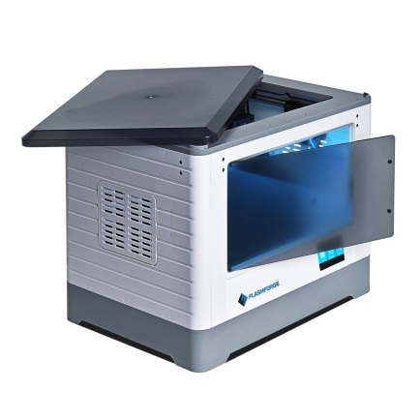 | 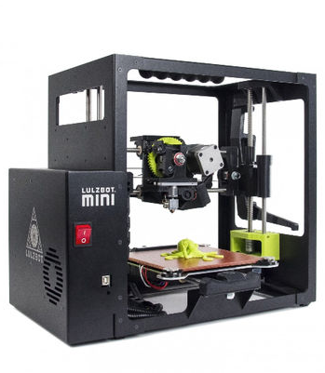 | 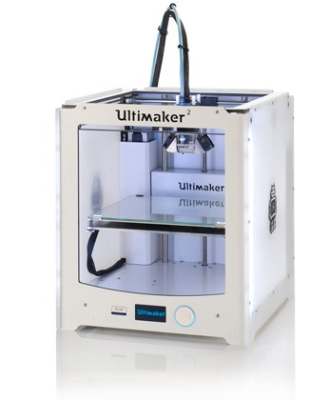 | 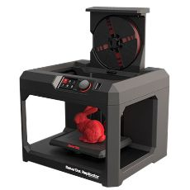
Bed Dimensions and Features | Bed size – 9.1 x 5.9 x 5.5  295 cubic inch build area  Heated alloy  Assisted-leveling | Bed size – 6 x 6 x 6  223 cubic inch build area  Heated glass  Self-leveling | Bed size – 9 x 8.7 x 8  626 cubic inch build area  heated glass  Assisted-leveling | Bed size – 9.9 x 5.9 x 7.8  456 cubic inch build area  Unheated acrylic  Assisted-leveling
Extruder Details | Dual extruders that feed from internally housed left and right side filaments | Single extruder that feeds at head with open design and arm that holds spool | Single extruder that feeds from the back through bowden tube | Smart Extruder cartridge with spool stored in compartment - up to load
Best Resolution | Layer height to .1mm | Layer height 0.05 mm | Layer height .02 mm | Layer height to .1 mm
Max Temperature | Nozzle temp to 240 C  Bed temp to 120 C | Nozzle temp to 300 C  Bed temp to 120 C | Nozzle temp to 260 C  Bed temp to 100 C | Nozzle temp to 240 C  Bed temp N/A
Filament Options | PLA, ABS, PVA – 1.75mm | Range of filaments – 3mm | PLA, ABS, CPE – 3mm | MakerBot’s PLA – 1.75 mm
Display/Connection | SD card with LCD display  USB or WiFi connection | No display or SD card  USB to computer | SD card with LCD display  USB to computer | USB drive with LCD display  USB or WiFi connection
Software | Flashprint Software with options for slicing engine | Choice of Open Source (comes with Cura) | Cura (Open Source) | MakerBot Software
Features | 4GB Internal Storage | Cleaning pad for nozzle | Room for dual extruders | Camera and mobile app

