Tactile Graphics Go 3D
Facilitated by Gaeir Dietrich and Lisa Wadors
This preconference session provides participants with hands-on exploration of lending libraries. In addition, participants will see examples of 3D printed objects, learn how to optimize the usefulness of tactile learning objects in colleges and universities, and gain exposure to emerging resources and best practices.
1:30 p.m. | Opening introductions
1:45 | Examples to get us started — three different ways to think about 3D printing  o Technology to Empower  o Work Smarter not Harder  o Increase Access to Learning  o Chelsea Cook: TED Talk
2:00 | Context – How tactile learning objects fit within a bigger picture
2:15 | o 3D Forum — Benetech in California June 2015  o Books that are optimized with links to files that are print-ready  o The decision-making processes — the Decision Tree for tactiles and the matrix for 3D  o Choosing the right tool for the job — low-tech to high-tech options
2:45 | Hands-On Try the 3D pens, Raised-Line Drawing Kit, PIAF, and the IVEO  - Please take a break when needed
3:15 | 3D Printing Tools and Resources  - Software — basic introduction with focus on free options  - Materials — characteristics of different filament types  - Printers — overview of key features to consider with 3D printers
3:45 | Hands-On  - Exploration of Libraries — searching for existing files, downloading files  - Experienced Users — What works and what doesn’t, tips and tricks
4:15 | Discussion — whole group — Thoughts? Questions? When would you use 3D objects?
4:30 | Session End

Getting Started
There is tremendous promise in 3D printing. Within this session we will be focusing primarily on the use of tactile learning objects to facilitate postsecondary student learning, but there are many reasons to be excited about rapid prototyping. In the introduction of this pre-conference we will hit upon three distinct ways in which 3D printing can be relevant to the work of disability/accessibility minded professionals in higher education.

Technology to Empower
3D printing can mean much more than accommodations. It can mean putting the power to create and make into the hands of individuals themselves. This can be transformative. Maker spaces can be found at colleges, universities, even elementary schools and libraries. These connections can encourage students who have historically felt marginalized to become engaged, seeing themselves as future engineers or designers, and equipping themselves and others with personalized solutions.

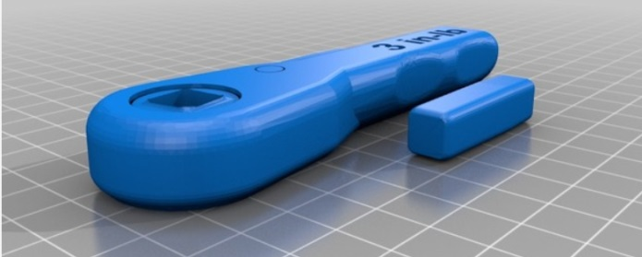
Working Smarter
3D printing can mean that colleges and universities save money. Items like fraction kits and anatomical models can be quite expensive, but with 3D printers, these models (or their replacement parts) can be printed on demand at a fraction of the cost.
As an example, consider the “NASA Wrench” which is actually a ratchet that has been leveraged and adapted to create a tool that can be distributed across campuses for use with adjustable height tables. The tools cost pennies to print and the process of tweaking the design has provided great professional development opportunity for staff. This example traces development of a wrench plan shared by NASA, through a dual head design that required support when printing, to a modified design that features an open center with replaceable insert. It highlights the reality that we should expect to learn as we go, finding partial successes and perplexing challenges, but continuing to try so we can identify what works best.

Facilitating Learning
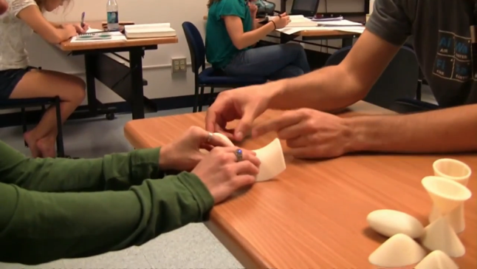
3D printing is one of many techniques to support tactile learning. Raised line graphics, traditional models, and low tech methods of conveying information are all important. Also critical is that not only individuals who are blind, but also those who have information processing preferences, learning disabilities, traumatic brain injuries, or who are learning English can all potentially benefit. To be clear though, it is not as though a 3D model can simply be handed to an individual and learning will magically commence. Rather, a 3D model can help convey what is being learned through a variety of representations and opportunities for questioning and problem solving. If you haven’t seen it yet - check out Chelsea Cook’s TEDx Talk - https://youtu.be/Gr2wFIFft2w

