Slide 1

Central Access
Slide 2

Presenters
- Wendy Holden: Manager of Disability Services, Central Washington University
- Marshall Sunnes: Coordinator of Central Access, Central Washington University
Slide 3

What We’re Covering
- Who We Are
- Central Access’s Approach to Math Accessibility
- Tools to Get the Job Done
Slide 4

Take-Aways
1. No “one size fits all” solution to math
2. You can make accessible math Word docs
3. CAR reads math
4. CAR Check and CAT are resources to get you there
Slide 5


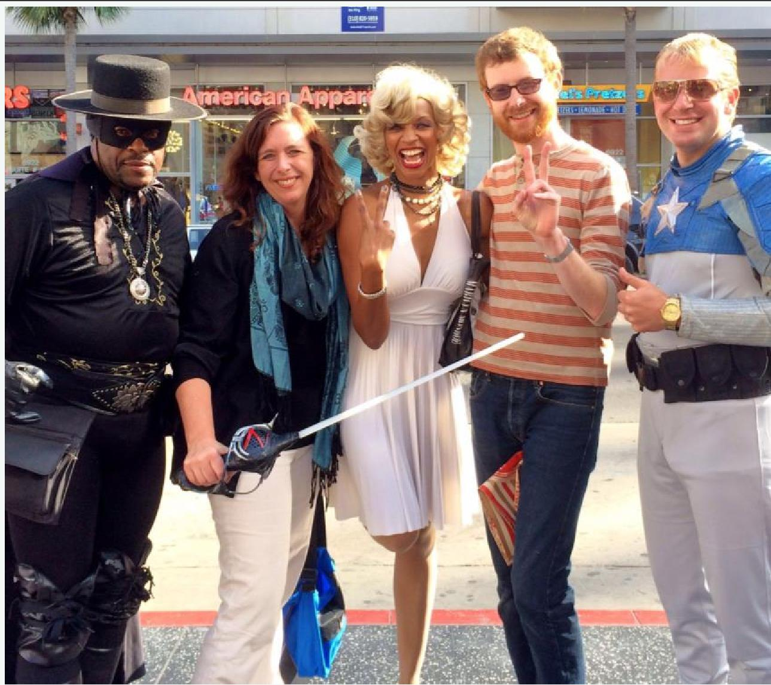
Slide 6
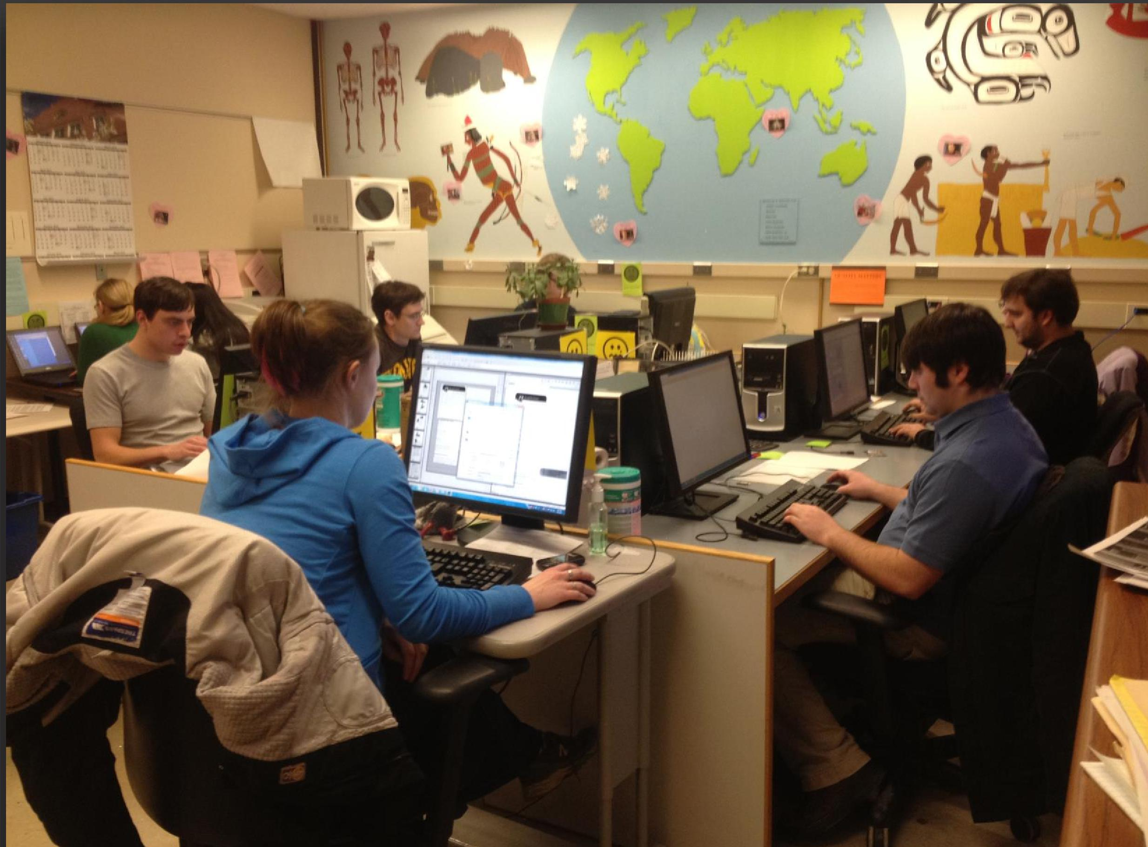
Slide 7
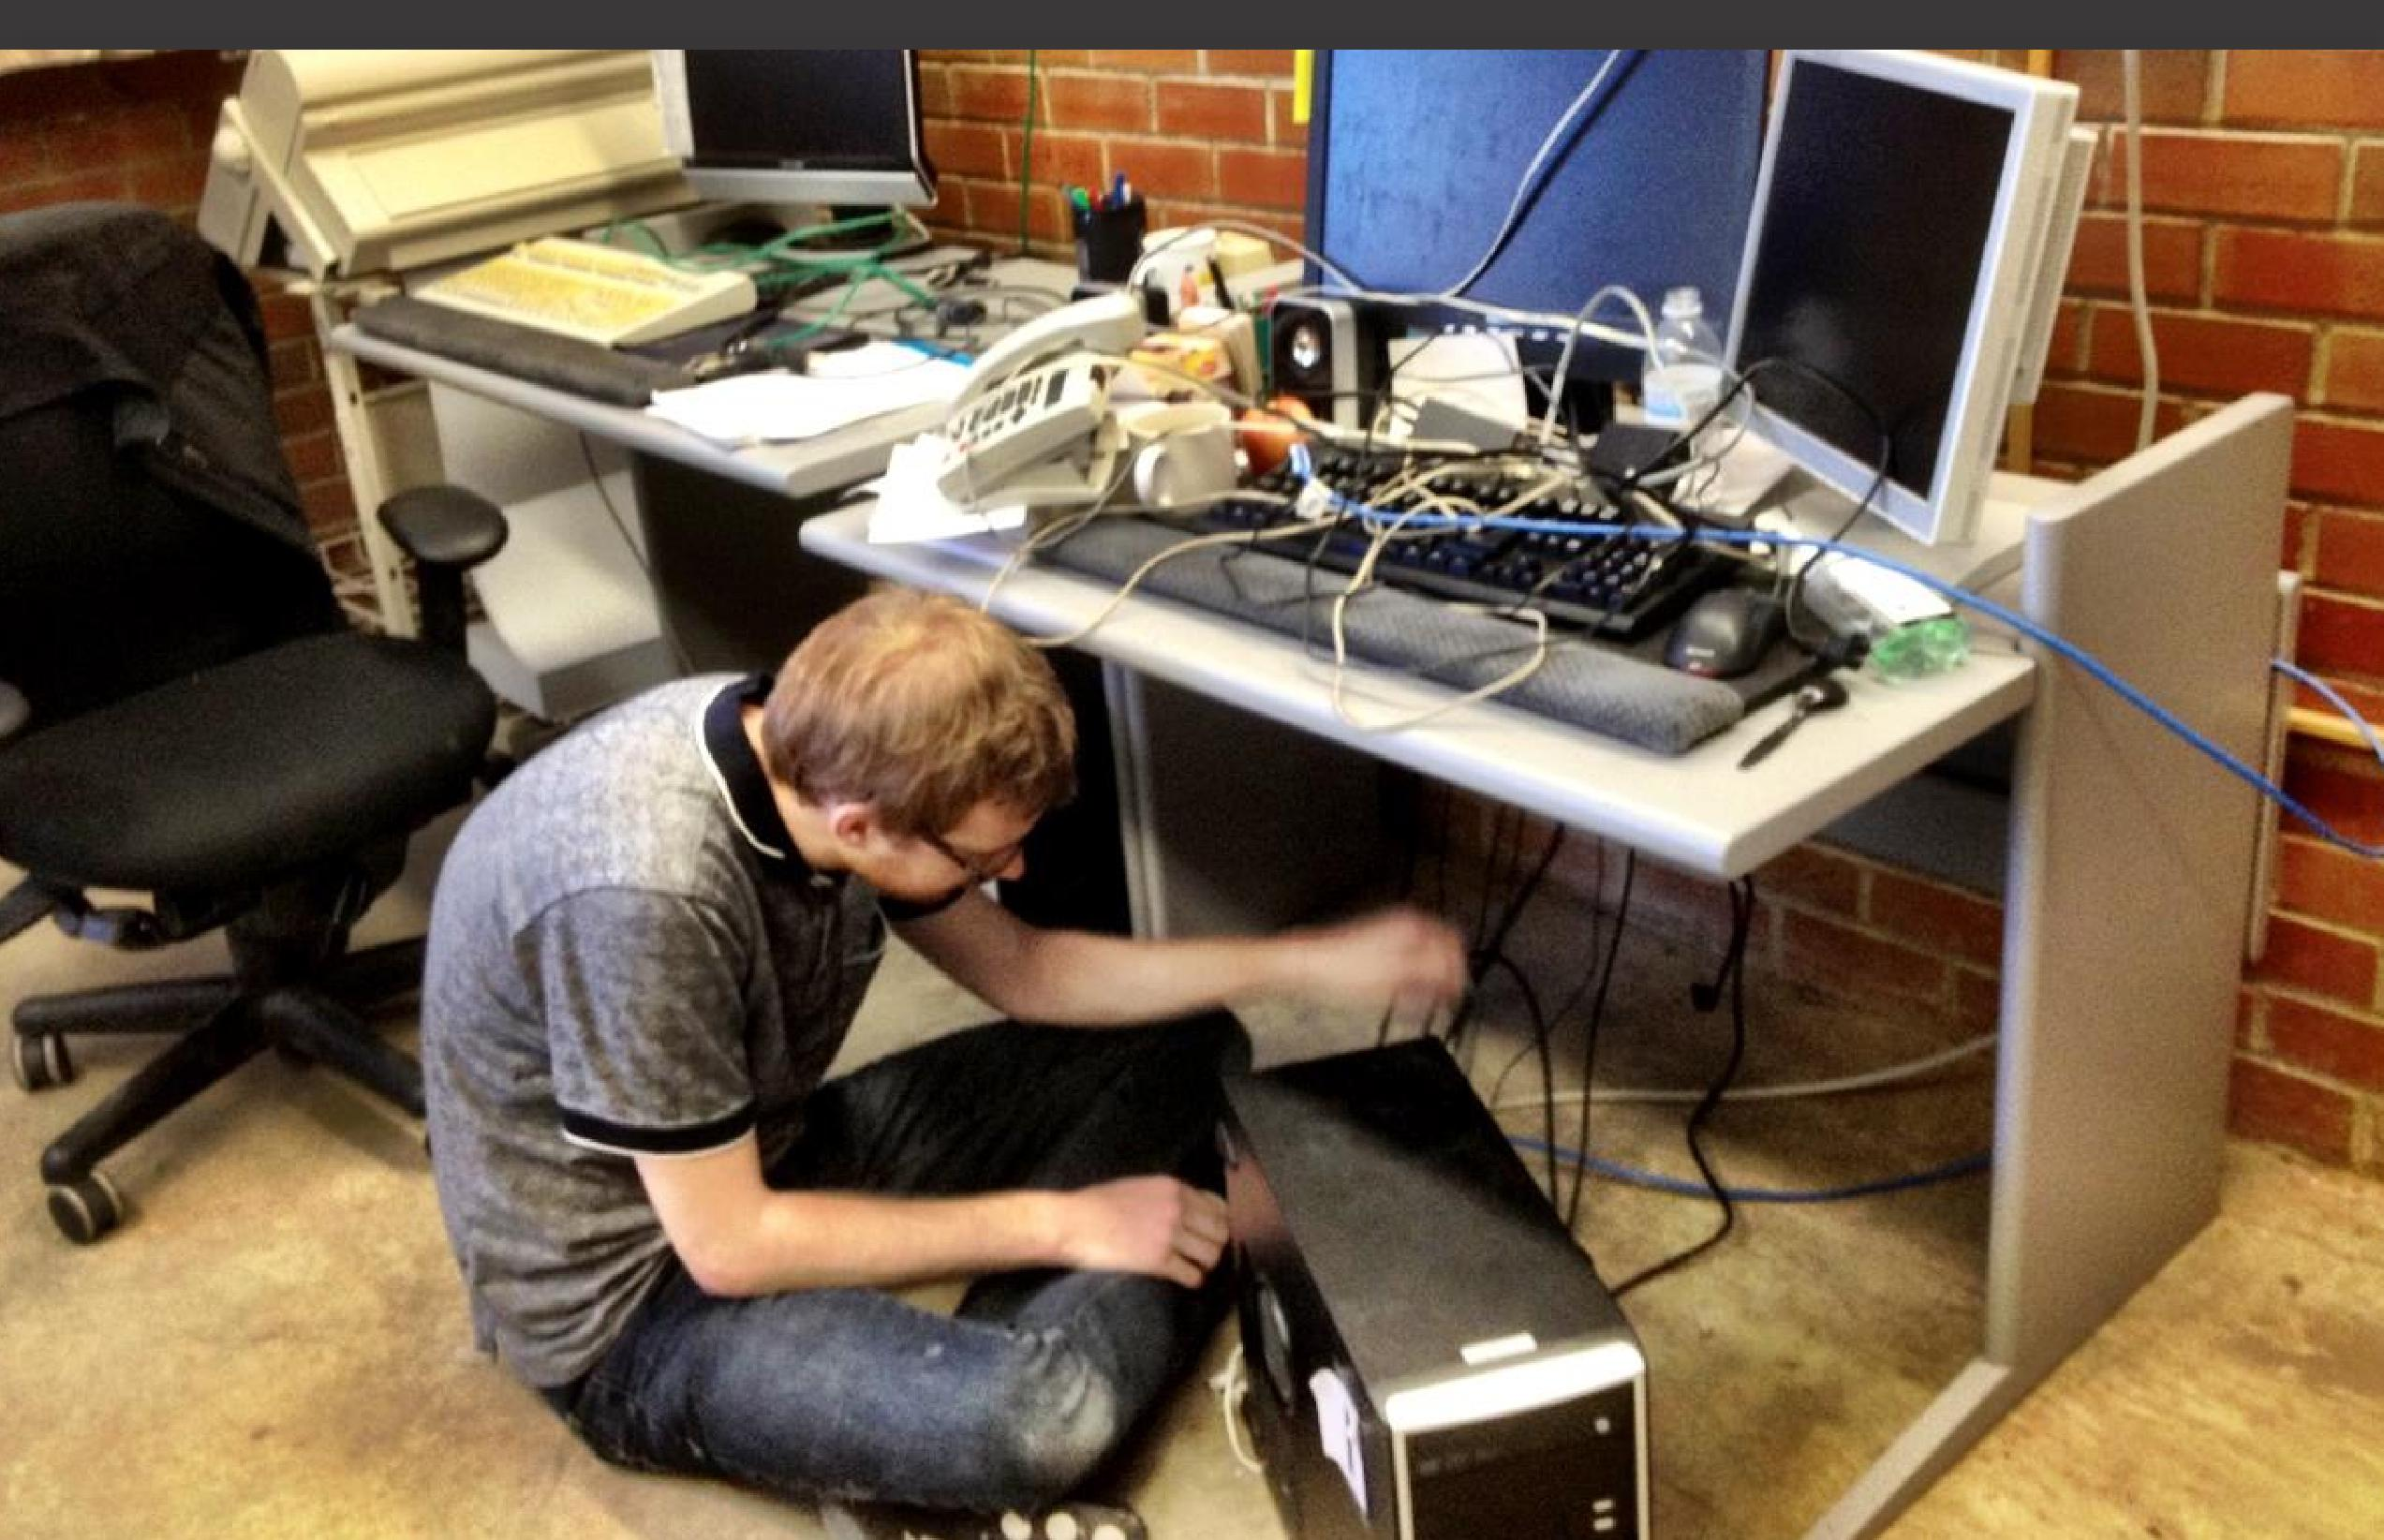
Slide 8
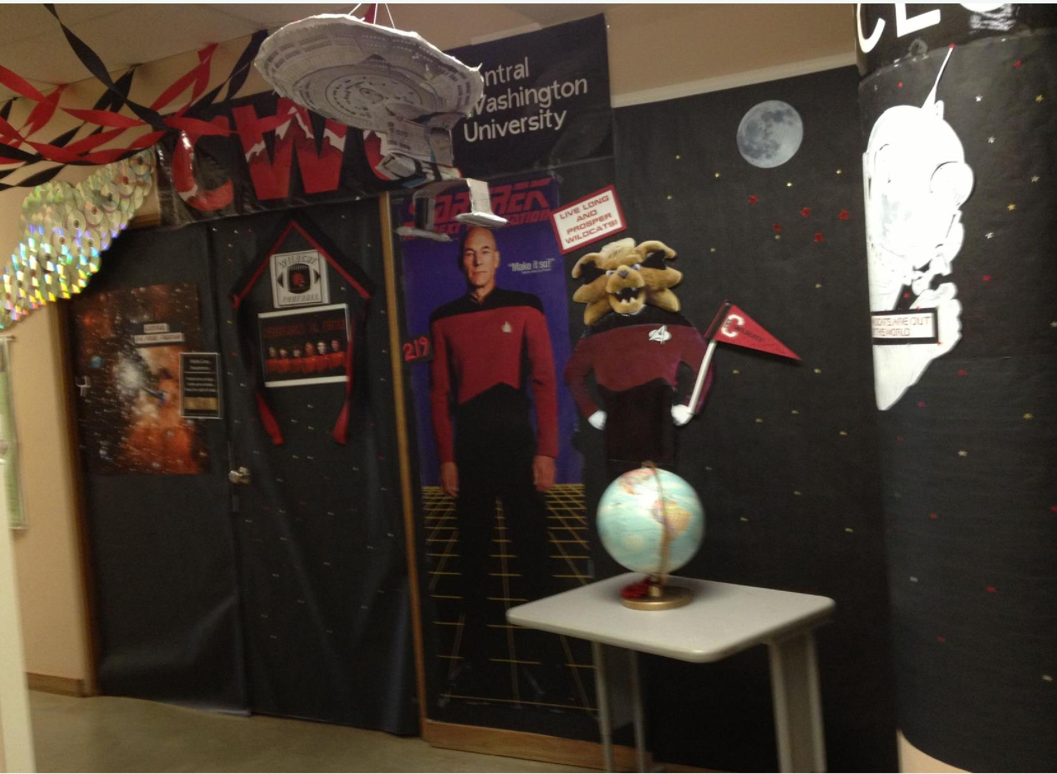
Slide 9
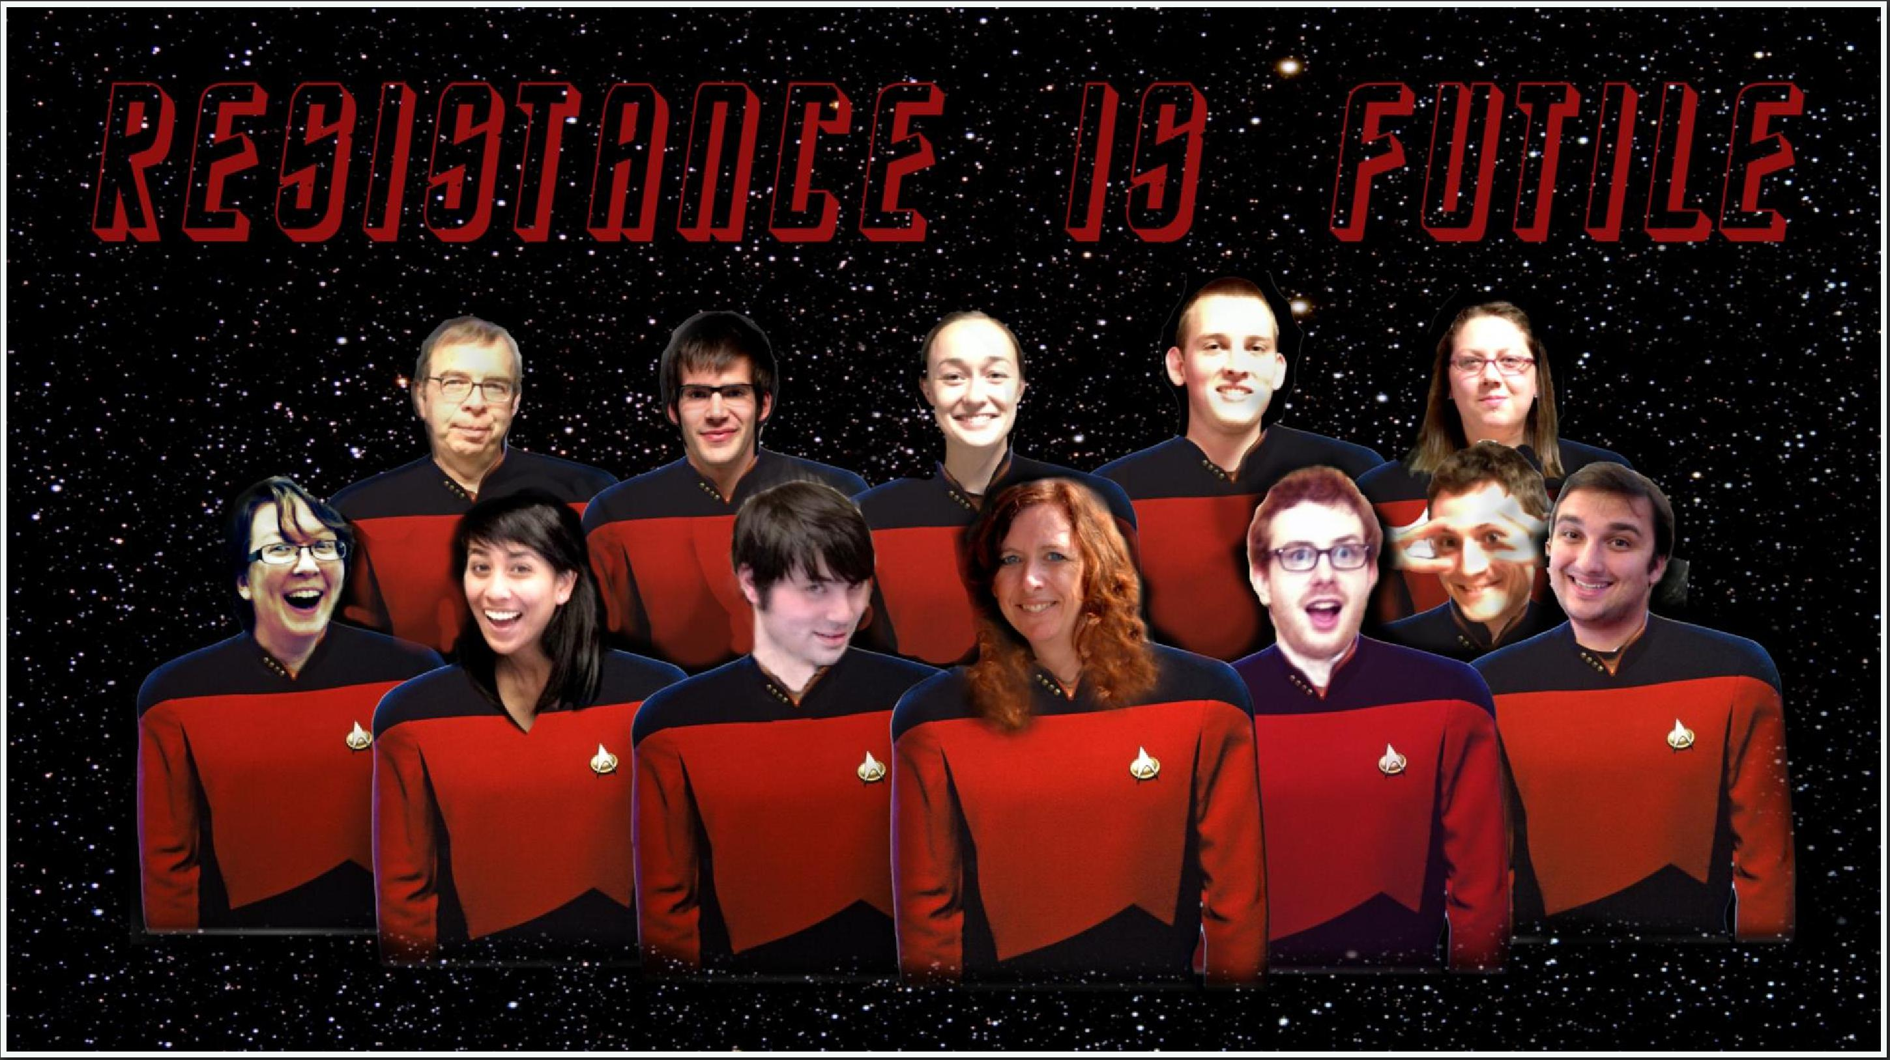
Slide 10
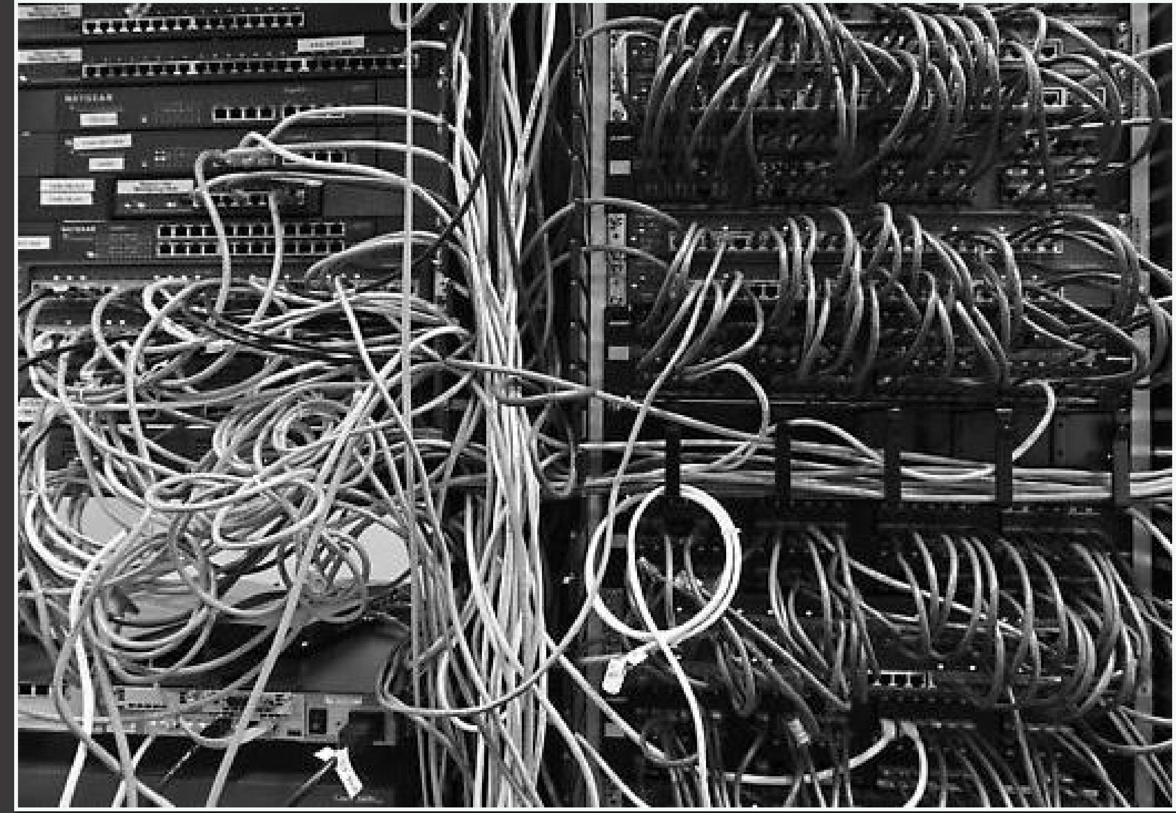
Slide 11

Slide 12

Slide 13

Slide 14
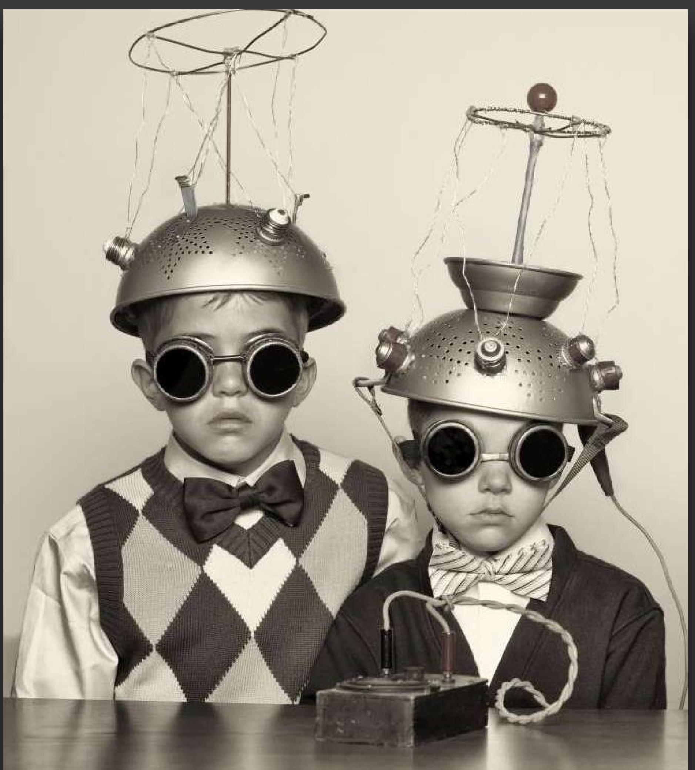
Slide 15
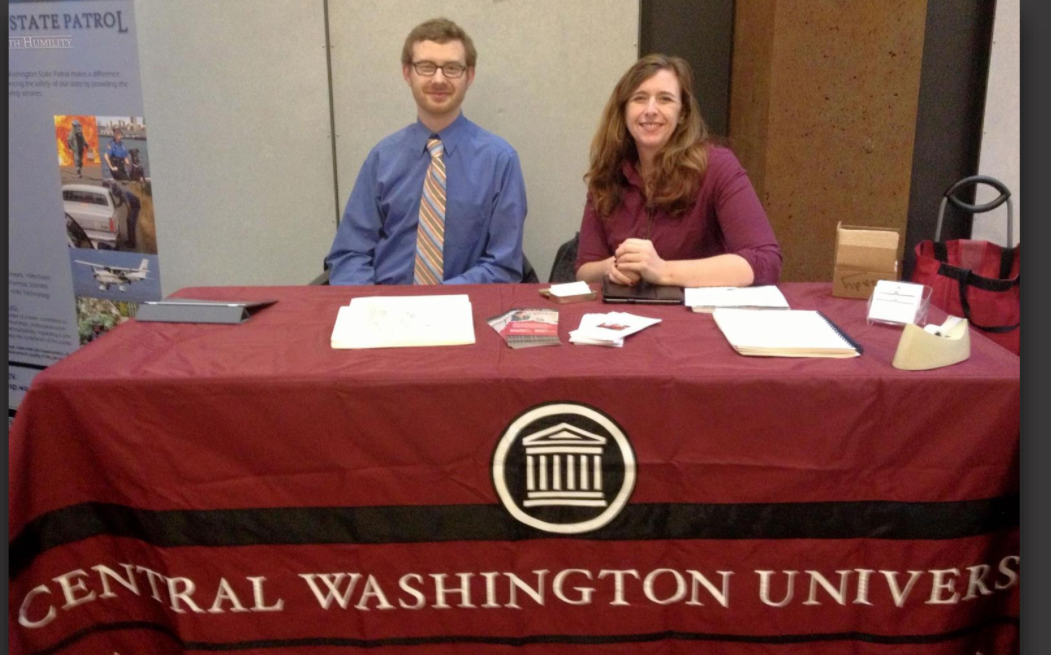
Slide 16

Software Covered

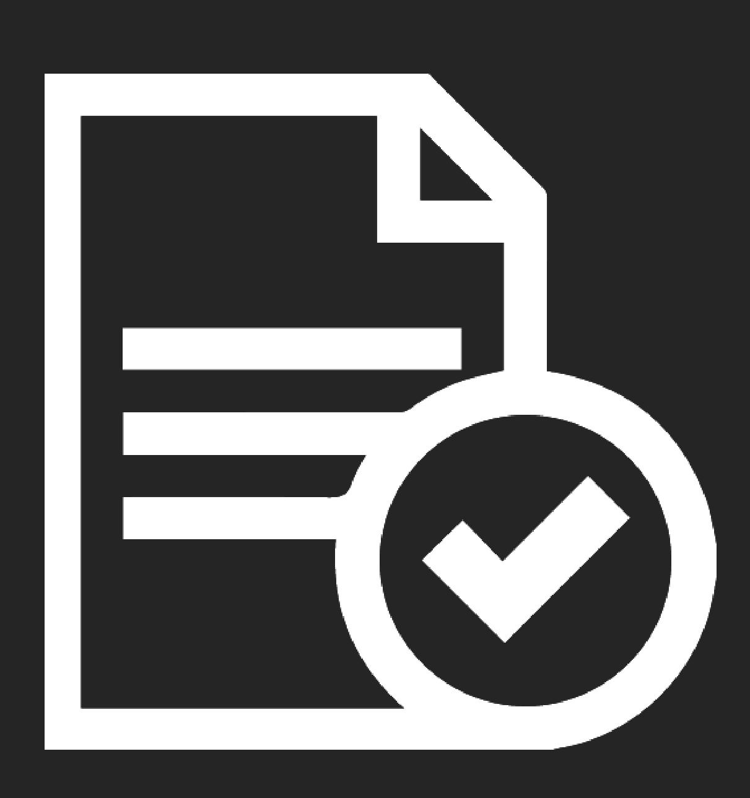

Slide 17

Central Access Reader
- Text-to-Speech
- Opens Word Docs & Pasted Text
- Highly Customizable
- Reads Math
- Exports to MP3 & HTML
- STUPID SIMPLE

Slide 18
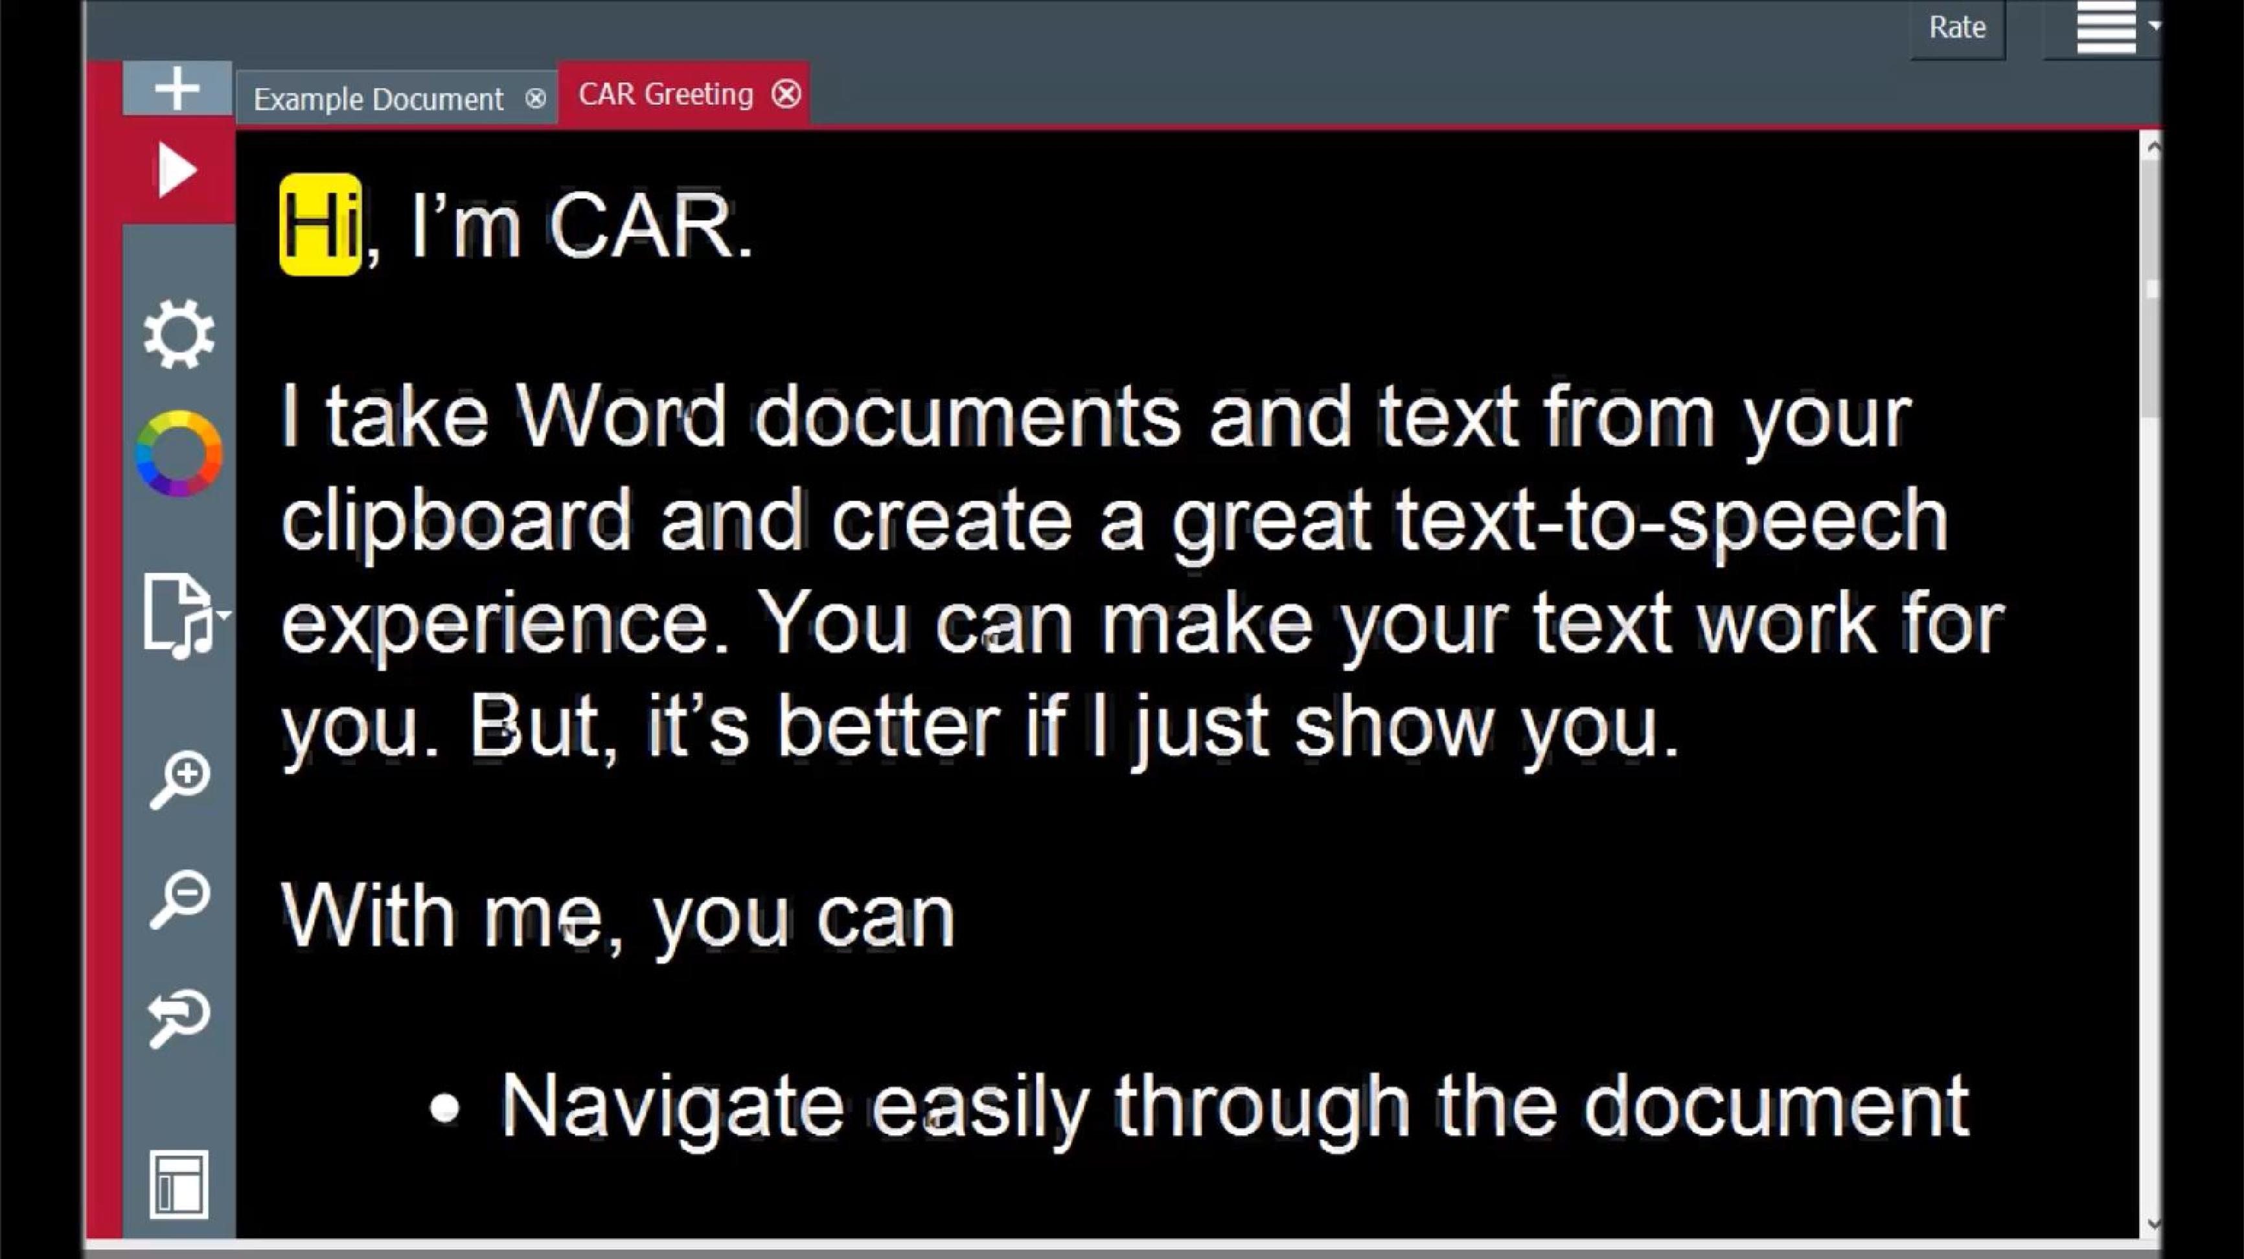
Slide 19

CAR Check
- Add-in for Windows Word
- Made With Faculty in Mind
- Fixes Big Accessibility Issues
- Stealth Teaching
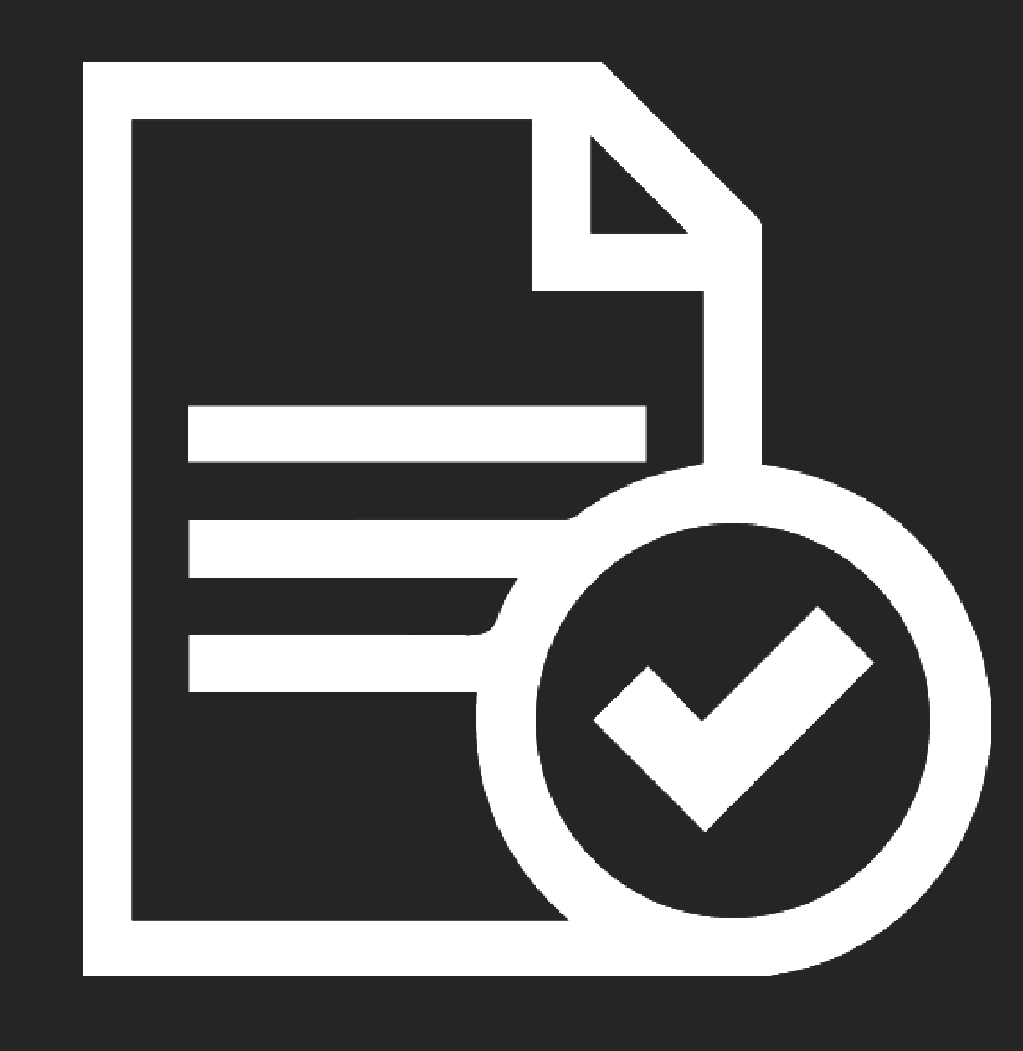
Slide 20
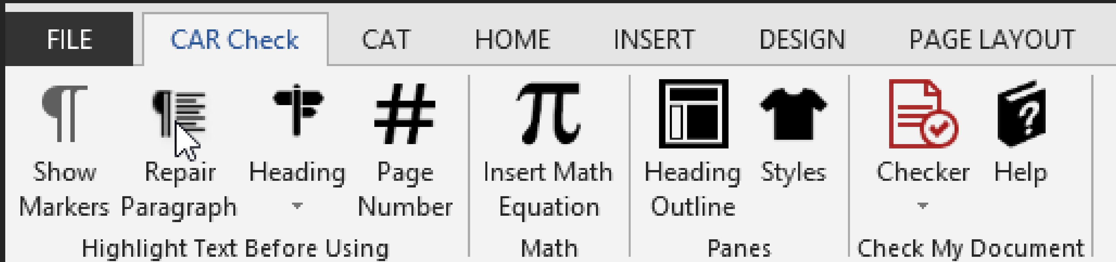
Slide 21
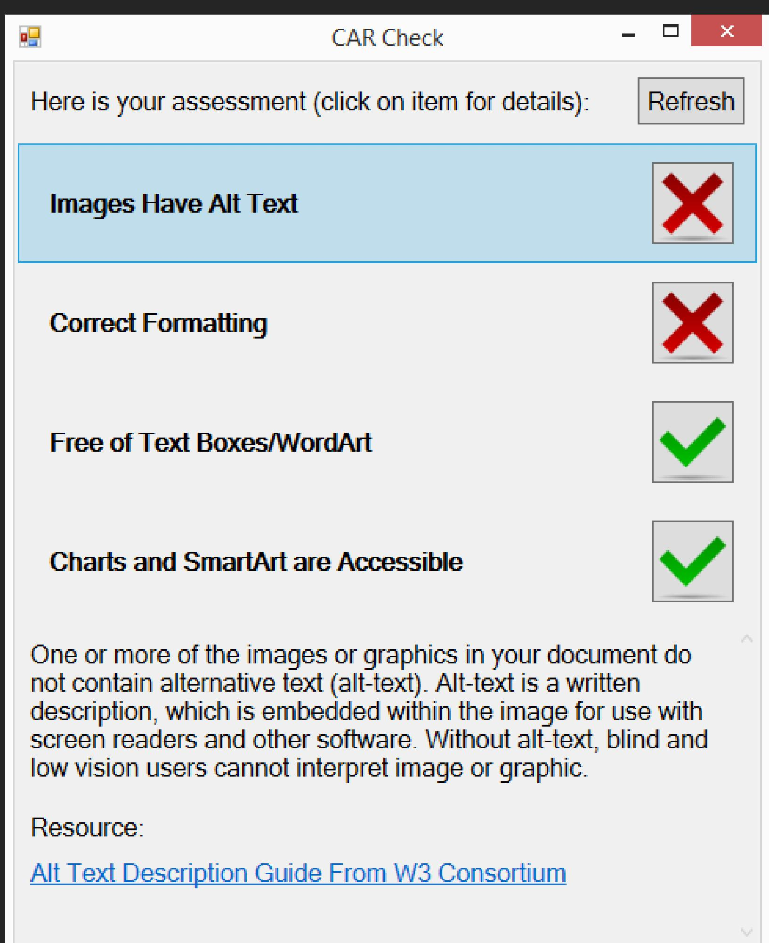
Slide 22
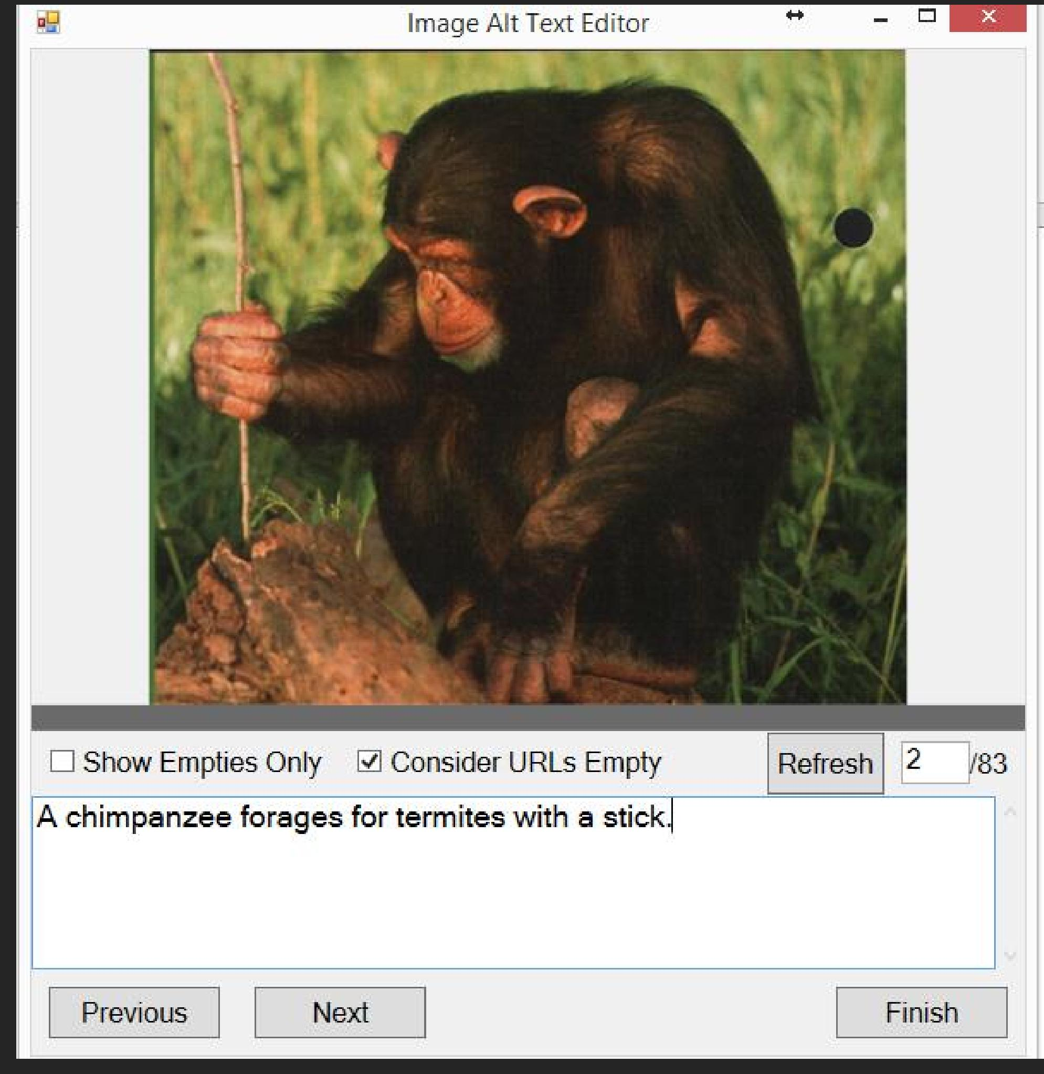
Slide 23

Repair Paragraph
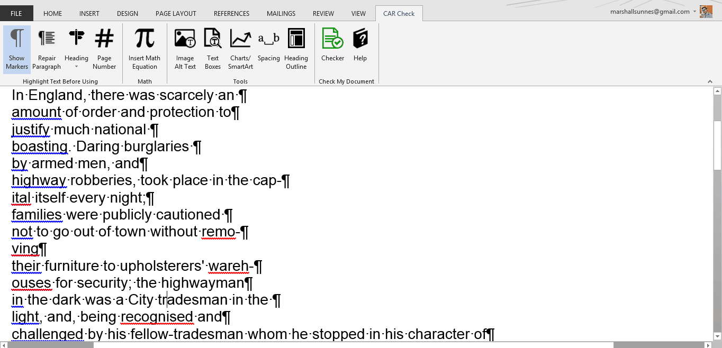
Slide 24

Mark Headings Easily
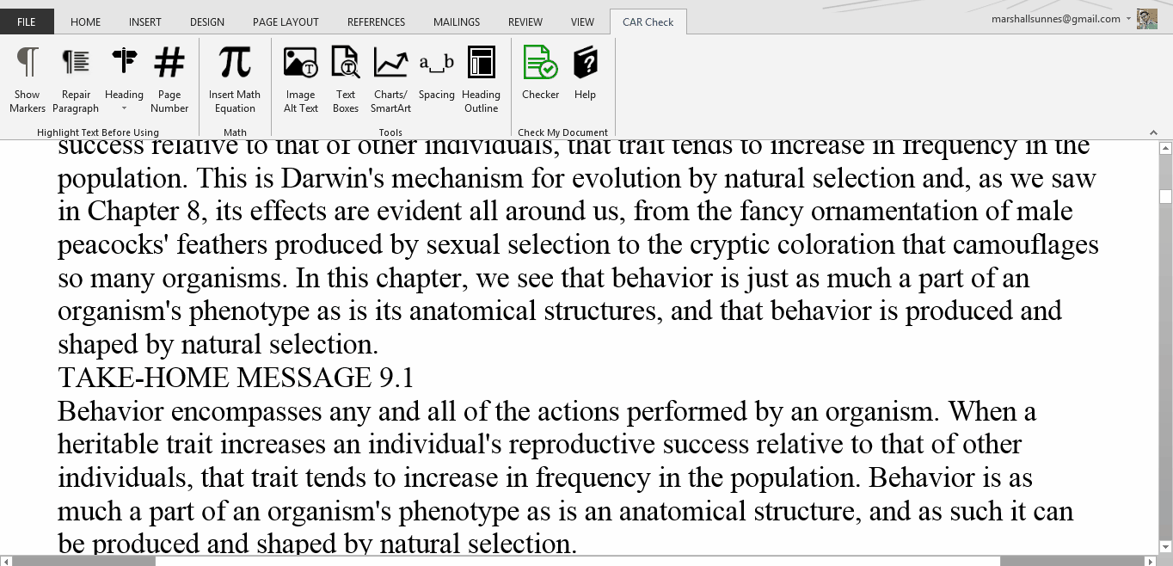
Slide 25

Mark Pages Easily
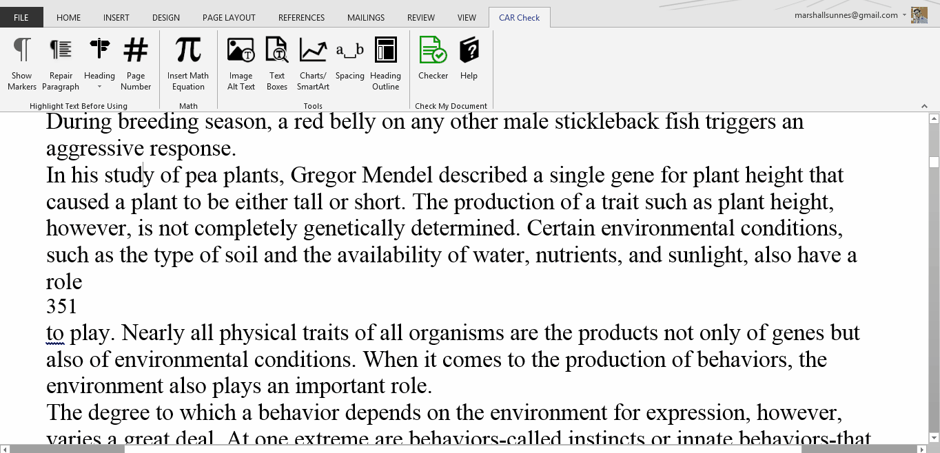
Slide 26

Central Access Toolbar
- Add-in for Windows Word
- Made Alt-Media Labs in Mind
- HUGE Processing Time-Saver
- Tools & Reference in One

Slide 27
DEMO
Slide 28
CAR

- FREE
- Mac + PC
- Central Access Website
CAR Check

- FREE
- BETA
- Windows Word
- Central Access Website
CAT

- Invitation Only
- BETA
- Windows Word
- Contact Central Access
Slide 29
Want to BETA test CAT?
centralaccess@cwu.edu

