3D Printed Talking Tactile Learning Objects will make Learning by the Blind More Compliant
Mike Kolitsky, Ph.D., Biology, University of Texas at El Paso
makolitsky@utep.edu

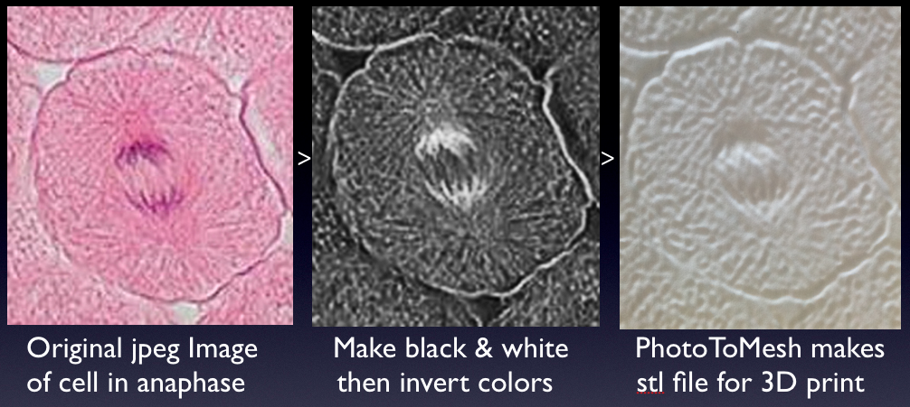
PhotoToMesh makes 3D print files from 2D photos taken with microscopes & telescopes.

Images below show ways to add audio to 3D printed tactile images of cells in mitosis.
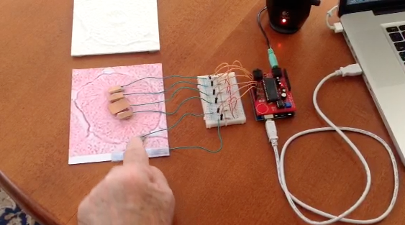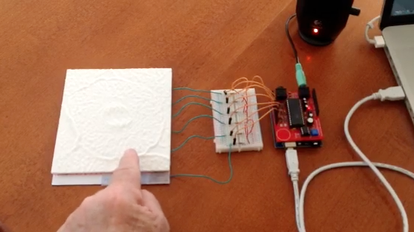
Touch-audio response using capacitance sensing and Spikenzie voice chip
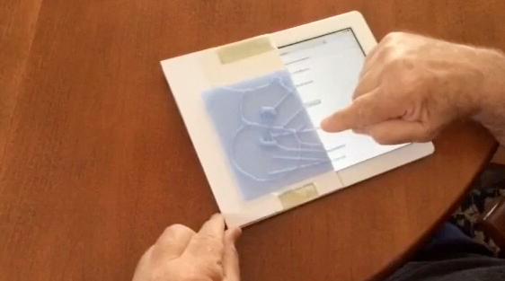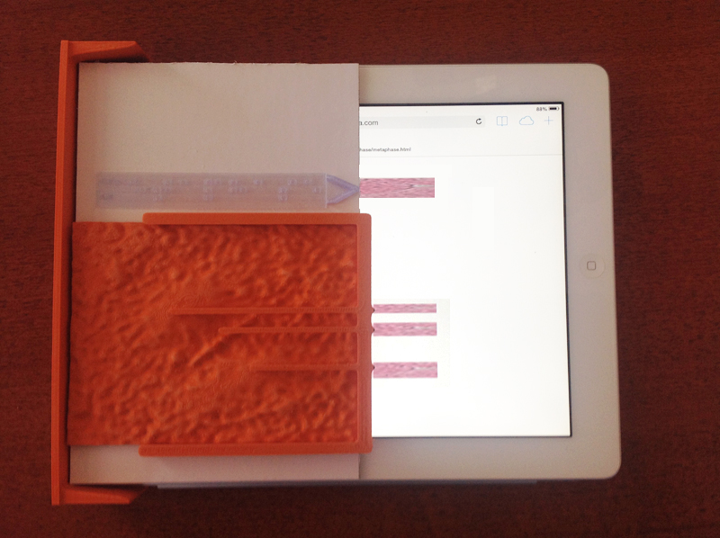
Audio from iPad with VoiceOver Audio from iPad & HTML5 Javascript

Currently, image-intensive STEM courses that utilize the microscope or telescope meet current compliance expectations by using alt text and tactile graphics. But now with prototypes being made for 3D printed tactile images that include audio, one can predict a future in which reasonable accommodations will be expected to include talking tactile 3D prints to be in compliance for blind or visually impaired students.

