Promoting Collaboration between
Disability Services and Information Technology

Presented by Cindy Camp

This presentation is sponsored by pepnet2. Pepnet2 is a federally funded project whose mission is to increase the educational, career and lifetime choices available to individuals who are deaf or hard of hearing. And whose goal is to improve postsecondary outcomes individuals who are deaf or hard of hearing, including those with co-occurring disabilities.


Why do we need to collaborate? Because we don’t work in silos any longer. In the past we were sometimes able to compartmentalize job duties. Today; however, we need to work as a team and be cross trained. No one can be a standalone expert. We need collaboration to ensure the best services for our clients.


Although disability service (DS) professionals and information technology (IT) professionals cross paths on a regular basis, their interaction is has not always been positive. Sometimes it may feel like a cat and dog fighting because we are coming at a situation from very different angles.



It can feel like DS and IT are speaking different language. We may use similar words but they can have very different connotations. Sometimes we may not even realize we aren’t communicating until there is a problem.


Today it is no longer that we should collaborate but it is essential that we do to ensure access for our clients. When we pit ourselves against one another, it only causes friction and almost guarantees limited success, at best.

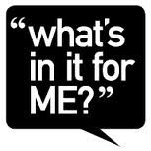
Each side of the team will benefit from successful collaboration. But more importantly the client will be the ultimate winner. Access and accommodations require knowledge of both technology and disabilities.

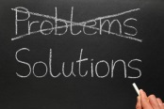
Successful people are always looking for opportunities to help others.
Unsuccessful people are always asking, what’s in it for me?
Quote from: www.statusant.com


We all come into our jobs with different perspectives and filters. DS staff sees the world through the lens of accessibility. IT staff have a whole different perspective on what access means. We need to be able to see things from the other’s perspective and explain our needs and achieve access for the client.


Clear communication is the key. When DS and IT meet, they each need to understand the right balance of information. They each need to provide enough information to get the job done but not so much that the other is overwhelmed and tunes out. It is also important to use common vocabulary and avoid highly specialized terminology. And patience is

Five Principles of Collaboration
Collaboration:
  - Requires that all team members want to work together towards a common goal

  - Is based on a sense that all participants are valued
  - Embraces the unique perspectives of all team members
  - Is based on a strong sense of purpose
  - Requires trust and a sense of shared responsibility
Critical Elements for Collaboration
2008, University of Vermont and Pacer Center

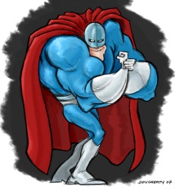
When you are able to put all the collaboration tools into practice you will create a champion for your “side.” This is a person in the other department who understands your needs and is able to act as an advocate. For example when someone in IT understands disabilities and the need for access they become the go to person in their department on all things related to disabilities. In this way they can be an inside person “championing” disability rights and accessible technology.


It is important to remember that when you want to develop a collaborative relationship you should be friendly, thankful, and considerate. When you ask for assistance do so in a nice way. Be grateful for the help you receive, even if it is the other person’s job to provide it. We all respond much better when approached in a positive way rather than an adversarial manner. Be considerate of the other person’s time and limitations. We all have a job to do but we can accomplish more when we work as a team.

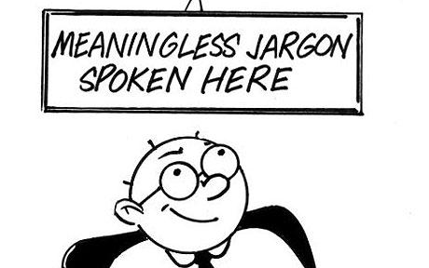
Be aware of the language you use. It is easy to get in the habit of using disability specific or highly technical vocabulary. The other person doesn’t like feeling “stupid” by asking you to explain what you mean all the time. When possible use terms that are commonly understood and don’t sound condescending when you do have to explain a concept.


Creating Universal Design is a team effort. No one person or department can do it alone. The concept is bigger than that. Since true accessibility requires a team each member of the team should understand the overall goals and have ownership in the final results.

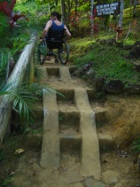
When there is a problem with creating access remember to think outside the box. Rarely is there ONLY one solution to a problem. When IT says “This CANNOT happen because of this technical issue” and DS says “This has to happen because of ADA” it is a loose/loose situation. But when the issue is presented and both sides work to find a solution that fits with technology restrictions and disability accommodations then it becomes a win/win.

When addressing accessibility and technology there can be larger issues involved. There are some things that it is good to know before you begin pointing fingers and playing the blame game.

  - Know your institution’s policy on who pays for adaptive technology.
  - Know the rights and limitations of the software licenses.
  - Know who is responsible for the maintenance.
  - Communicate with IT about scheduled maintenance and updates.
  - Time is money. Understand why IT has certain procedures.

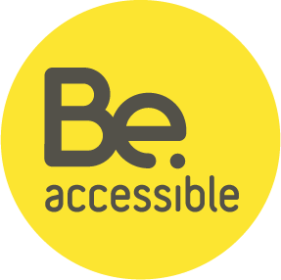
It is also important to remember that your internal IT department is not the only IT people you’ll need to work with. DS and IT at an institution will also need to work with external IT such as those at companies you purchase software and equipment from.
- Ask vendors to demonstrate the accessibility features.
- Get an accessibility statement, which includes upgrades, from vendors in writing before buying.
- Have a review process for technology to ensure accessibility.
- Provide faculty with an accessibility checklist.
- Don’t wait for accommodation requests. Be proactive

Here are additional resources for learning more about technology and disabilities.
- "From Where I Sit" Video Series
  - http://www.calstate.edu/accessibility/resources/videos.shtml
- Pepnet2
  - Access: The Fundamentals
  - http://www.pepnet.org/e-learning/access
  - QuickClasses
  - http://www.pepnet.org/quickclasses
- DO-IT: Disabilities, Opportunities, Internetworking & Technology
  - http://www.washington.edu/doit/
- Free Technology Tutorials Beaches
  - http://members.tripod.com/MR_LEGO_JOE/free_online_tutorials.htm
- GCF LearnFree.org
  - http://www.gcflearnfree.org/Computer/

Cindy Camp, Personnel Development Specialist
cindy.camp@pepnet.org

Please visit www.pepnet.org to see more pepnet resources.

