Captioning using Camtasia 8.0

- Open up Camtasia and then select Import media and browse for the file that you would like to caption.
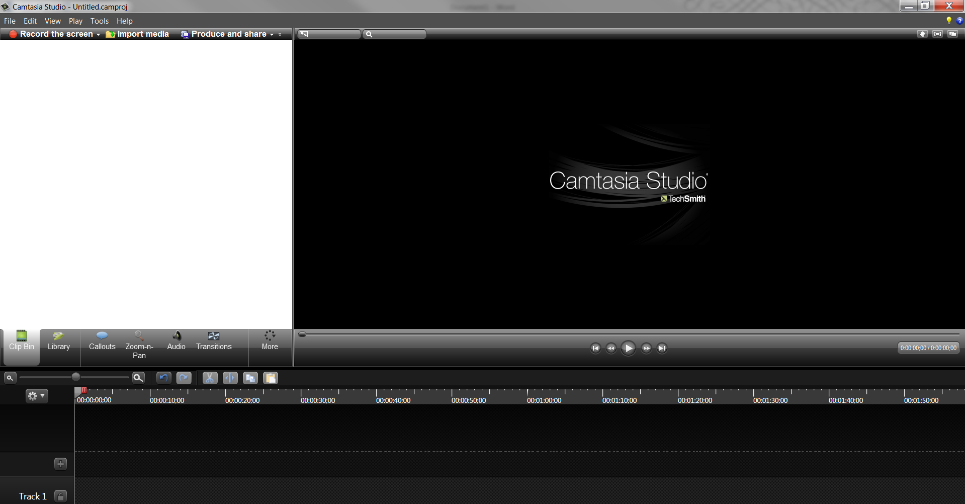
- Right-click on the file located in the clip bin and select Add to Timeline at Playhead.
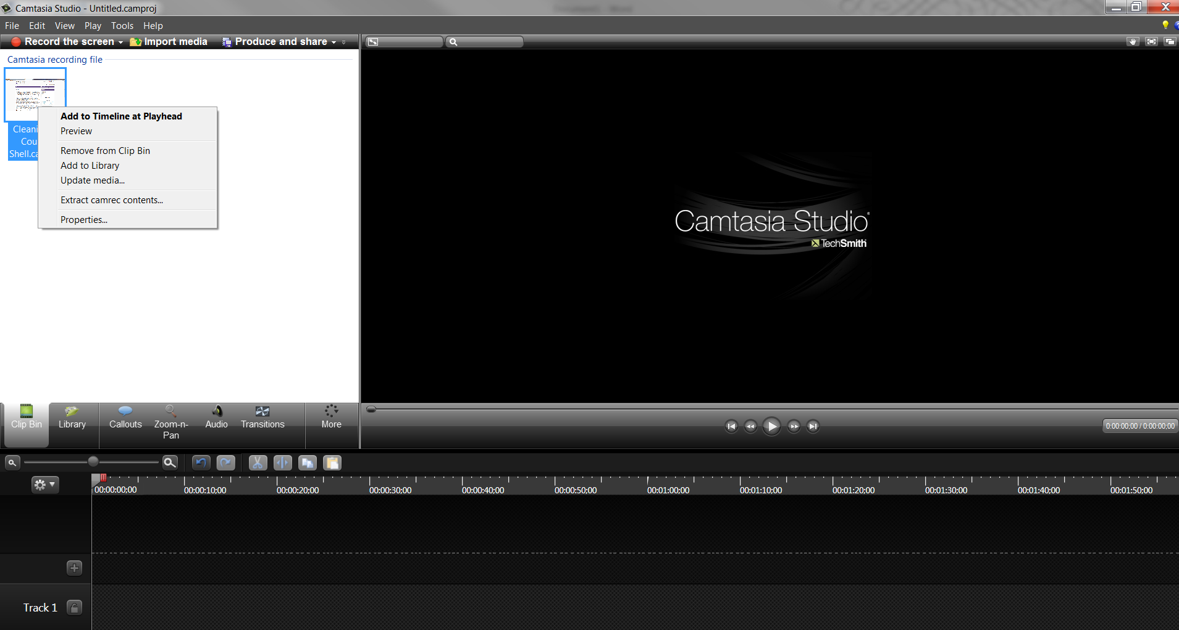

- After the file is added to the timeline, a window will pop up asking What size do you want your video to be? You can choose:
  - 1280x720 (for HD quality that will be uploaded to YouTube)
  - 640x480 (if the captioned video will be uploaded directly to an LMS)
  - The Automatic (default) resolution that show up if you are not sure.
- Select OK
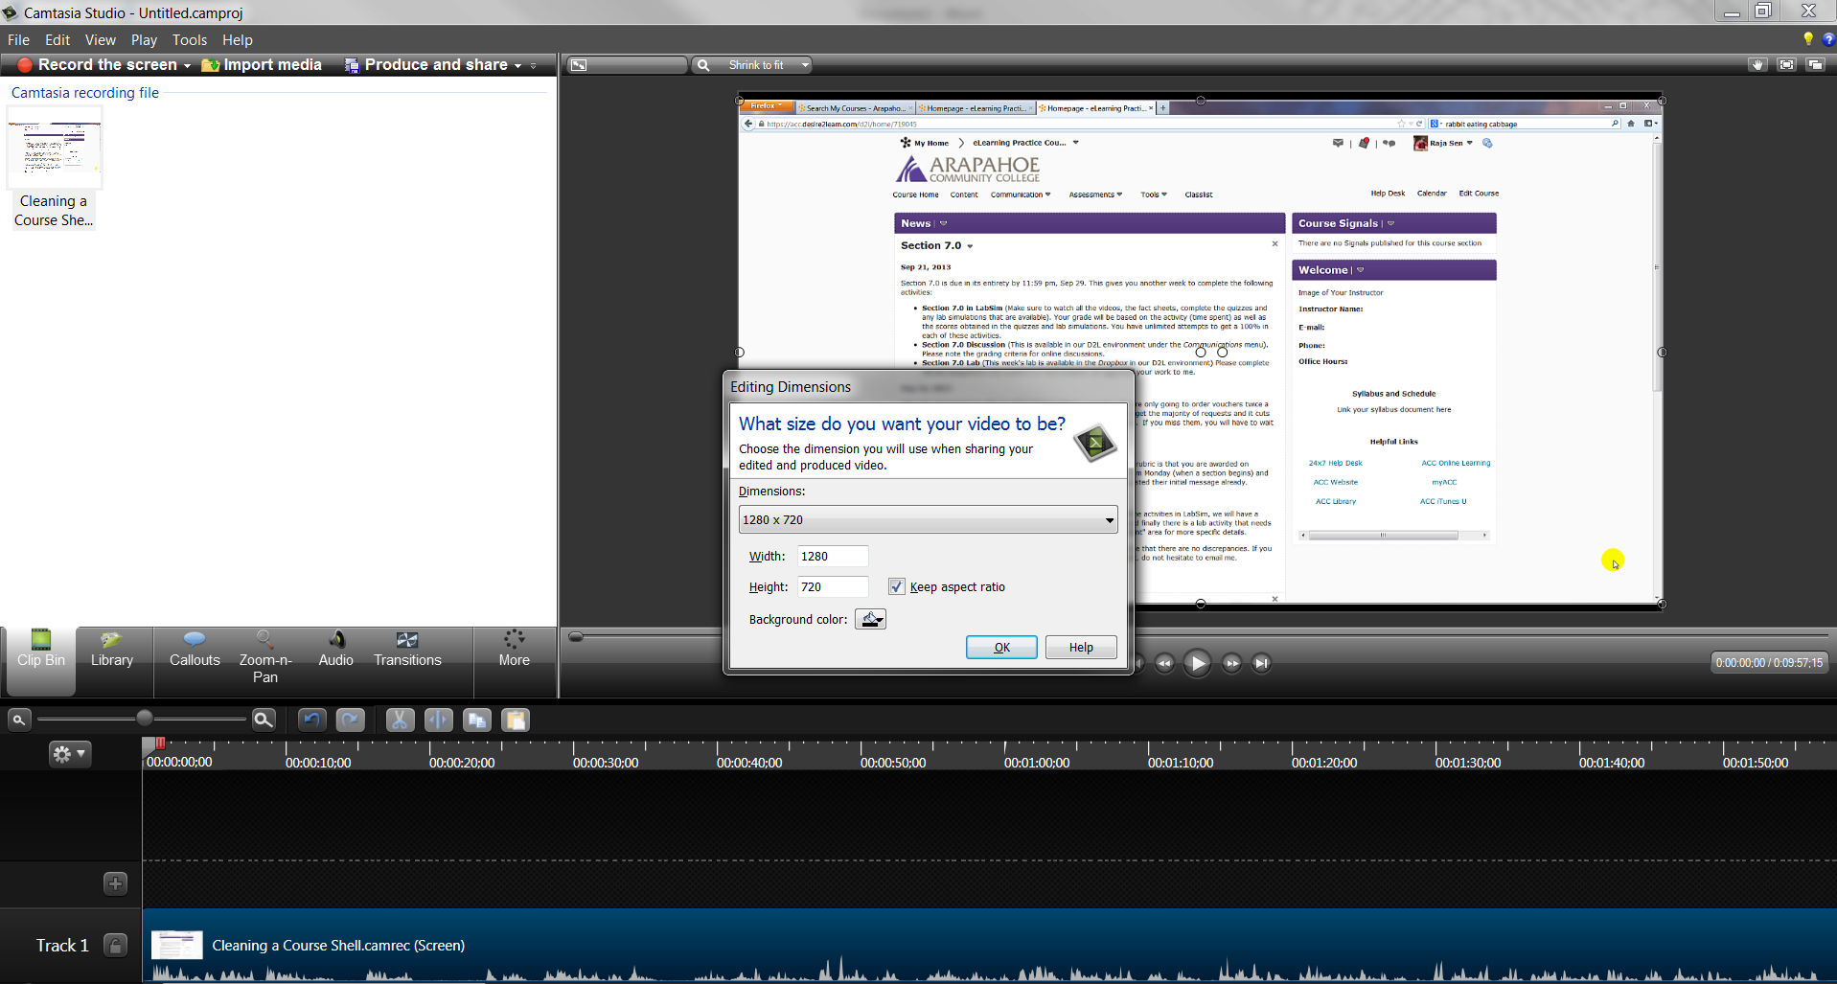
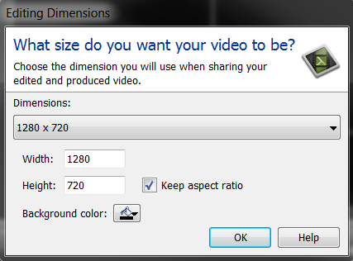

- Next select the More option and select Captions.
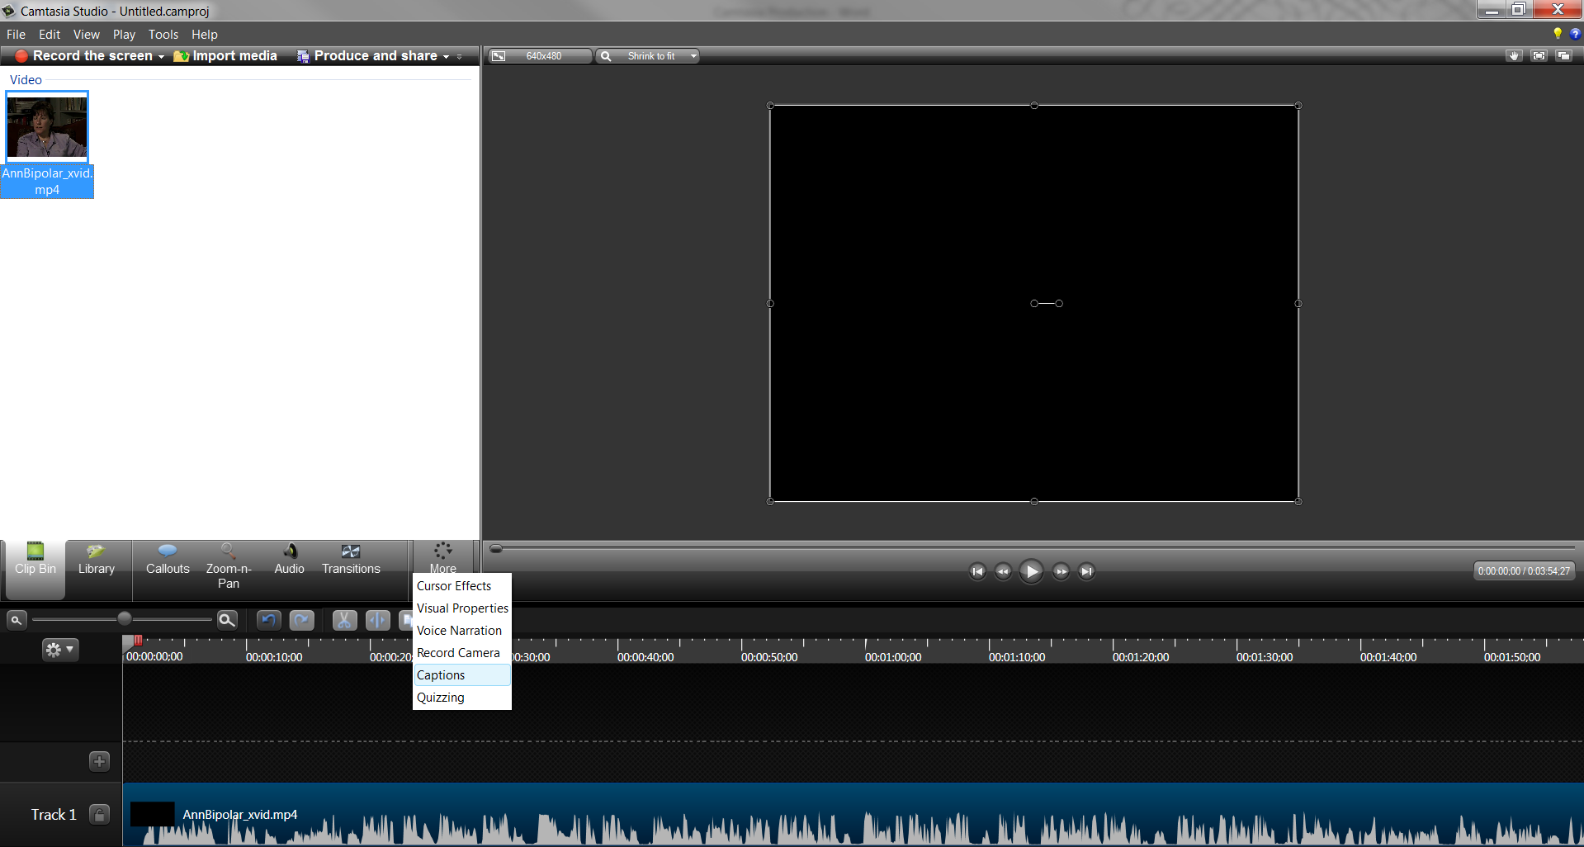
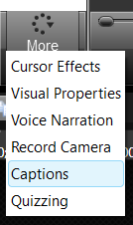

- A captioning pane will now appear on the left upper corner. Right-click and paste your transcript into the box that says Click to paste script or add caption. You can also type out your captions here.
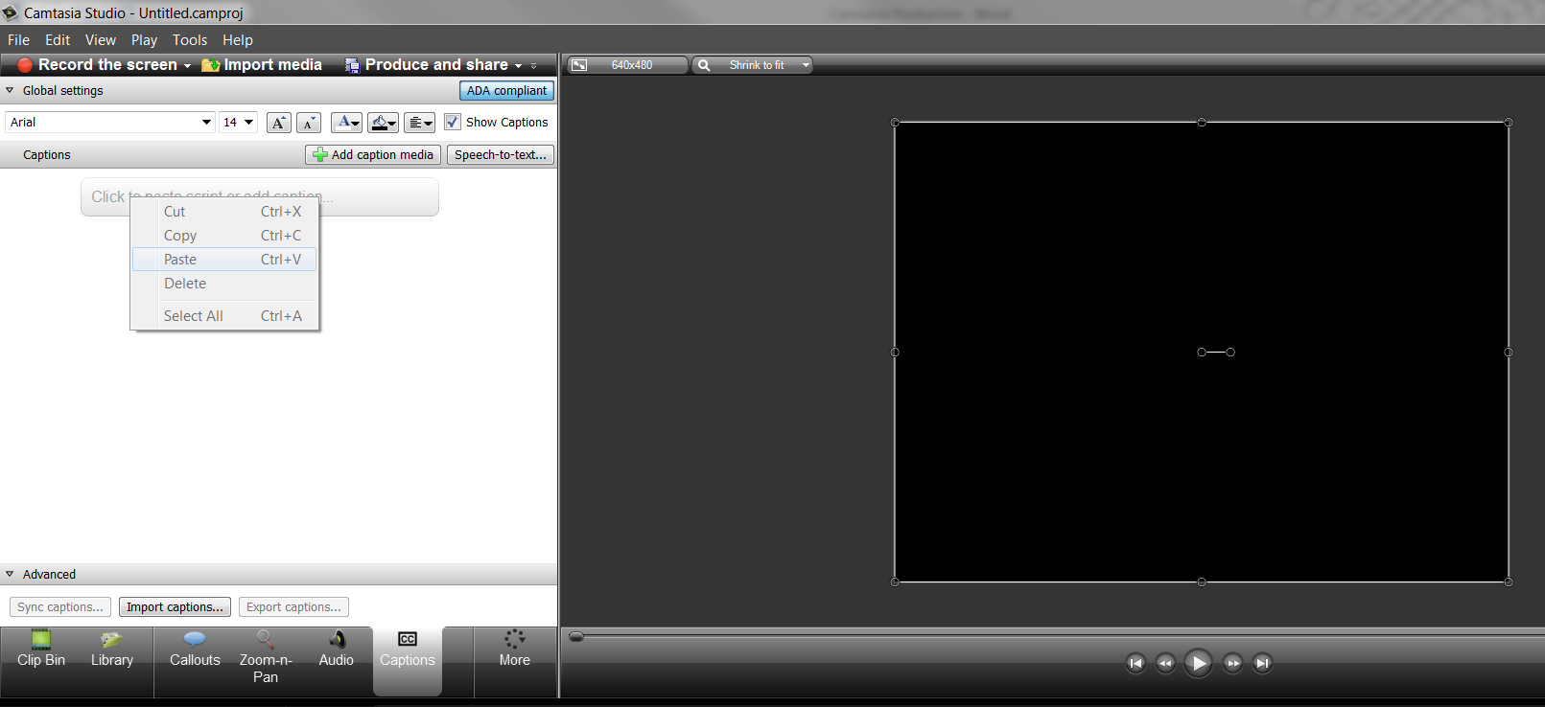
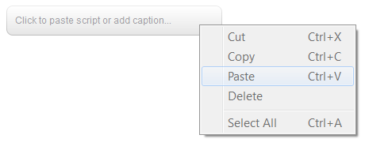

- The first three lines of the transcript appear at the beginning of the video automatically. When you are ready to sync, click on the Sync captions option.
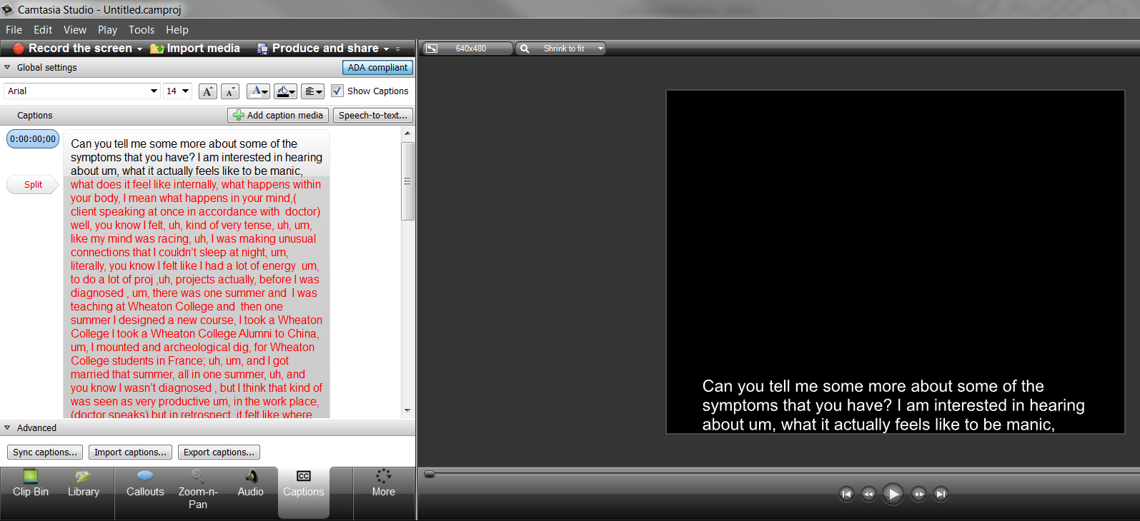
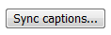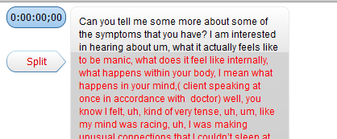

- A hints window will pop up. Select Continue when you are ready to begin syncing.
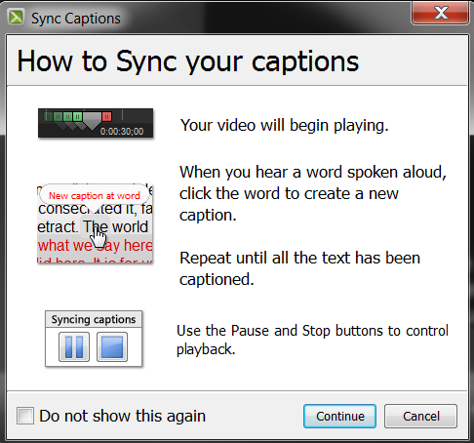
- The syncing process starts. Click on the first word of the line in red when you hear it in the video. Continue this process until the whole video is complete and all the captions are synced. If you need to pause syncing at any time, use the pause icon or use the stop icon to stop syncing.
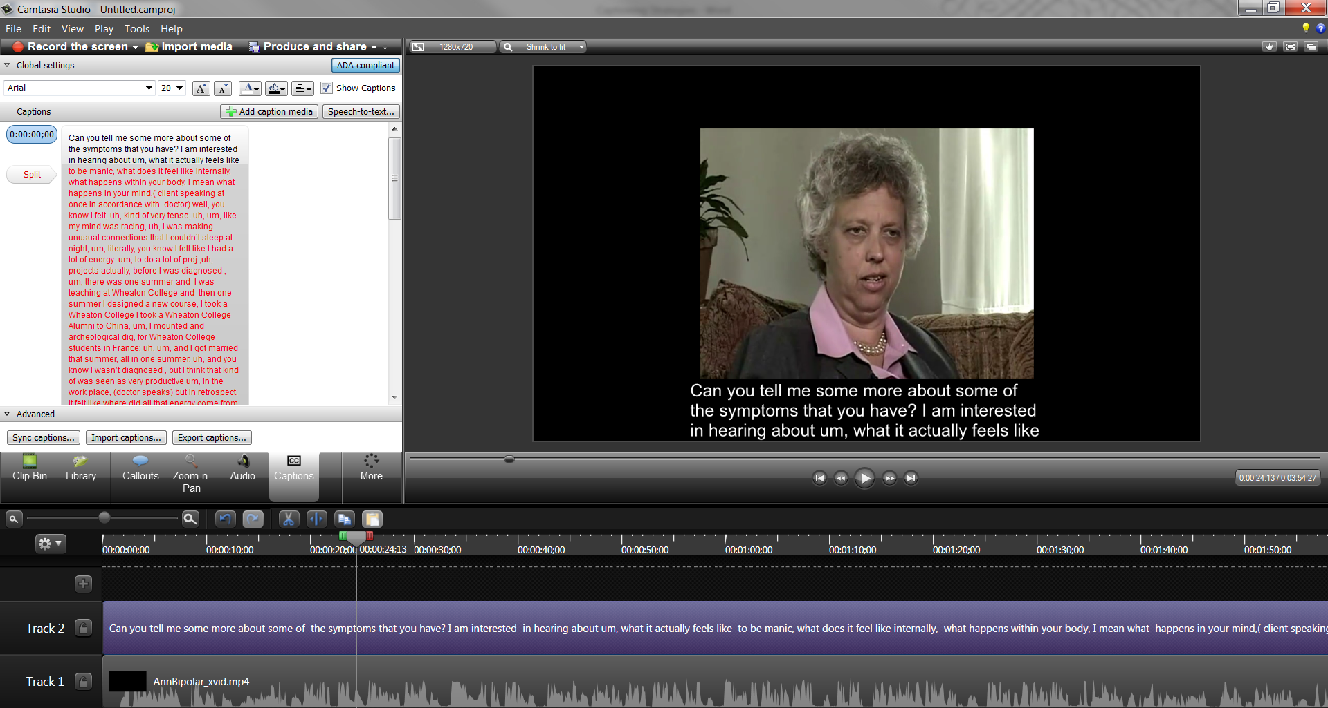
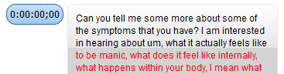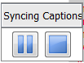
- After the syncing is complete, review the video and produce it (use the produce “with player” option to get closed captions. Any other production setting will have open captions).

- Make sure to save the project when done (prompts when you attempt to close the window and will allow you to make changes/edit your captions later, if needed).

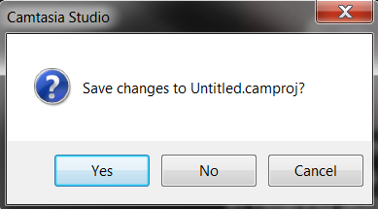

Captioning on YouTube

- Once logged onto your YouTube account, go to the Video Manager. Here you will see a list of all your uploaded videos.
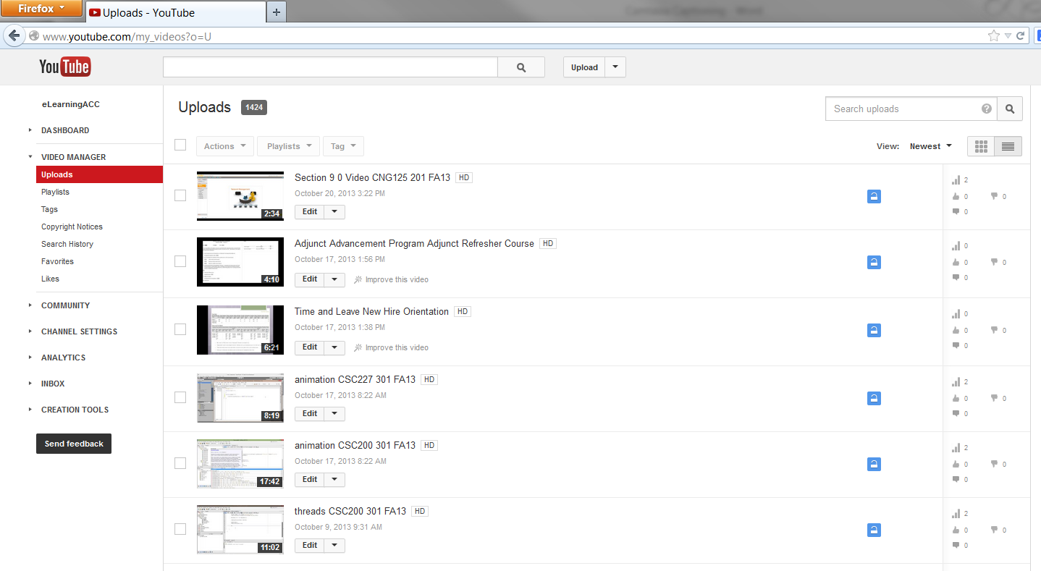
- To caption a video, select the dropdown menu next to the Edit option on the video and choose Captions
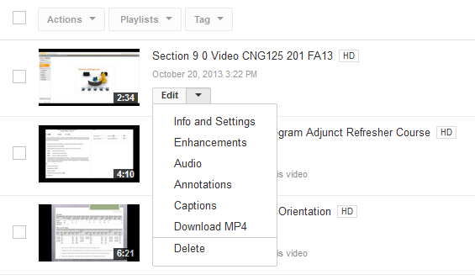
- The video will open up with different captioning options. Notice that YouTube provides an automatic speech-to-text feature that creates an automatic captions track.
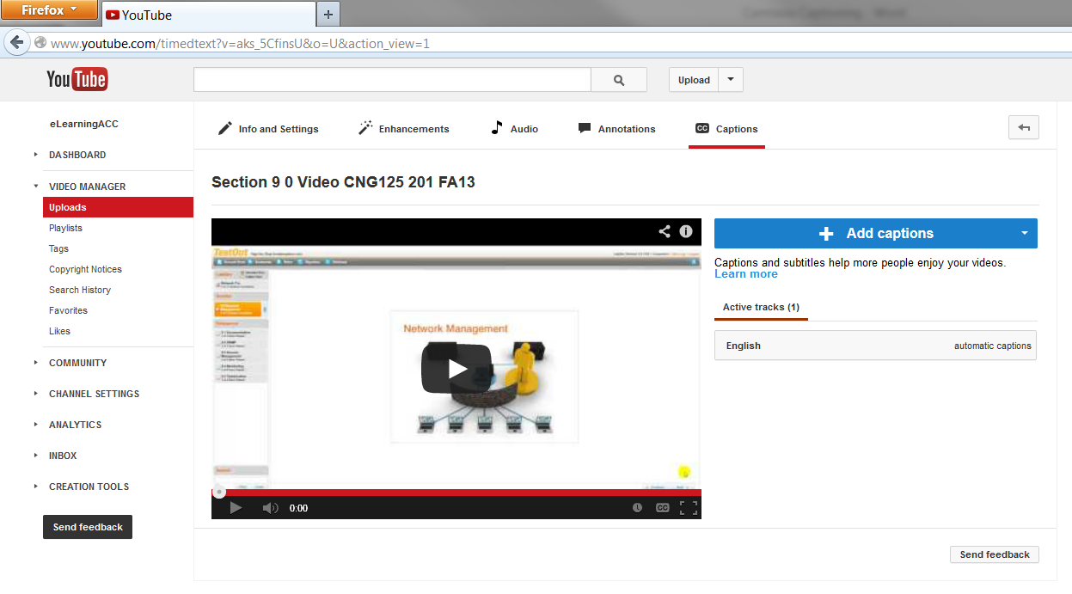
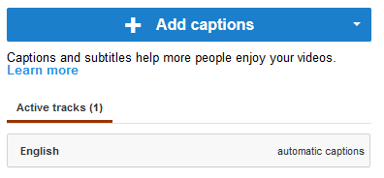

- One way to caption the video is by editing the automatic captions track. Click on the English track to expand it. This will allow you to preview the video, and make active edits/corrections on the track itself. Make sure to Save a copy, which creates another caption track with your edits.
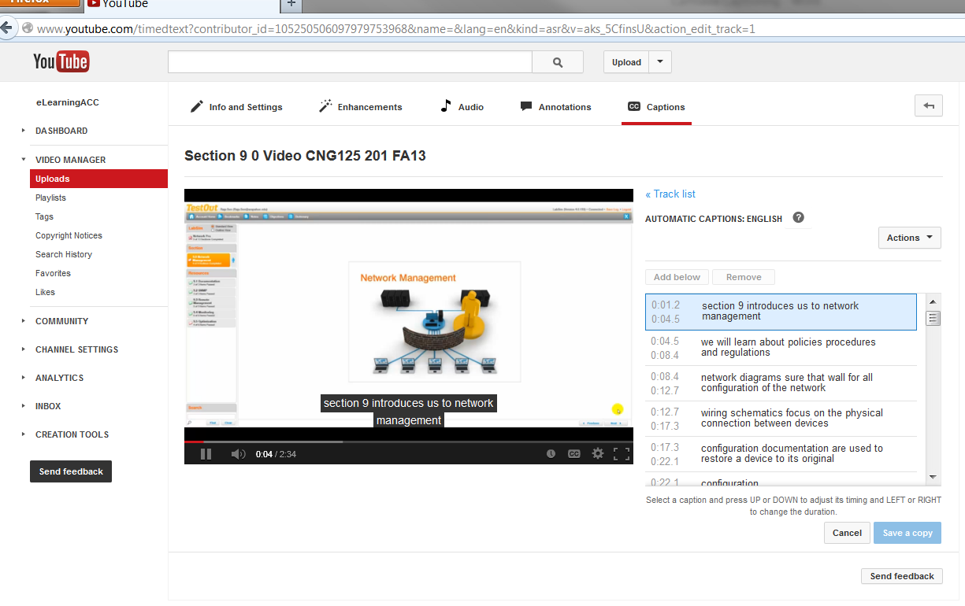
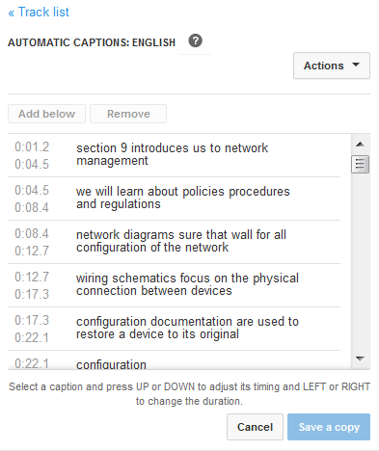
- The other way to caption the same video on YouTube is to transcribe and sync captions right on YouTube itself. This provides you the opportunity to transcribe the video into a box and then use the sync feature to automatically create the time stamps. From the Captions page, select Add cations and then choose Transcribe and sync.
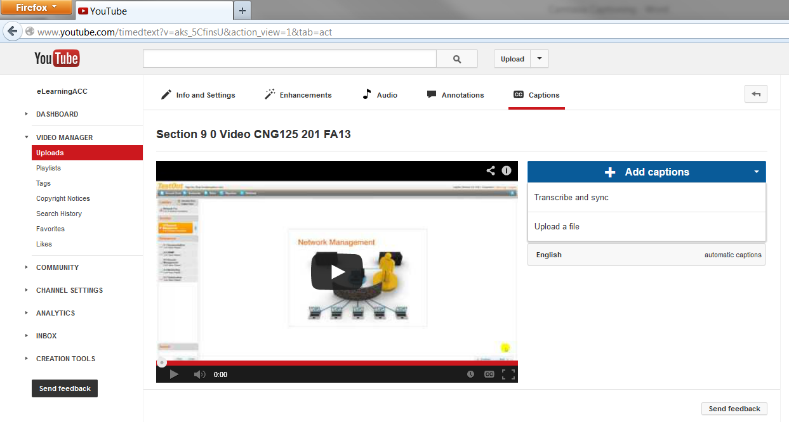
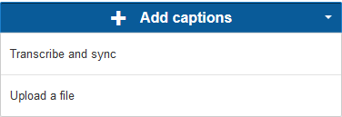

- You can now type out your transcript in the box provided while listening to the video. YouTube provides a hands-off feature in which the video pauses automatically when you start typing. When you finish transcribing, select the Sync option for YouTube to sync the transcript and create captions automatically.
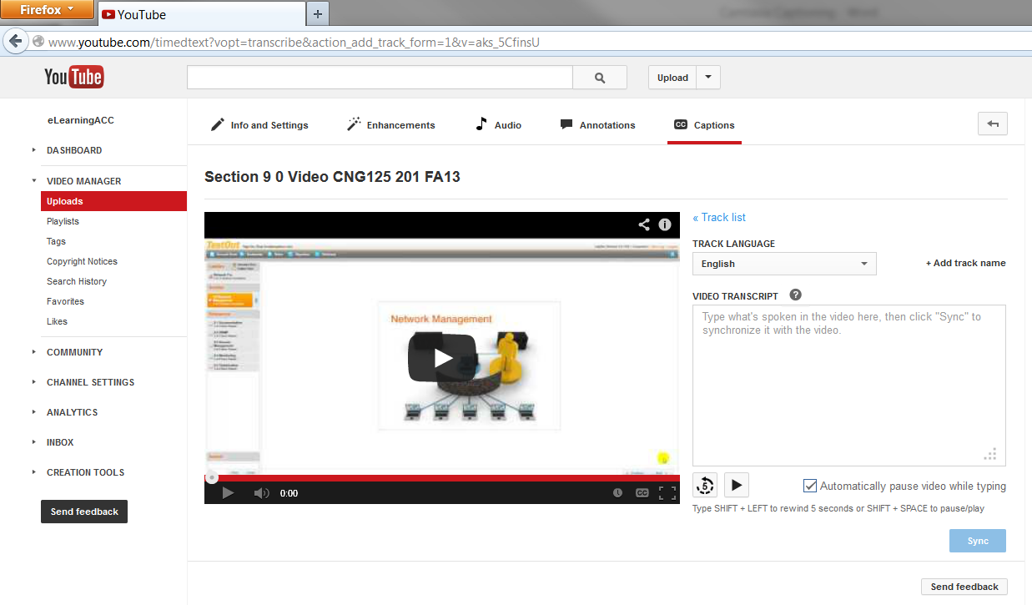
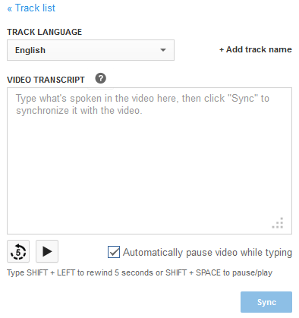
- The syncing process takes some time, but once initiated, you do not have to do anything else.

