ATLS 3519 – Lab #7 – 12 pts.
  - Lab#7: Evaluating a site from a ScreenReader perspective

Objectives:
- To learn how a ScreenReader (voice output technology) accesses a Web page
- Learning to use a Screenreader as another tool for evaluating a page or site for accessibility

Background
Although it is not required to use a ScreenReader to determine the accessibility of a page, using a ScreenReader such as JAWS, Window-Eyes, or NVDA, provides perhaps the best sense of what it is like for a blind person or a person with what is termed a “print disability” (the inability to read text due to cognitive, perceptual or visual issues) to access a Web page. For this assignment we are going to use a ScreenReader (JAWS or NVDA – your choice), along with some other tools, to evaluate the ATLAS site.
(Note: you will need a Windows-based machine to run JAWS or NVDA. You can conduct this lab on a Mac using VoiceOver if you like).

Preliminary Review of the ATLAS Site
First, let’s take a look at the ATLAS site at http://atlas.colorado.edu/. Take a look at the page, access some of the menu items and review some of the sub-pages. Think about the design concepts we reviewed in weeks 3 and 4: typeface, contrast, alignment, navigation, Interaction Design, Information Architecture, language, etc. What do you notice about this page? Does it have features consistent with good design and usability.

Report item 1: Write a paragraph describing your initial impressions of the ATLAS home page.

Reviewing the Site with a ScreenReader
Now, let’s review the site with a ScreenReader.
I’m going to recommend downloading the demo version of the JAWS ScreenReader (this is the most popular ScreenReader, at least in the U.S.). As an alternative you can use NVDA (Non-Visual Desktop Access), an Open Source application. I’m more familiar with JAWS and find it easier to use but you might want to try NVDA since it does not time out after 40 minutes as per the JAWS demo. However, the keystroke hints I provide below will be for JAWS. You will have to read the NVDA documentation for the corresponding keystrokes/hotkeys.
The following are the download sites for each program:
JAWS: http://www.freedomscientific.com/downloads/jaws/jaws-downloads.asp

NVDA: http://www.nvda-project.org/
(Aside: what do you notice about the NVDA site?)

- Use the above urls to download and install either JAWS or NVDA.

- If you installed JAWS you will probably get a message about “no authorization found.” Choose the option to run the program in demo mode. As mentioned above, you will have 40 minutes until the program times out. You will then have to reboot your computer to get it to function for another 40 minute session.

- Open the ATLAS site in Internet Explorer. Start JAWS or NVDA if it is not already running. With JAWS you should hear summary information about the page each time you open or move to a new page; for example, the title of the page, the number of links, etc. JAWS will then proceed to read the whole page in sequence. You can halt the “reading” at any point by pressing the CTRL key.

- You can resume JAWS reading by pressing Insert+Down-Arrow (or CapsLock+down-arrow).

- Use the down-arrow to move down through the ATLAS page one item at a time. Use the up-arrow to move in the reverse direction.

- Some other JAWS keystrokes

  - Tab – move to the next link.
  - Enter – activate a link or button
  - Insert+F1 (or CapsLock+F1) – context sensitive JAWS help
  - Insert+T – read title of page
  - H – next heading
  - Backspace – previous url

- Moving through the page and using some of the keys listed above, what do you notice about the structure of this page? Are you able to access links on this page? Is the page well structured? (For example, does it use headers to divide up the page logically into major content areas?).

- As a comparison, try going to the new Disability Services page: http://disabilityservices.colorado.edu/ . If you’re feeling adventurous, you can use the Ctrl+O command to open a dialogue box to enter the url via JAWS instead of typing the url into the address box.

- As you use JAWS to move around the page what do you notice about the layout and structure of the Disability Services page compared to the ATLAS home page?

- Feeling really brave? Try shutting off or covering your display. Can you navigate to a subpage and back? Can you move around a page and keep your orientation?

Report item 2: Write a paragraph or two describing the problems you see with the ATLAS site based on your interaction of the page with JAWS.

Using other Tools to Analyze the ATLAS site
Now that we have a sense of what it’s like to access a page using a ScreenReader, let’s use some other tools to supplement our analysis of the ATLAS site.

WAVE

- Let’s start with a tool called WAVE, developed by WebAIM. WAVE is an easy-to-use tool with a nice graphical-user-interface for analyzing and displaying the structure and accessibility errors on a Web page.

  - You can either install the WAVE toolbar into Firefox (download the toolbar at: http://wave.webaim.org/toolbar) or you can cut and paste a url into the WAVE page at: http://wave.webaim.org/

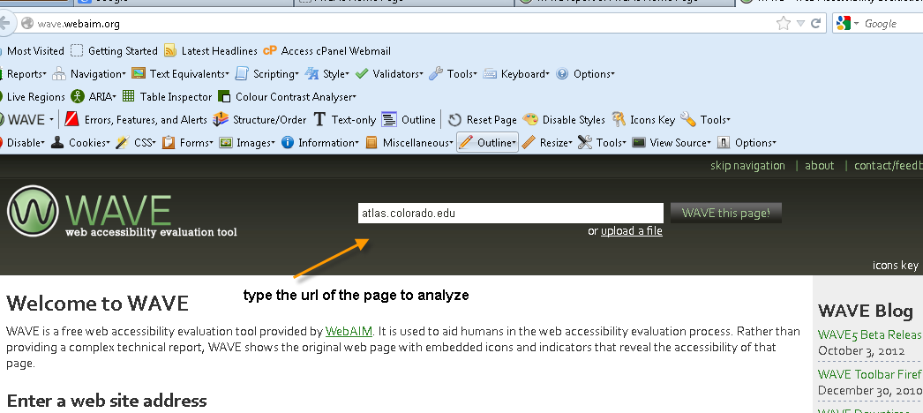

  - Whether we use the WAVE toolbar for Firefox or the website version, you’ll notice that there are four main evaluation categories:

    - Errors, features & alerts
    - Structure/Order
    - Text-only
    - Outline

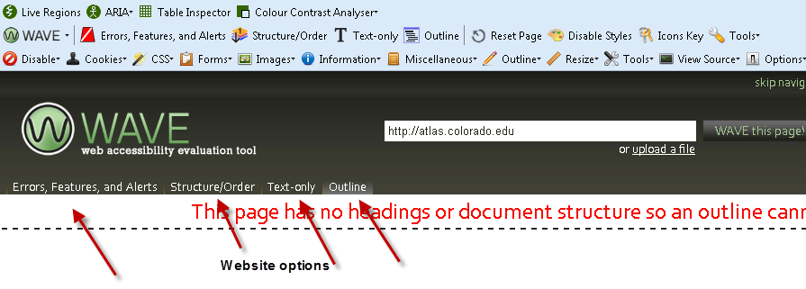

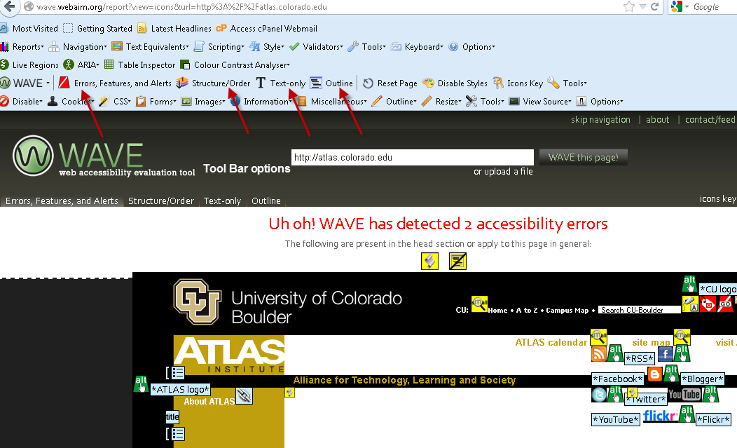

- If you select the “Errors, features & alerts,” you will see notification of errors such as missing alternative tags (images without text descriptions), missing form labels, the placement of lists, etc.
  - When you run this option on the ATLAS home page two serious errors are reported (interestingly, when I run this option directly from the toolbar on the ATLAS page I get 6 errors – I’m not sure why).

  - If you move your mouse pointer over any of the icons a popup will appear explaining the meaning of the icon. A red icon indicates a serious accessibility error.

- The “Structure/Order” option will show you the code-order of objects on the page.

- The “Text-Only” option will display how the page looks without images (in other words, how it looks to a ScreenReader).

- The “Outline” tool will show you the headings and other structures on the page. If you select this option and see no headers on a page this is a quick indication that the page lacks structure and semantic markup.

Achecker
- Another tool you may want to check out is achecker at http://achecker.ca. Similar to the webpage version of WAVE you enter the url into the field at the top of the page (see below). This tool is more text-based but more intensive and provides a more detailed analysis, including an analysis of color contrast and font size.

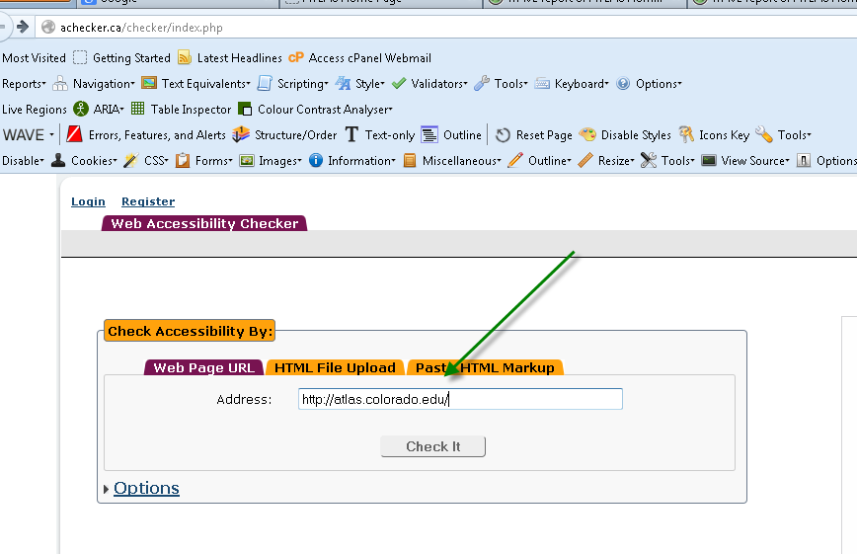

Report your findings – Due Friday, 4/12/13, midnight
In addition to the 2 paragraphs asked for above, report on the following items based on the information derived from your evaluation of atlas.colorado.edu using the screenreader and at least one of the 2 tools listed above. Include the following:
- Note all problem features – usability & accessibility
- List necessary corrections
- Do some recoding if you can
- You can focus on reporting or on recoding as follows
  - 2 page report (600 words) & no recoding – but describe in some detail how you would correct the problems on the page
  - 1 page report (300 words) with recoding – upload your recoded pages to the dropbox or upload the url where your recoding is located.

Due date: April 12, midnight – to dropbox #7.

