Lab#1: Evaluation of 3 sites using Norman’s concepts – 12 pts.

Objectives:
- To apply the design principles of Norman to web design: visibility, affordance, constraints, feedback
- To learn to discern the underlying structure of websites and how it relates to issues of accessibility
- To learn the evaluate the accessibility and usability of websites

Software tools required:
- Firefox
  - Addons required (go to “tools” menu in Firefox, “addons,” and search and add-on the following extensions):
    - Firefox accessibility extension - https://addons.mozilla.org/en-US/firefox/addon/5809?src=api
    - Web developer toolbar - https://addons.mozilla.org/en-US/firefox/addon/60?src=api
    - Wave accessibility toolbar - http://wave.webaim.org/toolbar (Note: you may need to go directly to the Wave page to add this toolbar)
After installing the above add-ons, the top of your Firefox screen should look similar to the following:

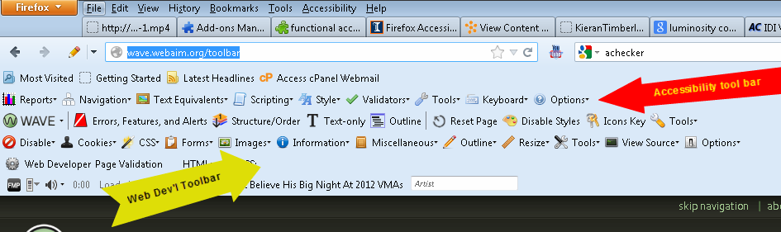

Note: the WAVE toolbar is between the Web Dev’l & Web Accessibility Toolbar.

Instructions:
Now we’ll use these tools to evaluate a number of sites for meeting Norman’s requirements for good design.

The first site we’ll look at may have been designed to be obnoxious. In any case, it demonstrates almost everything we want to avoid in a design.

- http://www.lingscars.com/
  - Demonstrates features to avoid
    - Poor contrast, annoying and distracting animation, music that provides no control for shutting off and has no time limit.
    - Flashing graphics
    - Graphic links with no alt tags
    - Poor structure
    - Use of poor style methods such as “spacers”
    - “Breaks” conventions of navigation
- Remember our 7 principles of good design mentioned in video 2 for this week
  - Affordance – Can the user easily determine the action possibilities of an element on the screen?
  - Visibility – Can the user tell what the state of the element is and the alternatives for action?
  - Conceptual model – Is there a good conceptual model with consistency in presentation of operations and results and a coherent, consistent system image?
  - Constraints – Can the user determine what actions are possible at any given moment?
  - Mappings – Are there good mappings where it is possible to determine the relationships between the actions and results, between the controls and their effects and between the element state and what is visible?
  - Feedback – Does the user receive full and continuous feedback about the results of the actions taken?
- First impressions: this site has too much “visibility” and “feedback.” In other words, there’s a lot of noise, both visual and auditory, distracting the user from determining and performing the action to achieve their desired task – in this case, finding options for car rental. So, in a sense, this is a case where too much visibility, too much noise, causes invisibility and thus a lack of affordance. It is not clear where you should go or focus on initially.
In addition, any type of feedback on this screen would probably get lost in all the other information presented to the user.
Compare this site to the Amazon site (demonstrated in the videos for this week). As Kathy mentioned in her video, Amazon is very good at presenting the important information on the screen and highlighting one product at a time – along with other important information related to that product (i.e. shipping options, cost, etc.).
- In fact, let’s briefly visit the www.amazon.com site.
  - What information do you focus on or notice first when you go to their home page?
  - What do you notice first on the lingcars site? Anything? (Or do you just get a headache?)
- Let’s use some of our Firefox tools to evaluate the lingcars site in more detail.
  - While on the lingcars site, select “Outline” from the Wave toolbar
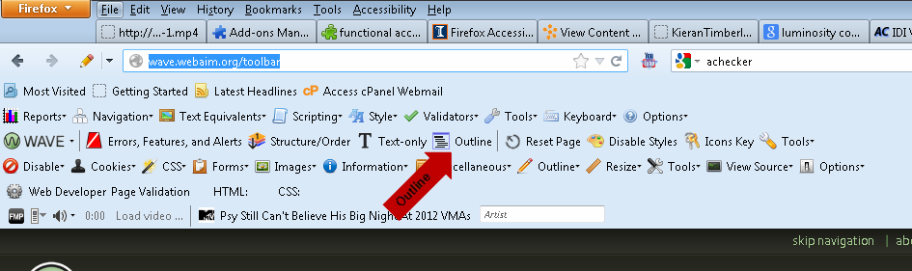
You should see something similar to the following:

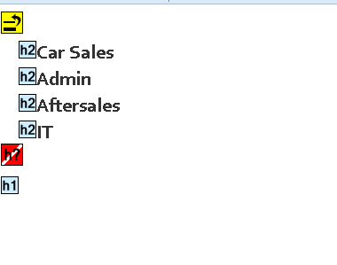

- The above outline tells us that there is some structure on the page. We’ve mentioned headings and semantic structure briefly but not in detail. For now, remember that headings (designated as h2 and h1 above) are one of the key ways web pages are organized. They help both search engines and the user of assistive technology (AT) by structuring the page into blocks of information that can be more easily navigated (and weighted by search engines).
- Although the above WAVE report tells us that there is structure to the page, it probably would not be much of a help to either search engines or the AT user (or anyone for that matter), for a number of reasons, including:
  - The headings are not in a logical order (heading 2 should follow heading 1, for example)
  - (It seems that) the headings do not represent the most important or key sections of the page. Are these the areas a user would be most interested in?
  - The heading names are abbreviated. In particular, IT, is too ambiguous an abbreviation for both users and SEO.
  - There is too much extraneous information. Even if an AT user (such as a user with visual impairments using a screenreader) could locate one of these headings, there are so many other objects (links, text, graphics) on the page that it would still be difficult to find the information sought.
- To get a sense of the busyness of the page, select “Structure/Order” from the Wave toolbar.
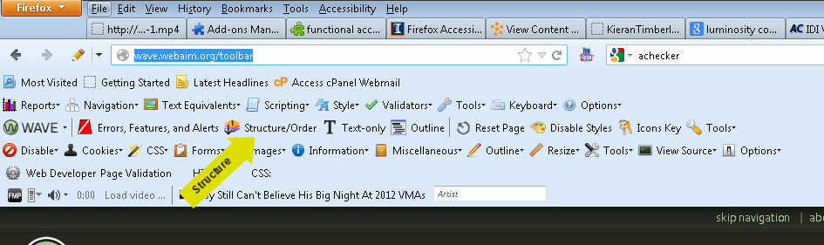

You should see something similar to the following:
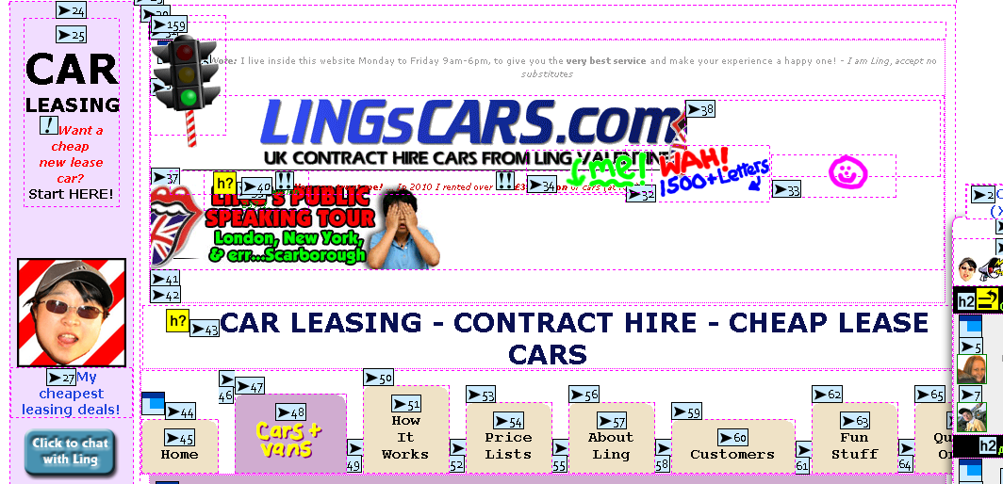
The numbers tell us the order of objects on the screen. Note there are a few hundred items on the page.
- One more task. Reset the page (by either reloading the page through the browser or selecting “reset page” in Wave toolbar).
  - Now try tabbing through the page. Is there any indication or feedback of your location?

For a comparison, let’s visit the NY Times site.
- New York Times – www.nytimes.com
  - Select the “Outline” and then the “Structure/Order” option from the WAVE toolbar
    - What do you notice?
    - Headings
      - The headings of the Times site is more logically structured. News headlines are coded as H2 or H3. The subsequent bylines are coded for H6. Someone using a screenreader can move through this page by following the header structure. Similarly, the structure of the page would benefit SEO.
    - Menus
      - Many (though not all) of the various menus (for example, “multimedia”, “tools and more,” etc.) are marked by headers (H6). The menu items are presented in unordered lists. The unordered list provides additional semantic structure to the document, telling the AT user and the search engine that these items (in the menu list) are related.
- Let’s jump back to lingcars.com one more time to get back to some of Norman’s concepts.
  - If we select “text-only” from the WAVE toolbar, the actual structure of the page without styling is revealed. As you scroll down the page, do you notice menu items and information you did not see previously?
  - Does the design of the lingcars.com site actually hide useful information from the user?

- Let’s return to the NY Times site. This time we’re going to use the “images” option in the Web Developers Toolbar:
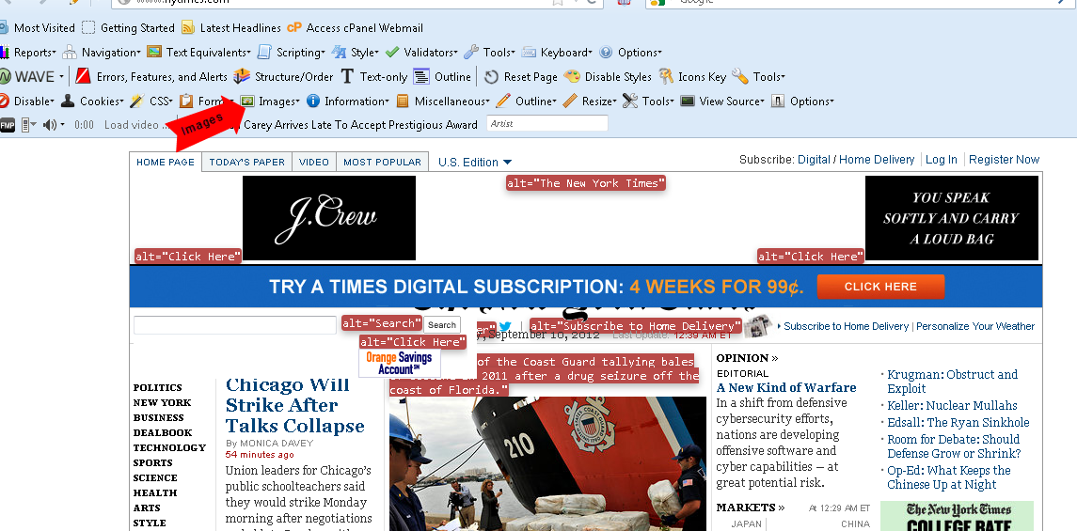

Select “display alt images” under the images option.
  - This will show the text equivalents (i.e. alt text) for all the graphic elements on the page.
  - Notice that most non-text items have alternative text.
    - Do you notice any problems with the alt text that appears on the NY Times home page? Is the text concise and does it convey the essence of the graphic or picture sufficiently?

  - (Optional: ) Look at Wall Street Journal or Washington Post as a comparison news site – www.wsj.com

- Next: we’ll look at another problem site but not one as glaringly bad as the lingscar.com site.

  - http://kierantimberlake.com/home/ - architectural site
  - From a visual perspective, what do you notice about the design of the page?
  - Explore the menus and structure of the site; use the tools we reviewed above to evaluate the site.
  - Questions to consider:
    - In what ways, if any, does this page break from convention (or break our mental model) in site navigation?
    - Is there a problem with visibility on this site?
  - Some other tools to use on this site.
    - Use the “ATRC (x)” tool under “Tools” on the Web Accessibility Toolbar
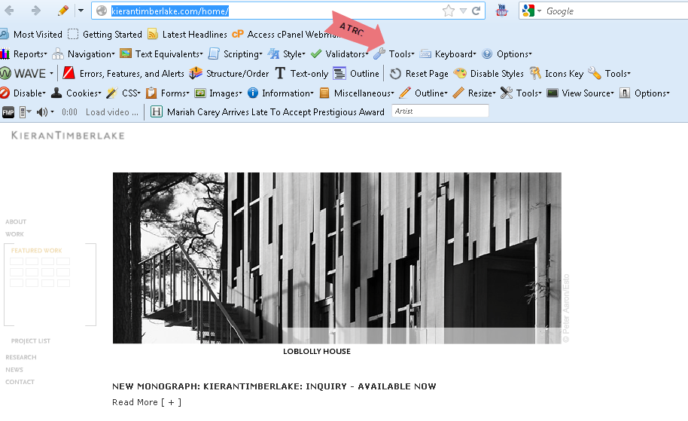
      - This will take you to the site for the “achecker” tool. You will need to copy and paste the kierantimberlake url into the achecker url field.
      - What does the achecker report reveal about color contrast and keyboard access (note: information on keyboard access is at the bottom of the report)?
(You can read more about color contrast at: http://www.w3.org/WAI/GL/WCAG20/WD-WCAG20-TECHS/G18)

Lab #1 Report Assignment: Select any 2 sites from the list below and one site of your own choosing.
Using the tools we’ve reviewed above, evaluate each of the sites.
- Write a paragraph or two on each site reviewed, describing whether there was structure (i.e. headings, text equivalents, unordered or ordered lists); keyboard access (i.e. can the keyboard be navigated by the tab key; does achecker reveal any problems with keyboard access?).
- Are the color contrast sufficient and the text size large enough?
- If you can, and I realize this may be difficult, describe how the design of these pages meet or do not meet Norman’s concepts.
Site evaluation list (choose only 2 and then 1 site of your own):
  - www.thedailybeast.com
  - www.colorado.edu
  - http://classics.mit.edu/Browse/index.html
  - http://www.shmarketing.co.uk/recruitment.php (one of the sites Kathy reviewed in her lectures this week)
  - http://www.leoneck.ch/en/ (one of the sites Kathy reviewed in her lectures this week)
  - http://www.highcallingcockers.com/

Output: 500 words or greater.
Where to post: lab #1 dropbox.

