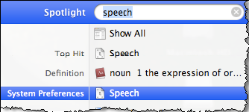
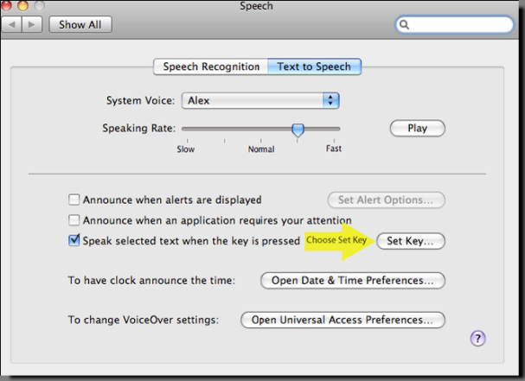
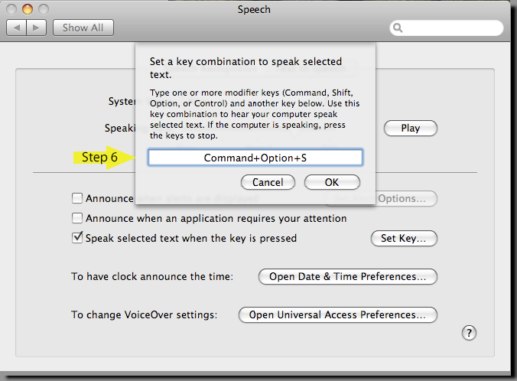
Step 1:
Go to Spotlight, (the search utility indicated by a magnifying glass in the upper right corner of your screen).

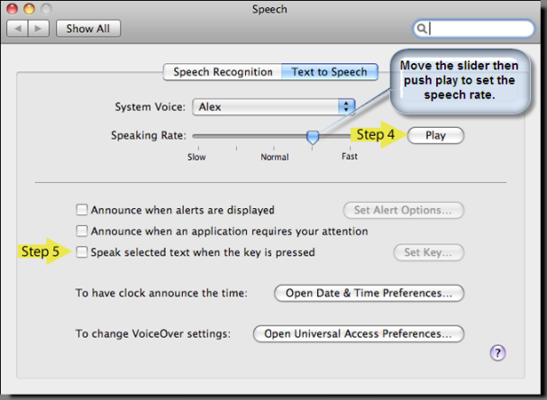
Step 2:
Type in "Speech", press enter or select System Preference Speech from the suggestions offered.

Step 3:
In “Speech” dialogue box that will appear, push Play to test the various Speaking Rates.
Use the slider to set slow, normal or fast. When the rate is right for you go on to the next step.
Hint: Vary the rate depending upon what material you are reading. Note that this is a great way to proof what you write.

Step 4:
Check the 3rd checkbox, which reads “Speak selected text when the key is pressed.”
A pop-up box will appear - enter the key combination you will use. If box does not appear, select the button labeled “Set Key…”
Press the keys you want to use (e.g.command option S), then press OK.
“Set Key” allows you to create the command you will use to stop and start the speech.
Hint: Including R for Read S for Speech or V for Voice might help you remember your choice of command.

Step 5:
Select (highlight) the Material you want to hear, press the key combination you created, and start listening! Press again to stop.
Go to your document or to a web page. Highlight or select the text you would like to have read. Press the key combination to start speech. Wait for the section to finish reading or press the key combination again to stop speech.

