Speak is a built-in feature of Word 2010, Outlook 2010, PowerPoint 2010 and OneNote 2010, which allows text-to-speech in the language of your version of Office. If you select some text, then select the command Speak, your text will be read out loud. This function is not included in the main menu options, so here is a method to make Speak easy to use.

Add Speak to the Quick Access Toolbar
You can add the Speak command to your Quick Access Toolbar by following these steps:
- Alongside of the Quick Access Toolbar, there is a small dropdown arrow, select this to get to the command “Customize Quick Access Toolbar:”
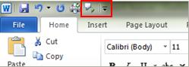
- Select “More Commands.”
- In the “Choose commands from” list, select “All Commands.”
- Scroll down to the “Speak” command, select it, and then click “Add.”
- Click “OK.”

Convert Text To Speech
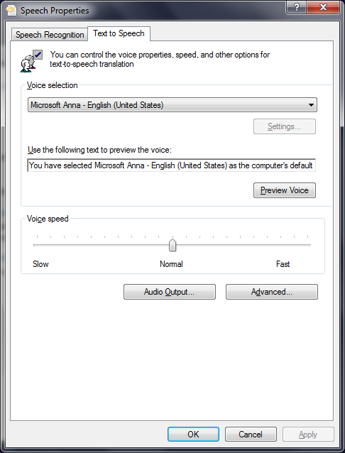After you have added the Speak command to your Quick Access Tool, you can hear single words or blocks of text spoken by highlighting the text you want to hear and selecting the Speak command. Select again to stop the text to speech output.
Changing the Speed of Text Reading
Go to “Control Panel”
Choose view by “Large Icons” or “Small icons”
Go to “Voice Recognition”
Select “Text-to-Speech” Use the slider to change the speed in which text is read. The default voice will be Microsoft Anna.
Windows® Keyboard Commands
General keyboard-only commands
F1 | Starts Windows Help
F10 | Activates menu bar options
SHIFT+F10 | Opens a shortcut menu for the selected item (this is the same as right-clicking an object
CTRL+ESC | Opens the Start menu (use the ARROW keys to select an item)
CTRL+ESC or ESC | Selects the Start button (press TAB to select the taskbar, or press SHIFT+F10 for a context menu)
ALT+DOWN ARROW | Opens a drop-down list box
ALT+TAB | Switch to another running program (hold down the ALT key and then press the TAB key to view the task-switching window)
SHIFT | Press and hold down the SHIFT key while you insert a CD-ROM to bypass the automatic-run feature
ALT+SPACE | Displays the main window's System menu (from the System menu, you can restore, move, resize, minimize, maximize, or close the window)
ALT+- (ALT+hyphen) | Displays the Multiple Document Interface (MDI) child window's System menu (from the MDI child window's System menu, you can restore, move, resize, minimize, maximize, or close the child window)
CTRL+TAB | Switch to the next child window of a Multiple Document Interface (MDI) program
ALT+underlined letter in menu: | Opens the menu
ALT+F4 | Closes the current window
CTRL+F4 | Closes the current Multiple Document Interface (MDI) window
ALT+F6 | Switch between multiple windows in the same program (for example, when the Notepad Find dialog box is displayed, ALT+F6 switches between the Find dialog box and the main Notepad window)

General folder/shortcut control
F4 | Selects the Go To A Different Folder box and moves down the entries in the box (if the toolbar is active in Windows Explorer)
F5 | Refreshes the current window.
F6 | Moves among panes in Windows Explorer
CTRL+G | Opens the Go To Folder tool (in Windows 95 Windows Explorer only)
CTRL+Z | Undo the last command
CTRL+A | Select all the items in the current window
BACKSPACE | Switch to the parent folder

