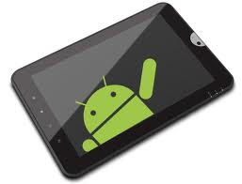
Apps for Android Phones and Tablets
Here are some apps that are able to do more and be more for every university student!

Image to Text Apps

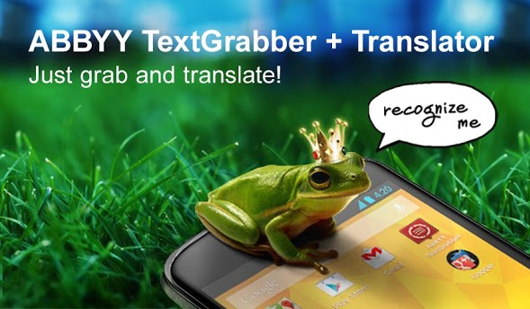
ABBYY TextGrabber + Translator
ABBYY Software House
$2.99
A multifunctional mobile scanner with full-text translation capability allows you to take a picture and send from your device!

Mobile OCR Free
Smart Mobile Software

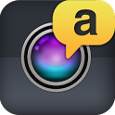

Mobile OCR Pro
Smart Mobile Software
$3.99

Notetaking

Classic Notes Lite + App Box
Fluffy Delusions

Classic Notes + App Box
Fluffy Delusions
$1.99

LectureRecordings
Acadoid Developer
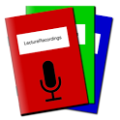
$1.32

- 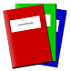
LectureNotes
Acadoid Developer
$4.26
LectureRecordings is an Android app for audio recording, mainly while taking handwritten notes using LectureNotes.
It is designed for using it for recording while teaching using LectureNotes .

Pdf to Speech
Practical Apps

Pdf to Speech Pro
Practical Apps
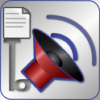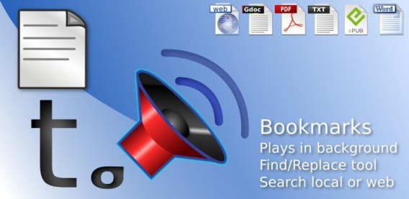
$2.99
Plays PDF, ePub, Txt, Doc Webpage. Plays in background. Search, OCR. Bluetooth Listen to your your office documents, books, articles and research papers

Mantano Ebook Reader Lite
Mantano SAS
Free

Mantano Reader Essentials
Mantano SAS
$2.99

Mantano Ebook Reader Premium
Mantano SAS
$6.99
Chinese font - Mantano Reader
Mantano SAS
Free
Japanese font - Mantano Reader
Mantano SAS
Free

DAISY

Darwin Reader
New Designs Unlimited, LLC
$14.95 Buy
Darwin Reader is the first accessible Android book reader designed specifically for blind, low vision, and print disabled users. The app fully supports DAISY. Free trial is good for 30 days.

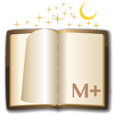 $4.99 Buy

Web E-Reader & Translator
Appsolute Perfection

(BETA)

AP Web Reader Translator
Imagine if you could read the web, while you run, in a language you just learned but now suddenly understand... This app shoots for just that. Whether it's reading the news or your favorite websites from ReadItLater (for more see www.ReadItLater.com), you can:
- Have it read to you while you run/ride/practice Tae Kwon Do
- Dictate by voice what you want it to read next
- Even read it in another language, and translate on click
•
Voice Lookup
Appsolute Perfection
Voice Lookup Definition Meanings etc. (i.e. by Speaking you immediately load search)
Install
•
Random Number Reader
Appsolute Perfection
Reads a number between 1 and your choice. Useful for target shooting, lotto ...
Install

Textbooks. Now featuring features.
- Inkling for Everyone.
All Inkling titles are now available for iPad, iPhone, PC & Mac. From free chapters to full titles, everything syncs between devices in real time.
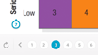
Digital publishing site has textbooks free publish and more.

Loudbook:
Loudbook – (Russian app) a huge collection of the best and highest quality audio books. With this application you can download and listen to a lot of the most interesting and recent books. Main features of the application:- To download a book from the vast collection- Ability to create your library- Handy player for listening to books- Support for multi-tasking. With LoudBook you can make your personal library of books - modern prose, the book business, teaching literature, poetry, classical literature, books for children. Application directory is constantly updated and contains over 1000 books
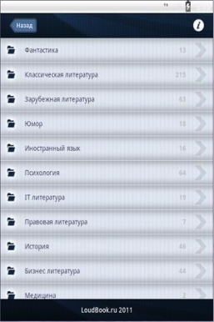View larger image

Audible
Audible provides recorded books that are of the highest quality. Variety of books can support some Higher Ed classes especially those that use literature. A good solution for those who want human reading voices.

Homework

myHomework
Associate classes and homework with your calendar. Allows entry of classes and displays homework due dates on calendar. Easy entry of information. Reminders only available with myHomework account.
2012 instin, LLC

Chem Pro
Lessons 1-20 Automatically Download with program. First year overview of Chemistry broken into concepts chapters.
Neither audio nor video alone convey full concepts but good for learners who want to reinforce their book learning. Auditory aspects not captioned- visuals not described.
iHelpNYC.com (free)

Mind Mapping

iMindMap

iMindMap HD
Free
IMindmap comes with a variety of cloud based support and user levels. When the Freedom subscription is purchased ($20.99/ year), material can be access on multiple systems and used with any computing envirorment. Basic components usable for free: Can add branches, photos, sketches and branch text in App.
Options to insert additional items such as floating text and central idea available with subscription purchase. Also enables ability to export.
NoteLynX Outliner
AstroDean
Free
Not especially intuitive but free.

NoteLynX Pro Outliner
AstroDean
$1.99
Outliner & Hierarchical Tree Note Editor. An Organizer for all your thoughts, ideas & information using cross reference links to create personal data networks
$1.99
$7.99

iThoughts (mindmapping)
Best mind mapping by voice!
http://www.ollapp.com/app/ithoughts-mindmapping/android

Useful Utilities to Support Using Apps

calibre - E-book management
calibre-ebook.com/
calibre is Especially well known for ability to convert formats regardless of original DRM. An all in one solution for all your e-book needs. Comprehensive e-book software.

Run Mobile Apps on Windows PC or Mac with BlueStacks | Android ...
bluestacks.com/
Download Bluestacks run Mobile Apps on Windows or Mac.

